**Day1: Download, Install and configure**

Download -> Install -> configure path in system environment variables

* Java

<https://download.oracle.com/java/21/archive/jdk-21.0.5_windows-x64_bin.exe>



* Git

<https://github.com/git-for-windows/git/releases/download/v2.49.0.windows.1/Git-2.49.0-64-bit.exe>

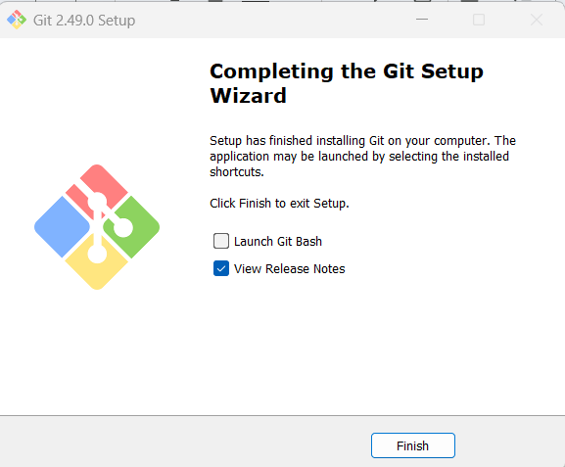

Download --> configure path in system environment variables

* Maven

<https://dlcdn.apache.org/maven/maven-3/3.9.9/binaries/apache-maven-3.9.9-bin.zip>

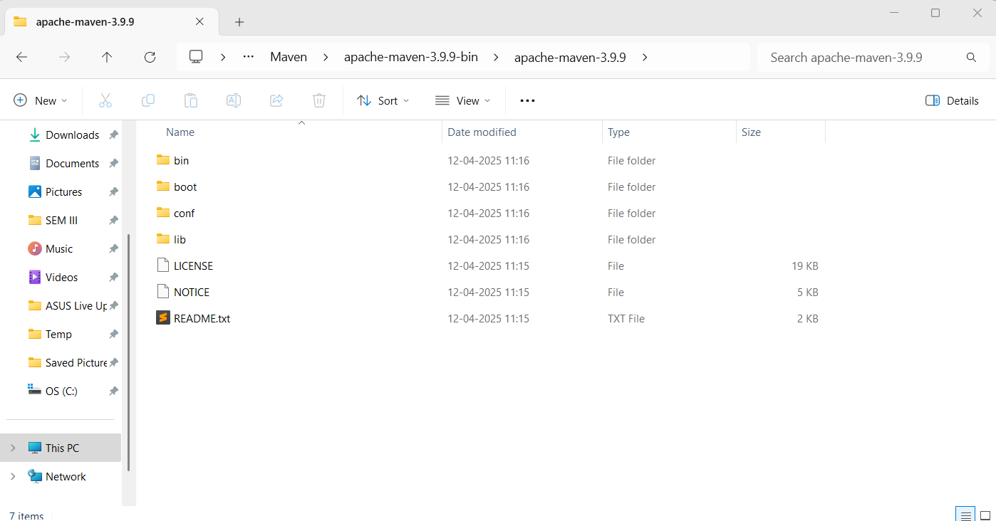

* Terraform

<https://releases.hashicorp.com/terraform/1.11.4/terraform_1.11.4_windows_386.zip>

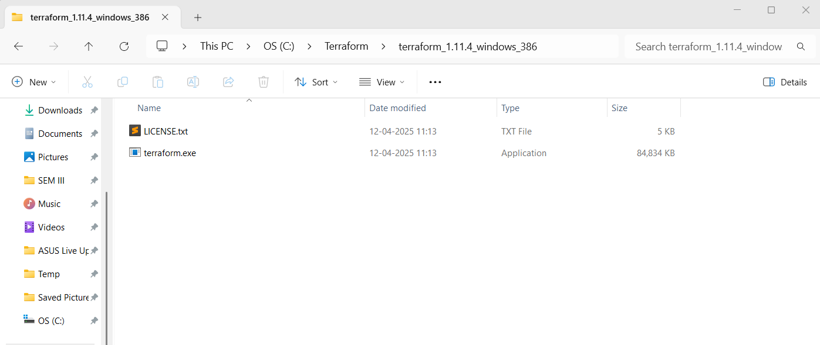

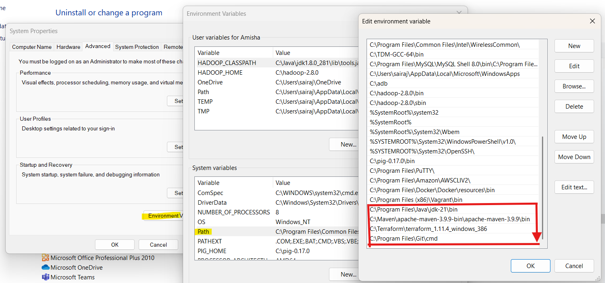

**Validate the installation:**

>java --version

>mvn --version

>git --version

>terraform --version

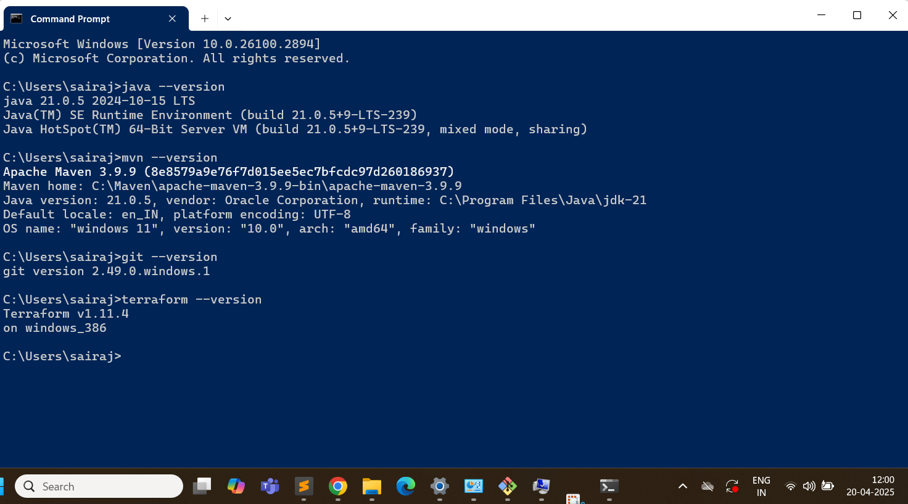

**Install IntelliJ IDEA & VSCode:**

IntelliJ IDEA Community Edition

<https://www.jetbrains.com/idea/download/?section=windows>

VSCode

<https://code.visualstudio.com/download>

**Create accounts:**

* AWS account
* Github Account
* Docker hub account

**Day3: Creating our first microservices**

Go to <https://start.spring.io/>

Select:

Project: Maven

Language: Java,

Springboot version: 3.310

Artifact name: makemytrip

Packaging: Jar

Add the dependencies: Spring Web, String Boot Actuator

Generate the zip file

Extract the zip file

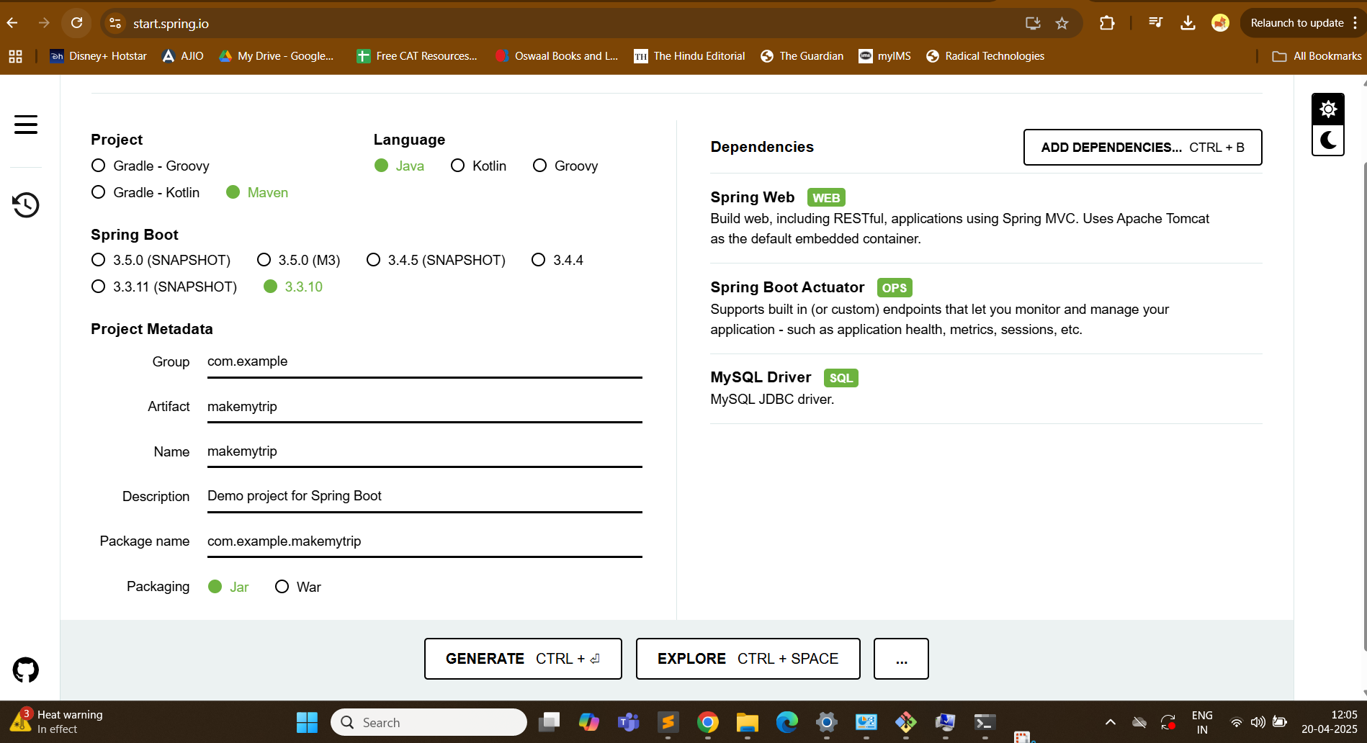

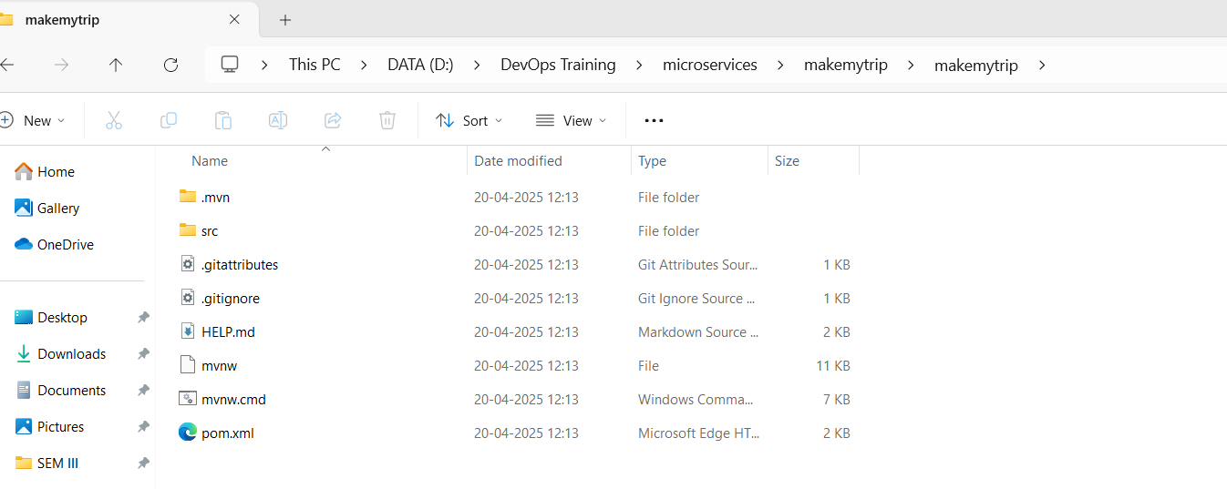

> mvn clean compile

(Creates .class file)

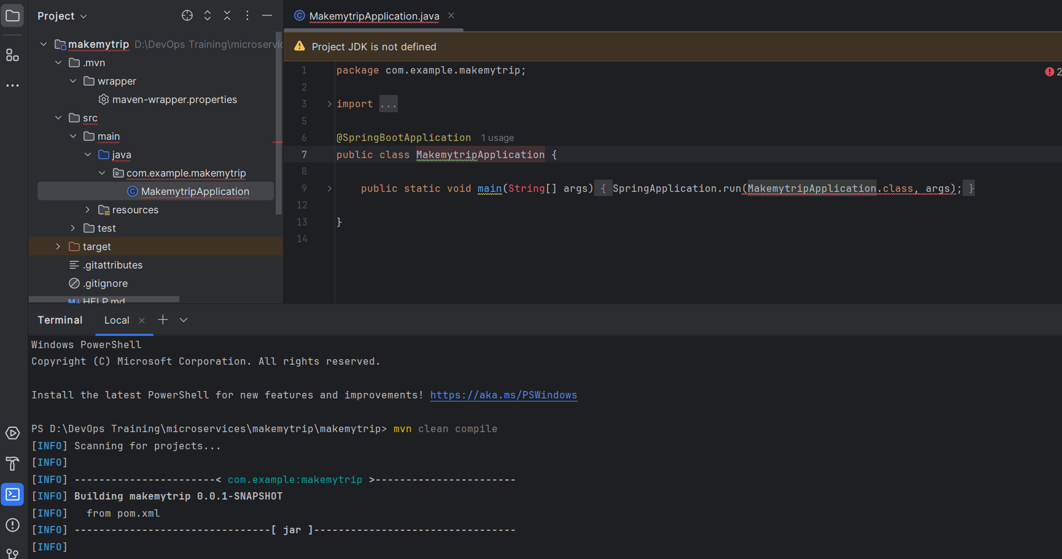

Location of .class file

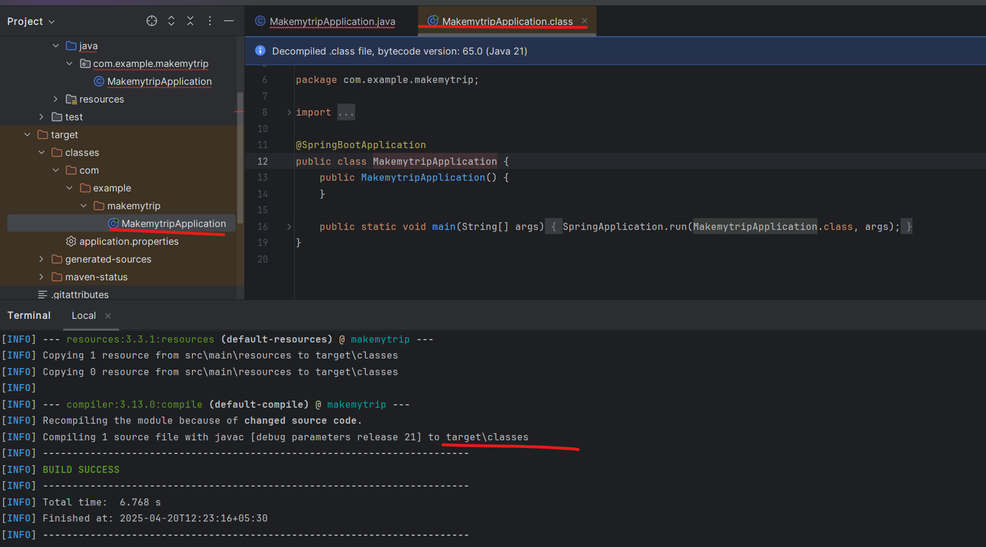

Now package:

> mvn clean package

Default package is .jar

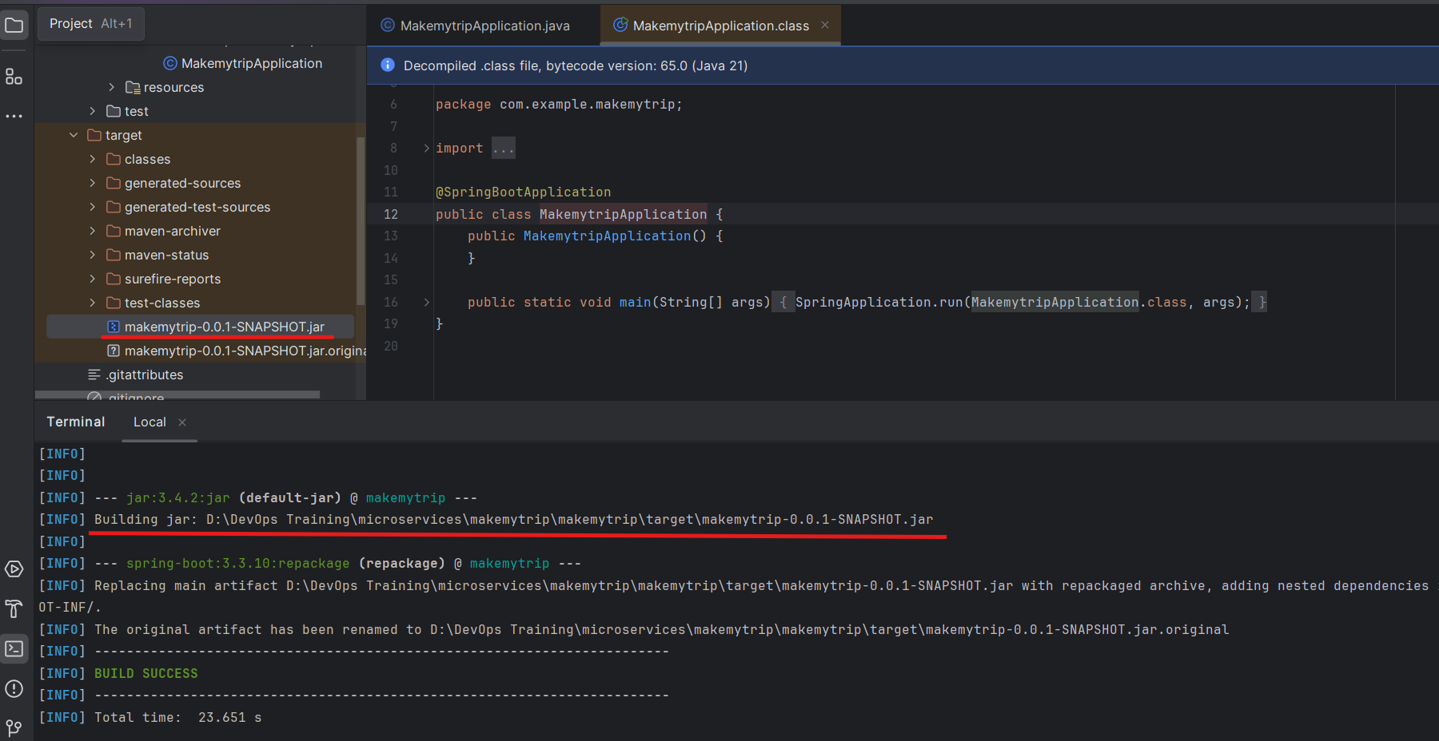

Now add a java fileRight click on java skeleton > new > java class > flights

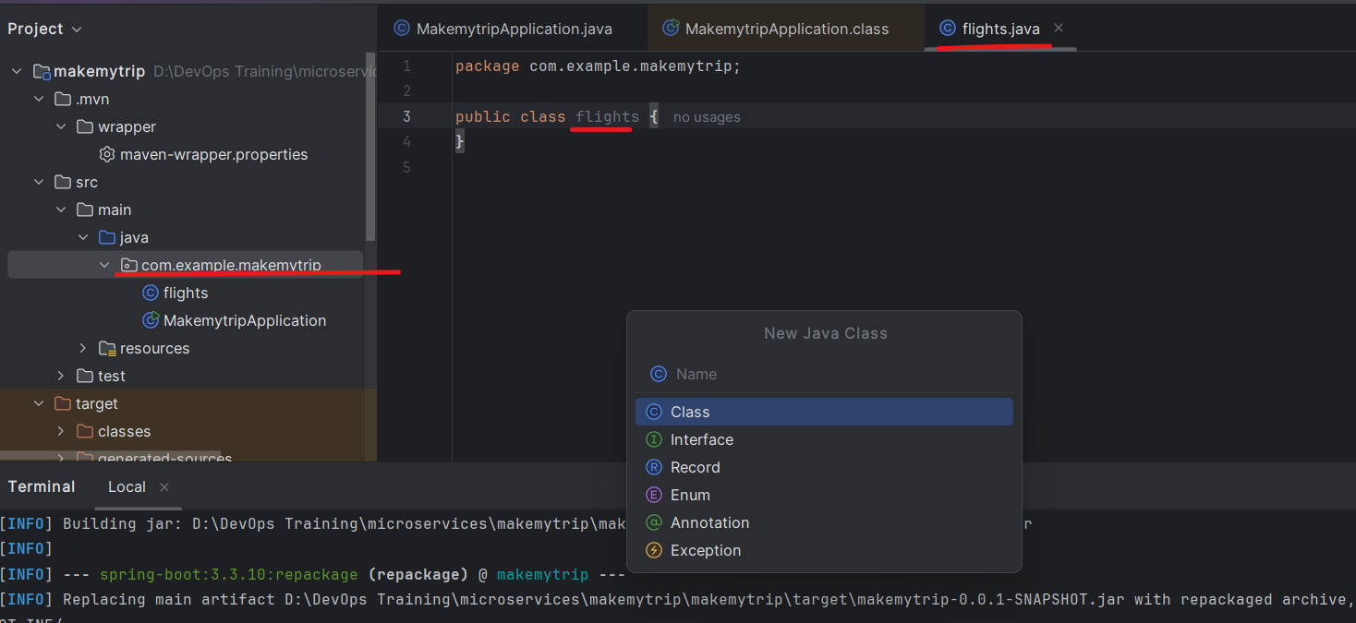

Add following to to this file flights.java:

package com.example.makemytrip;

import org.springframework.web.bind.annotation.GetMapping;

import org.springframework.web.bind.annotation.RestController;

@RestController

public class flights {

@GetMapping("/flights")

public String getData() {return "Book your FLIGHTS from Kolkata to Pune!";}

}

After ading new code - you need to compile and package it again.

> mvn clean compile

> mvn clean package

.class and .jar file is generated

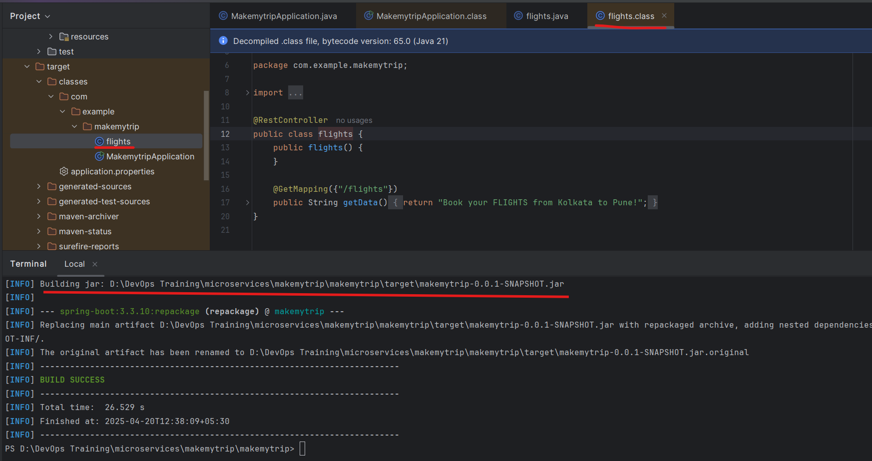

> mvn spring-boot:run

With help of this we will run the application on local system.

We can see the application is running on port 8080

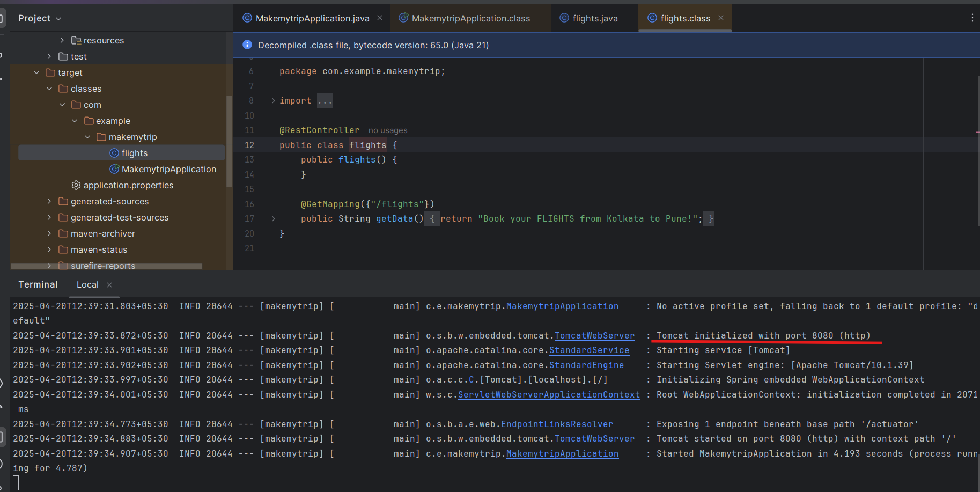

Now run the flights microservice on localhost

<http://localhost:8080/flights>

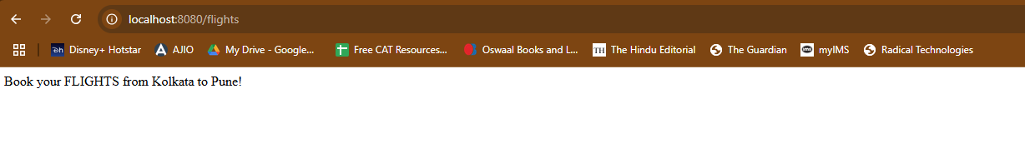

Press control C on terminal and the application will stop. If you check the link again it wont work anymore

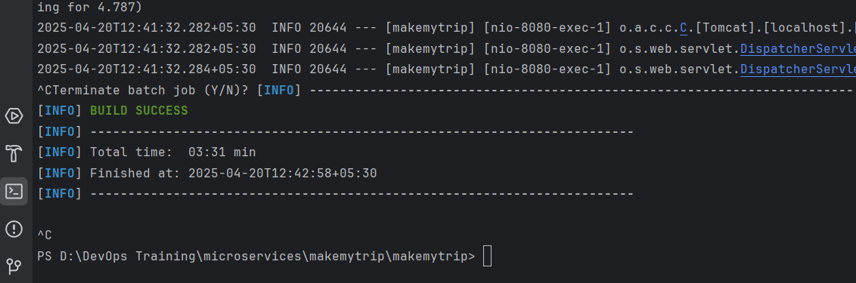

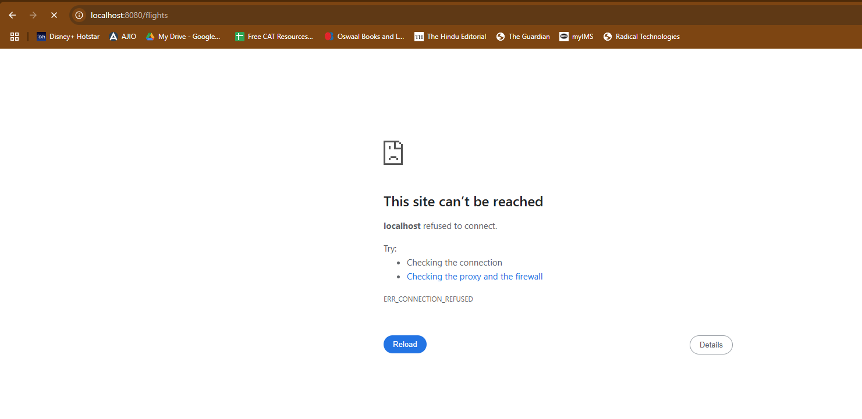

Add new feature now: hotels.java

package com.example.makemytrip;

import org.springframework.web.bind.annotation.GetMapping;

import org.springframework.web.bind.annotation.RestController;

@RestController

public class hotels {

public hotels() {

}

@GetMapping({"/hotels"})

public String getData() {

return "Book your HOTELS for Pune at 50% OFF!";

}

}

Now clean compile and package to make sure the new code is not spoiling the old working code.

> mvn clean compile

> mvn clean package

And then verify both the applications: hotels and flights

> mvn spring-boot:run

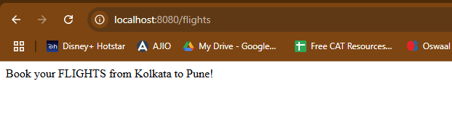

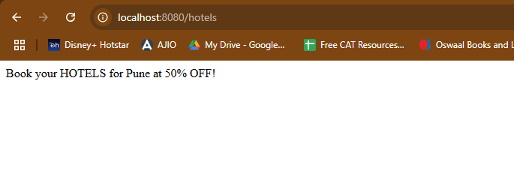

So we can see both features are working on local system.

Once the functionalities are verified and code is working - the code is supposed to be pushed on **github - shared remote code repository**.

Create new repository on Github: makemytrip

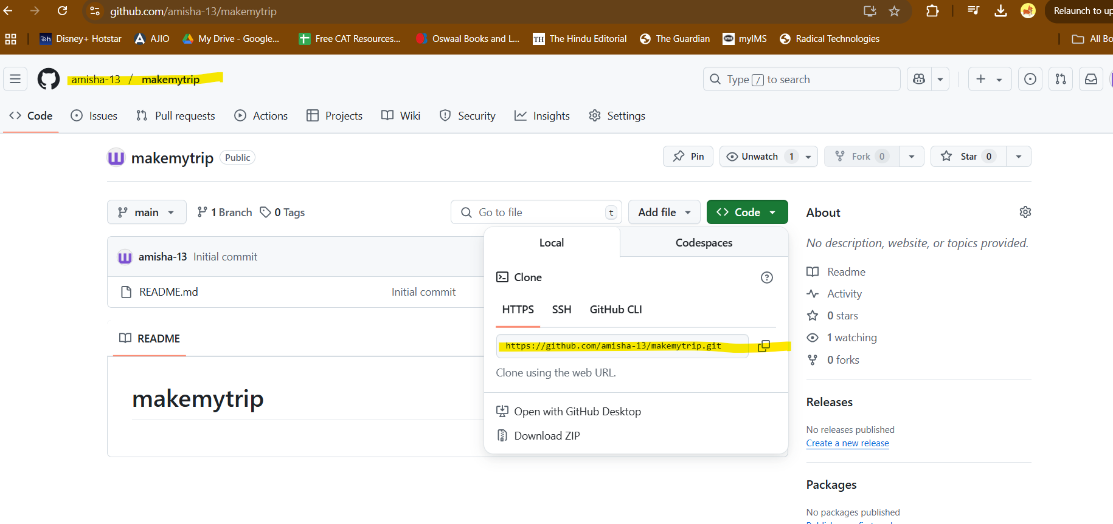

Push the code from local to remote repository

In IntelliJ IDEA enable version control integration:

VCS > Enable version control integration

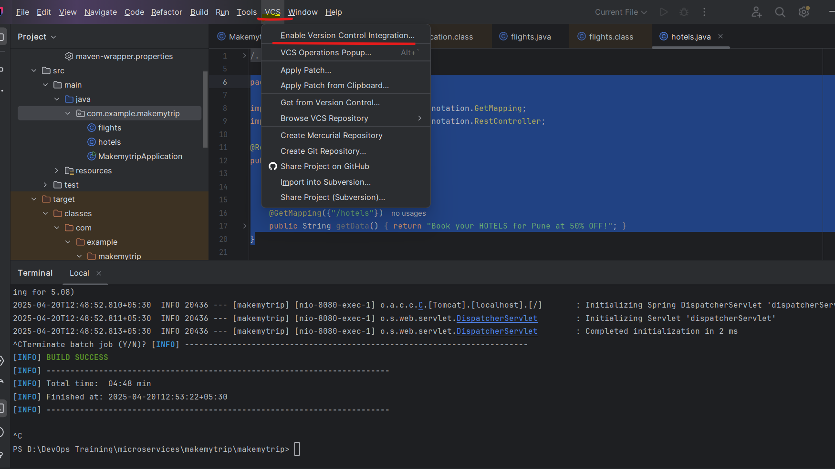

VCS > Manage remote > Enter URL of remote repository just copied

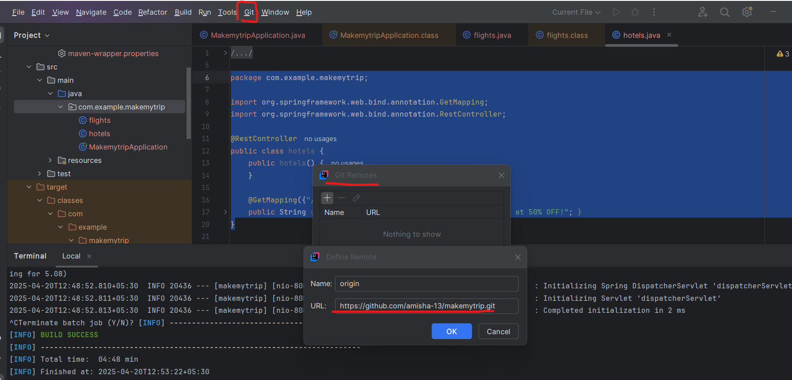

In my case - my default branch name is main and not master

> git pull origin main

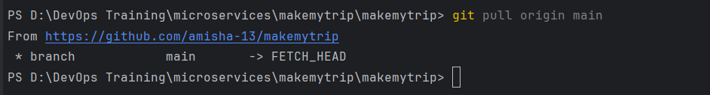

1st time you run this:

git pull

git pull origin master

git add --all

git commit -m "CodeRefactor"

git push origin master -f

2nd and all times

git add --all

git commit -m "message"

git push origin master

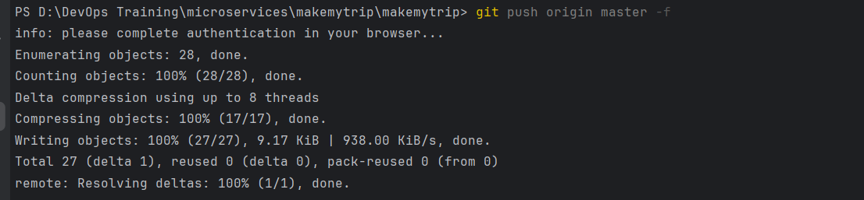

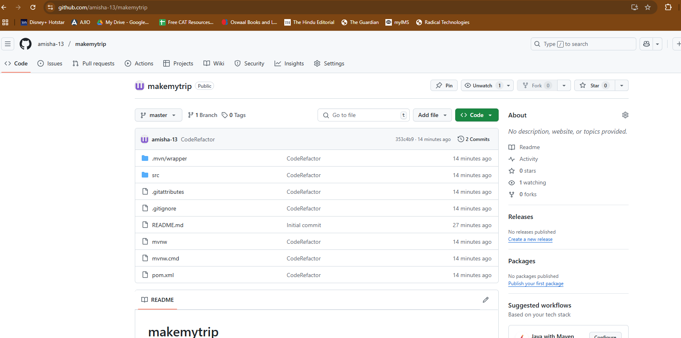

Add new class - bus.java

package com.example.makemytrip;

import org.springframework.web.bind.annotation.GetMapping;

import org.springframework.web.bind.annotation.RestController;

@RestController

public class bus {

@GetMapping("/bus")

public String getData() {return "Book your BUS from Kolkata to Pune at 10% OFF!";}

}

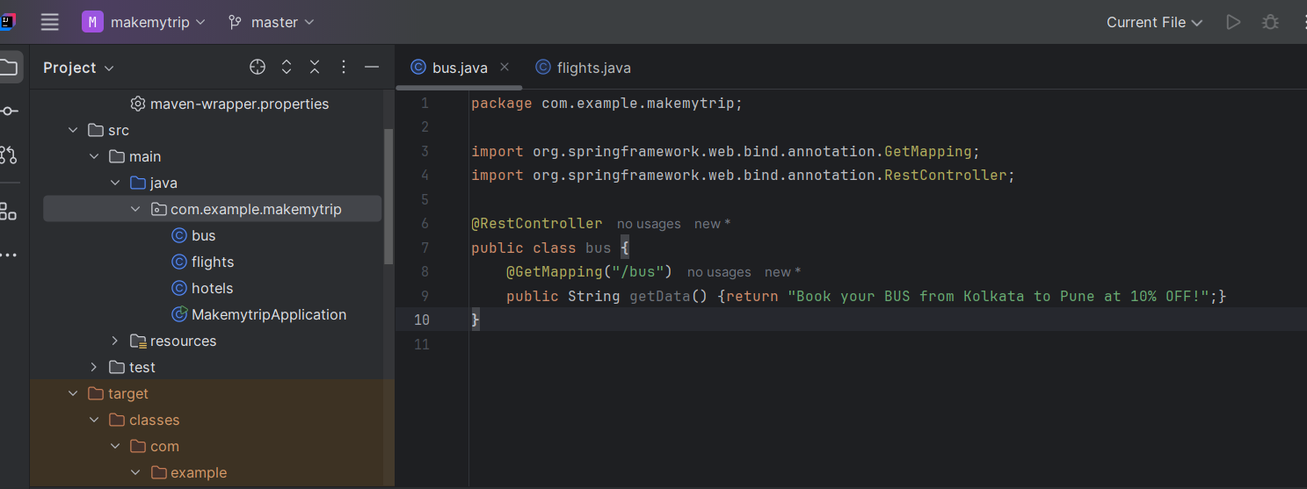

> mvn clean compile

> mvn clean package

> mvn spring-boot:run

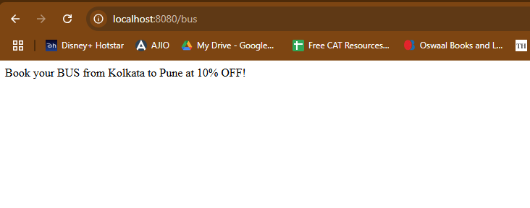

> git add --all

> git commit -m "Adding new java class"

> git push origin master

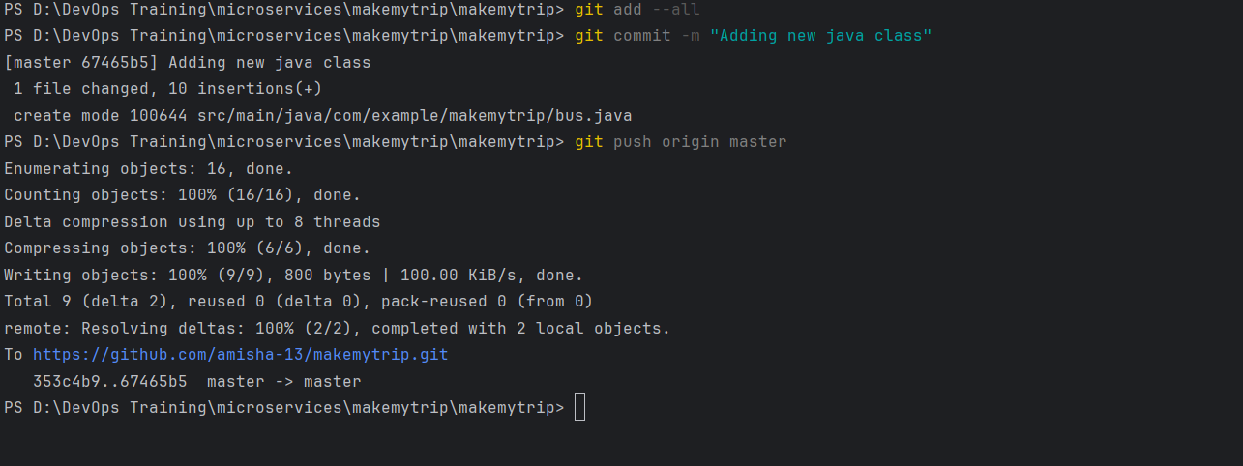

Code is now uploaded

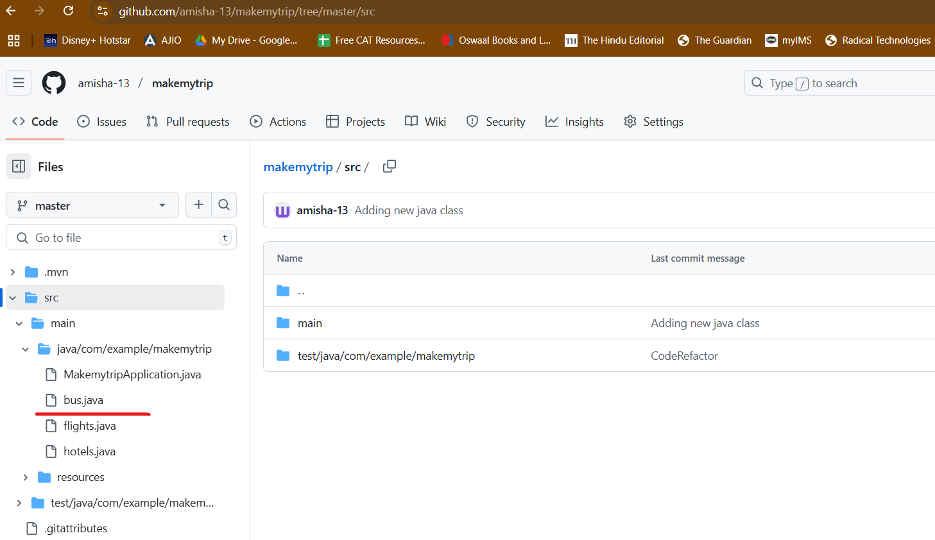

Day 4

Delete repo

Delete makemytrip folder

Perfrom cleanup

Download spring framework

Reopen code in IntellIJ Idea

Create new repo: makemytrip

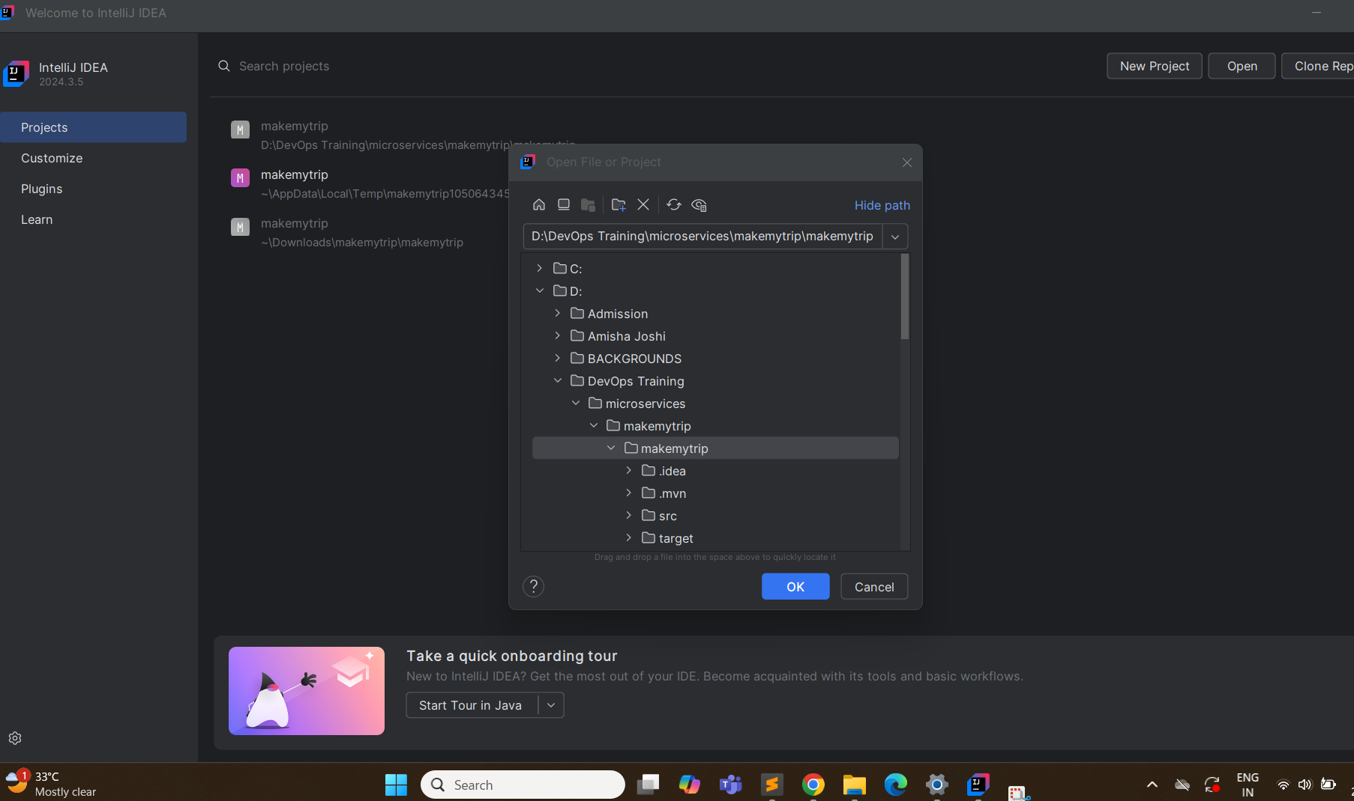

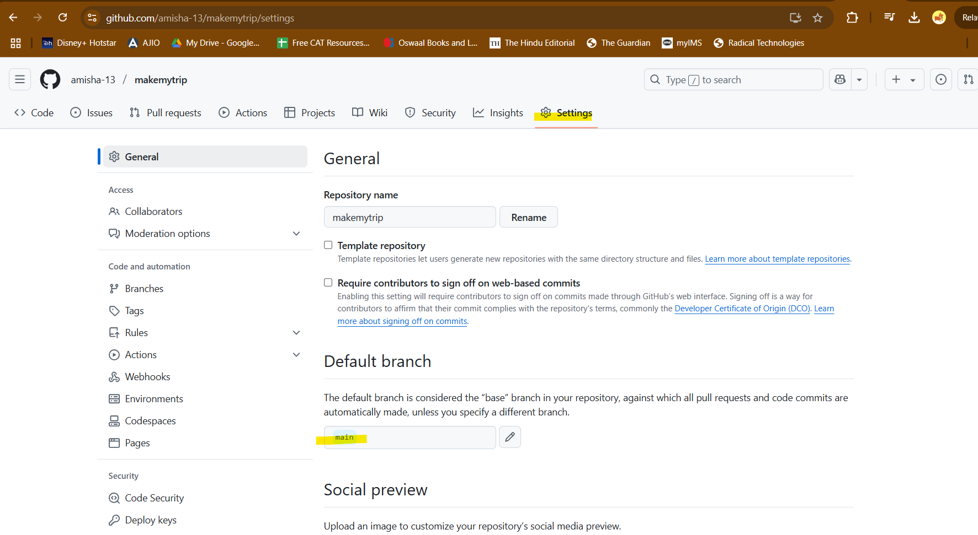

Change branch name to master

Enable Version COntrol on IntelliJ

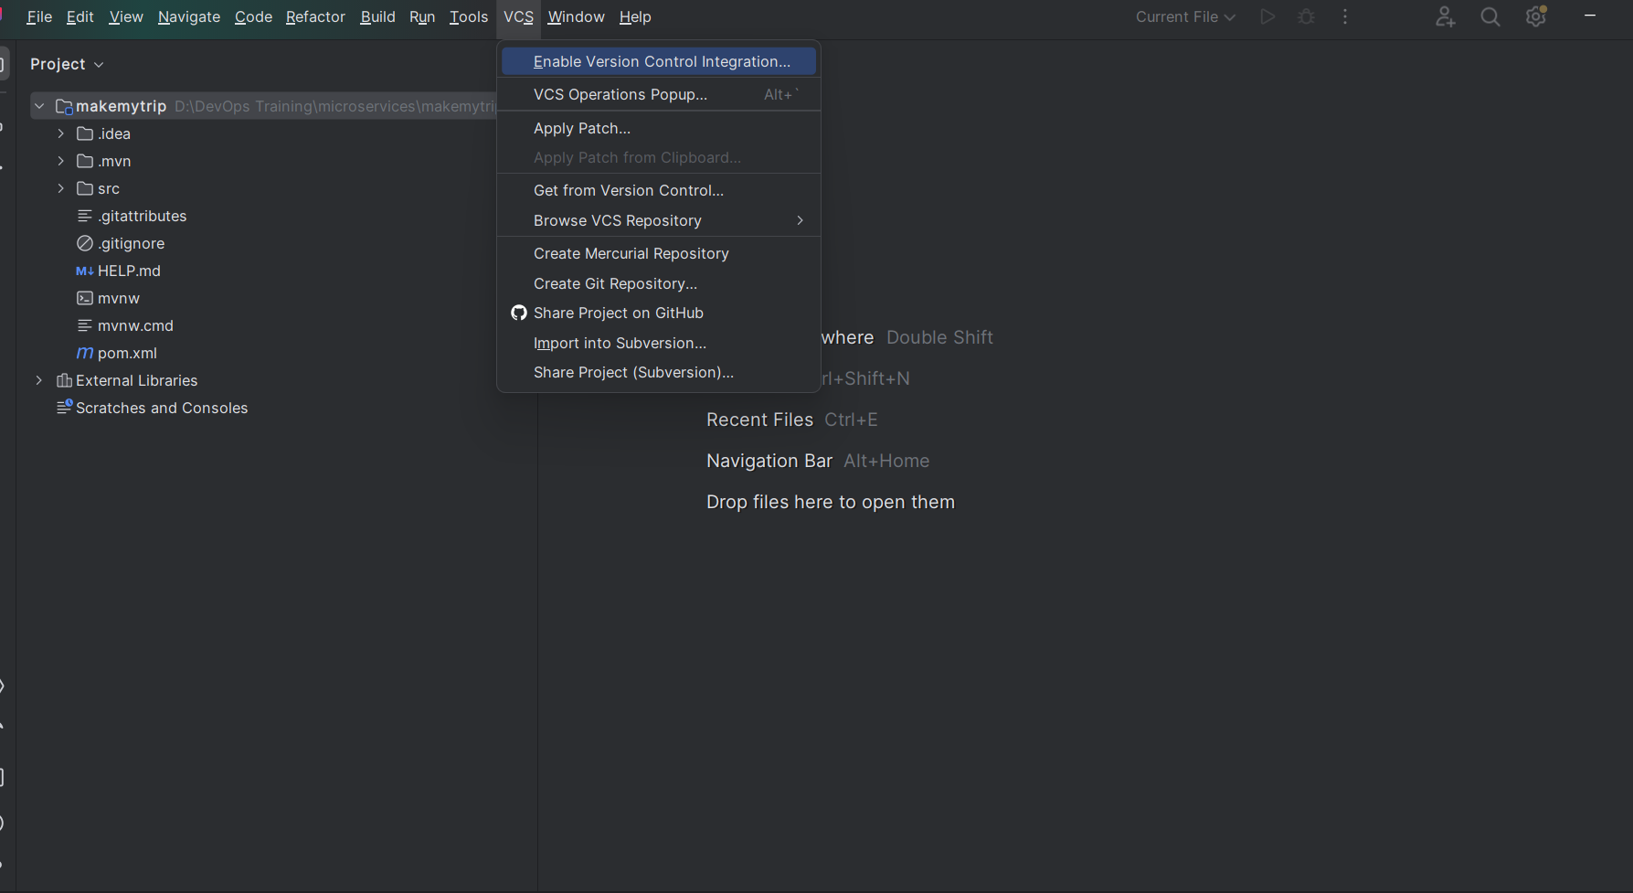

Select Git as the tool

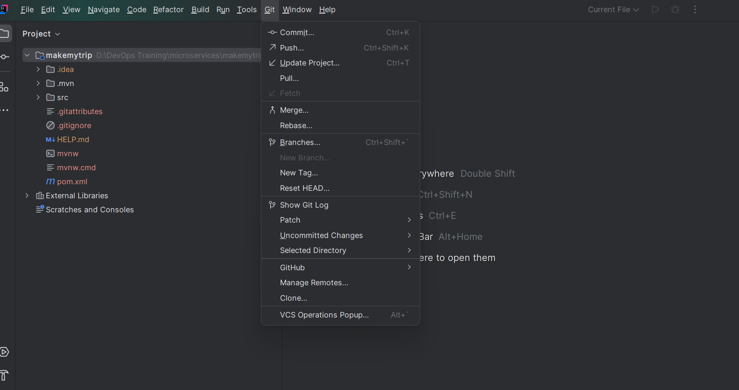

Now add remote repo: VCS> Manage Remote: add your git URL

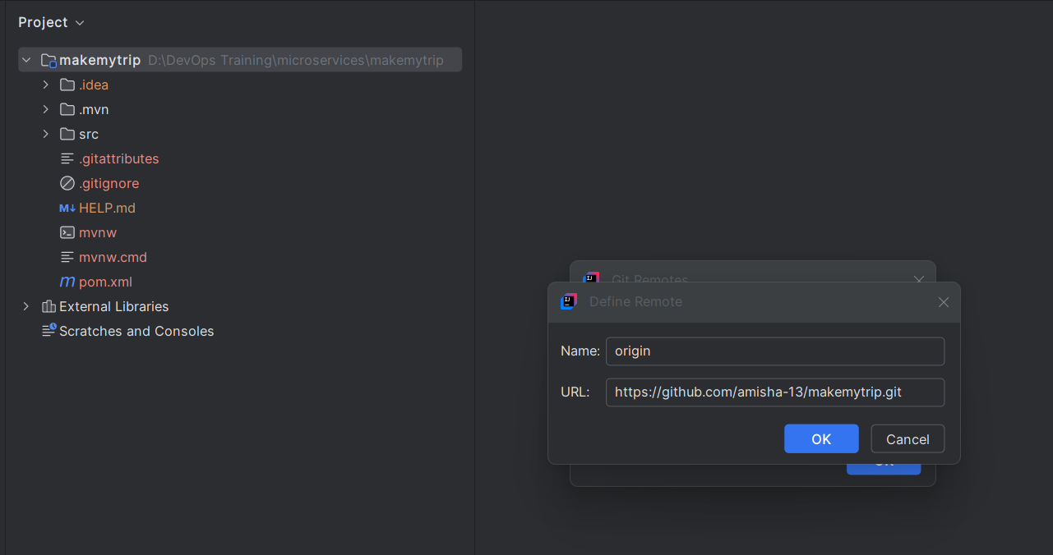

First time run:

> git pull origin master

> git add --all

> git commit -m "CodeRefactor"

> git push origin master -f

Created flights.java

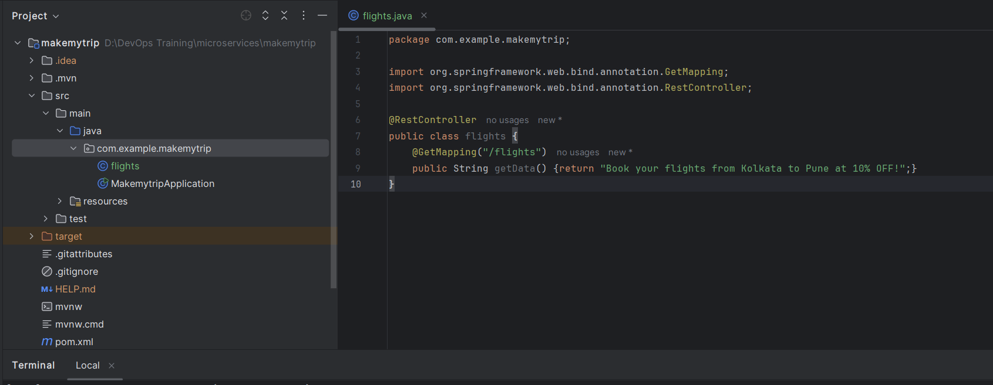

> mvn clean compile

> mvn clean package – jar file created

To create .war packaging - add this in pom.xml

<packaging>war</packaging>

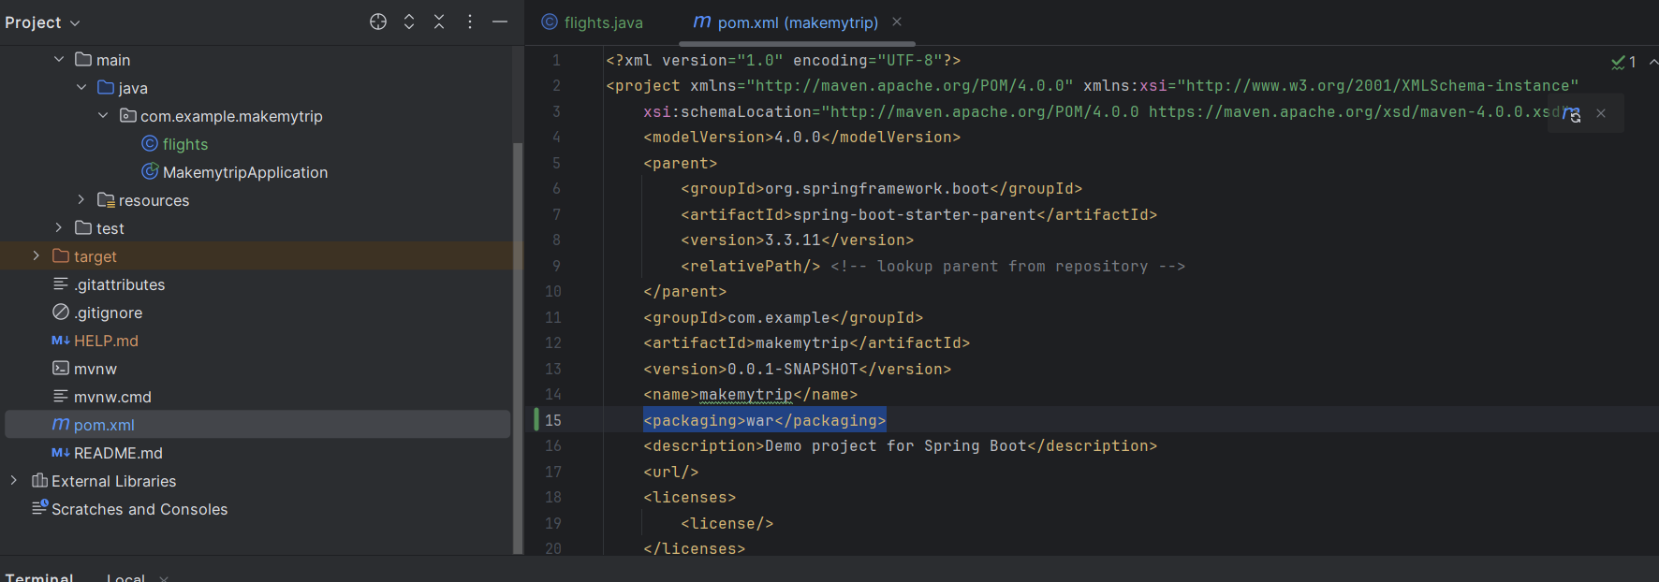

Now > mvn clean package

Created war file

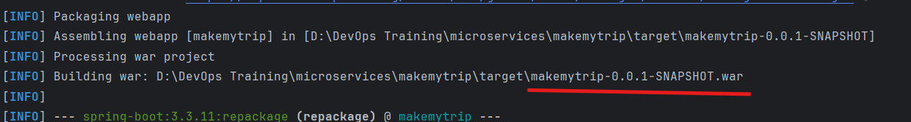

This is not added in remote repo:

> git diff

Tells the changes

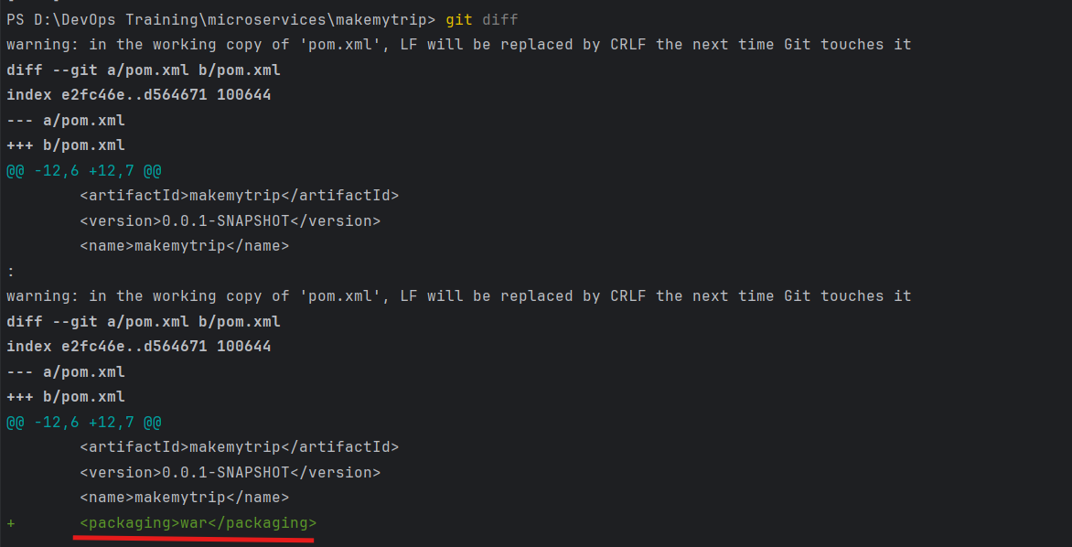

> git add --all

> git commit -m "Change in pom.xml"

> git push origin master — Move from local to remote

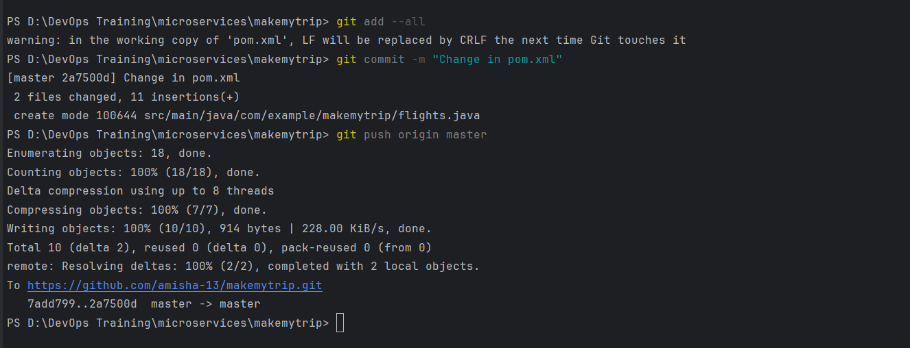

This is reflected in remote repo as well

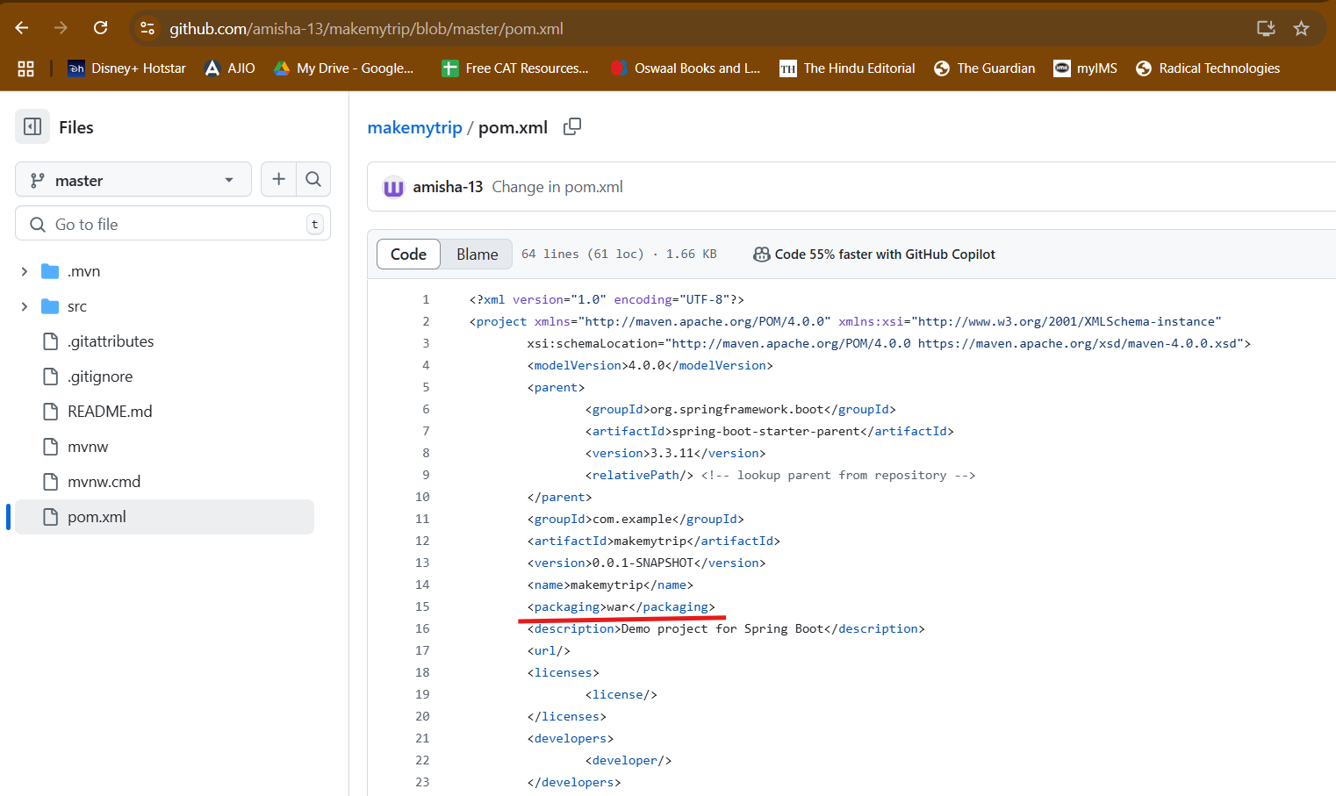

Create brand prod from master, preprod from prod and dev from preprod

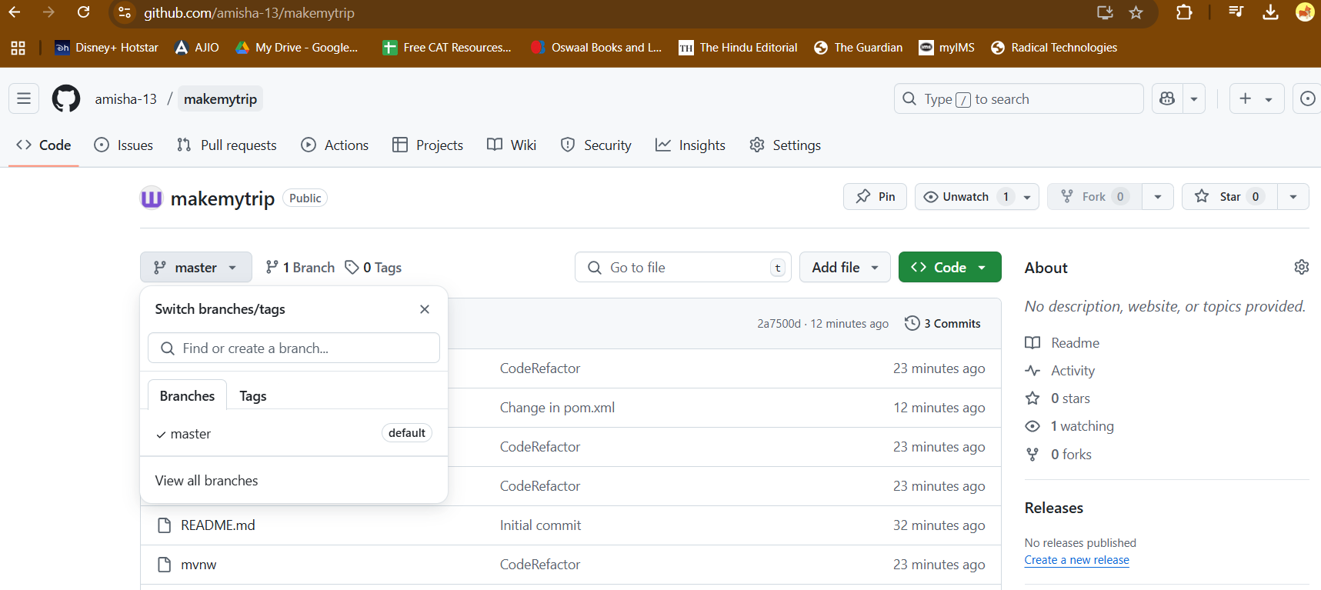

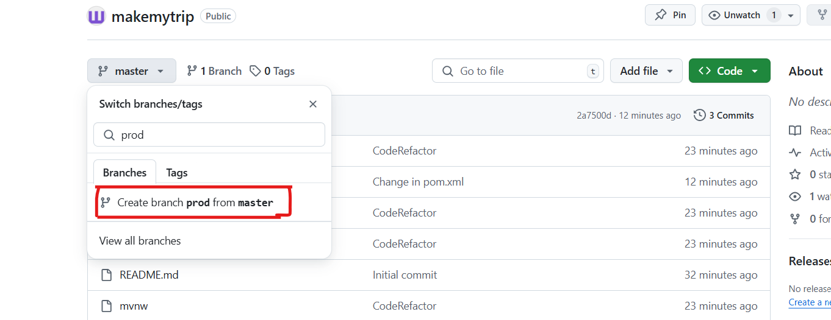

CHeck which branches you have

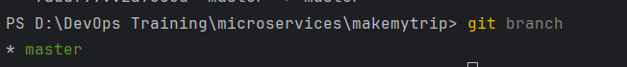

Dev is the lowest branch and We dont have dev branch in local

So:

Git fetch origin dev – get from remote to local

Git checkout dev – switch the dev branch

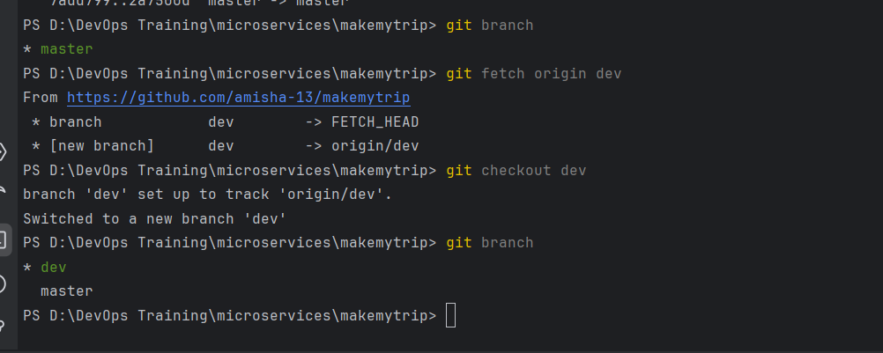

Make new java class : flights.java

Make some changes in pom.xml

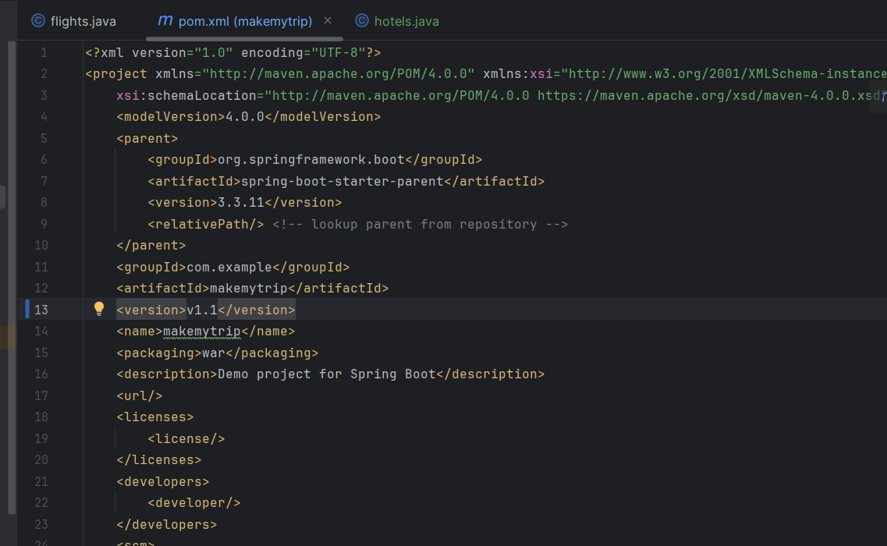

Git status – will tell changes modified in working directory

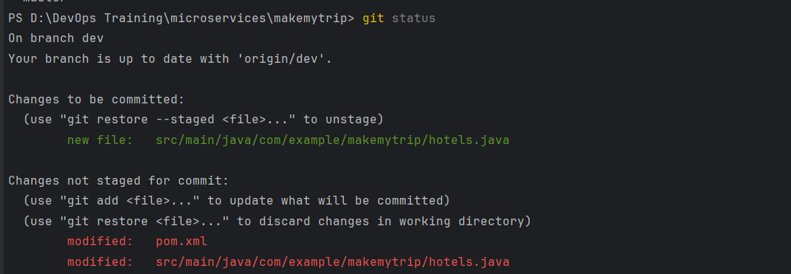

Now since i added new java file, package it

> mvn clean package (Runs compile also by default)

> git add --all

> git commit -m "New java class"

As a dev, I cannot push code in any other branch but dev

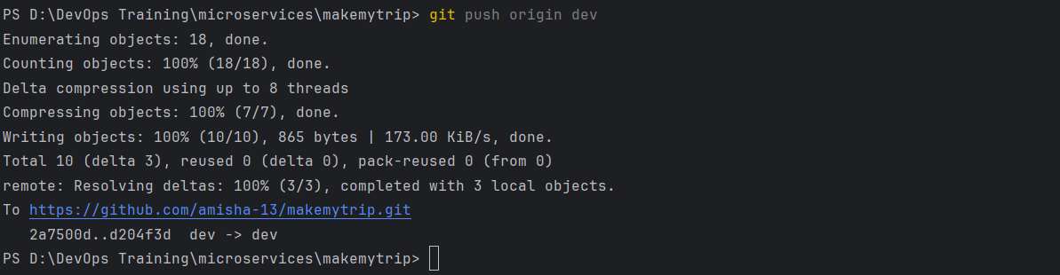

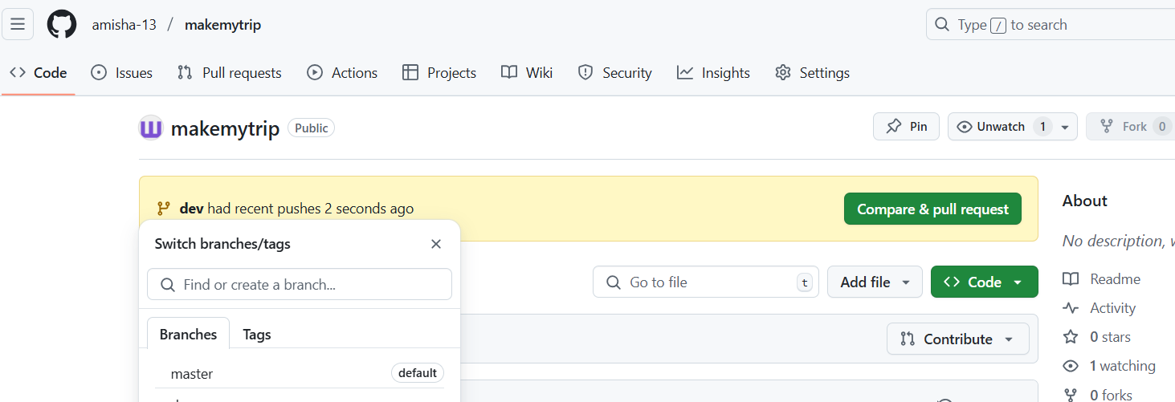

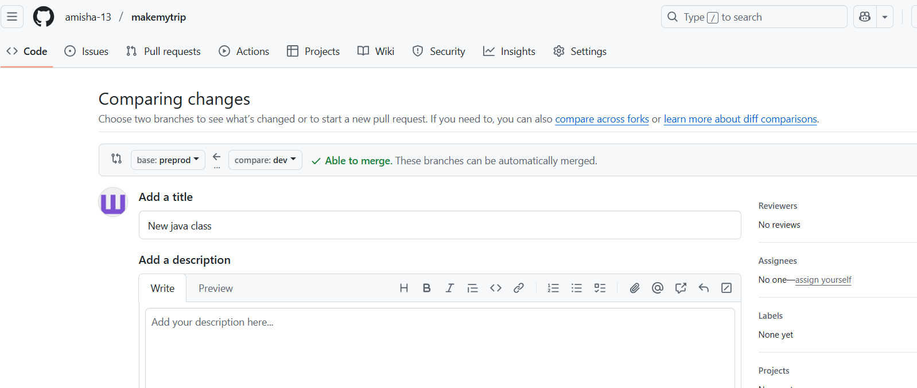

Dev changes will be merged into preprod only

And Preprod in prod

Prod need not be merged with master

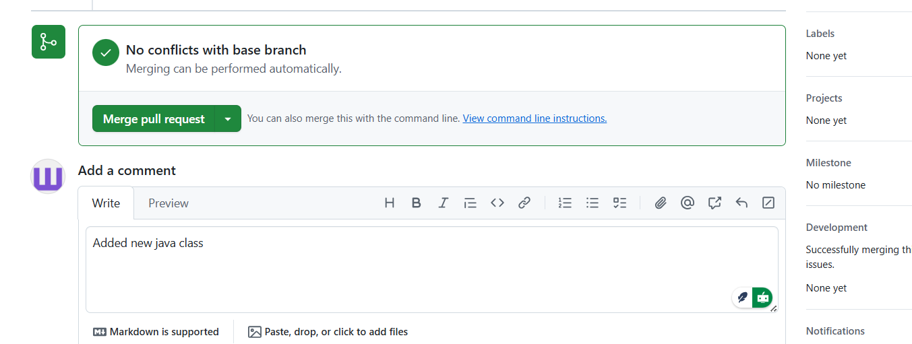



Add in reviewers, but you cannot approve it yourself

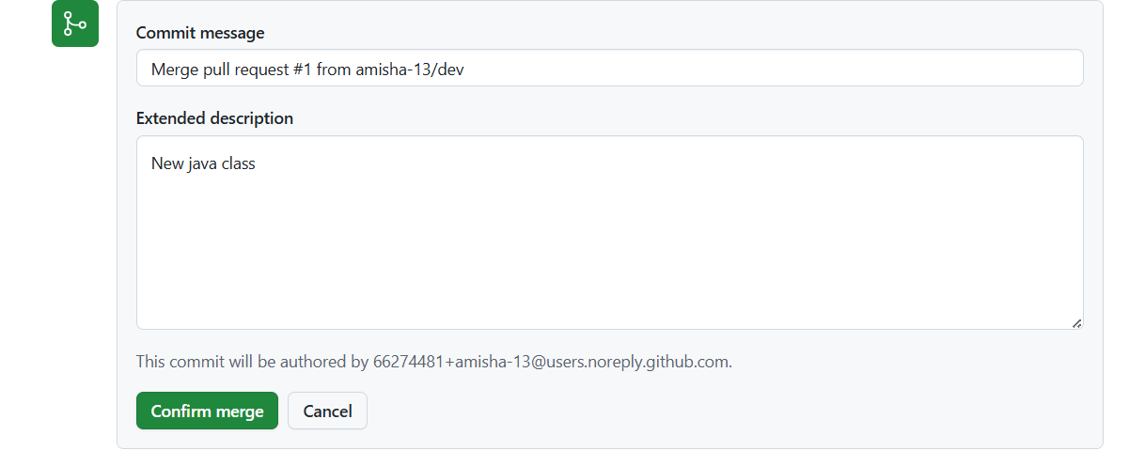

Confirm merge

Now push preprod changes to prod

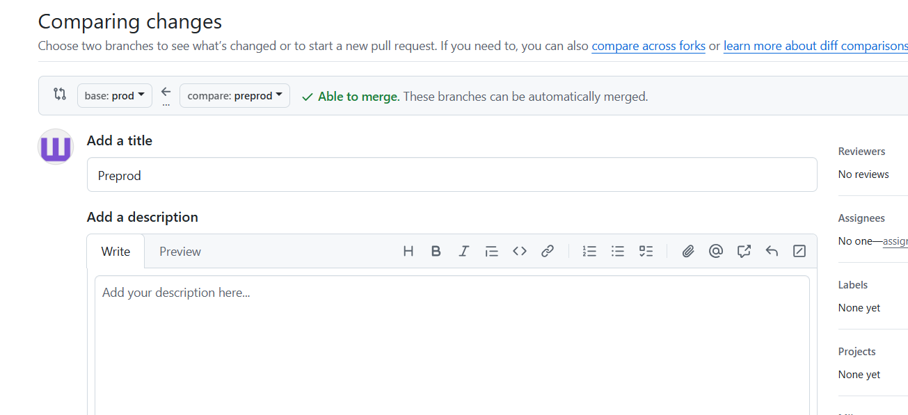

Because code is now deployed in prod already so no need to add it into master

> git pull origin dev – Dev branch files of remoted will be synced with local repository

> git checkout -b feature/holidays – new new branch from dev in local

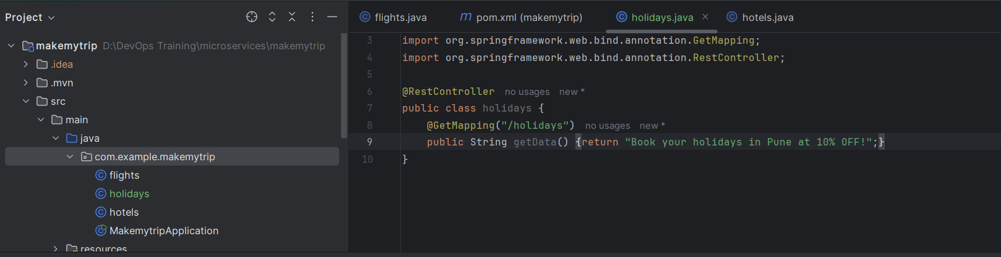

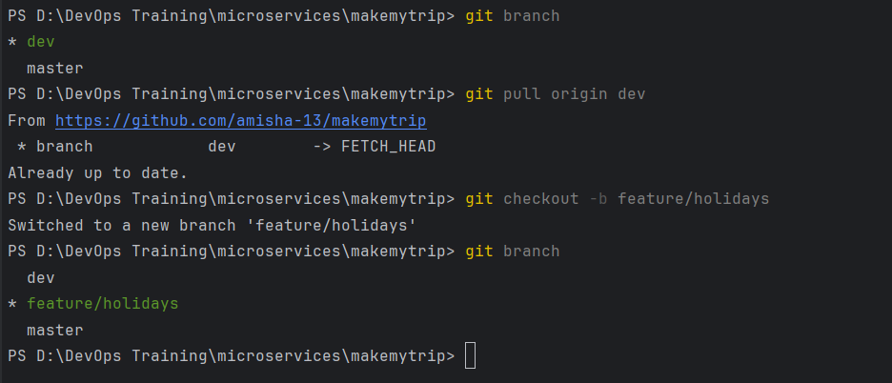

Make a new java class file: holidays.java

Run

>git status – to see the differences

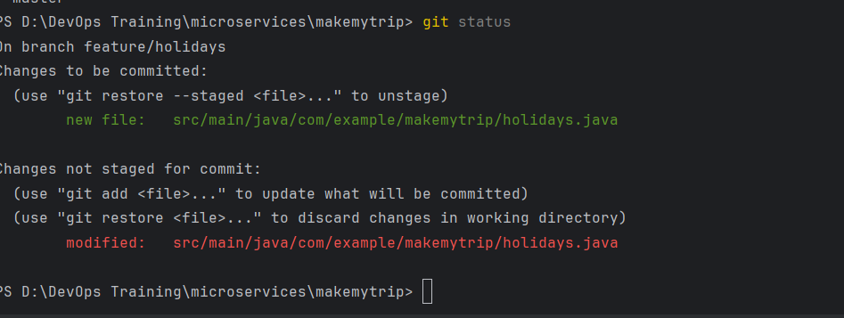

> mvn clean package

> git branch – make sure it is feature branch

> git add --all

> git commit -m "Adding new java class"

> git push origin feature/holidays

Now pushed into feature/holidays (local branch)

We can see new branch coming up in remote

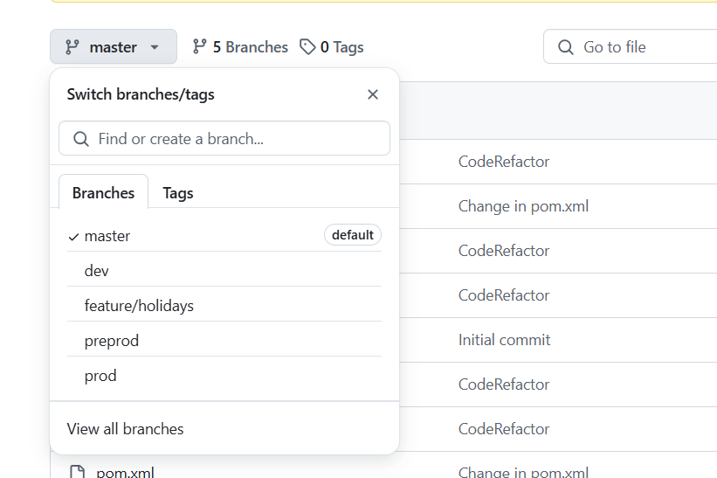

Push changes to dev

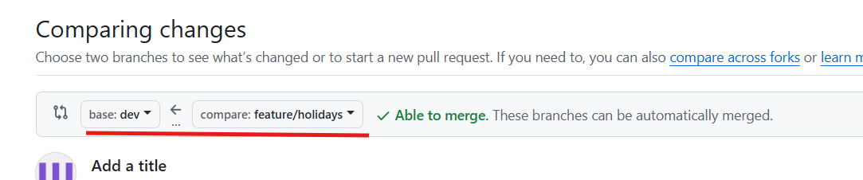

After merge, feature branch can be successfully deleted if you want

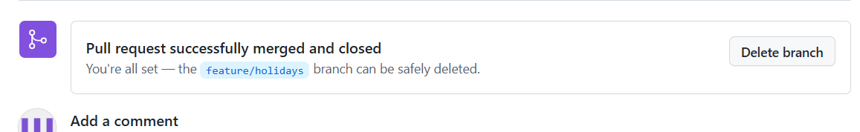

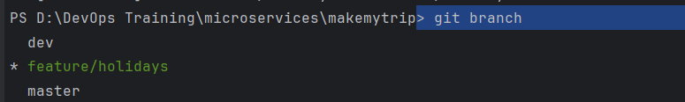

Pull dev from origin and Switch to dev

> git pull origin dev

> git checkout dev

This shows my dev branch is behind the remote

SO remote is UPSTREAM

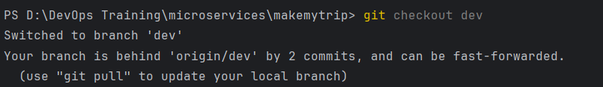

To bring in sync, pull the changes:

> git pull origin dev

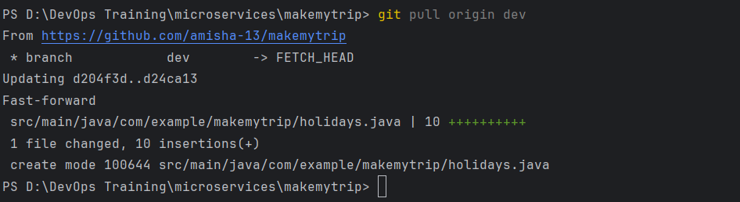

Now it is up to date with remote

Day 5: 27th April 2025

Made changes in pom.xml remote repo

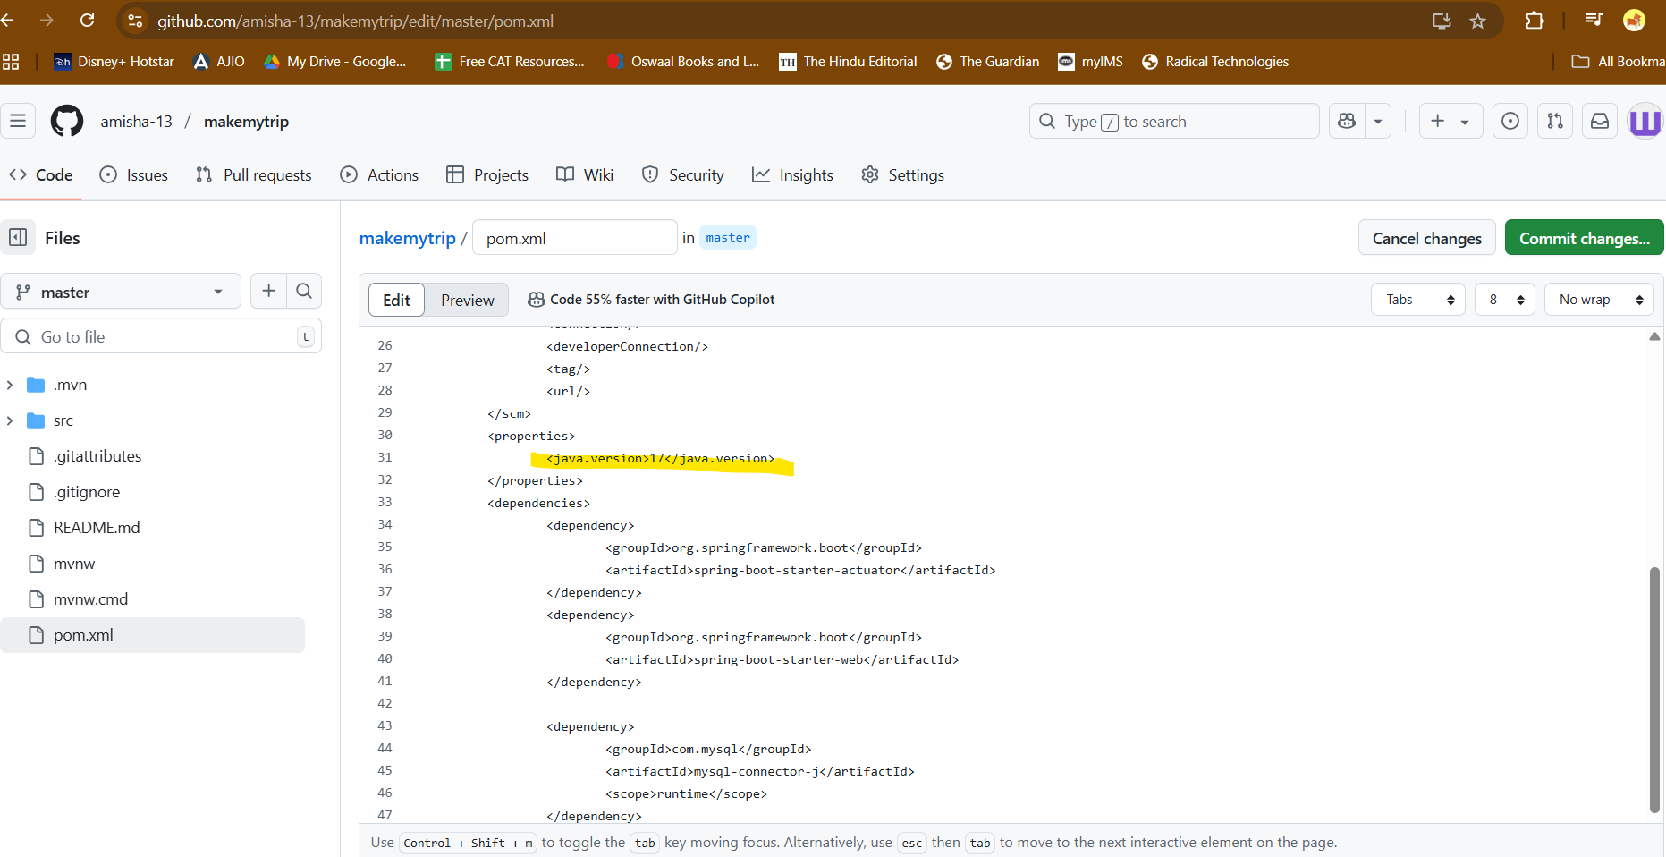

Made changes somewhere in local file as well

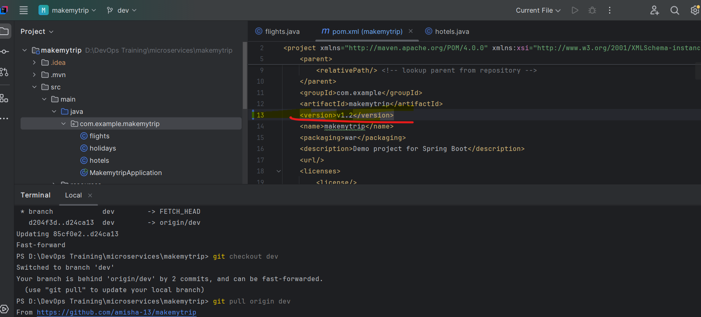

Now when we pull the changes in local from remote using git pull

Make any changes in pom.xml file

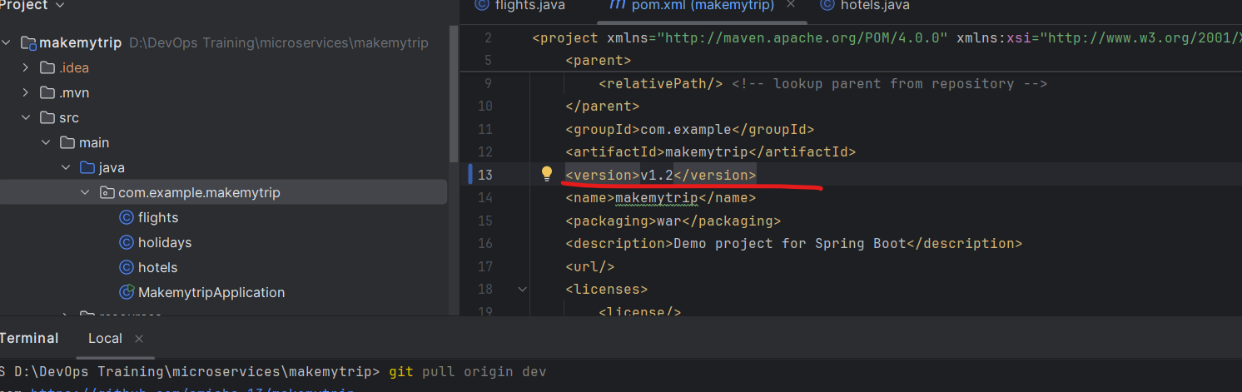

Git diff will show the difference - change within the file

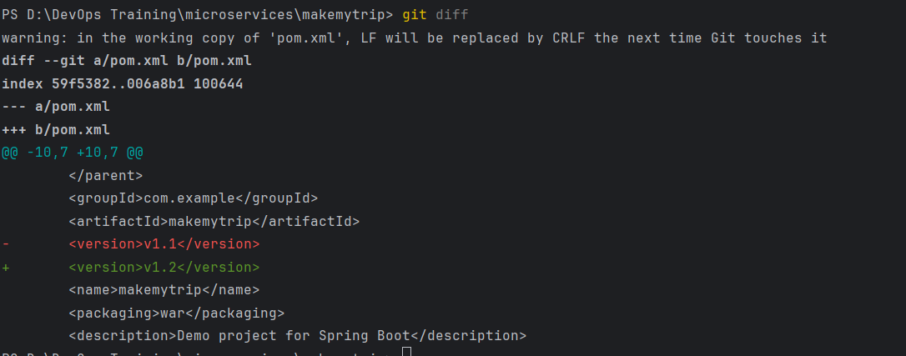

Git status will show the name of the file modified

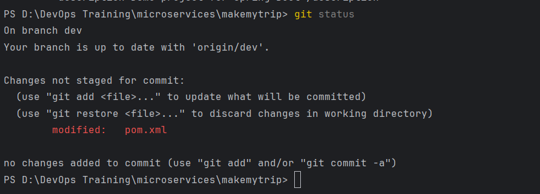

In remote DEV branch, make some changes in pom.xml file

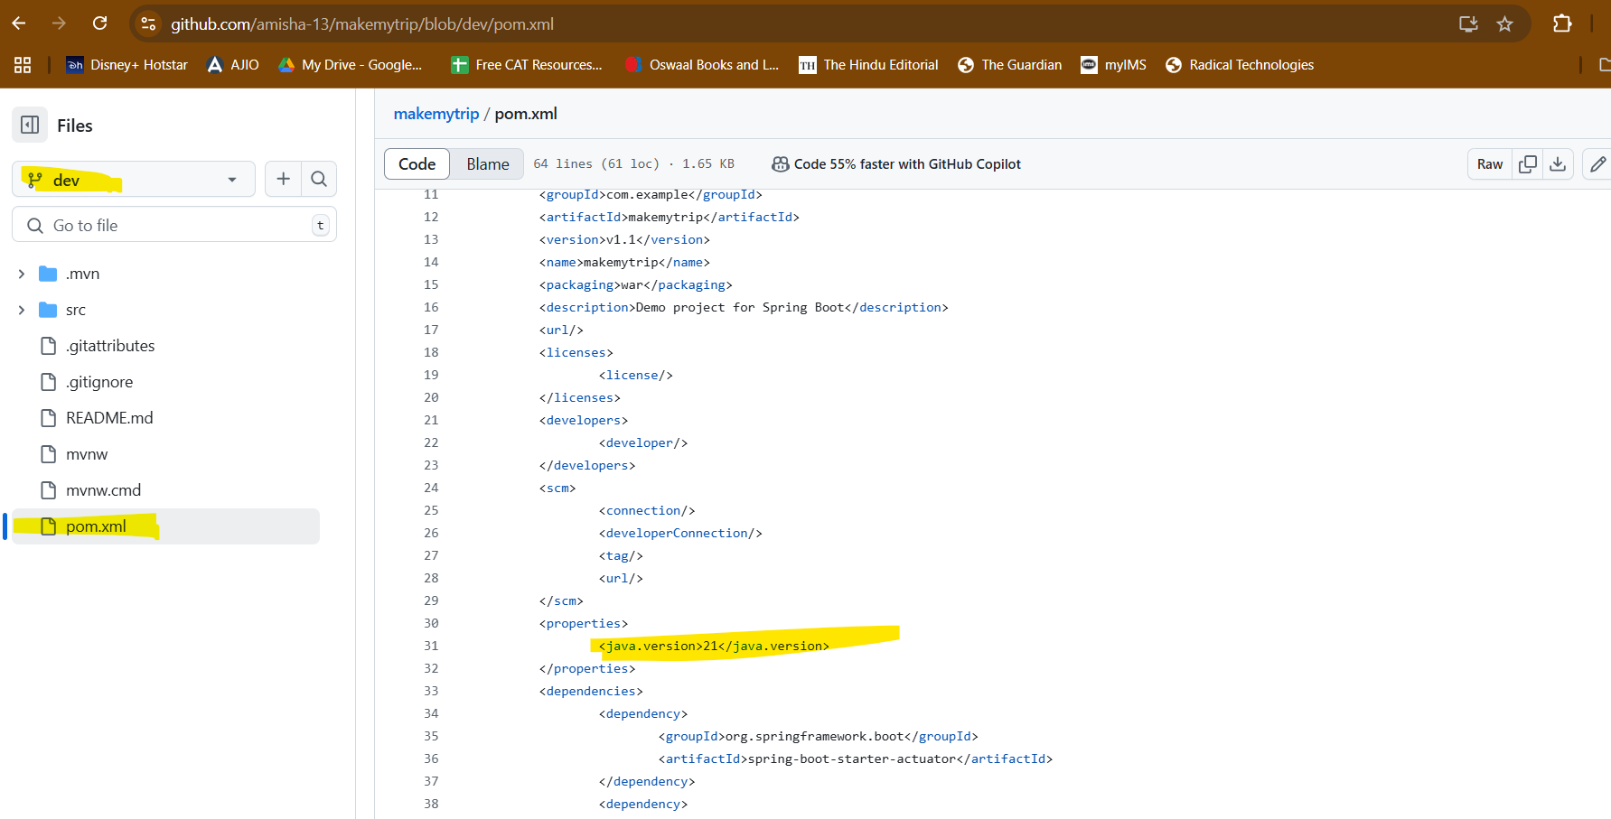

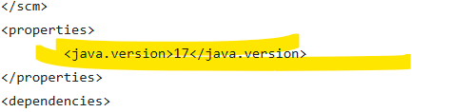

Commit changes in github

Now in local:

Check the branch you are on and make sure it is dev

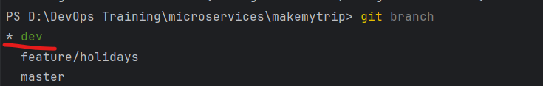

Now sync the changes using git pull

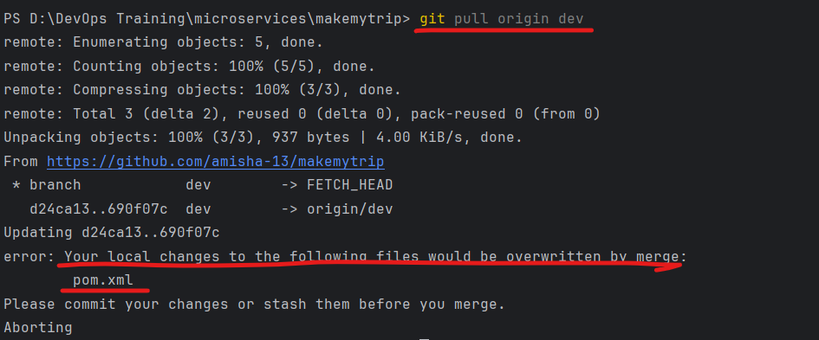

This is showing error because we made changes in both places (local and remote)

So roll back the changes in local and pull the changes

Roll back changes in local using - git stash (undo changes in local repo)



Now you can pull the changes:

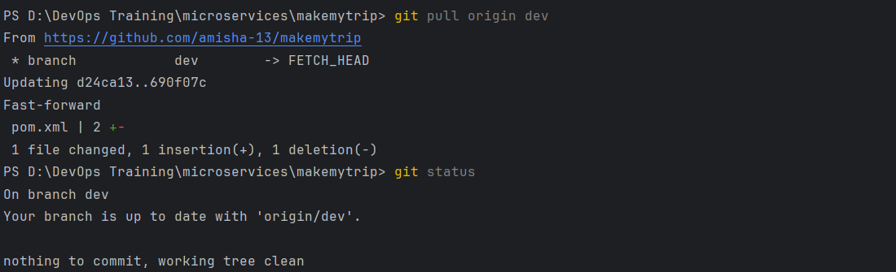

Make changes in a file

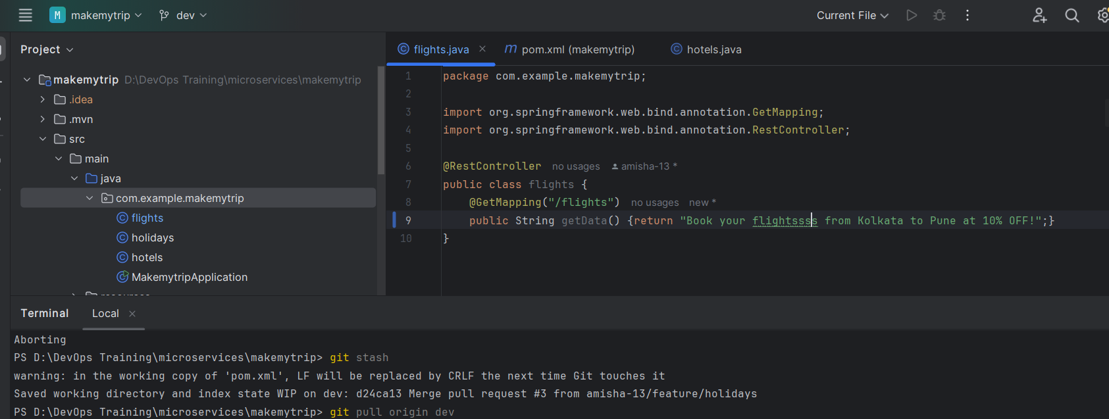

Git status

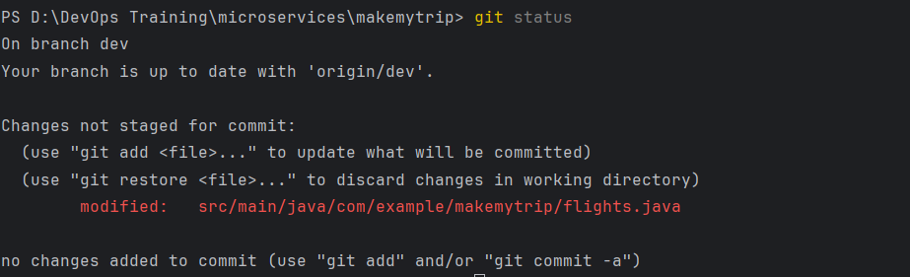

Shows modified changes in red

Git add will add it to staging area and red will look in green

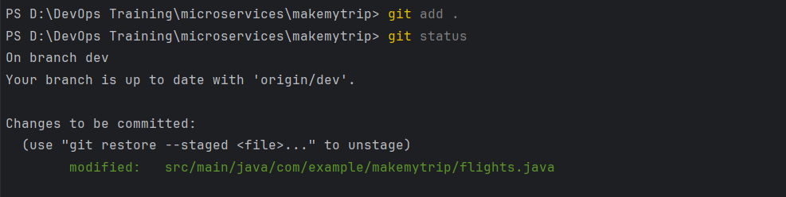

Now use git stash and it will still undo the changes

Meaning - changes can be stashed even from staging area



Git clone:

Git clone <https://github.com/amisha-13/makemytrip.git>

Once local branches are merged, they can be deleted.

To delete local branches - use - git branch -D <branch name>

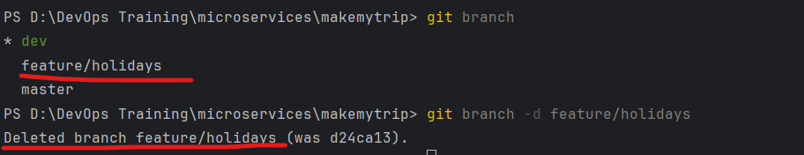

You cannot delete a branch you are ON



Branch protection rules

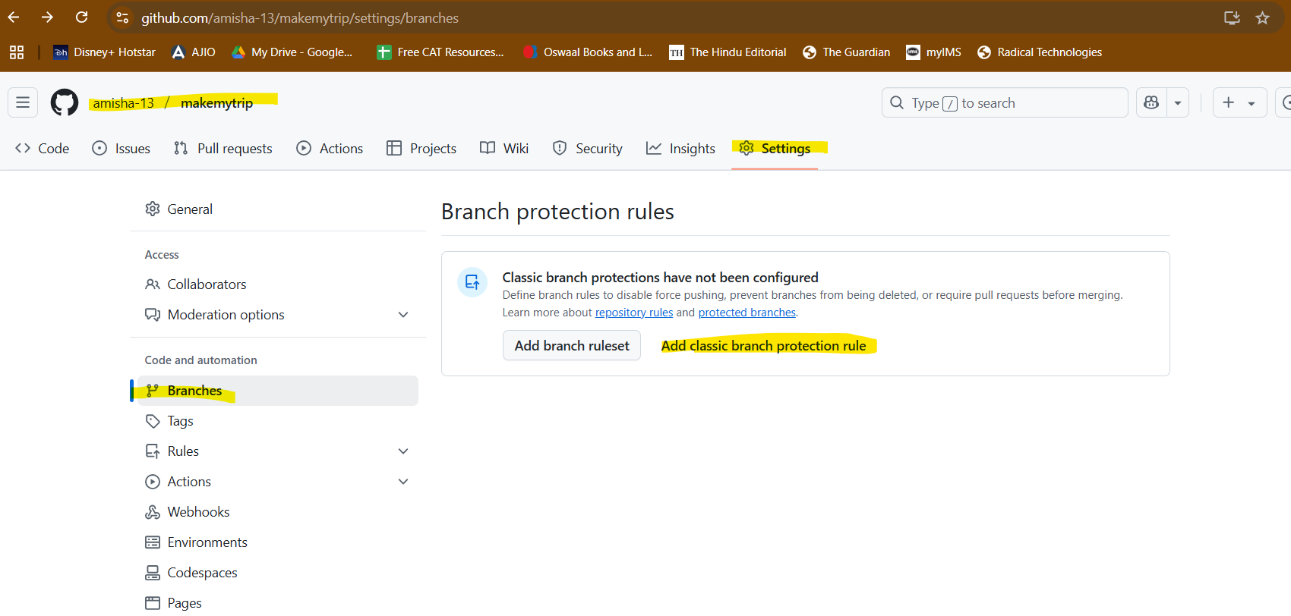

Require pull request

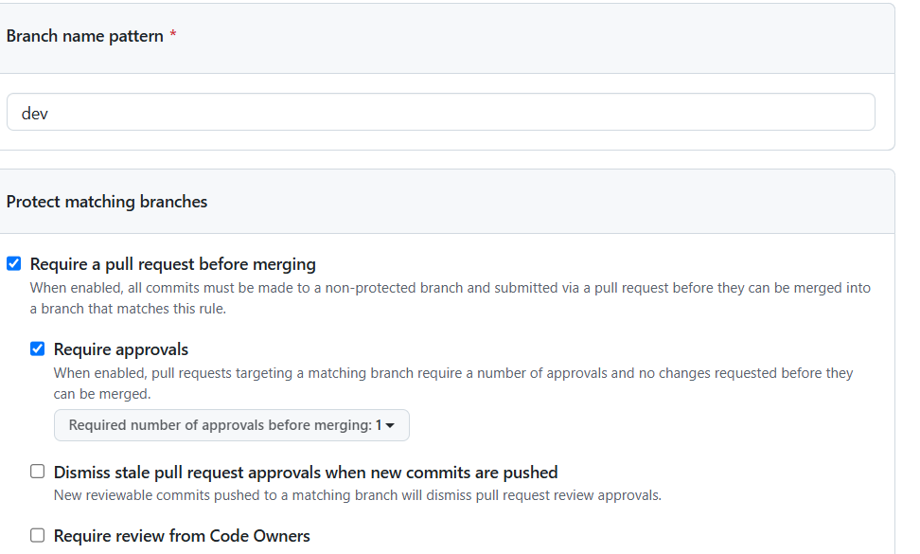

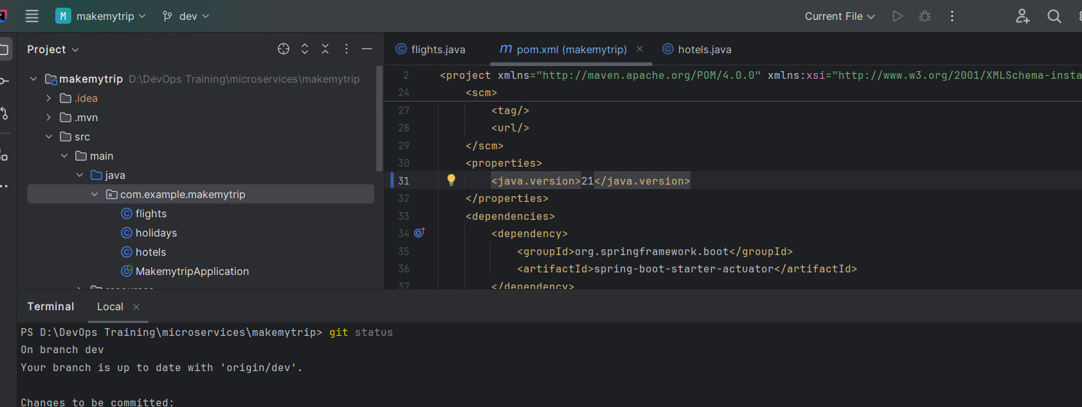

Make changes and try pushing it now - it will not allow you

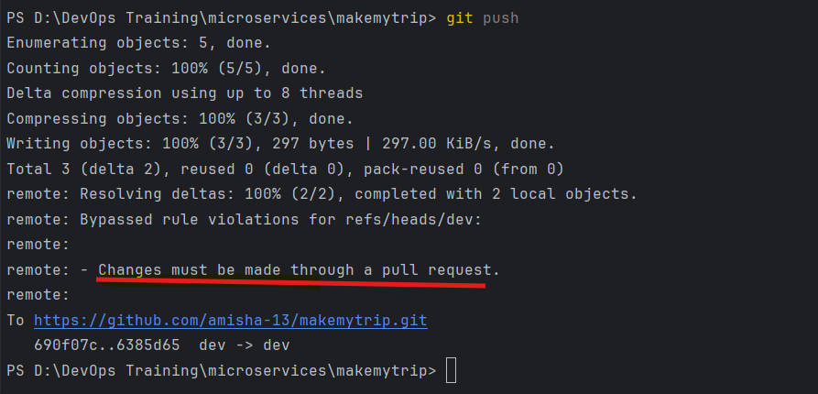

Require approvals from CODEOWNERS

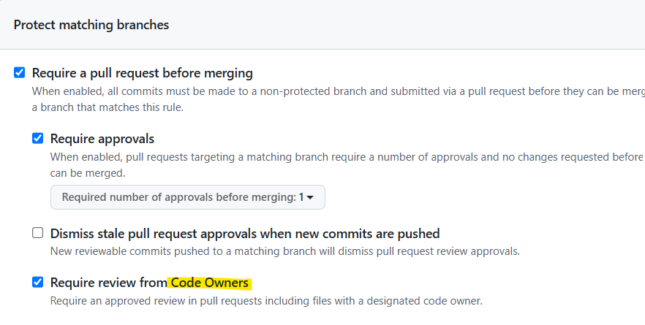

Create CODEOWNERS file and add names of code owners to approve

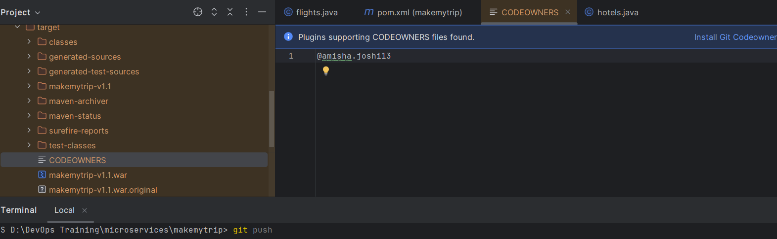

Merge Conflicts:

As Dev A

Right now everything is clean

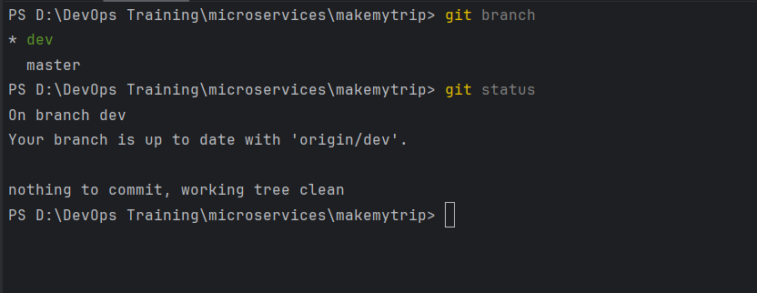

Added new file in dev branch

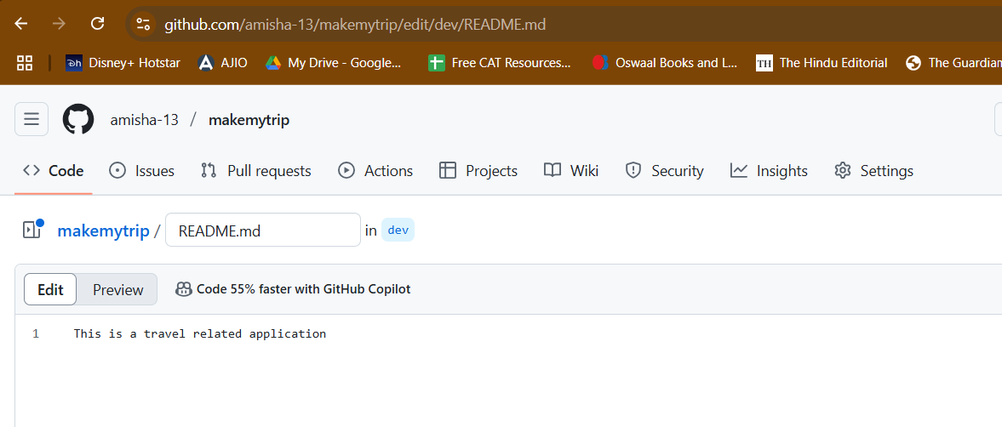

But we dont have this file in local as dev B

Dev B added new file: CODEOWNERS

Made modification in codeowners file

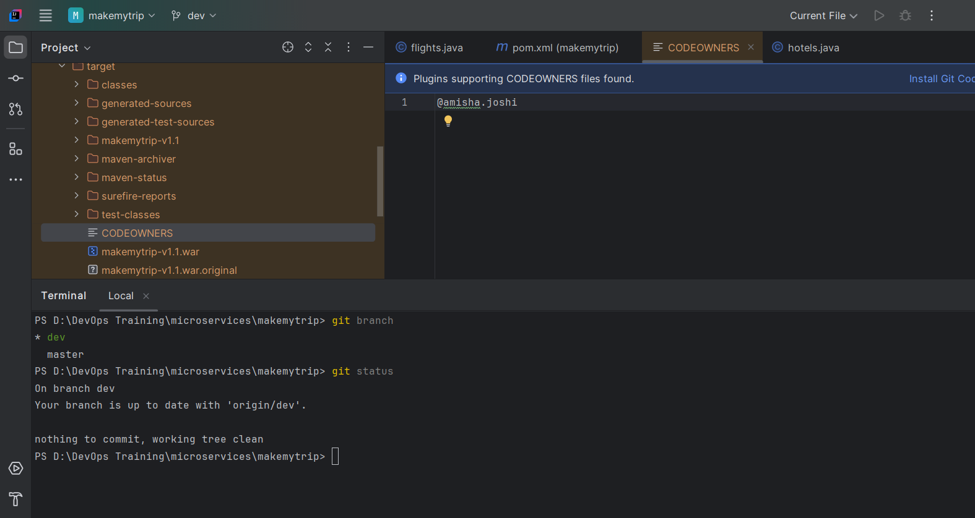

Now DEV B:

Git push will give error: remote repo has work which you dont have in local

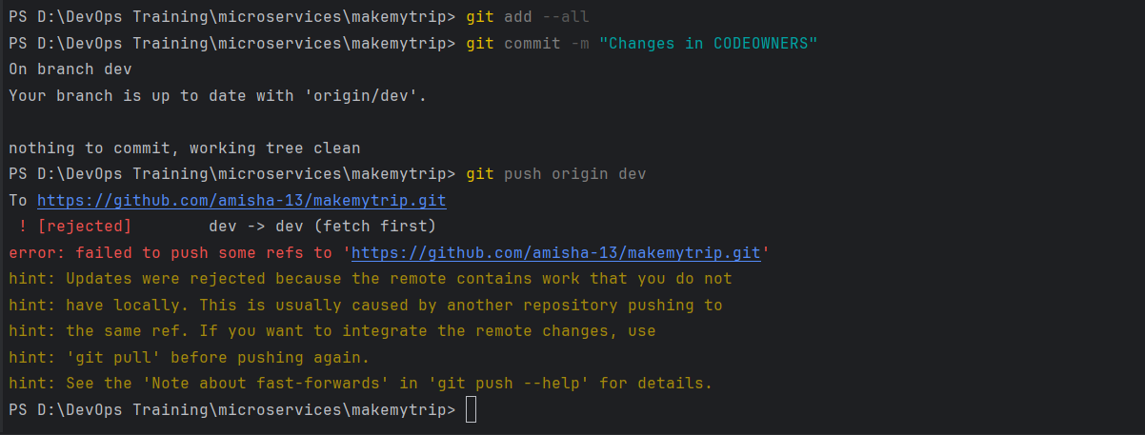

This is called merge conflict

So to resolve:

Git pull origin dev – will pull the changes from remote to local

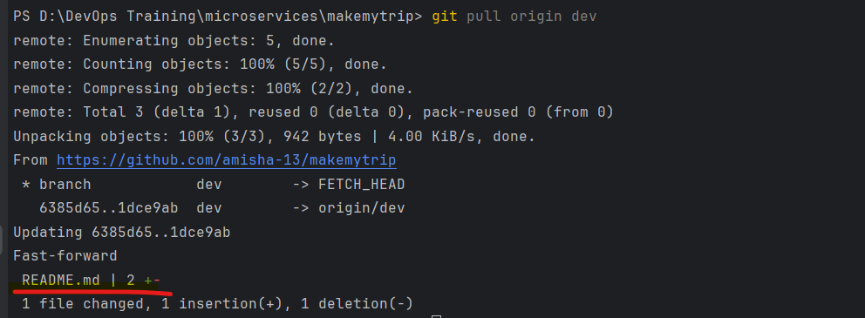

This pull the changes

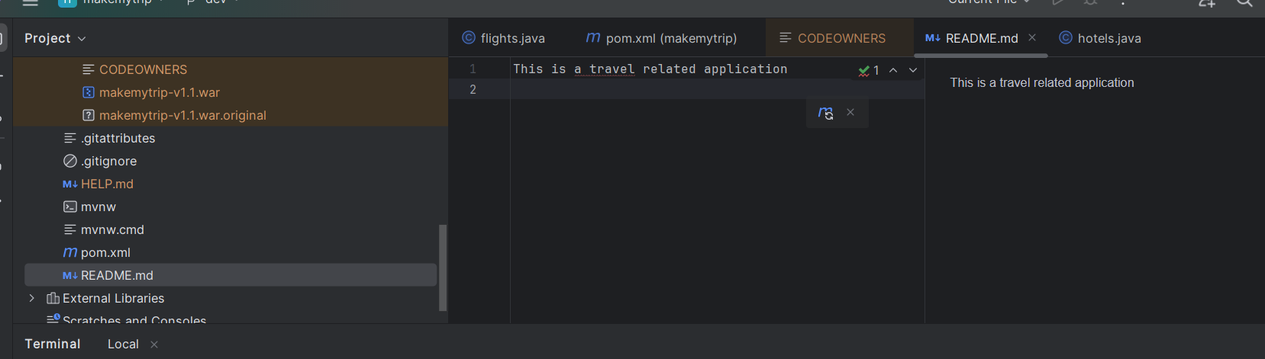

Now git A,C,P

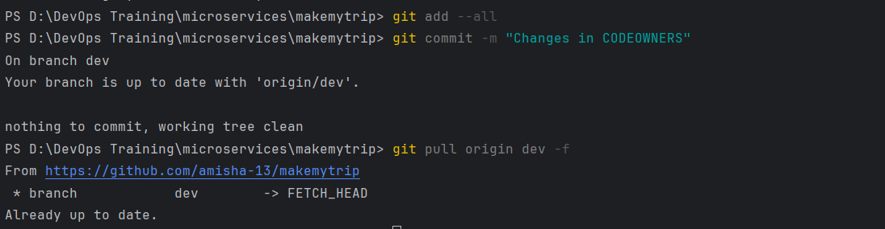

git pull origin dev -f

Forceful push

Mere conflict in differnet file changes

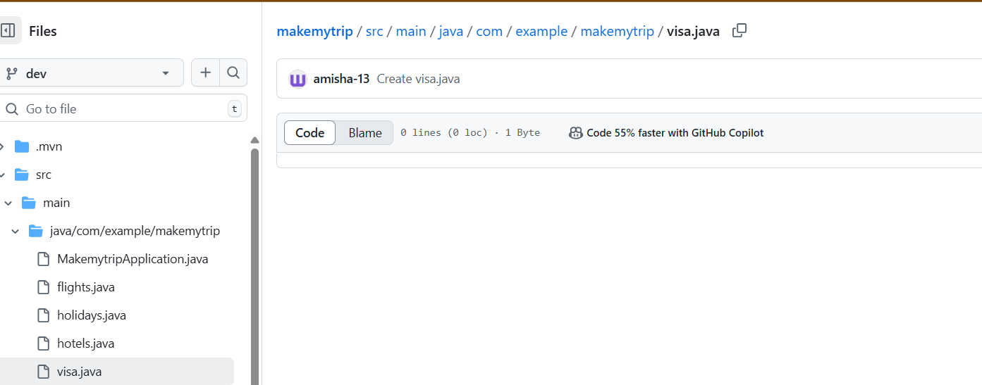

Dev A:

Added changes in visa.java

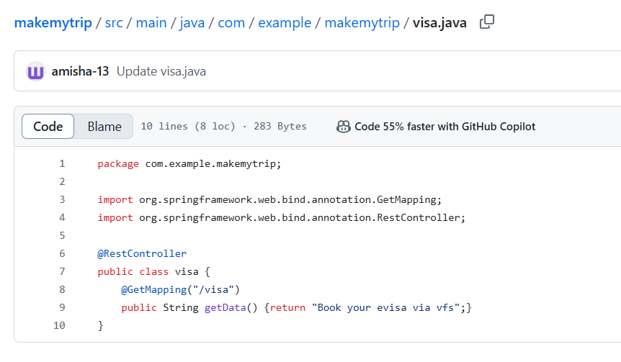

Dev B:

Makes changes in a differnet file: flights.java

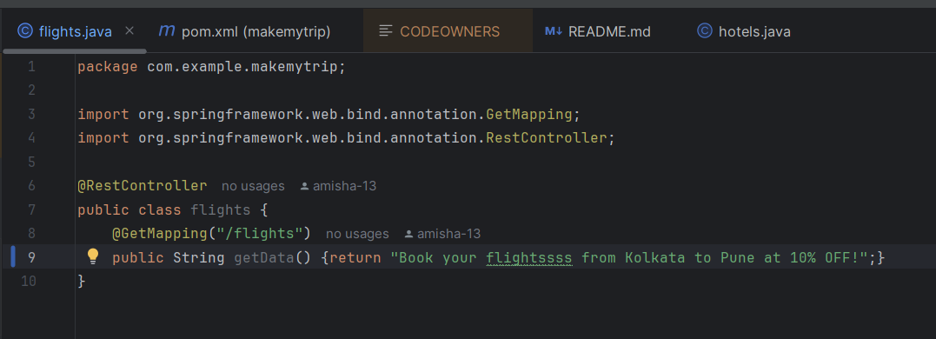

Git status shows my local changes in flights.java file

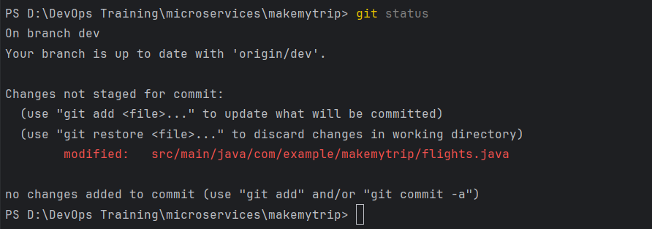

Git A,C,P

Git push origin dev - failed

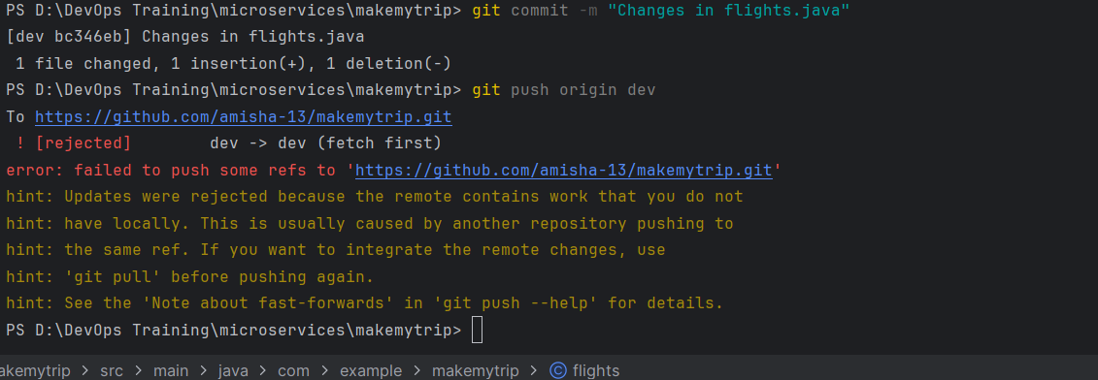

So now git pull origin dev will pull the changes from remote and merge it without an error

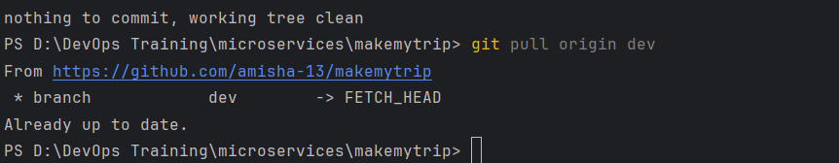

Now since this is java code, we need to maven clean, package

Once that is file you can go ahead and push the changes

> mvn clean package

> git add -all;git commit -m "Changes in flights.java";git push origin dev

Merge conflicts with changes in same files

Dev A:

Made changes in visa.java

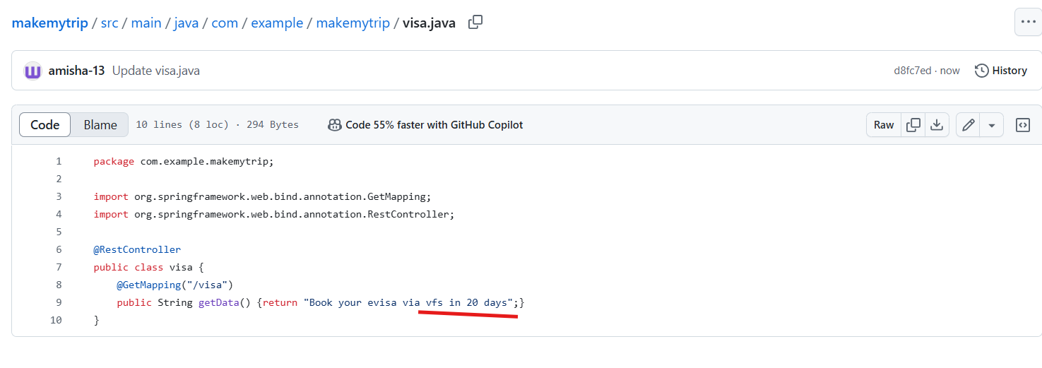

Dev B: Also makes changes in same file but 30 days

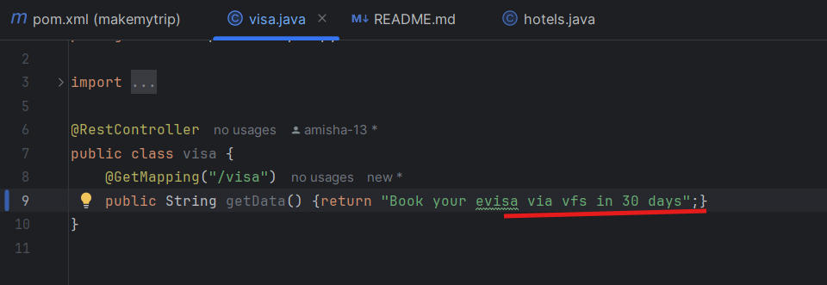

Now git a,c, push: Error out

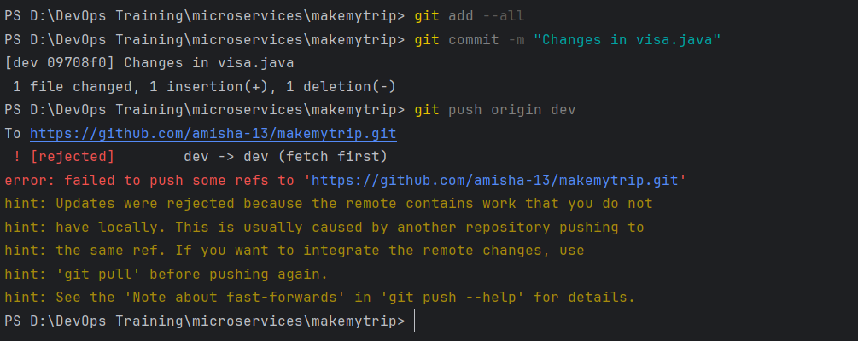

So again we pull the changes as suggested in hint but this time auto merge will fail because changes are in same file

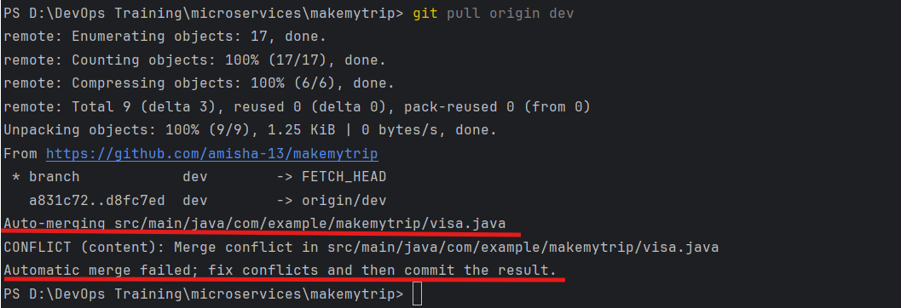

Auto merge is successful - when changes are in different files

Auto merge is failed - when changes are in same files

To resolve failed auto merge:

We can see there are two commits - one is Dev A, other Dev B

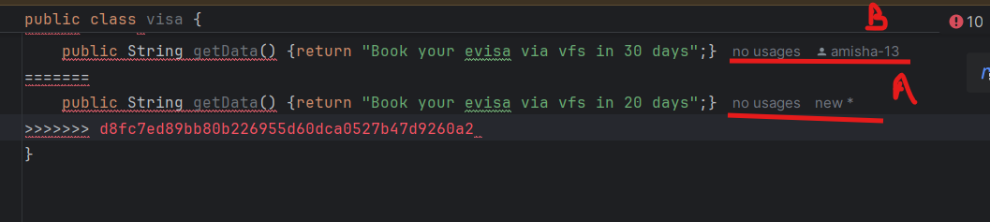

So you need to decide which changes are right according to you and accordingly keep that code and remove the other one

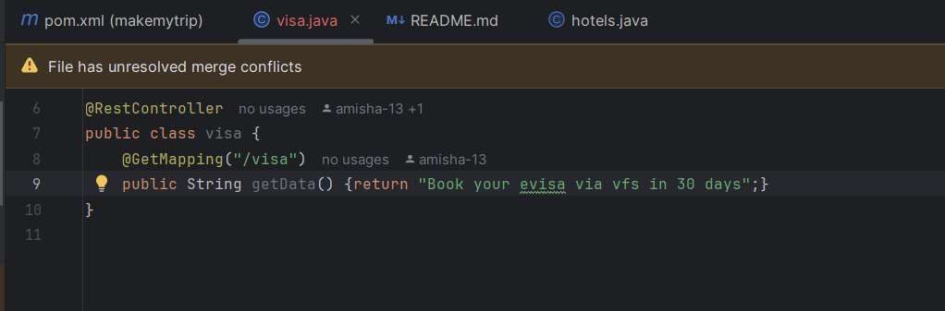

Now maven clean package to have both codes in sync correctly

Once build is successful, git add, commit, push

Now changes are merged

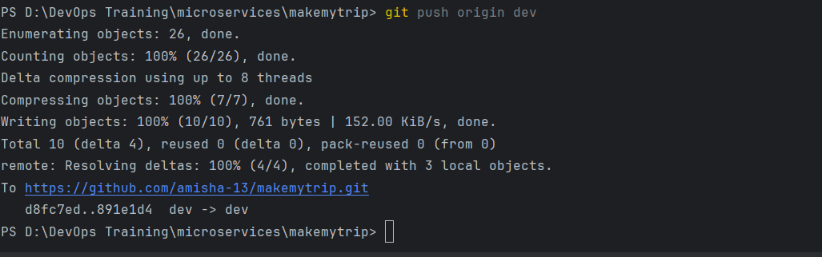

Case 3

git pull origin dev

Same changes both sides right now

Dev 1 made changes in dev branch - visa.java

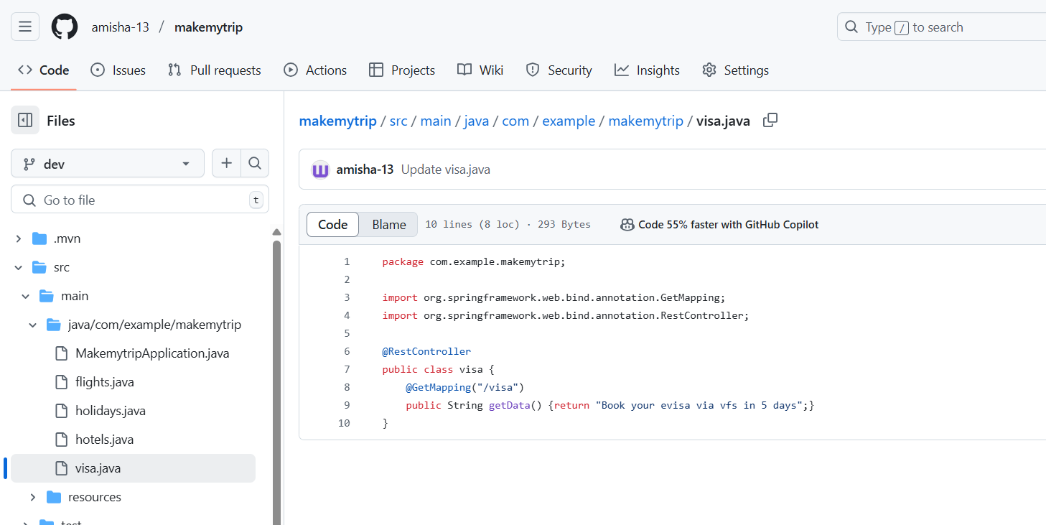

Dev e (myself) dont have this change

I create a new branch

git checkout -b feature/xyz

Then makes changes in visa.java

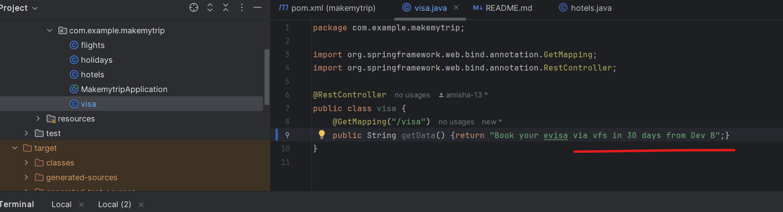

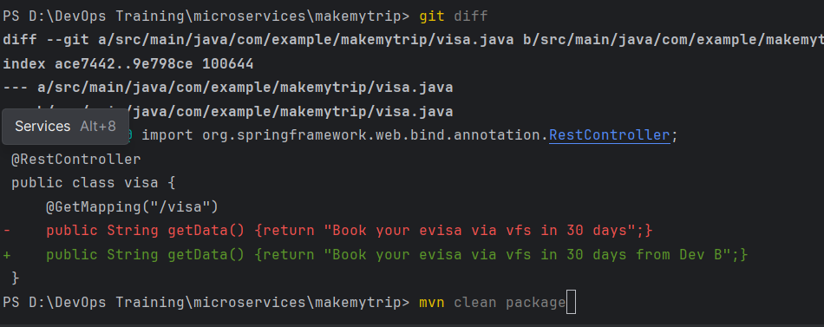

Now maven clean package

Then push code

git add --all;git commit -m "Changes in visa.java by Dev B";git push origin feature/xyz

Open pull request to merge in dev branch

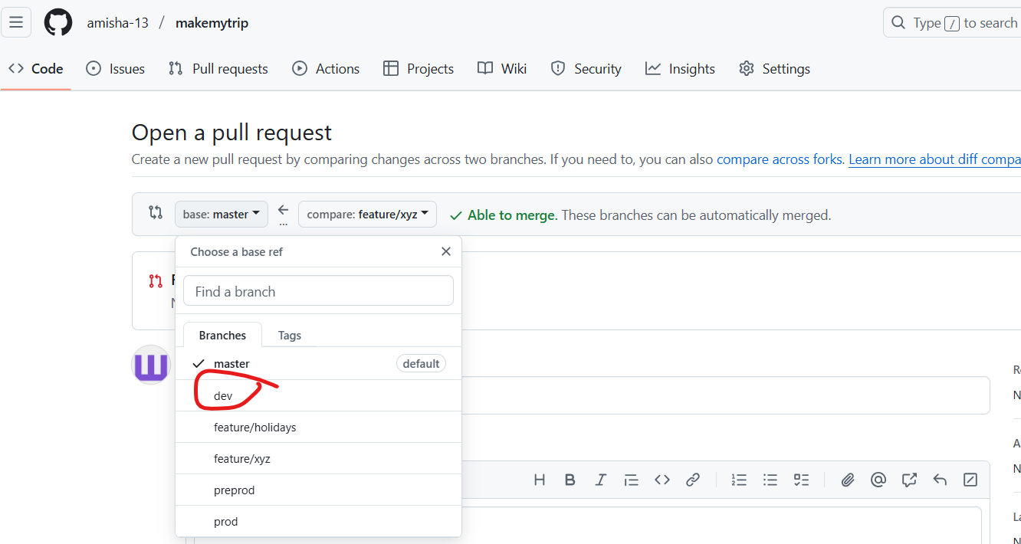

It gives error: that it cannot merge automatically

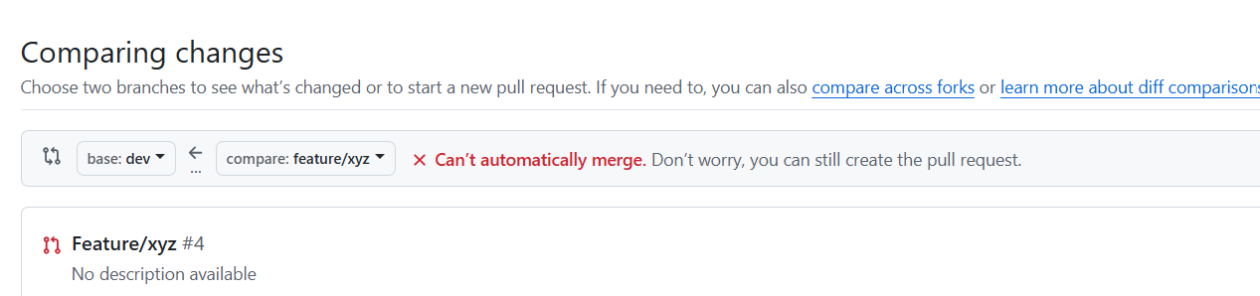

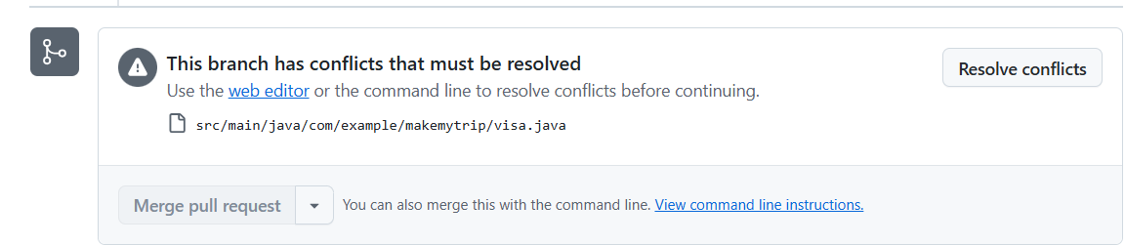

Out of the two branches, dev is the updated one and you need to resolve conflict > click on resolve conflicts

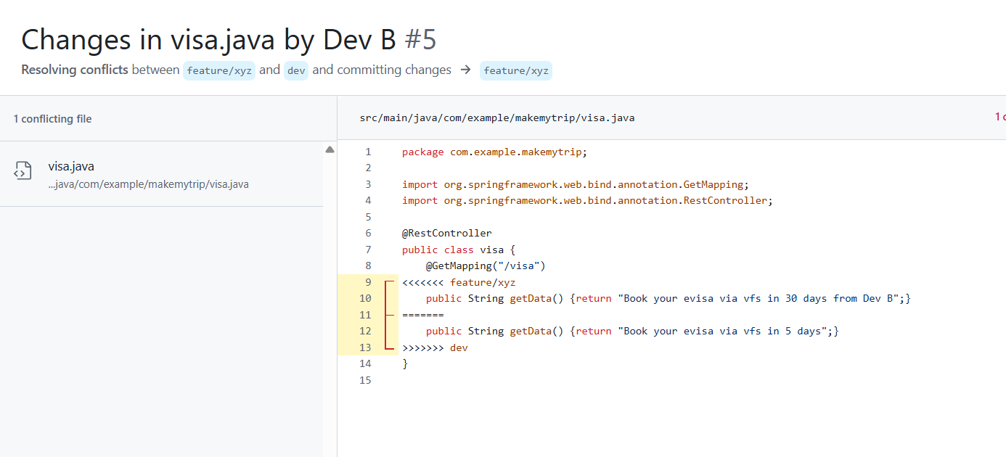

So now we are in branch feature

But we will now pull changes of dev

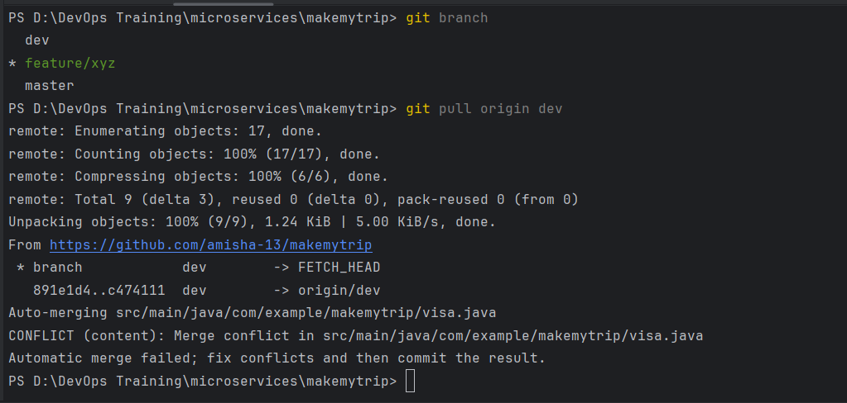

Auto merge is failed so fix it manually now

Chosse which code to keep and run > maven clean package

Then push

WHenever you push for 2nd time you use -f option

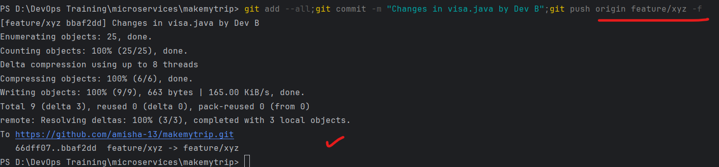

The PR was already created earlier, and now it is updated without error and we have the option to merge

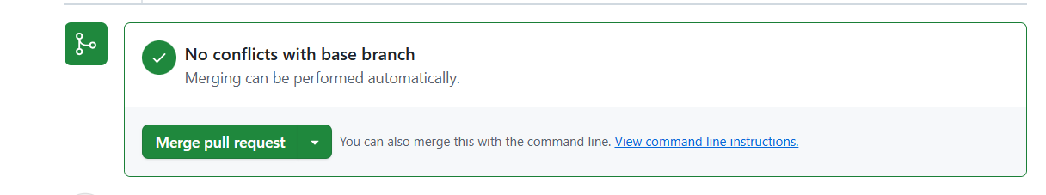

4th May - Day 7

In mumbai region, create Ec2 instance

Name:

AMI: Linux

Instance Type: t2.medium

Create a ey pair - .ppk (downloaded)

Create

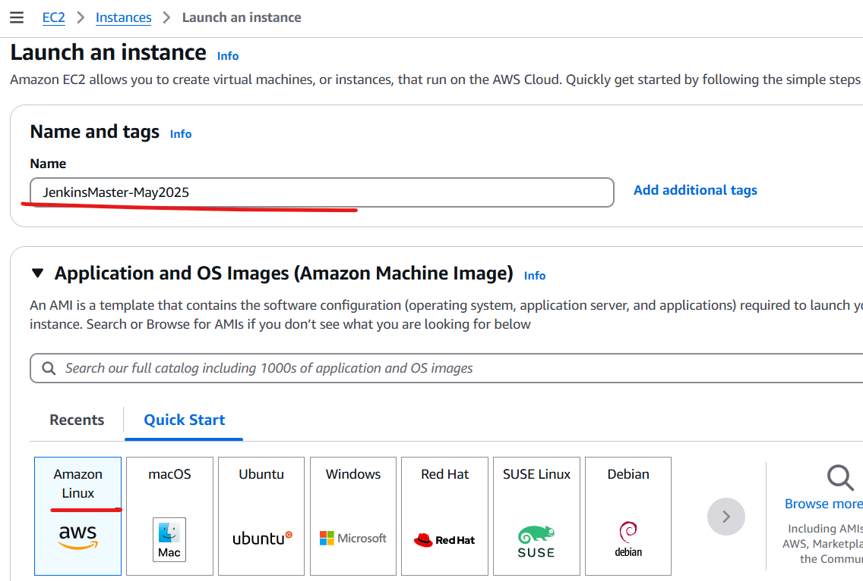

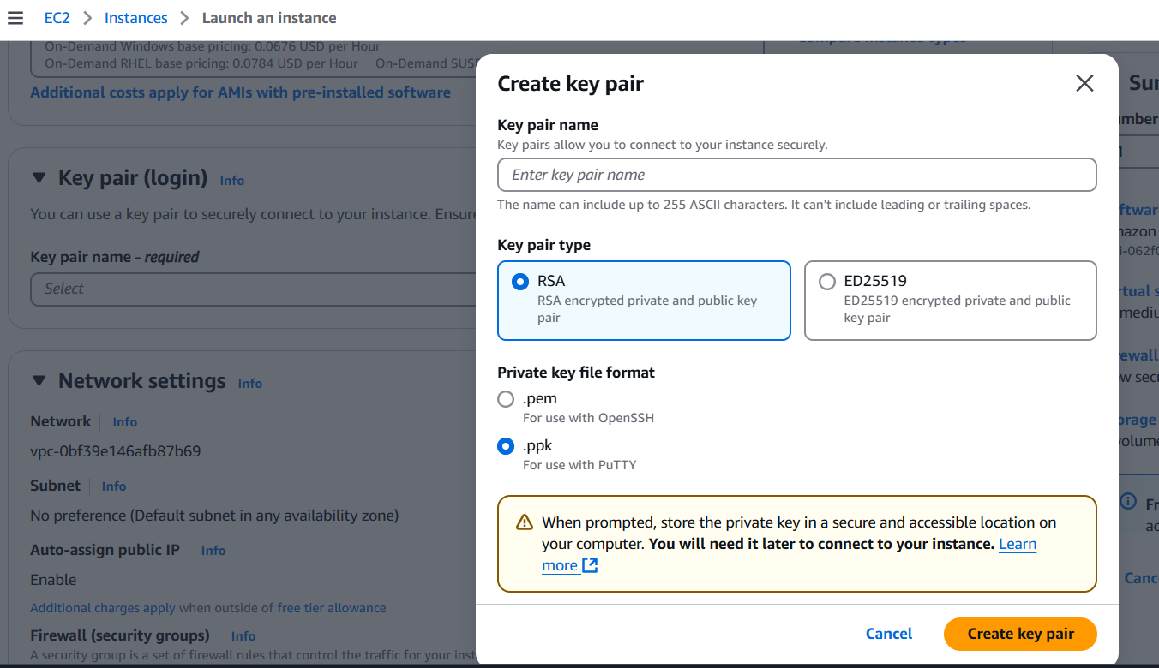

We will connect to server using putty

We need to modify server inbound rules to enable us to connect from anywhere to this machines

Go to security group > edit inbound rules

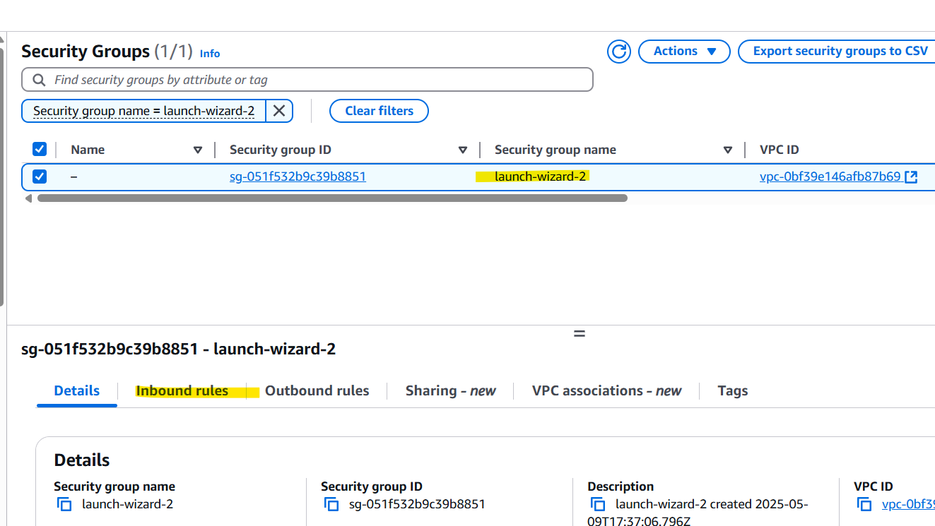

If you select your IP option you can connect only from your machine

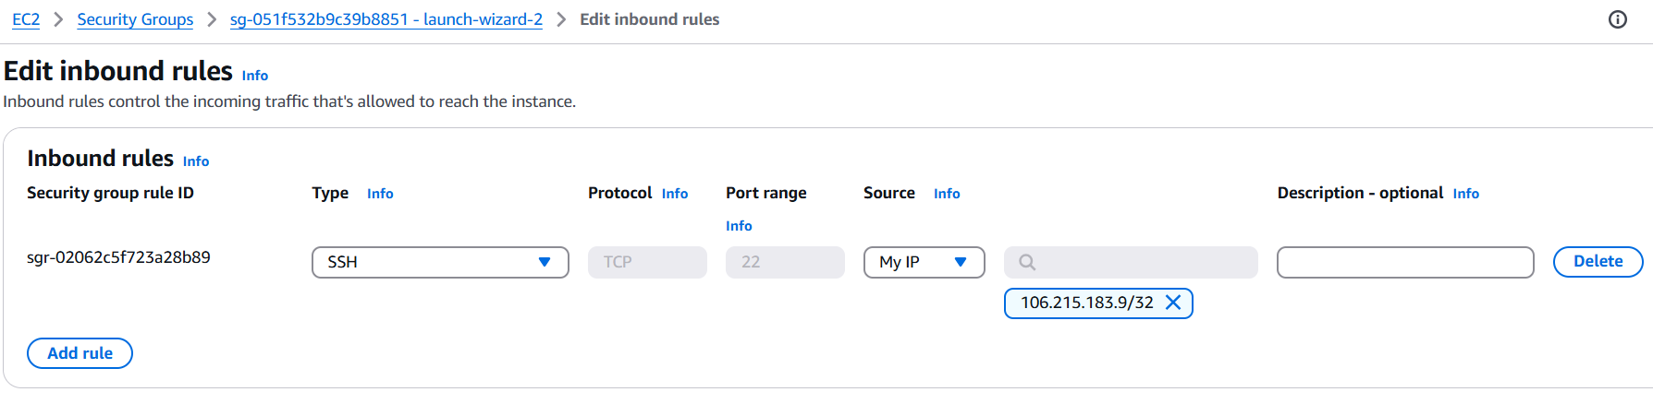

But we need connectivity from anywhere

Also add port 8080 connectivity for tomcat (jenkins)

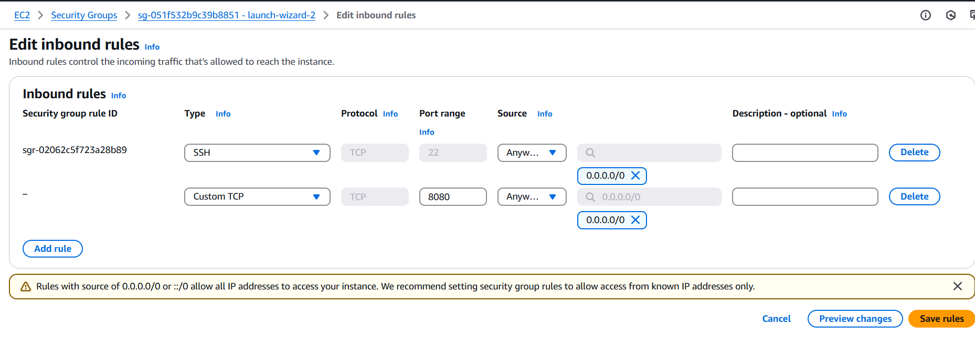

Connect to server using putty

Enter PUBLIC ip address > SSH

Provide the ppk key downloaded

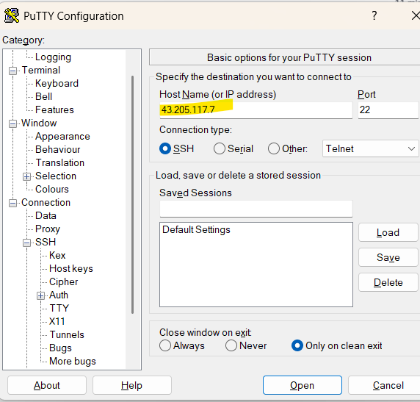

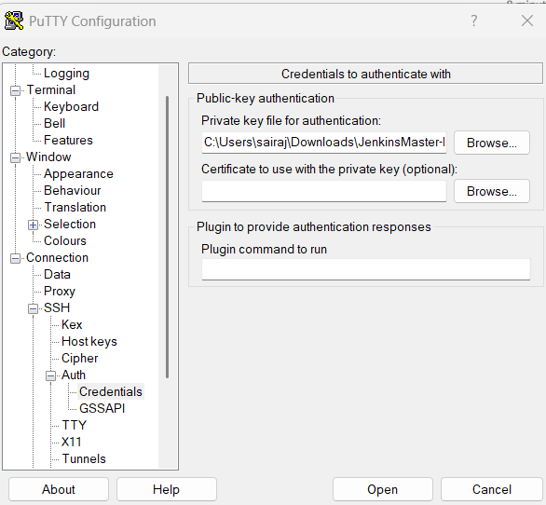

Browse to the .ppk file as private key

Login as ec2-user

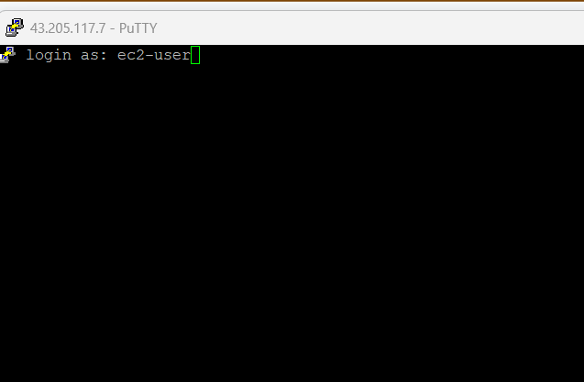

Install the apps

<https://github.com/satyam88/greentea/blob/master/ami>

**sudo su**

Will be running as root user

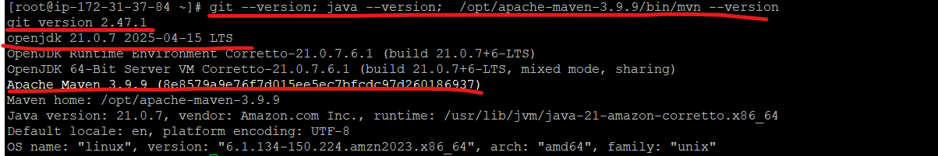

Once all apps are installed, check jenkins status (active)

>service jenkins status

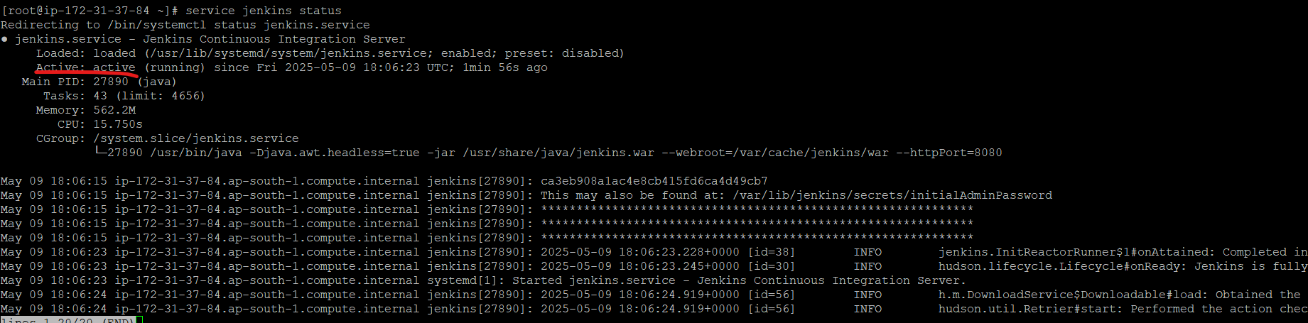

Now access jenkins:

<http://publicip:8080>

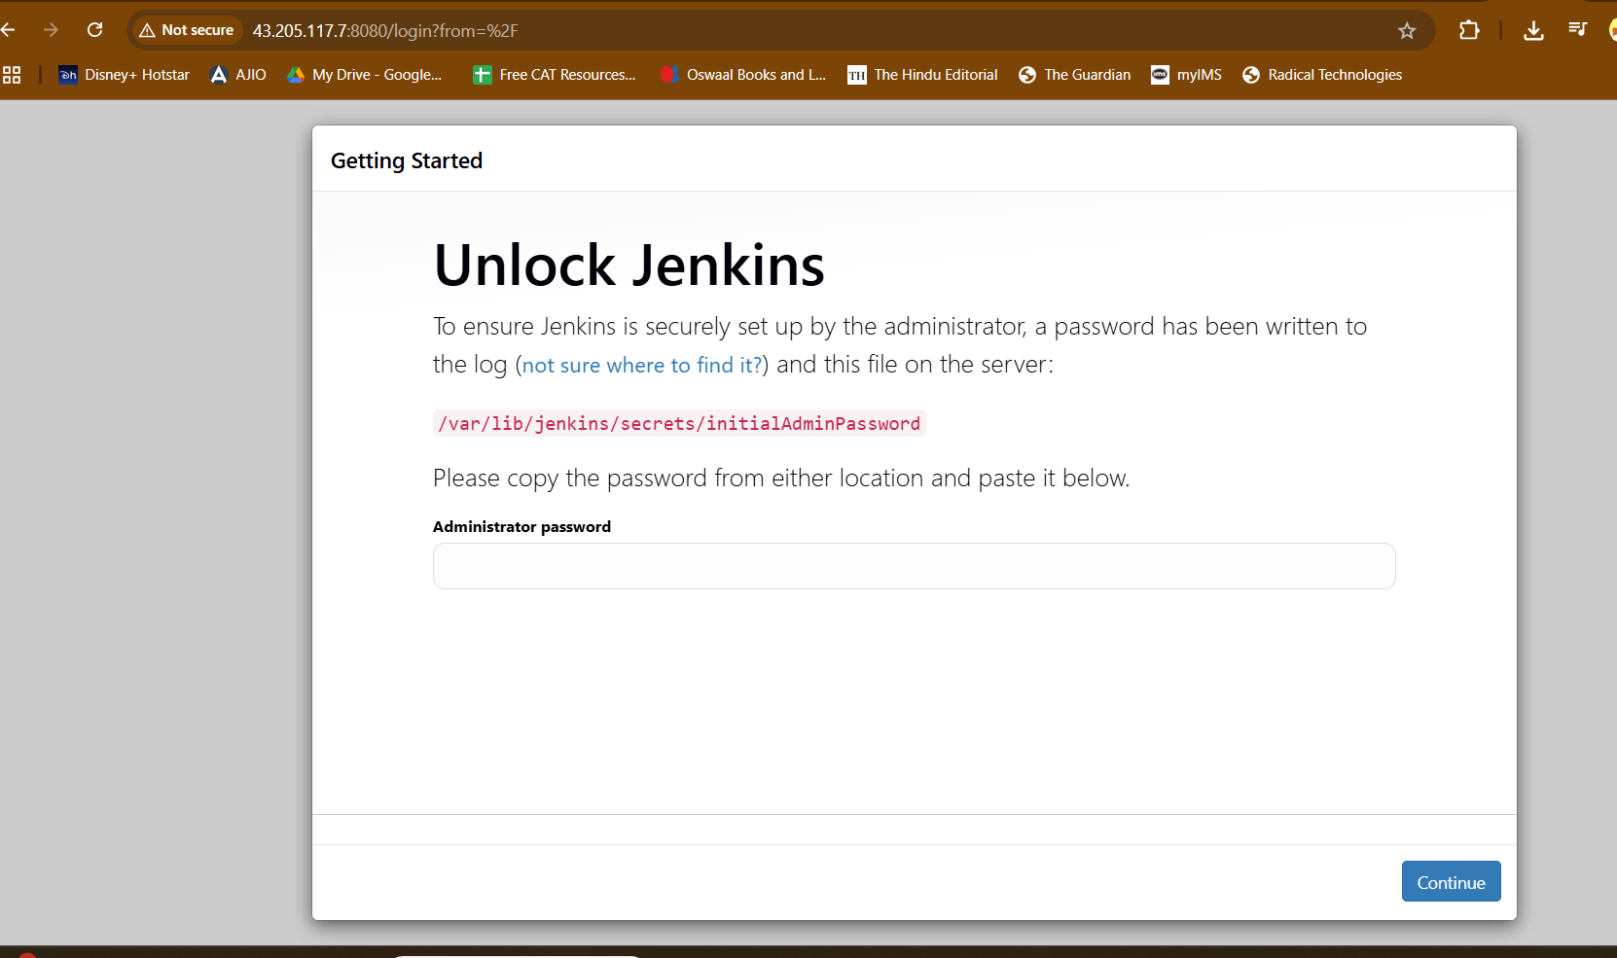

You need this password

So cat this file in screen



Install suggested plugins

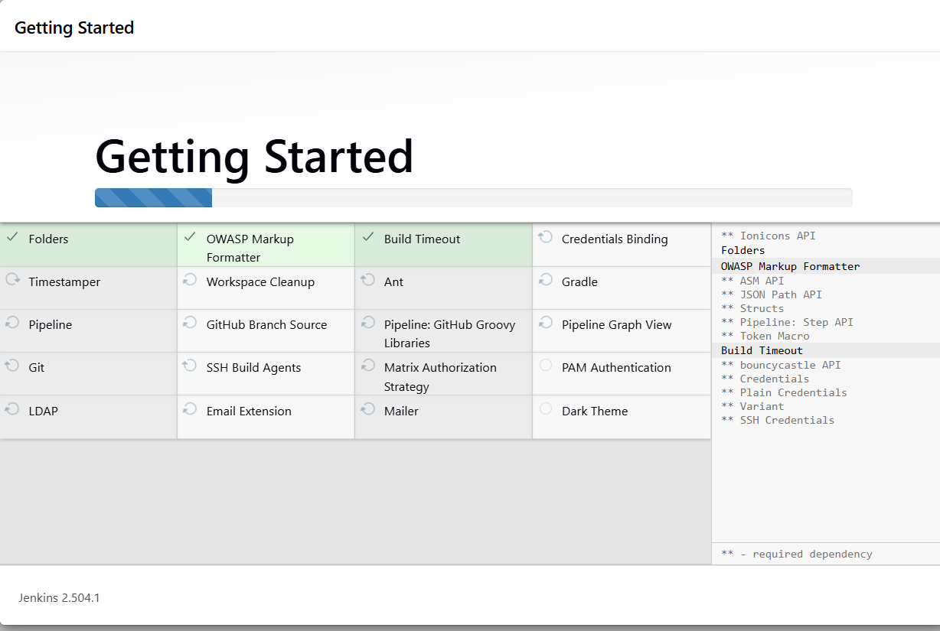

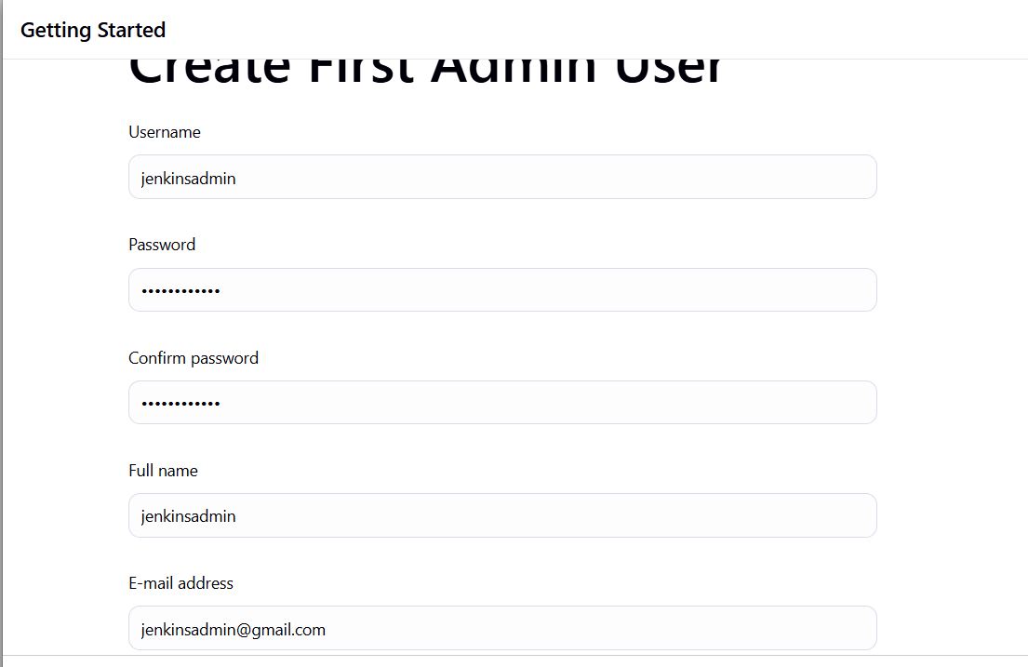

Ping google .com 5 times

[root@ip-172-31-37-84 ~]# ping -c 5 google.com

PING google.com (142.250.199.174) 56(84) bytes of data.

64 bytes from bom07s37-in-f14.1e100.net (142.250.199.174): icmp_seq=1 ttl=114 time=2.70 ms

64 bytes from bom07s37-in-f14.1e100.net (142.250.199.174): icmp_seq=2 ttl=114 time=2.70 ms

64 bytes from bom07s37-in-f14.1e100.net (142.250.199.174): icmp_seq=3 ttl=114 time=2.65 ms

64 bytes from bom07s37-in-f14.1e100.net (142.250.199.174): icmp_seq=4 ttl=114 time=2.36 ms

64 bytes from bom07s37-in-f14.1e100.net (142.250.199.174): icmp_seq=5 ttl=114 time=2.61 ms

--- google.com ping statistics ---

5 packets transmitted, 5 received, 0% packet loss, time 4007ms

rtt min/avg/max/mdev = 2.359/2.604/2.702/0.127 ms

[root@ip-172-31-37-84 ~]#

[root@ip-172-31-37-84 ~]#

[root@ip-172-31-37-84 ~]#

[root@ip-172-31-37-84 ~]#

[root@ip-172-31-37-84 ~]# ping -c 5 google.com > /tmp/google.txt

[root@ip-172-31-37-84 ~]# cat /tmp/google.txt

PING google.com (142.250.192.142) 56(84) bytes of data.

64 bytes from bom12s18-in-f14.1e100.net (142.250.192.142): icmp_seq=1 ttl=114 time=2.16 ms

64 bytes from bom12s18-in-f14.1e100.net (142.250.192.142): icmp_seq=2 ttl=114 time=2.47 ms

64 bytes from bom12s18-in-f14.1e100.net (142.250.192.142): icmp_seq=3 ttl=114 time=1.94 ms

64 bytes from bom12s18-in-f14.1e100.net (142.250.192.142): icmp_seq=4 ttl=114 time=1.89 ms

64 bytes from bom12s18-in-f14.1e100.net (142.250.192.142): icmp_seq=5 ttl=114 time=2.28 ms

--- google.com ping statistics ---

5 packets transmitted, 5 received, 0% packet loss, time 4006ms

rtt min/avg/max/mdev = 1.892/2.149/2.473/0.215 ms

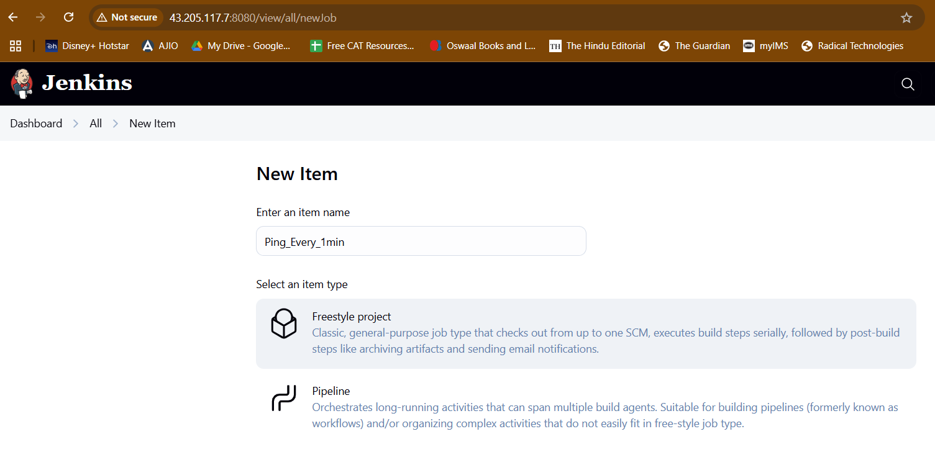

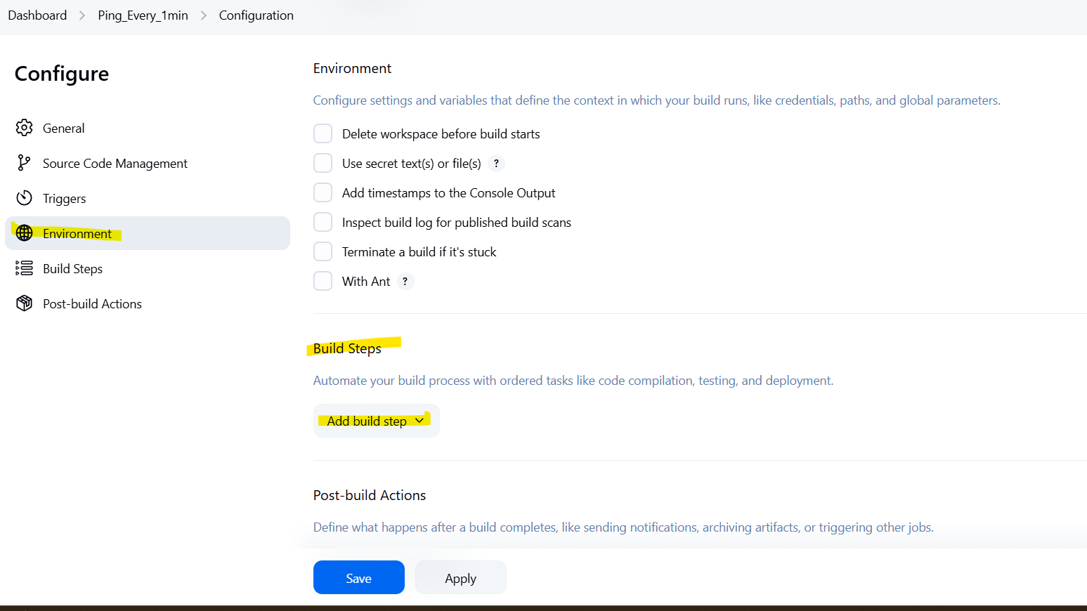

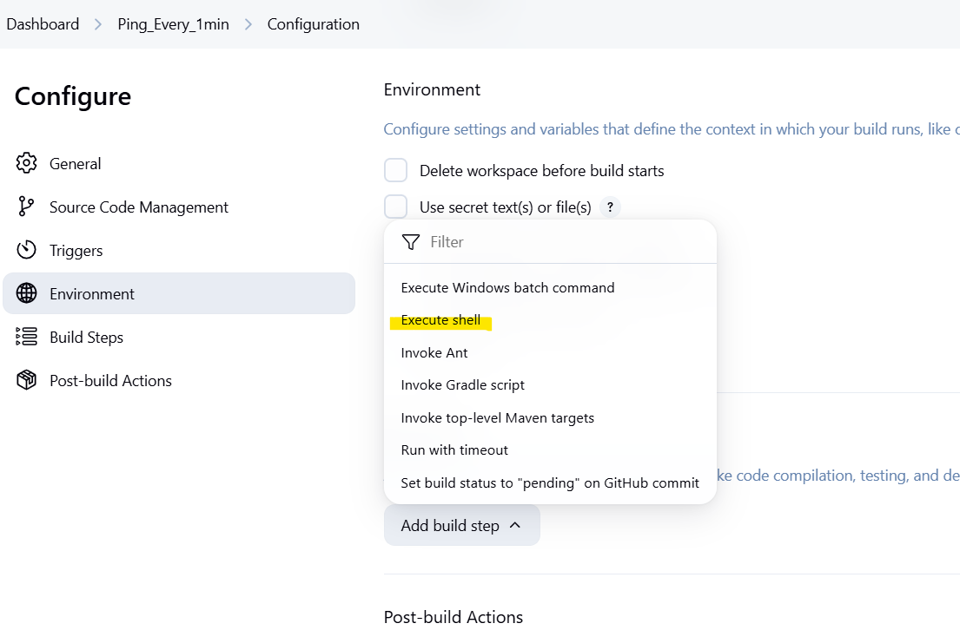

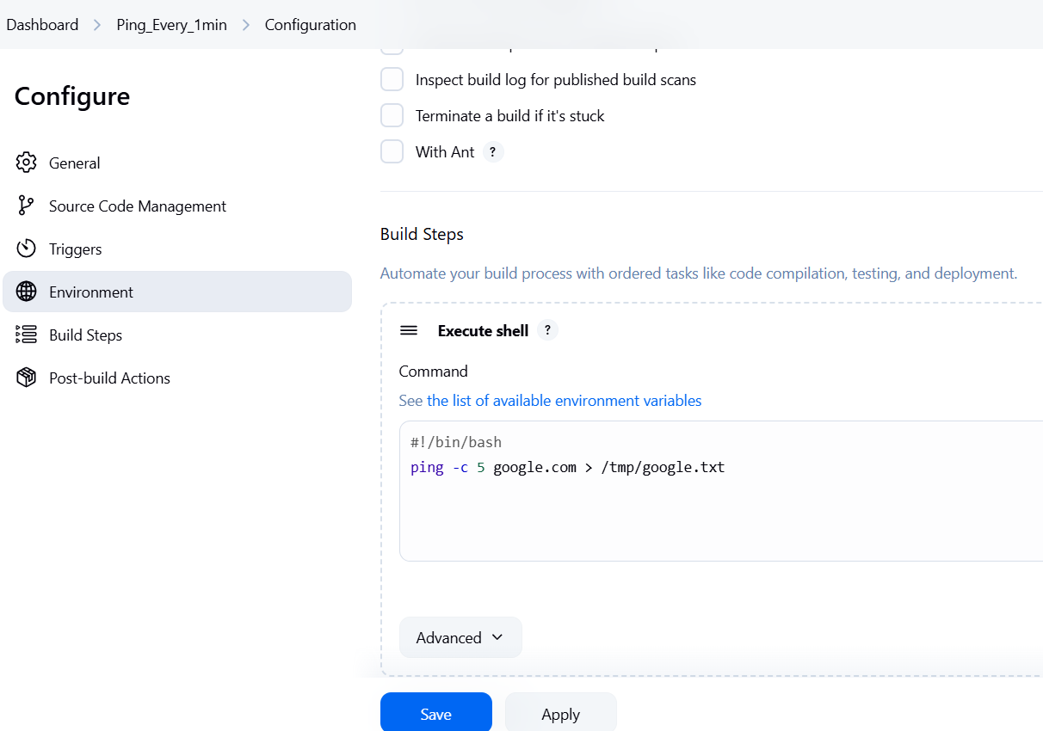

Build steps > execute shell

Add:

#!/bin/bash

This line is compulsory

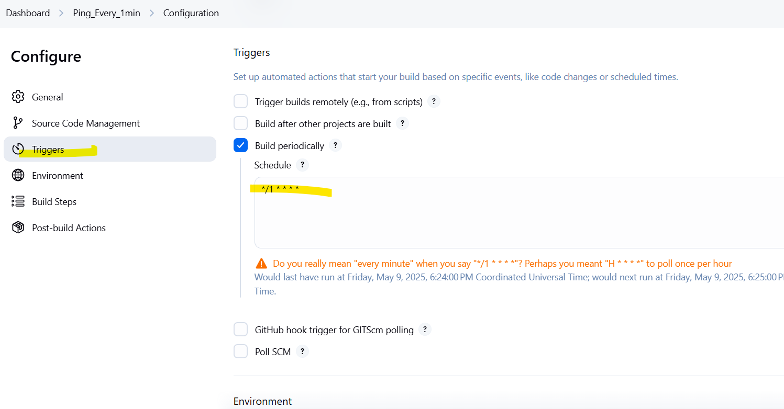

Also add trigger to run it every minute

*/1 * * * *

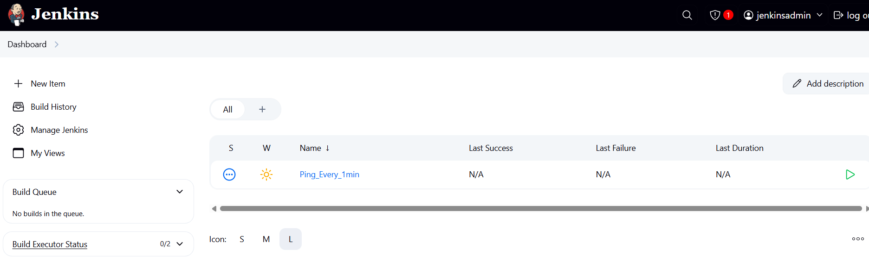

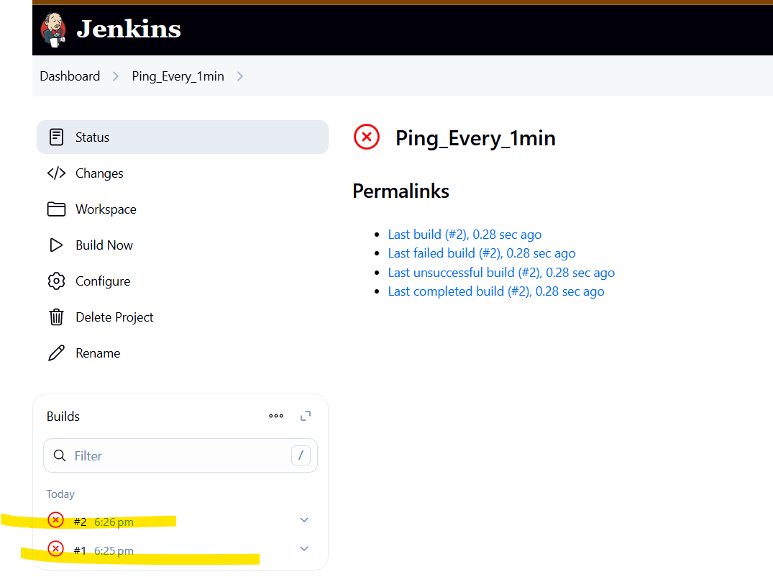

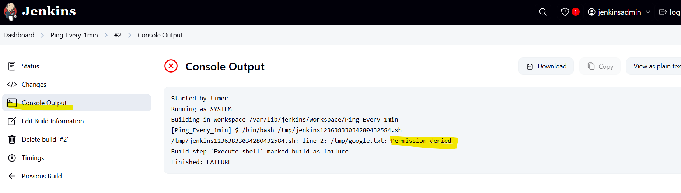

Jenkins user has no permission to this file

[root@ip-172-31-37-84 ~]# ls -ld /tmp/google.txt

-rw-r--r--. 1 root root 660 May 9 18:19 /tmp/google.txt

Oly root user has access to this file

Add entry of jenkins user

> visudo

To edit permissions

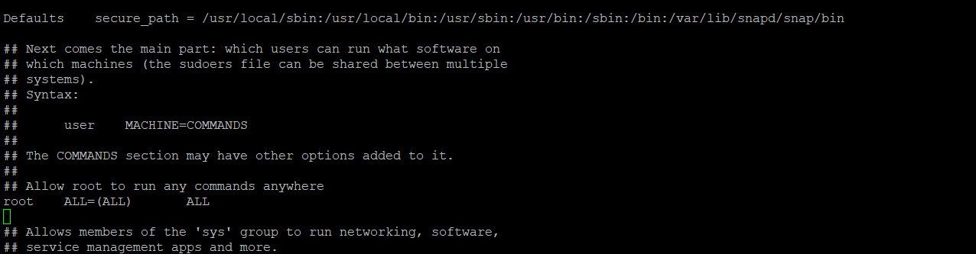

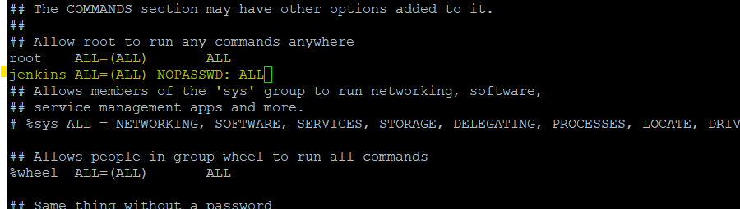

This gives jenkins root permissions

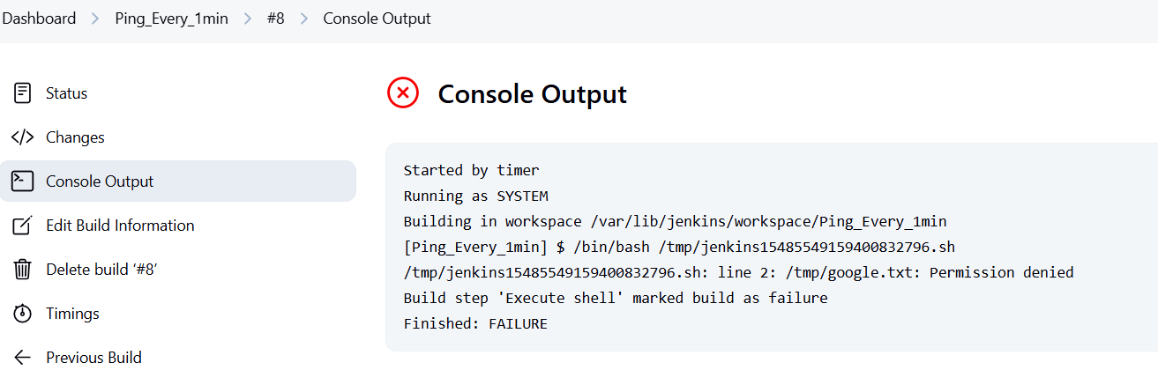

File owner is still root user

So change owner -

[root@ip-172-31-37-84 ~]# chown jenkins:jenkins /tmp/google.txt

[root@ip-172-31-37-84 ~]# chmod 755 /tmp/google.txt

> ls -ld /tmp/google.txt



Now jenkins is the owner of this file

Now job is successful -

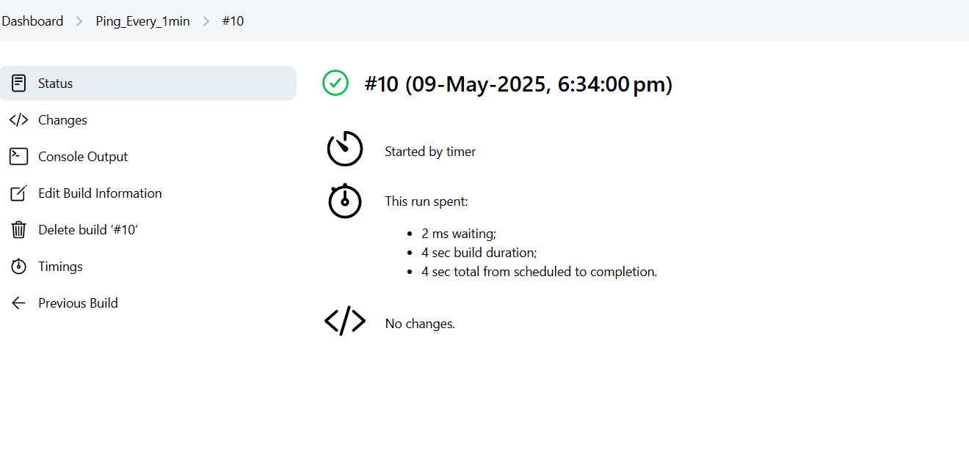

Flowing output

tail -f /tmp/google.txt

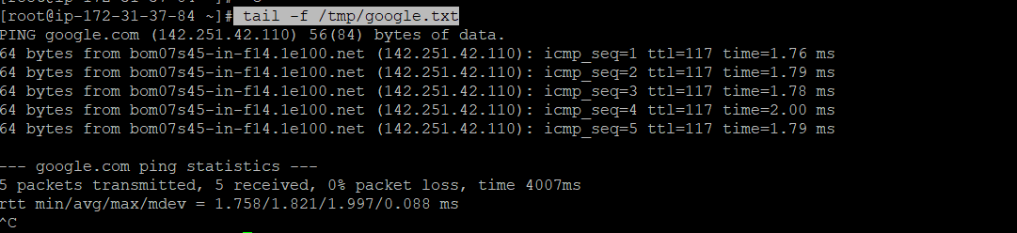

Change the job using configure option

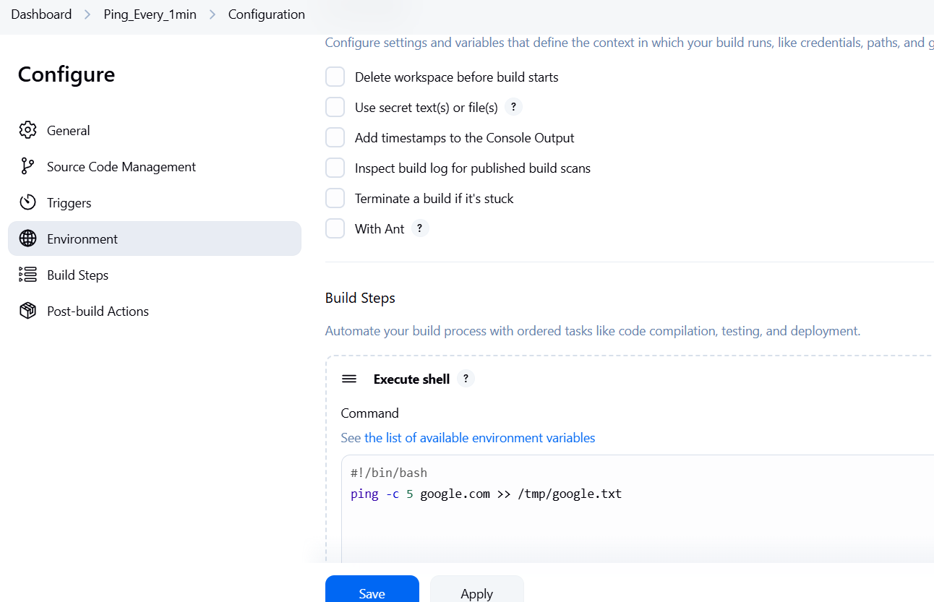

If yu put > arrow - it will replace the output

If you put >> - it will append the output

[root@ip-172-31-37-84 ~]# java --version

openjdk 21.0.7 2025-04-15 LTS

OpenJDK Runtime Environment Corretto-21.0.7.6.1 (build 21.0.7+6-LTS)

OpenJDK 64-Bit Server VM Corretto-21.0.7.6.1 (build 21.0.7+6-LTS, mixed mode, sharing)

[root@ip-172-31-37-84 ~]# which java

/usr/bin/java

[root@ip-172-31-37-84 ~]# readlink -f /usr/bin/java

/usr/lib/jvm/java-21-amazon-corretto.x86_64/bin/java

[root@ip-172-31-37-84 ~]# cd /usr/lib/jvm/java-21-amazon-corretto.x86_64/

[root@ip-172-31-37-84 java-21-amazon-corretto.x86_64]# ls -ltr

total 52

-rw-r--r--. 1 root root 1244 Apr 10 18:06 release

drwxr-xr-x. 71 root root 16384 May 9 18:03 legal

drwxr-xr-x. 3 root root 18 May 9 18:04 man

drwxr-xr-x. 5 root root 146 May 9 18:04 conf

drwxr-xr-x. 5 root root 16384 May 9 18:04 lib

drwxr-xr-x. 3 root root 132 May 9 18:04 include

drwxr-xr-x. 2 root root 16384 May 9 18:04 bin

[root@ip-172-31-37-84 java-21-amazon-corretto.x86_64]# which git

/usr/bin/git

[root@ip-172-31-37-84 java-21-amazon-corretto.x86_64]# echo $M2_HOME

/opt/apache-maven-3.9.9

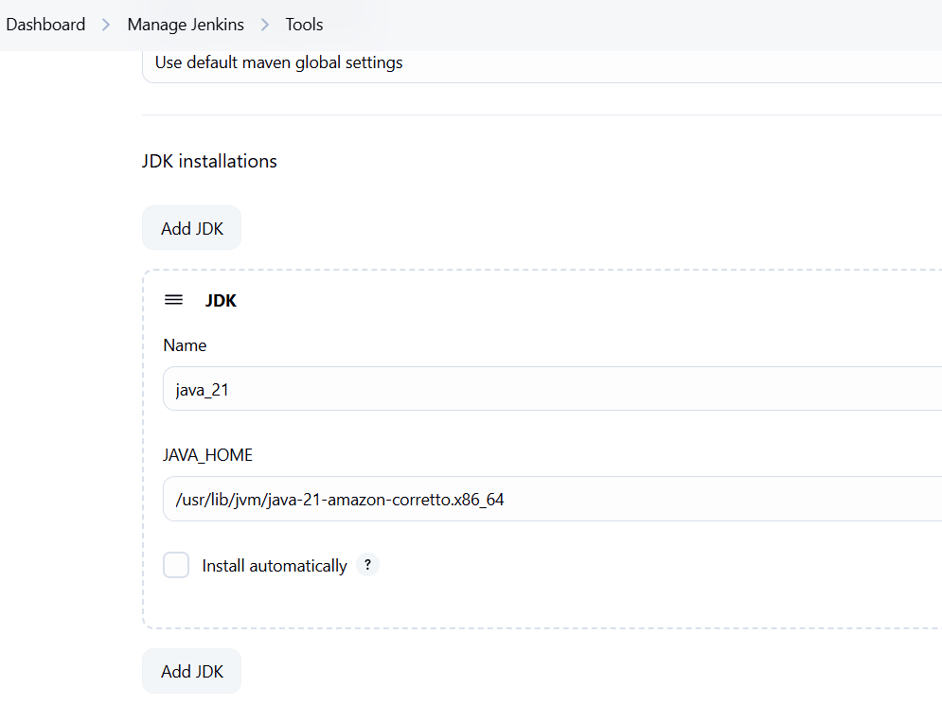

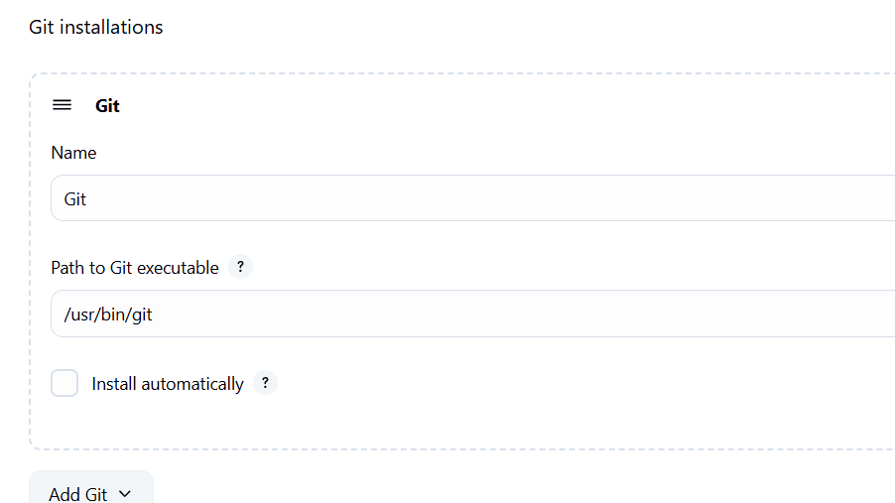

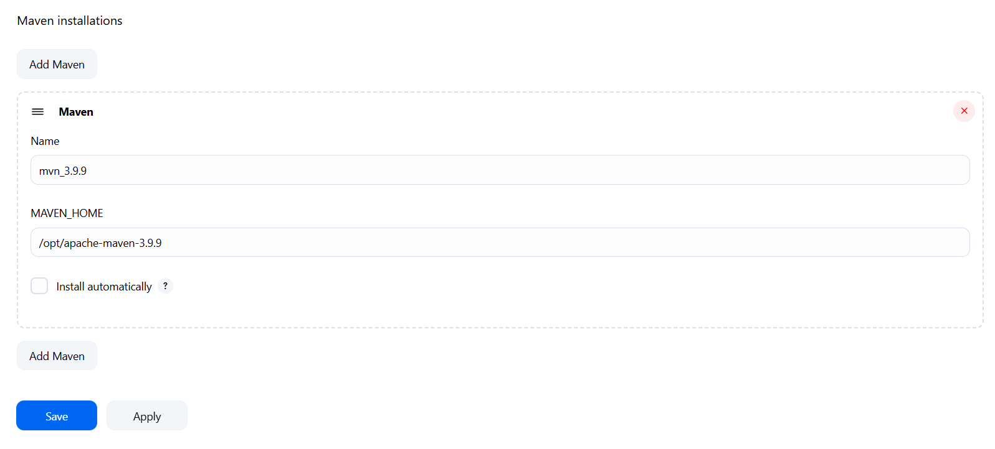

Add java, git and maven paths on jenkins

Day 8 - 10th May 2025

Create a webhook

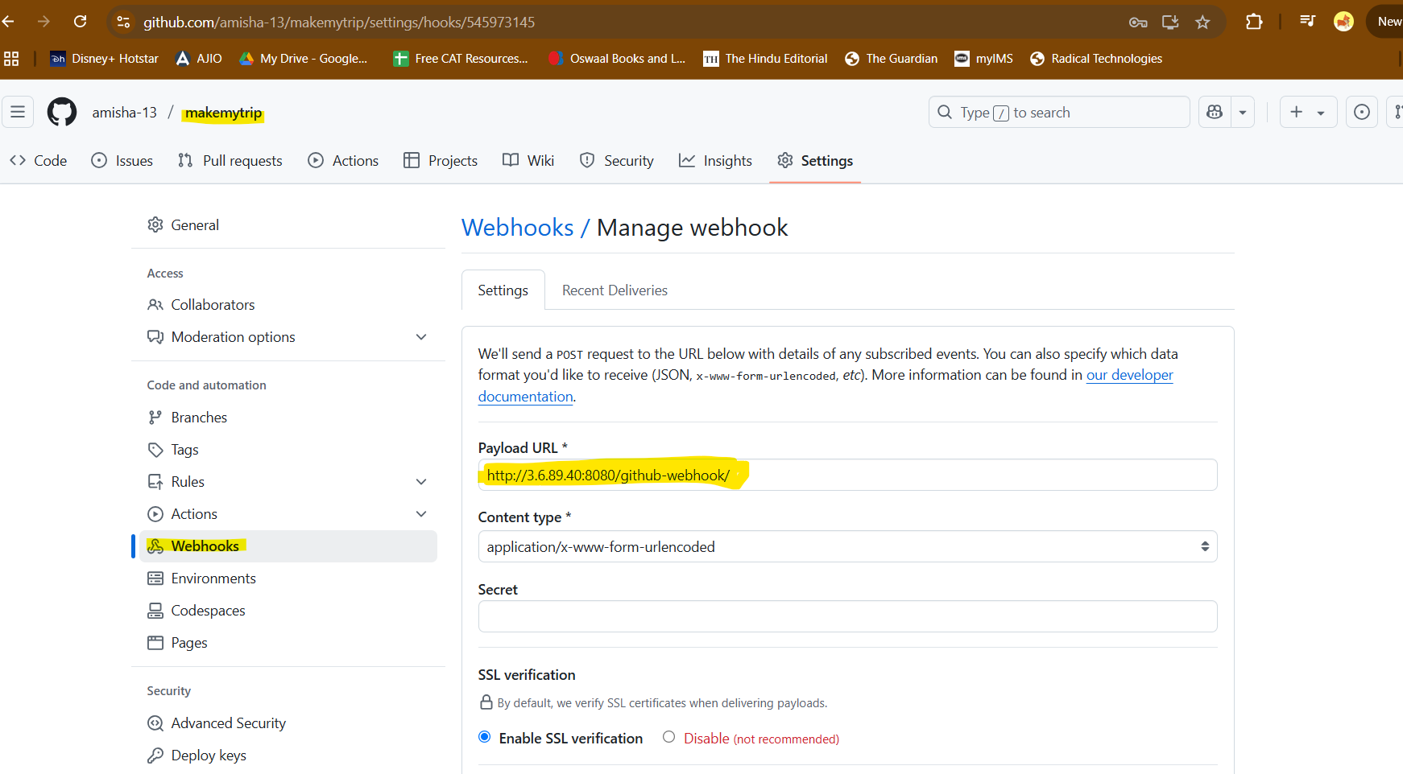

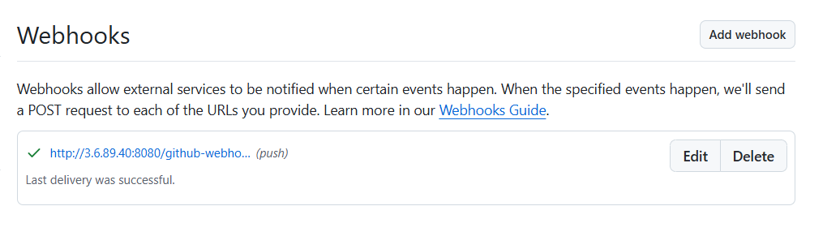

Jenkins is super slow, so change its URL in jenkins settings since public ip changes after restarting an ec2 instance

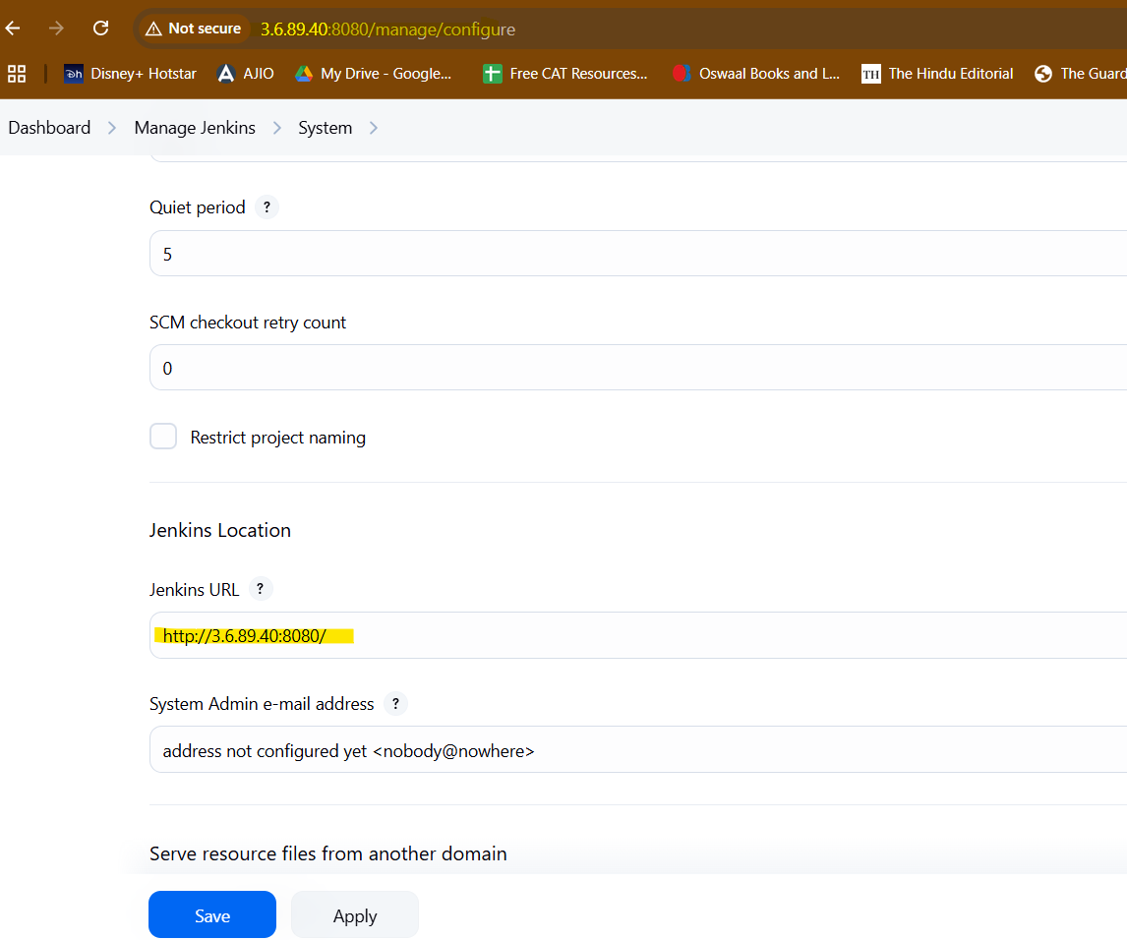

Install Maven plugins > restart jenkins

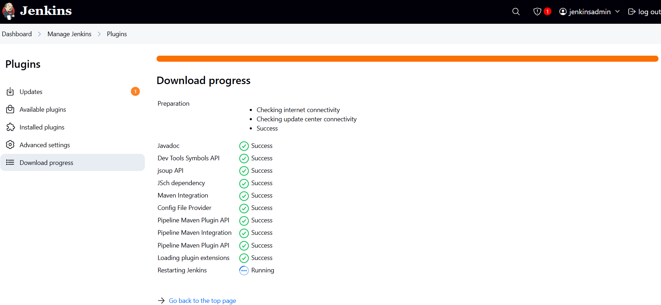

Create maven project job in jenkins

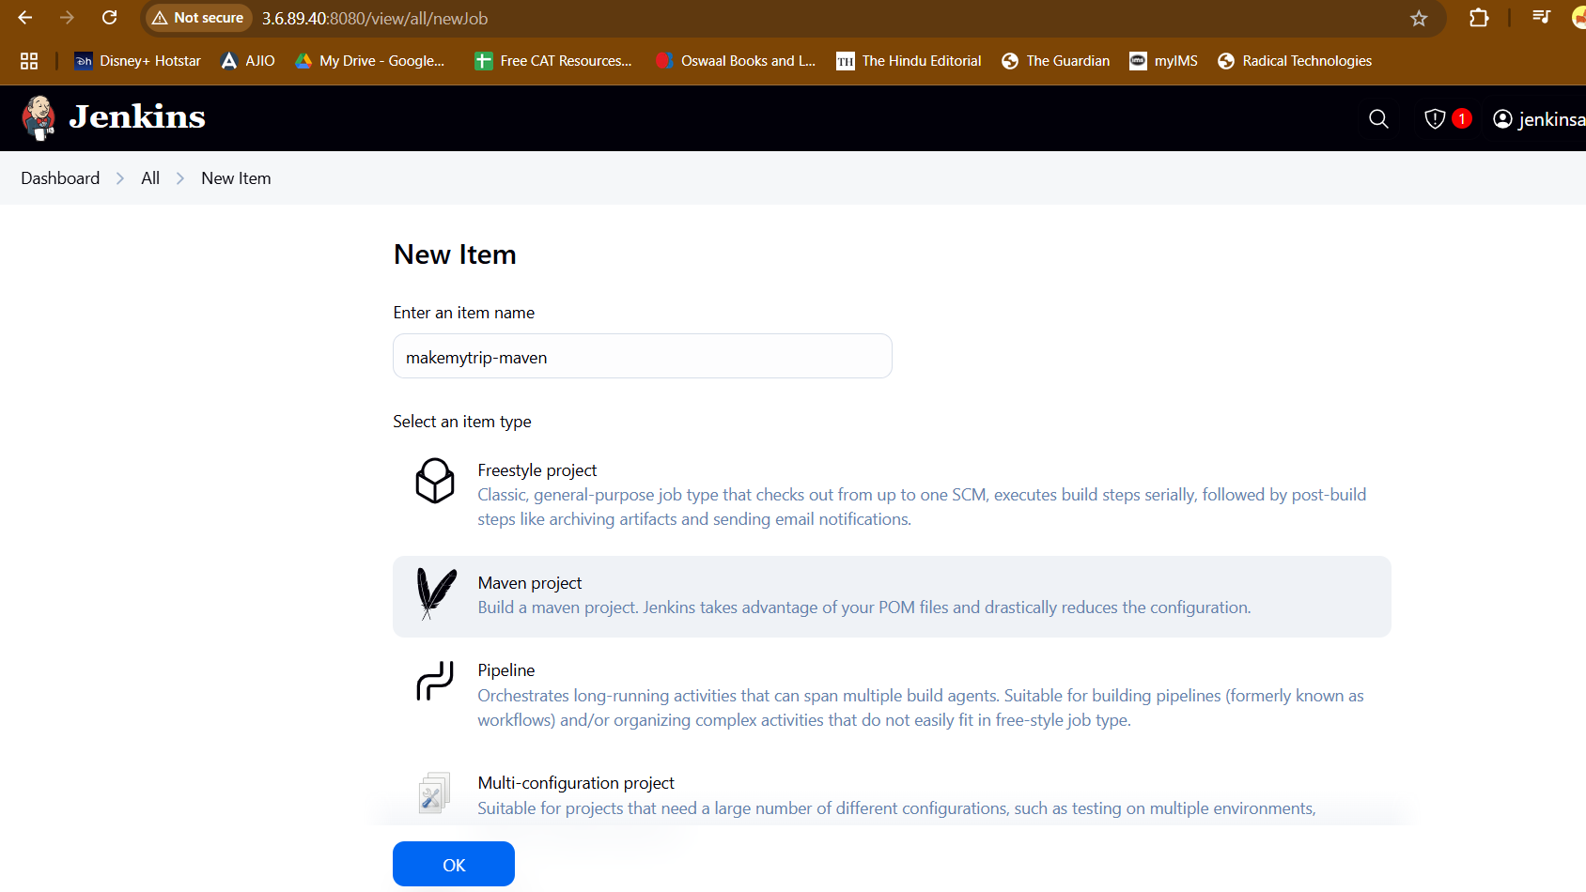

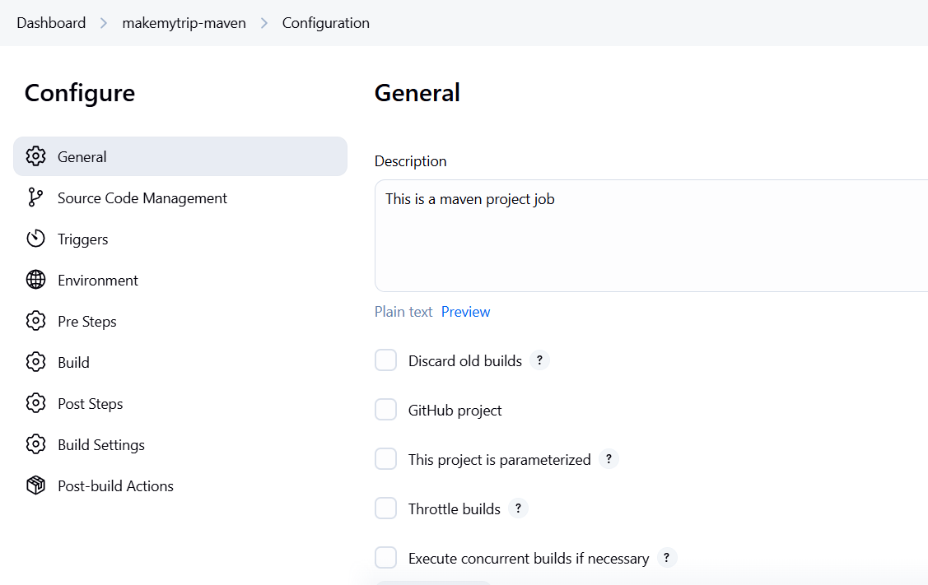

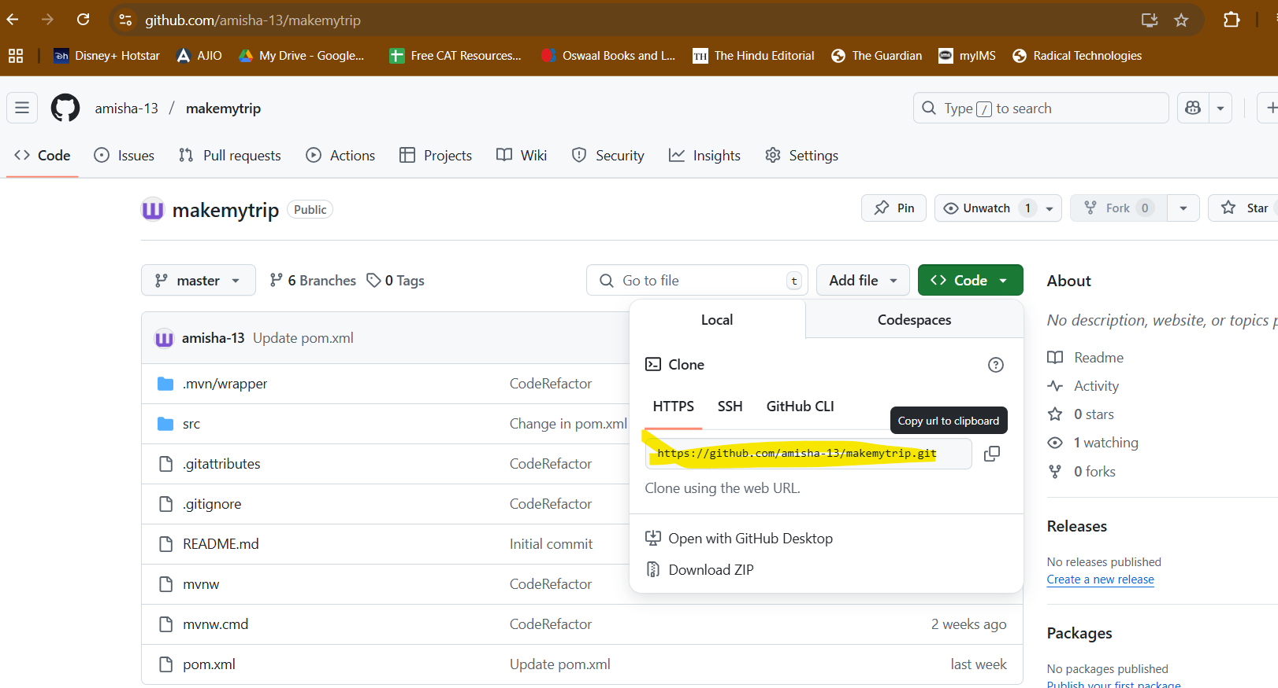

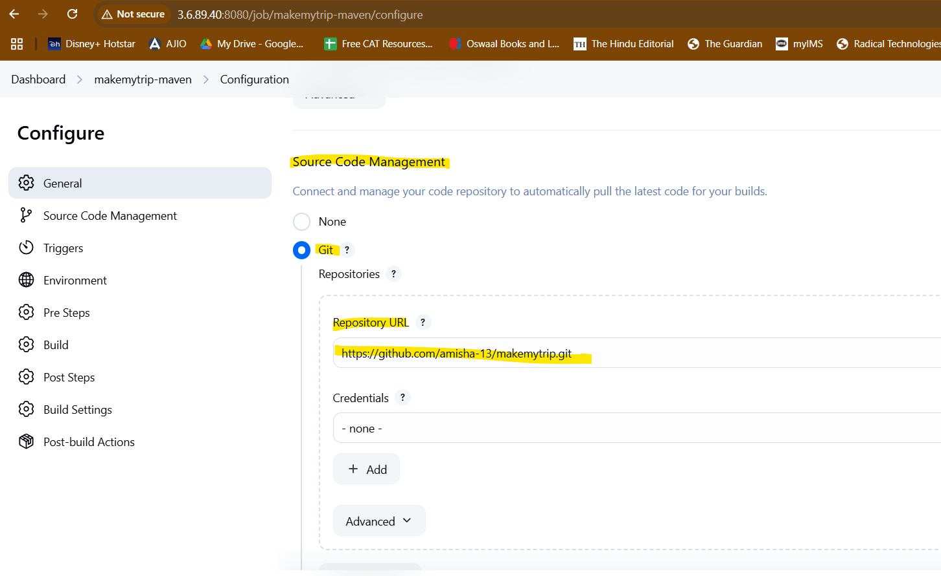

My repo is public so no credentials required for this one

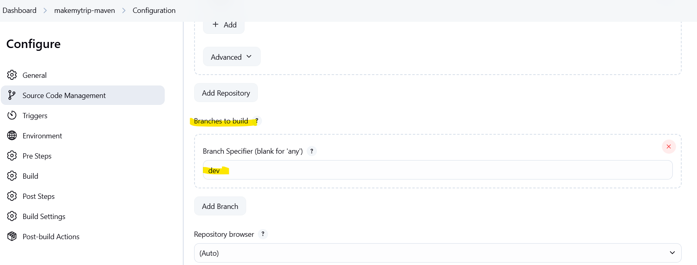

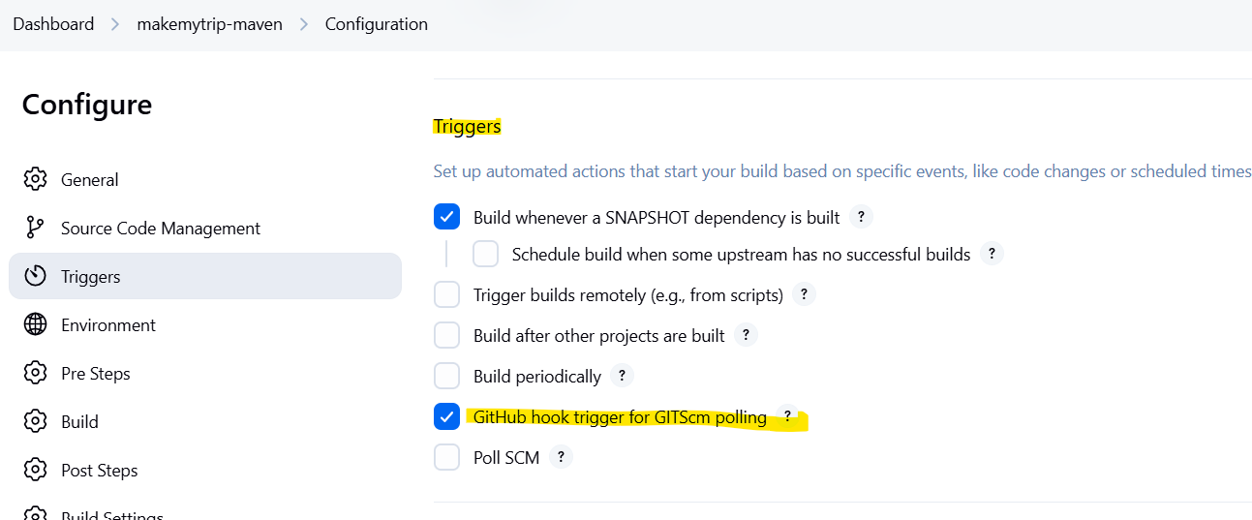

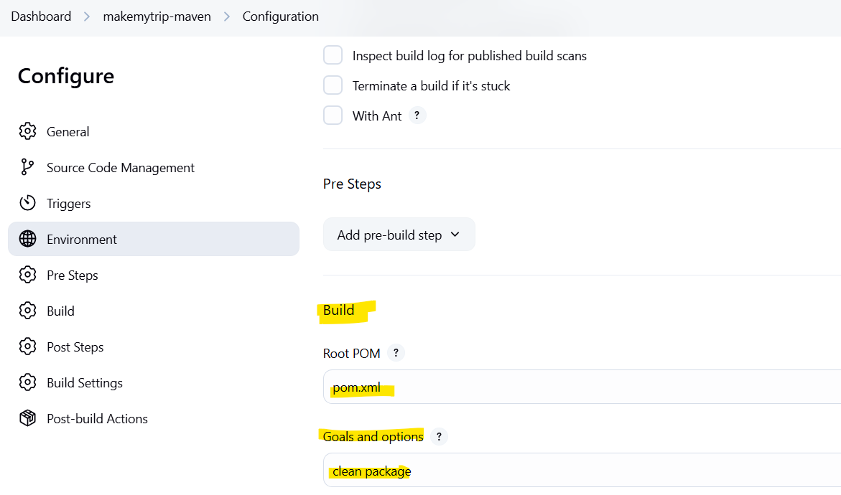

>git branch

>git pull origin dev

>git checkout -b feature/cexchange  
>git branch

Create new java class

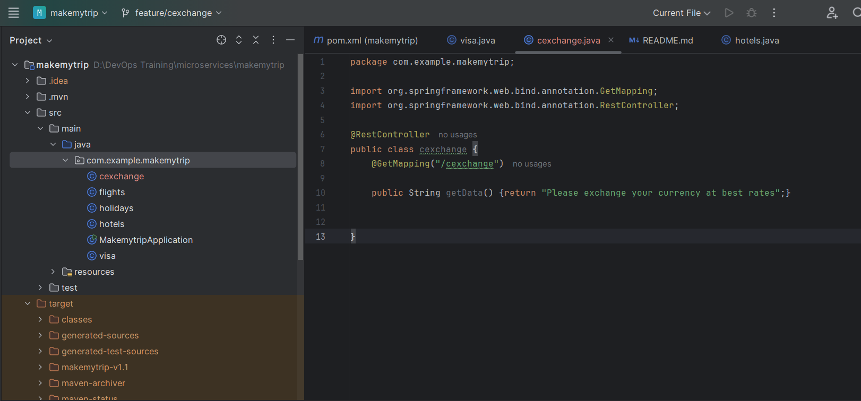

Since you made changes to java code

>mvn clean package

>mvn spring-boot:run





All apps are running including old and new

>git add --all

> git commit -m "Added cexchange.java"

> git push origin feature/cexchange

Create pull request feature to dev and merge

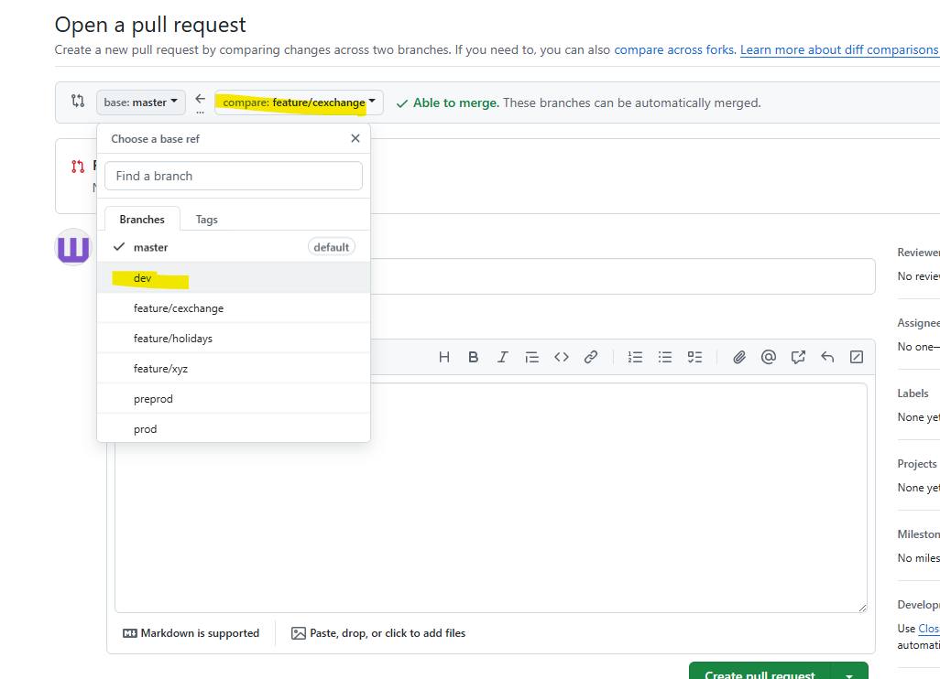

Webhook is triggered by this push and pushed the jenkins job

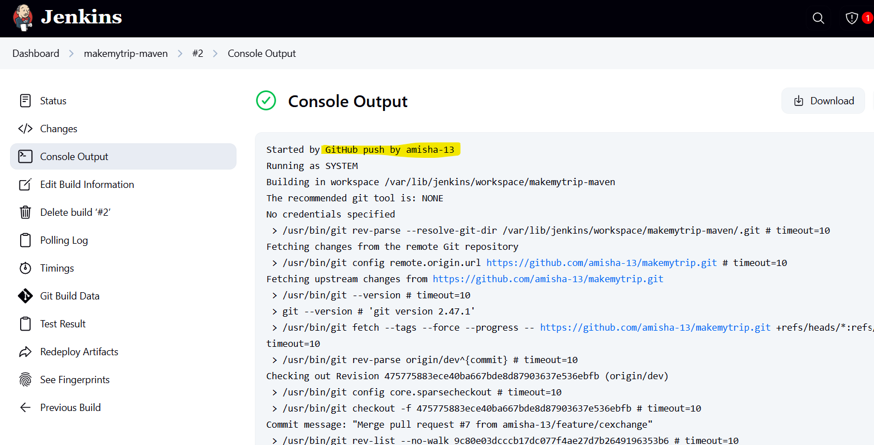

Since the goal was to clean package (create artifact) and store in EC2 instance (Jenkins server)

Earlier artifact was being stored in local machine.

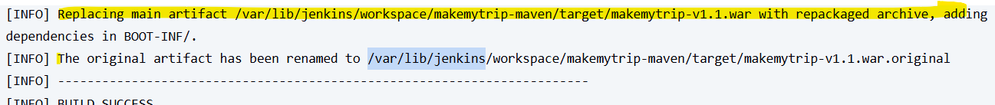

All jenkins job (workspace) are stored in /var/lib/jenkins/workspace folder

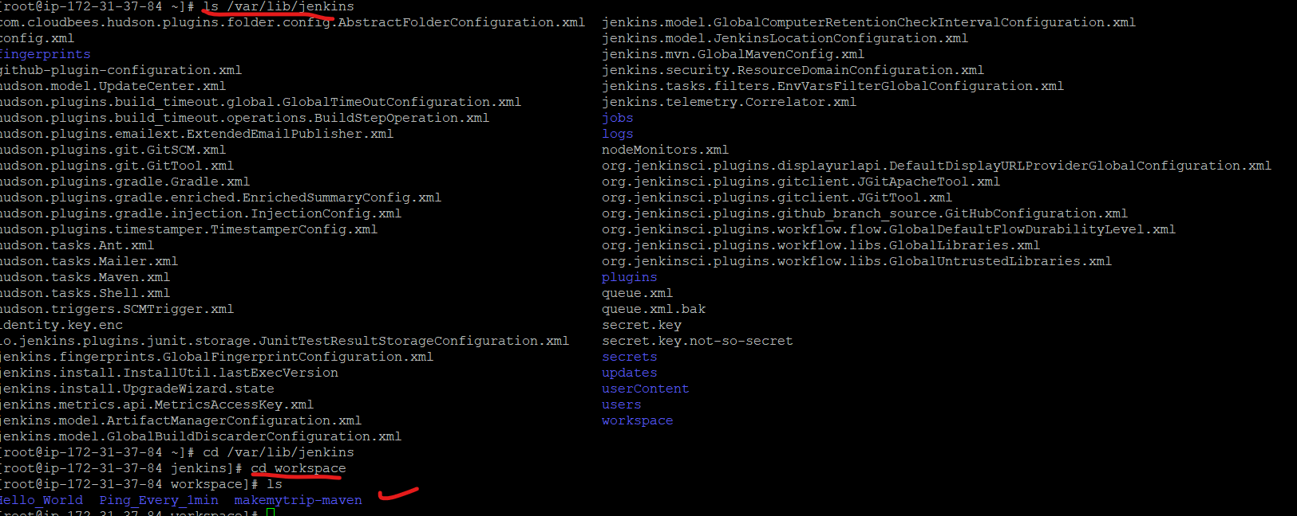

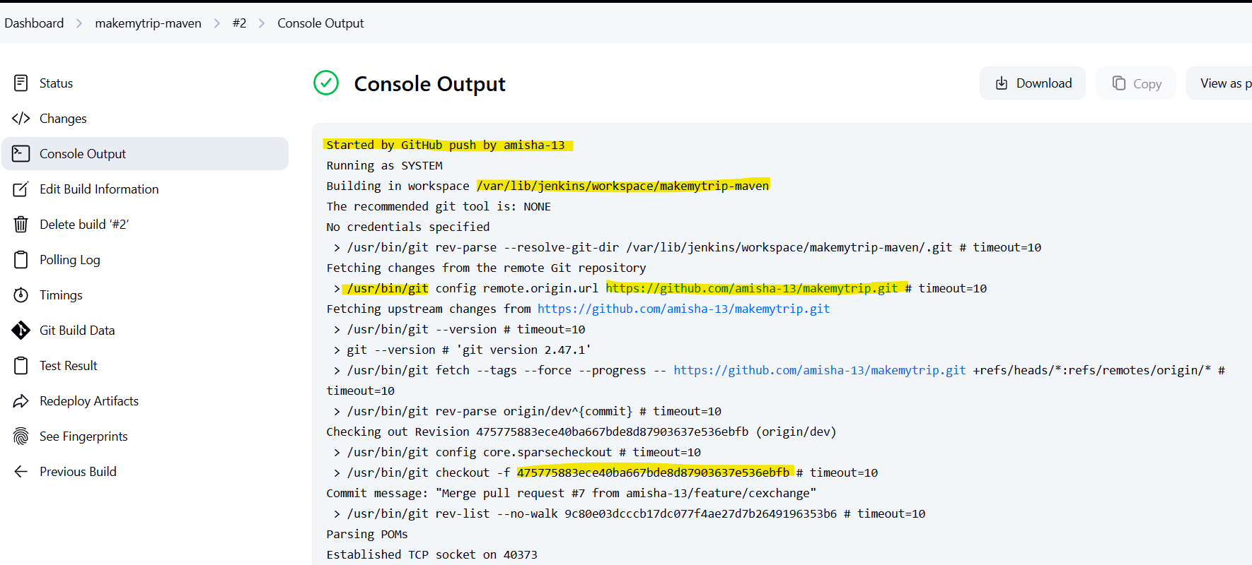

Commit id:

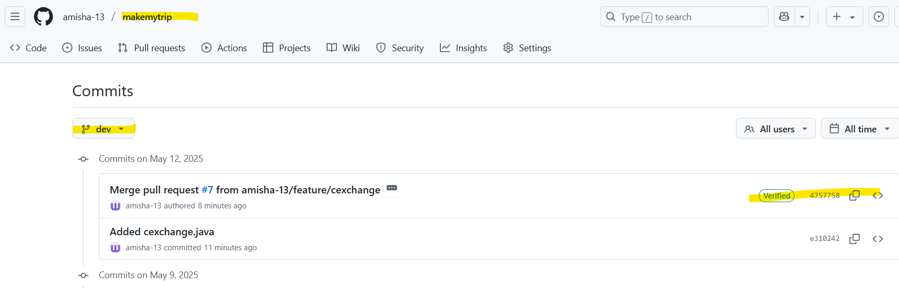

475775883ece40ba667bde8d87903637e536ebfb same as above ss

Create new pipeline

New item > Pipeline > makemytrip-pipeline

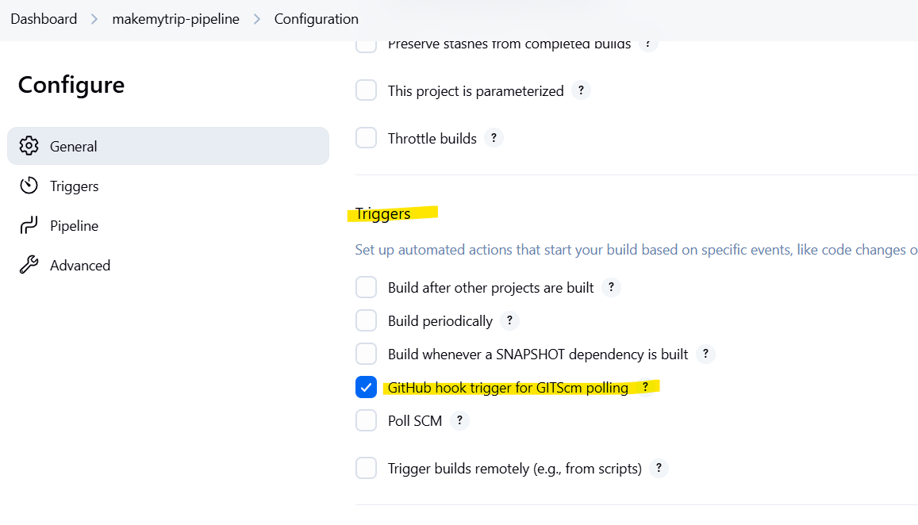

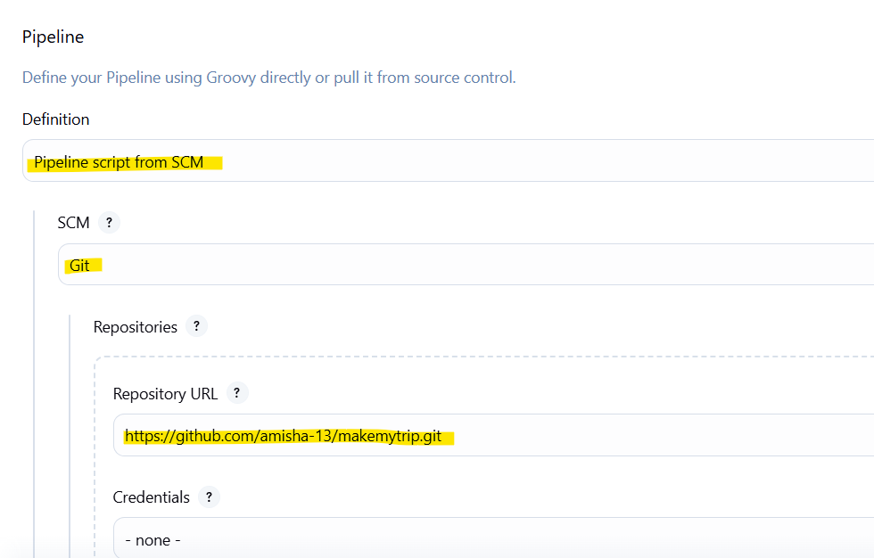

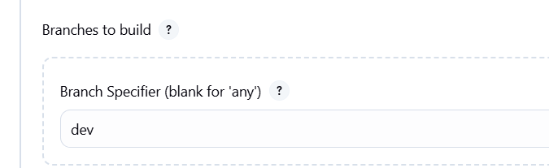

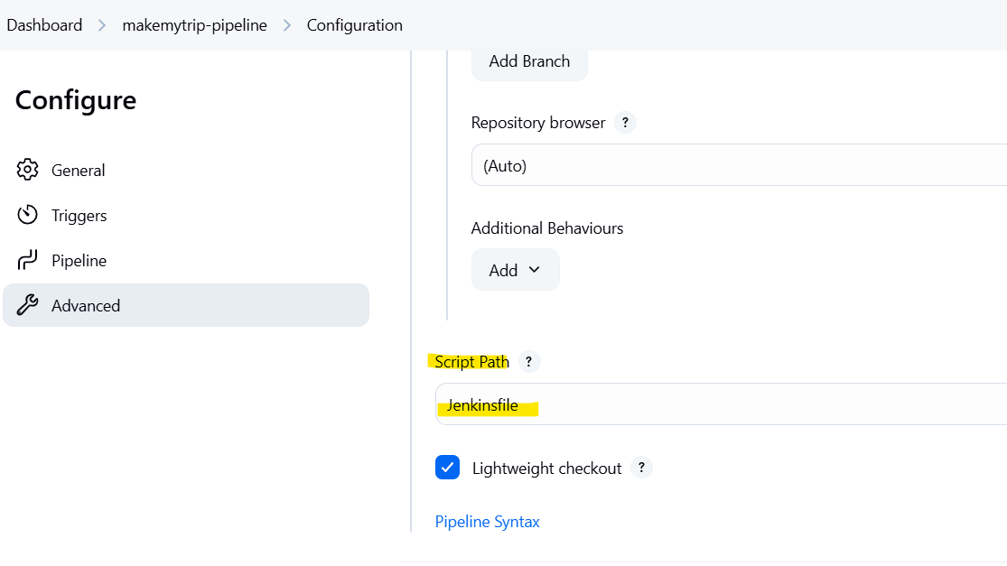

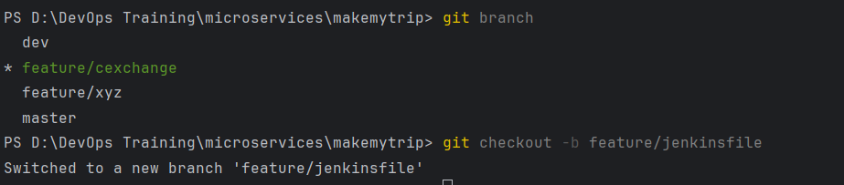

Git branch

Git pull origin dev

Git checkout -b feature/jenkinsfile

Create a file name: Jenkinsfile

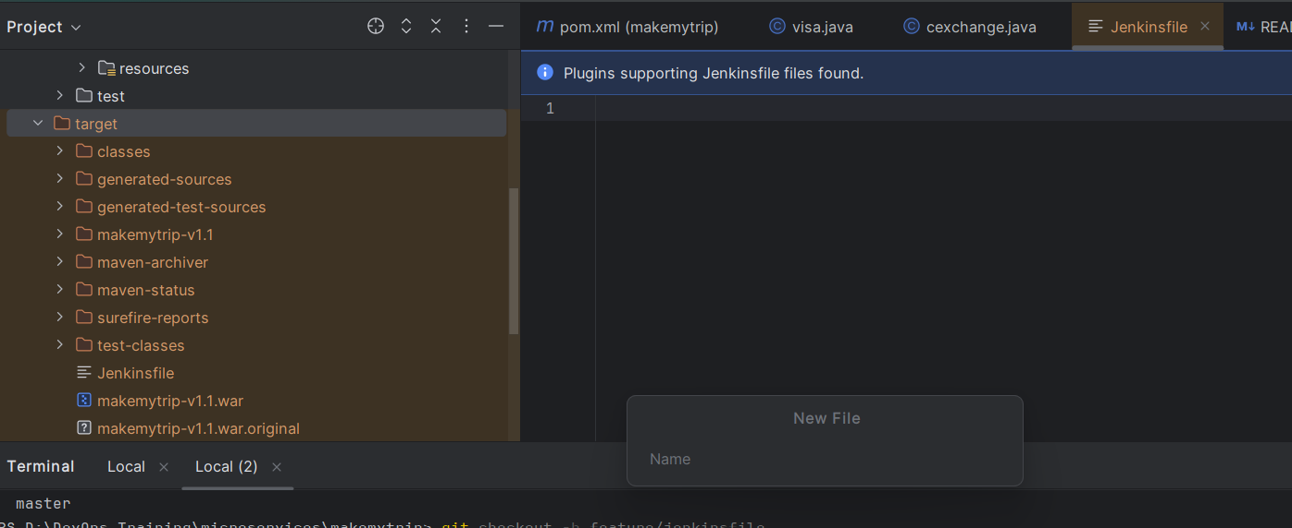

pipeline {

agent any

options {

buildDiscarder(logRotator(*numToKeepStr*: '3', *artifactNumToKeepStr*: '3'))

}

tools {

maven 'mvn_3.9.9' // Make sure this Maven tool is defined in Jenkins global tools

}

stages {

stage('Code Compilation') {

steps {

echo 'Starting Code Compilation...'

sh 'mvn clean compile'

echo 'Code Compilation Completed Successfully!'

}

}

stage('Code QA Execution') {

steps {

echo 'Running JUnit Test Cases...'

sh 'mvn clean test'

echo 'JUnit Test Cases Completed Successfully!'

}

}

stage('Code Package') {

steps {

echo 'Creating WAR Artifact...'

sh 'mvn clean package'

echo 'WAR Artifact Created Successfully!'

}

}

}

post {

success {

echo '✅ Build completed successfully.'

}

failure {

echo '❌ Build failed.'

}

}

}

> git add --all

> git commit -m "JenkinsFile"

> git push feature/jenkinsfile

Create merge request feature to dev and merge

After merge build was not started because two jobs are using same webhook trigger. So disable the trigger for previous job.

plugin to install

=================

stage

maven

aws

terraform

docker

kubernetes

sonarqube

nexus

ecr

ansible

Jenkins file code

<https://github.com/satyam88/greentea/blob/master/may-10>

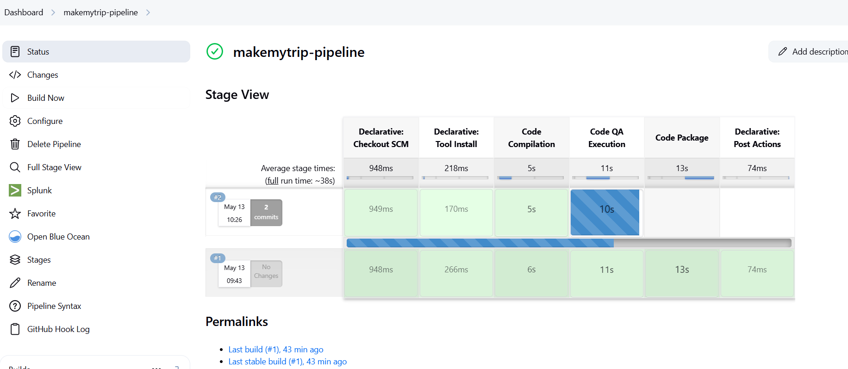

If trigger is still not working ensure webhook url is correct in github

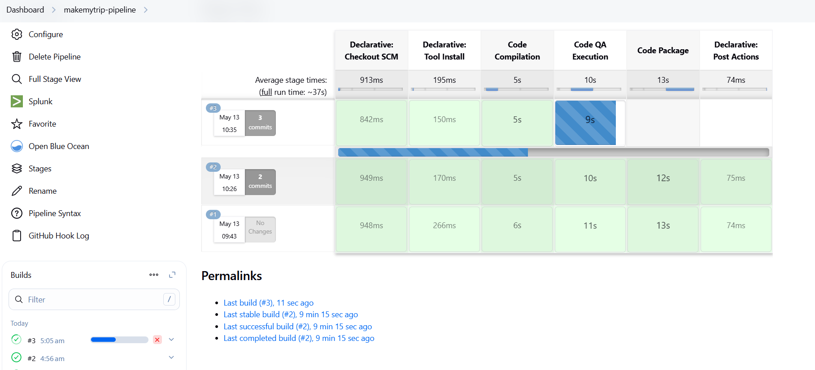

Day 09 - 11th May

Parameterized jenkins job

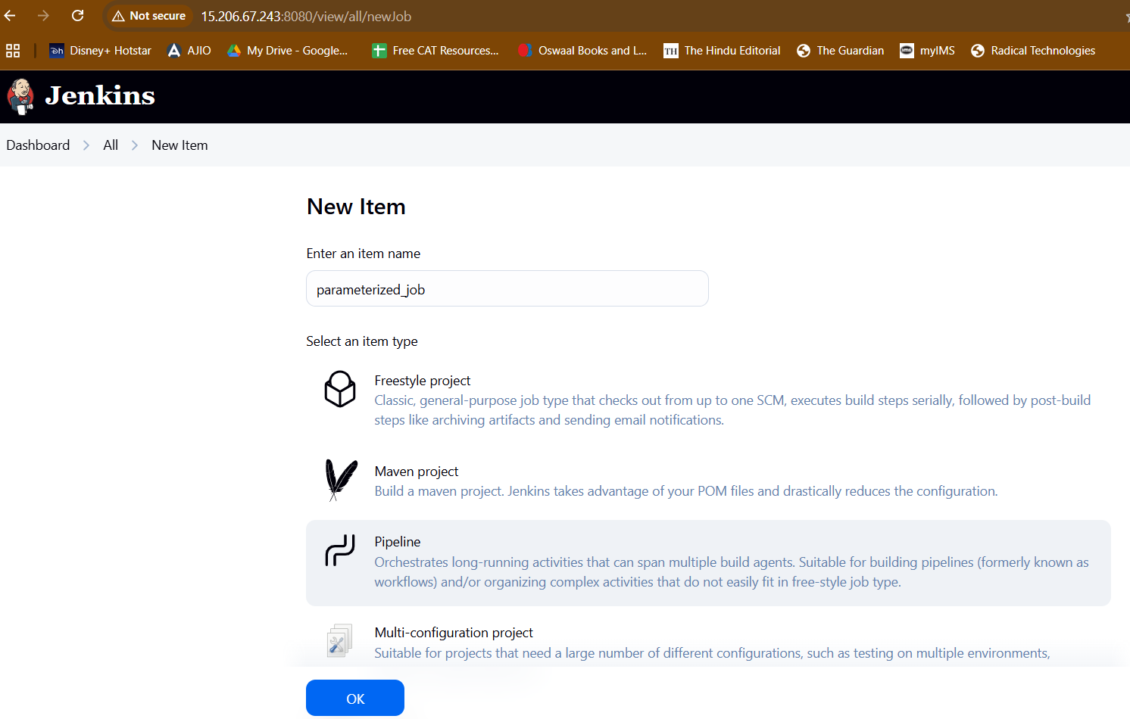

Create a new repo on github and add jenkinsfile

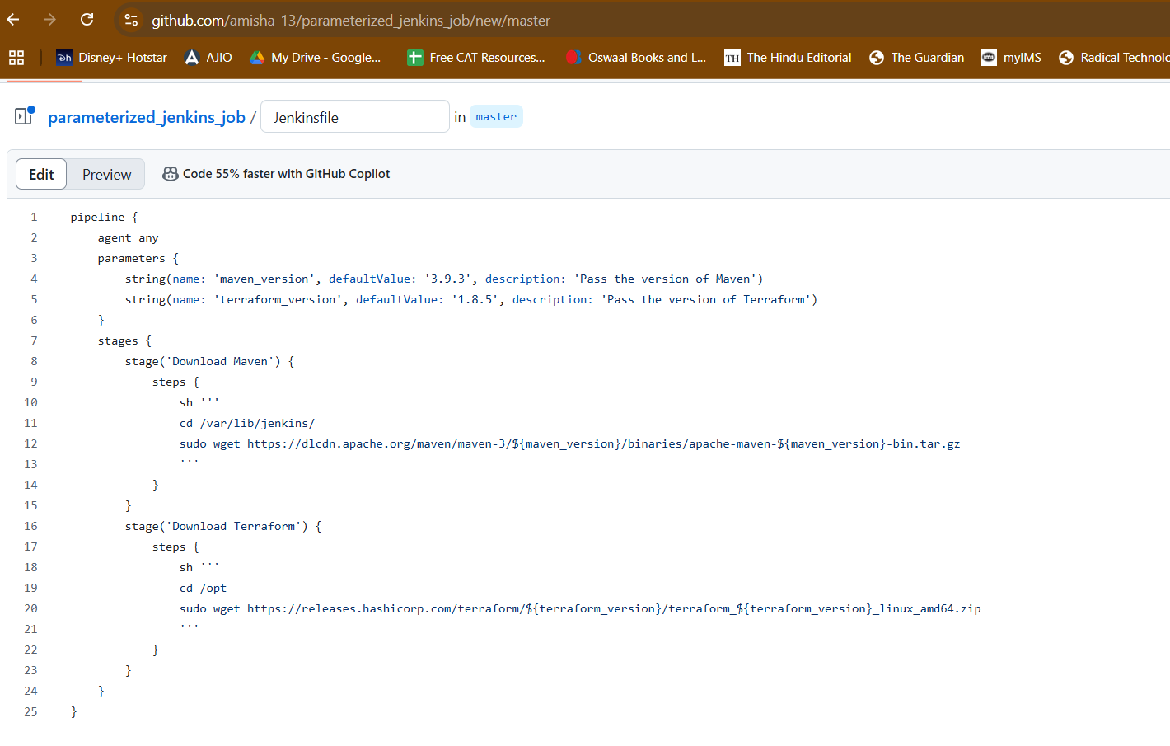

<https://github.com/amisha-13/parameterized_jenkins_job/tree/master>

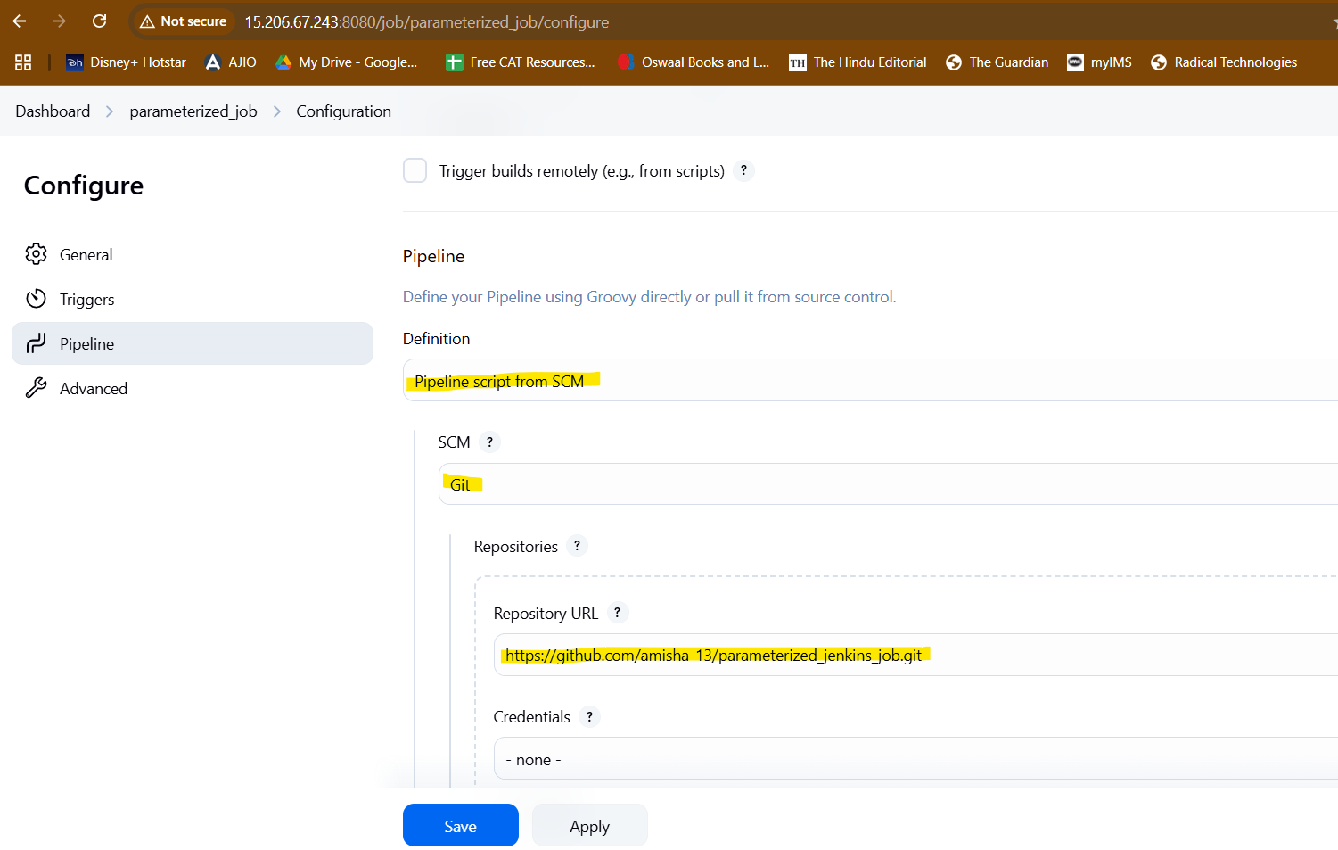

First time build manually. It will error out because no parameters were asked. And first time you don’t see any parameters.

Nxt time you get - build with parameters option

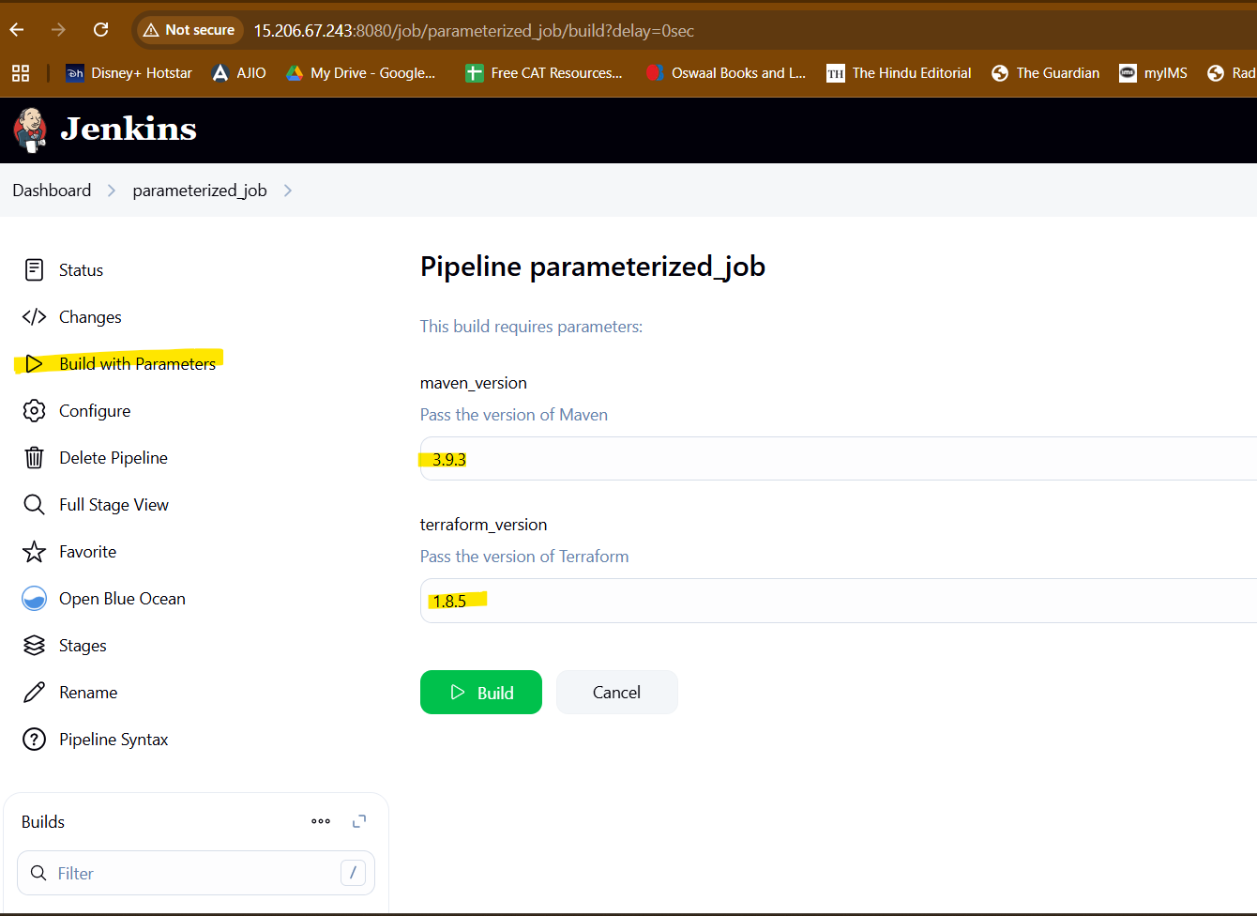

These are default parameters defined in code. To override them replace them with another value

This pipeline will download specified maven and terraform

pipeline {

agent any

parameters {

string(name: 'maven_version', defaultValue: '3.9.3', description: 'Pass the version of Maven')

string(name: 'terraform_version', defaultValue: '1.8.5', description: 'Pass the version of Terraform')

}

stages {

stage('Download Maven') {

steps {

sh '''

cd /var/lib/jenkins/

sudo wget https://dlcdn.apache.org/maven/maven-3/${maven_version}/binaries/apache-maven-${maven_version}-bin.tar.gz

'''

}

}

stage('Download Terraform') {

steps {

sh '''

cd /opt

sudo wget https://releases.hashicorp.com/terraform/${terraform_version}/terraform_${terraform_version}_linux_amd64.zip

'''

}

}

}

}

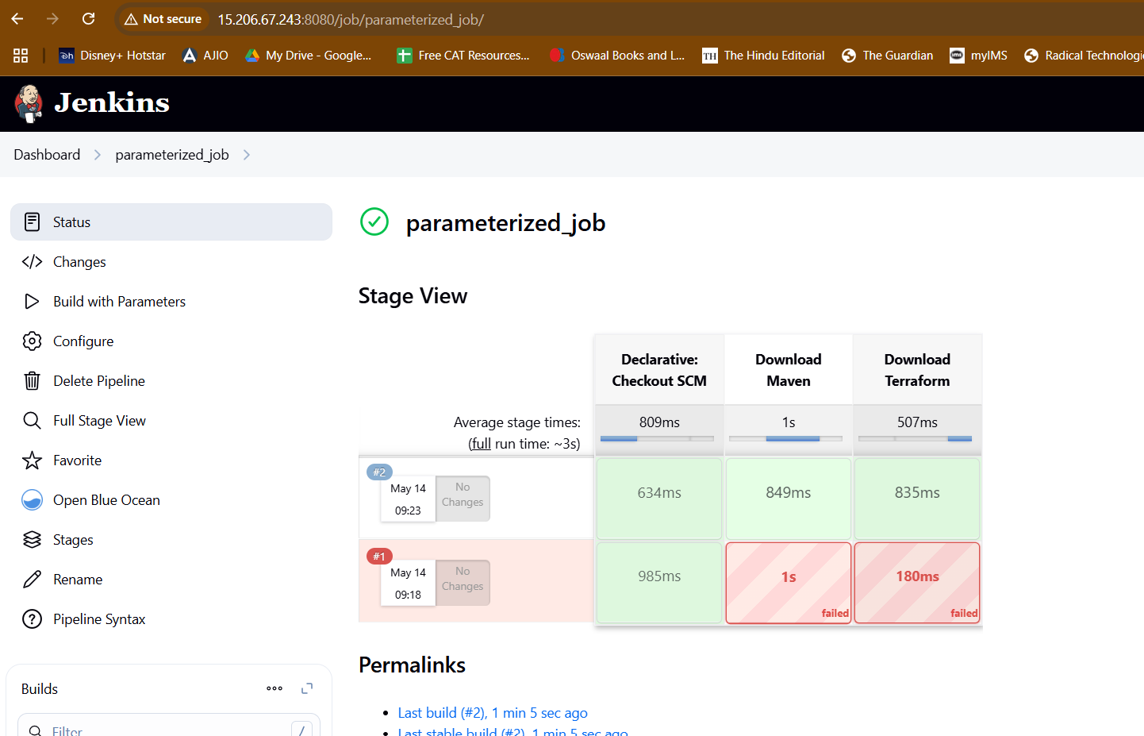

Parameterised job 2

pipeline {

agent any

parameters {

choice(

name: 'AWS_REGION',

choices: ['us-east-1', 'us-west-1', 'us-west-2', 'eu-central-1', 'eu-west-1', 'ap-south-1'],

description: 'Select the AWS region'

)

}

environment {

AWS_REGION = "${params.AWS_REGION}"

}

stages {

stage('List AWS Resources') {

steps {

script {

echo "Listing resources in the region: ${AWS_REGION}"

// Use withCredentials to securely access AWS credentials

withCredentials([usernamePassword(credentialsId: 'aws-credentials-id', usernameVariable: 'AWS_ACCESS_KEY_ID', passwordVariable: 'AWS_SECRET_ACCESS_KEY')]) {

// List all EC2 instances

echo "Fetching EC2 Instances..."

sh """

aws ec2 describe-instances --region ${AWS_REGION} --query "Reservations[*].Instances[*].{InstanceId:InstanceId, State:State.Name, InstanceType:InstanceType, PublicIpAddress:PublicIpAddress}" --output table

"""

// List all EBS volumes

echo "Fetching EBS Volumes..."

sh """

aws ec2 describe-volumes --region ${AWS_REGION} --query "Volumes[*].{VolumeId:VolumeId, Size:Size, State:State}" --output table

"""

// List all Security Groups

echo "Fetching Security Groups..."

sh """

aws ec2 describe-security-groups --region ${AWS_REGION} --query "SecurityGroups[*].{GroupName:GroupName, GroupId:GroupId, Description:Description, VpcId:VpcId}" --output table

"""

// List all Elastic IPs

echo "Fetching Elastic IPs..."

sh """

aws ec2 describe-addresses --region ${AWS_REGION} --query "Addresses[*].{PublicIp:PublicIp, InstanceId:InstanceId}" --output table

"""

}

}

}

}

}

}

<https://github.com/amisha-13/para_job_2/blob/main/Jenkinsfile>

Failed with credentials error

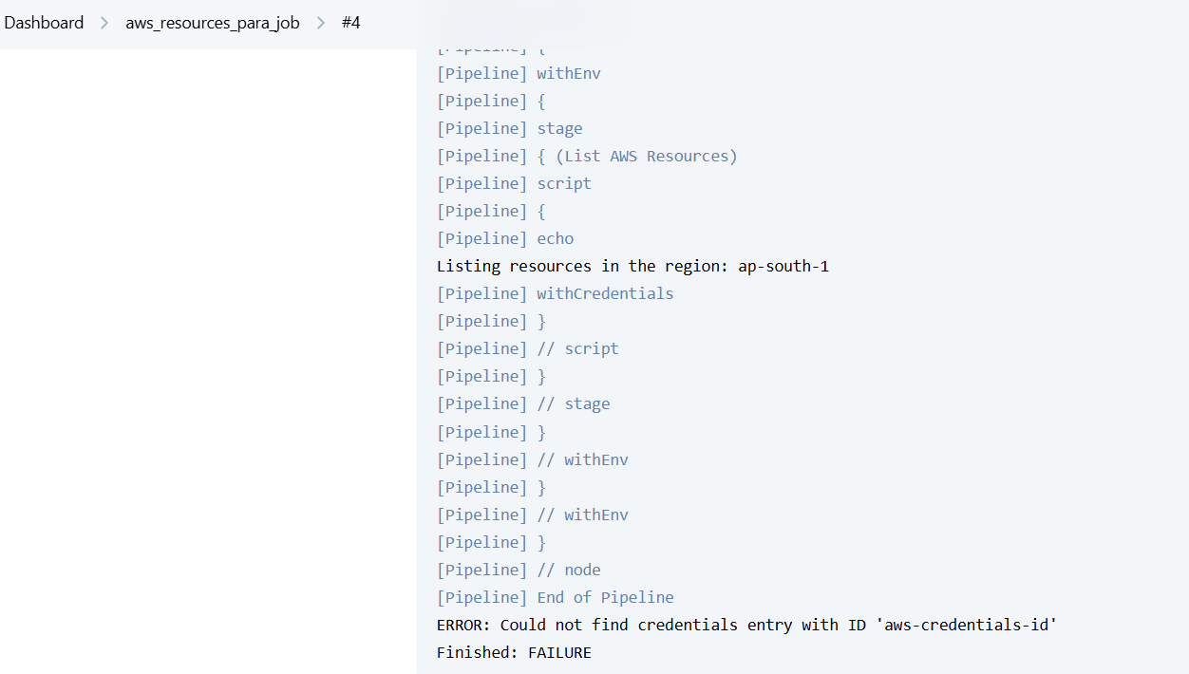

Create credentials in AWS under IAM

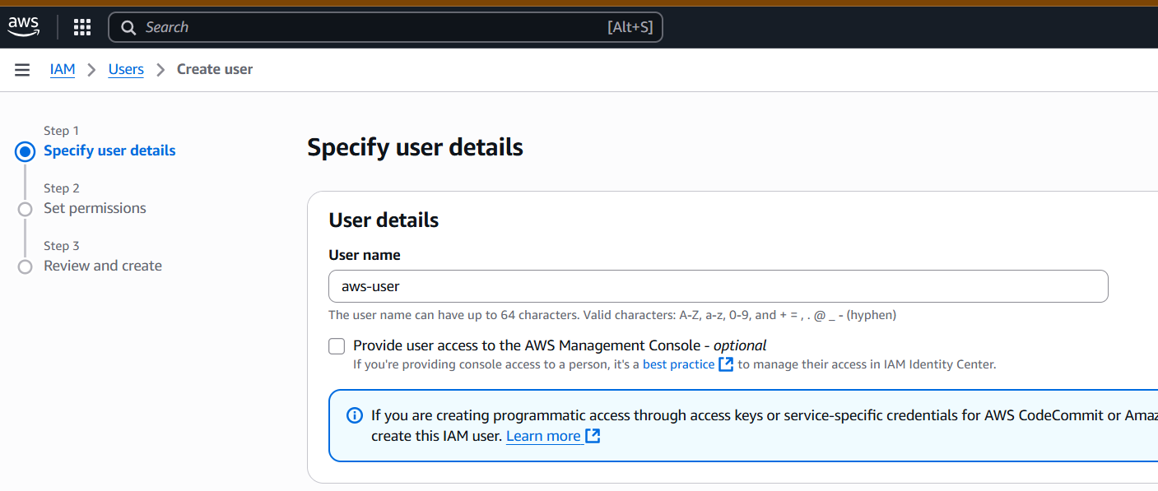

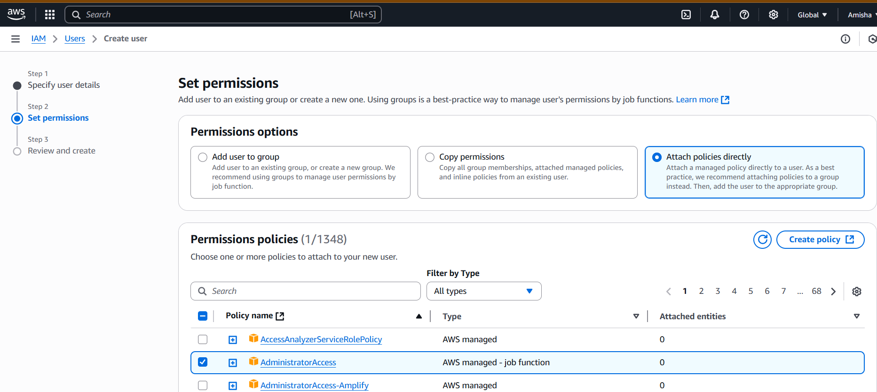

Attach policies > administrator access

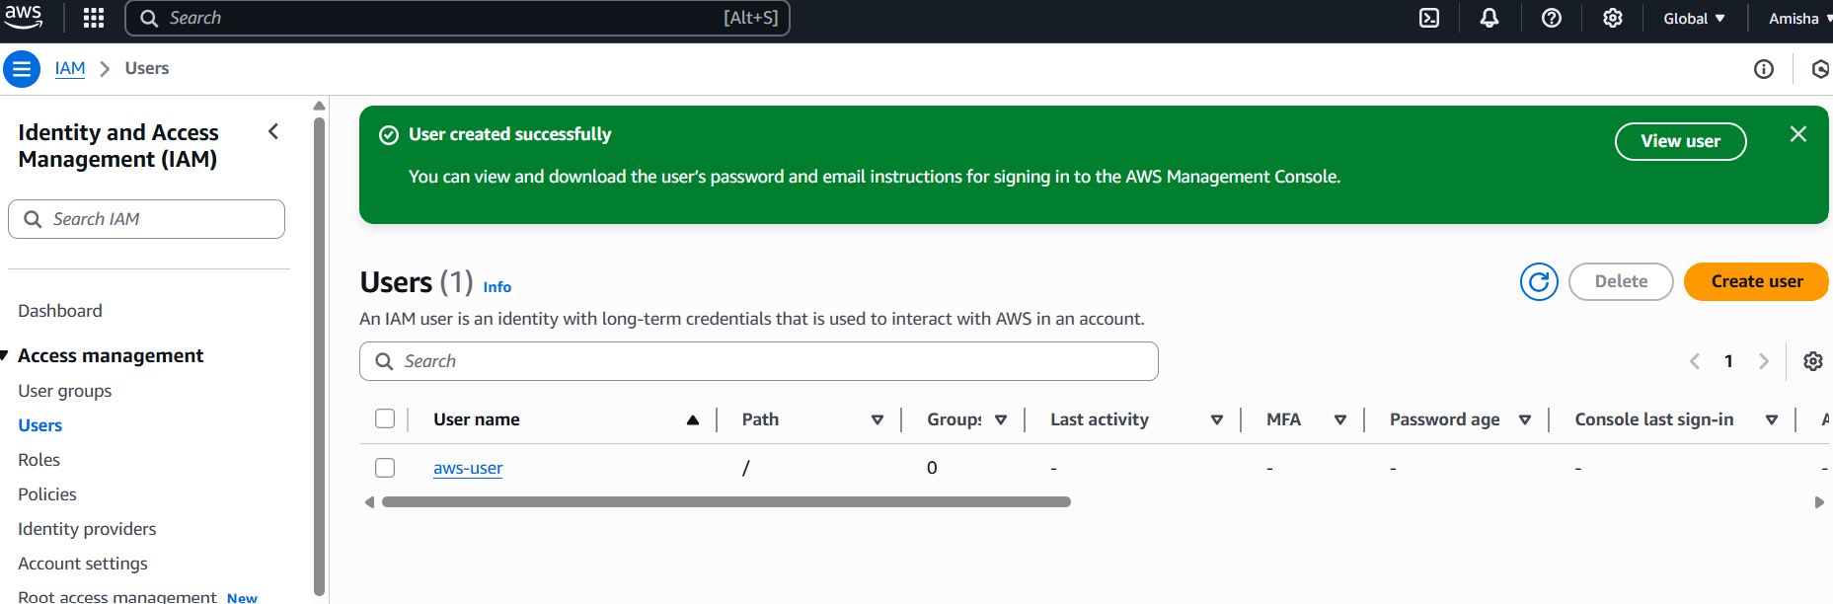

To extract access key and secret access key

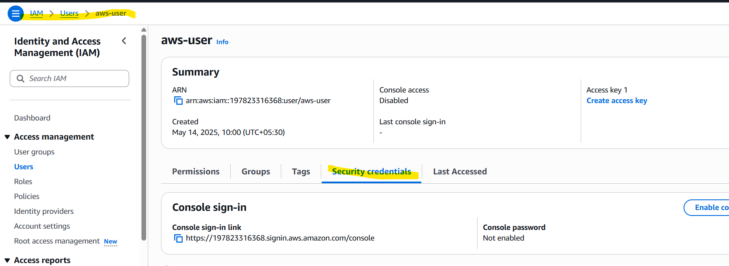

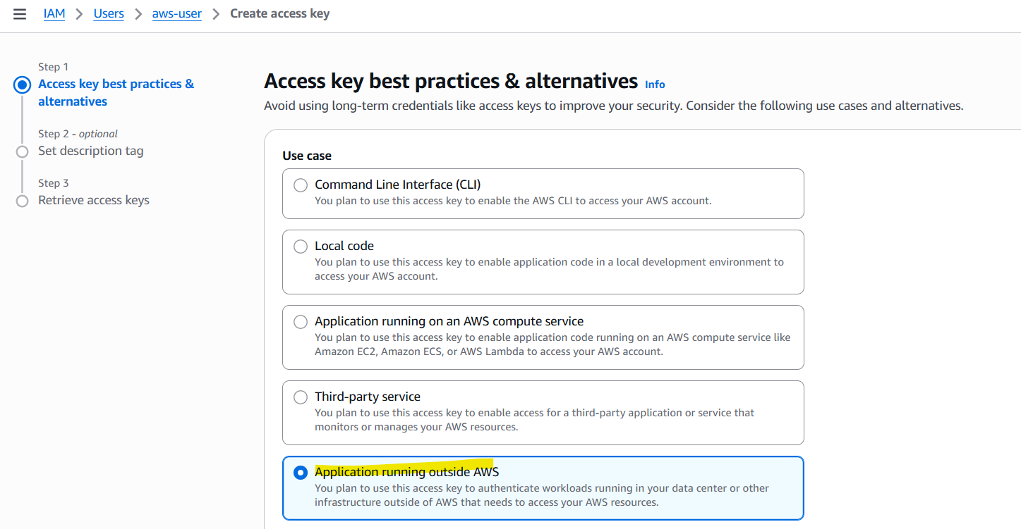

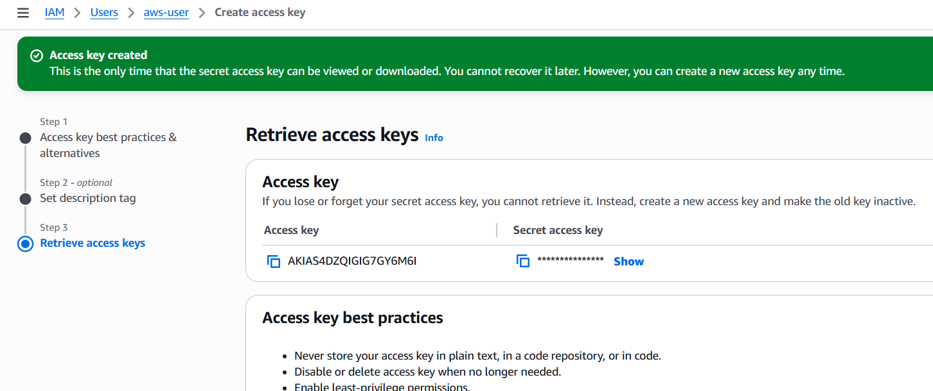

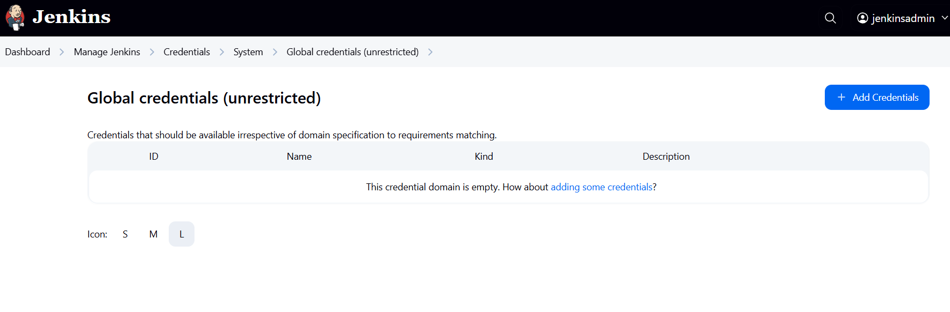

ID is the ID being used in pipeline

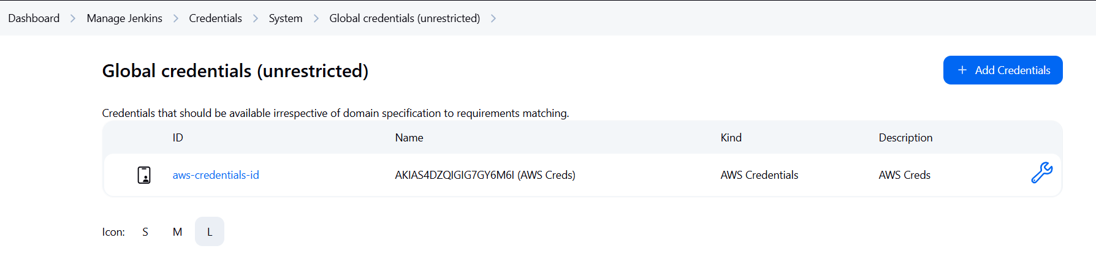

Job failed again:

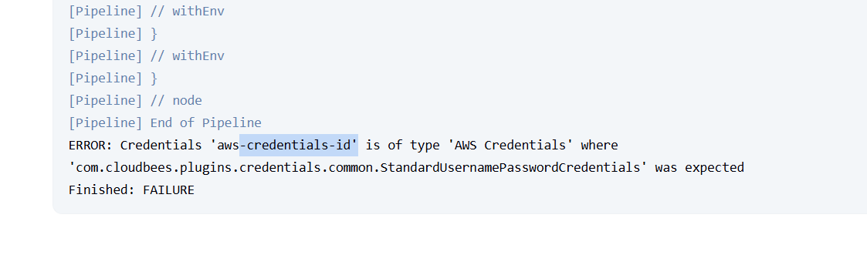

So credentials have to be of type Username and Password

Username: Access key

Password: Secret Access Key

Delete the old creds

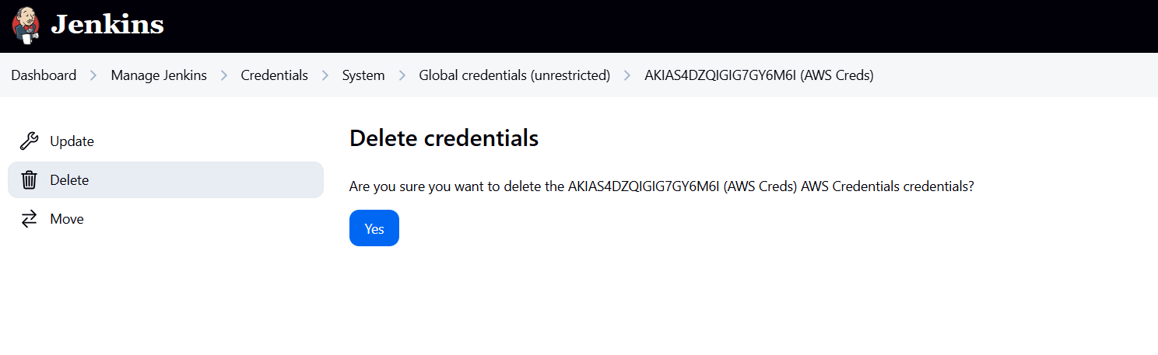

The build was now successful

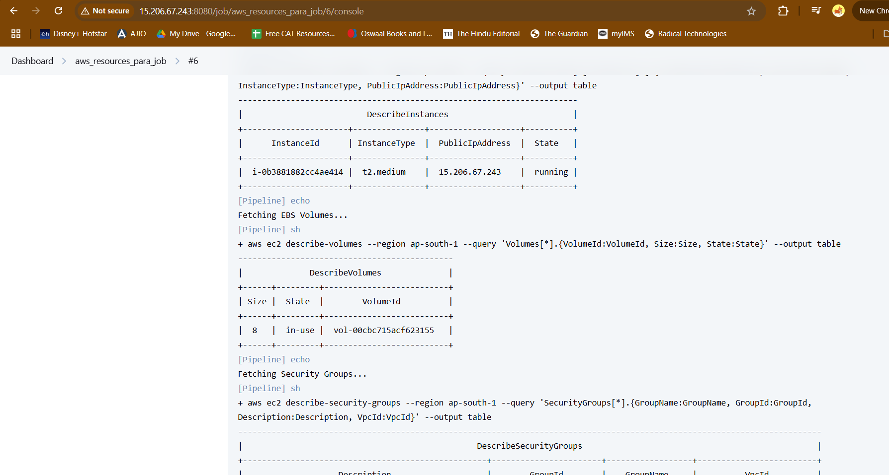

1. Trigger a job periodically

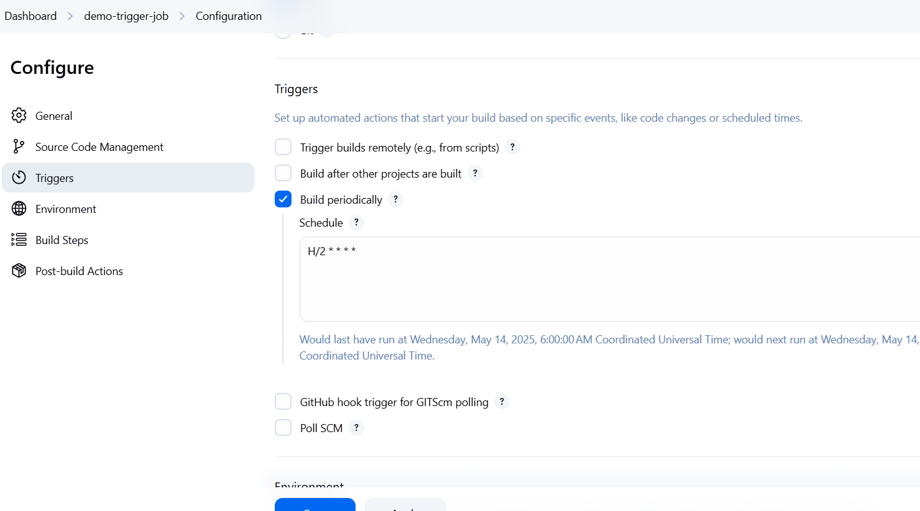

Cron expression: H/2 * * * *

1. Poll SCM

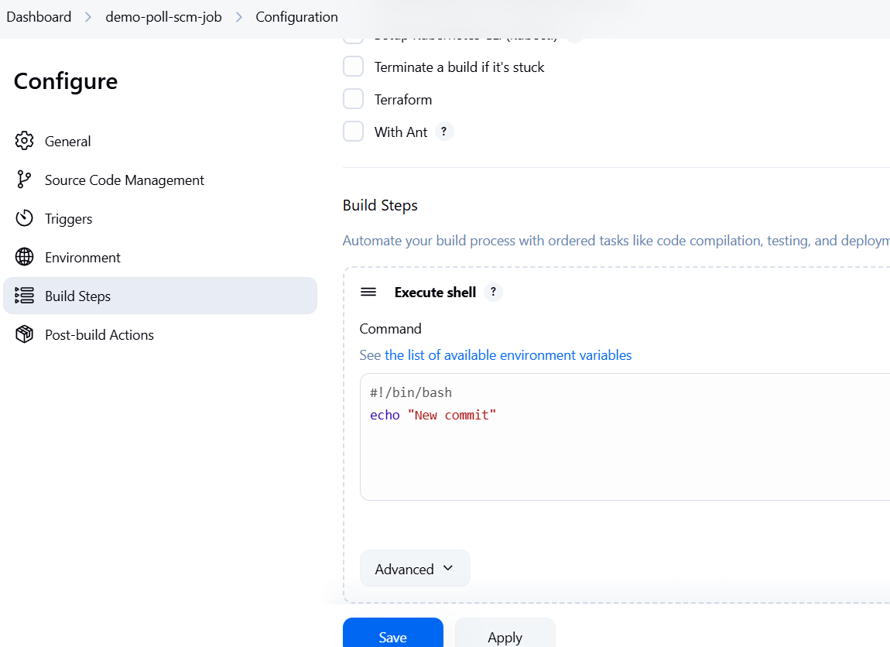

Add a build step

This demo Poll SCM will check the git repo every 1 min for any new commits. If yes it will run the build step or else no

Make a change in the repo add a file and commit, the job will be triggered

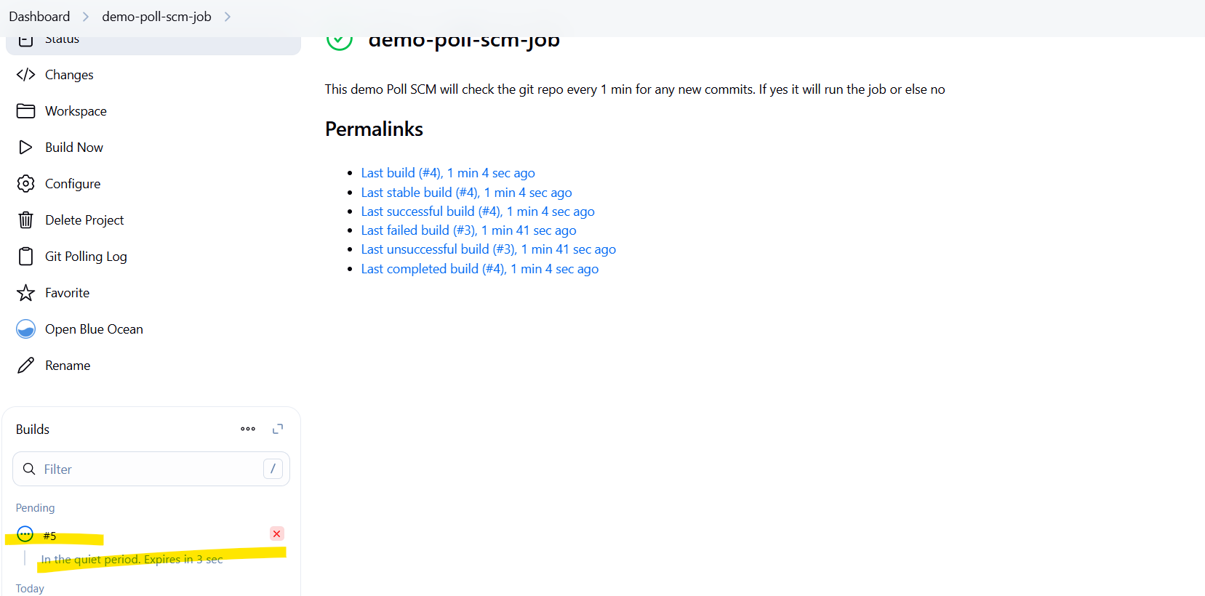

Check for the same commit id in console output

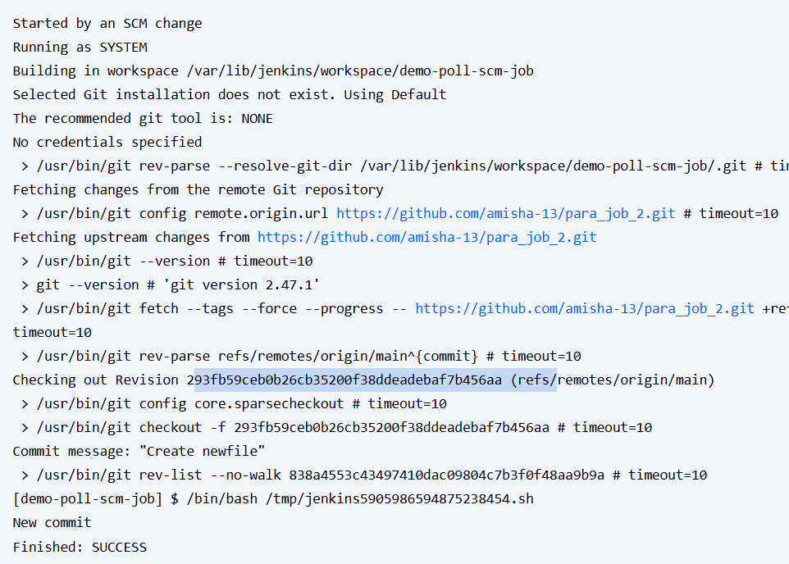

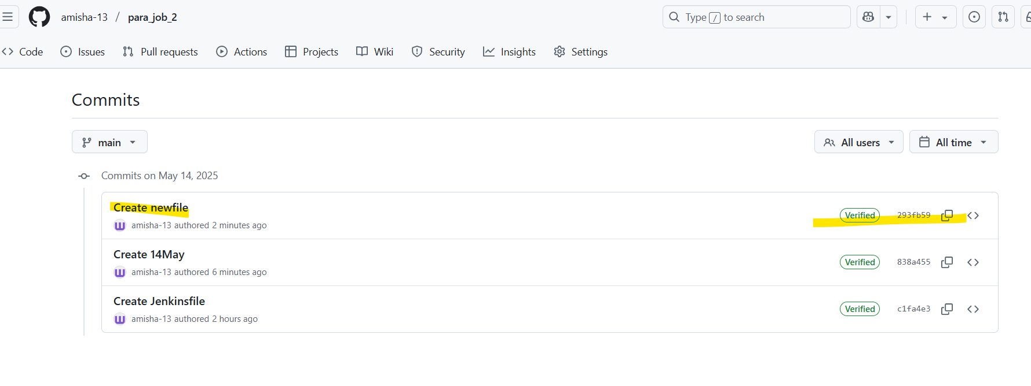

293fb59ceb0b26cb35200f38ddeadebaf7b456aa

1. Gihub webhook trigger

git branch

git pull origin dev

Git checkout -b feature/hello

Make changes in holidays.java

Git add –all; git commit -m “HELLO”

Git push origin feature/hello

Create pull request from feature to dev

Merge

Webhook will trigger the jenkins job

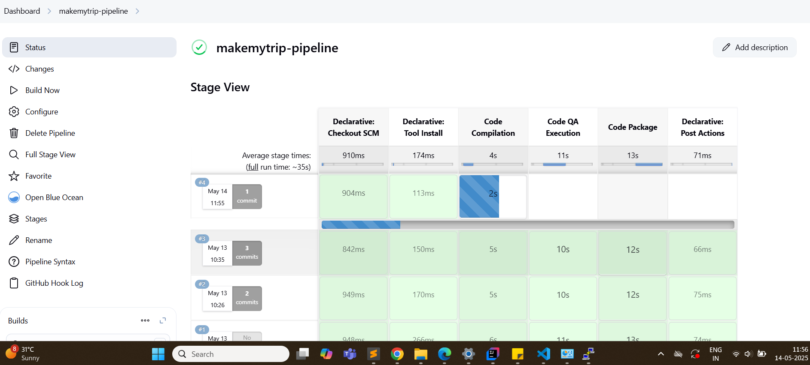

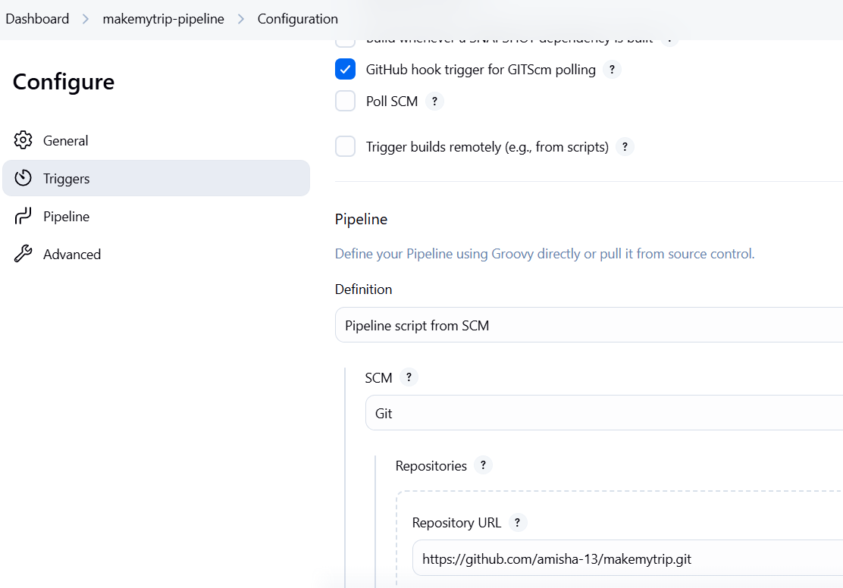

Change visibikity of a repo - to private

Now the same job will error out

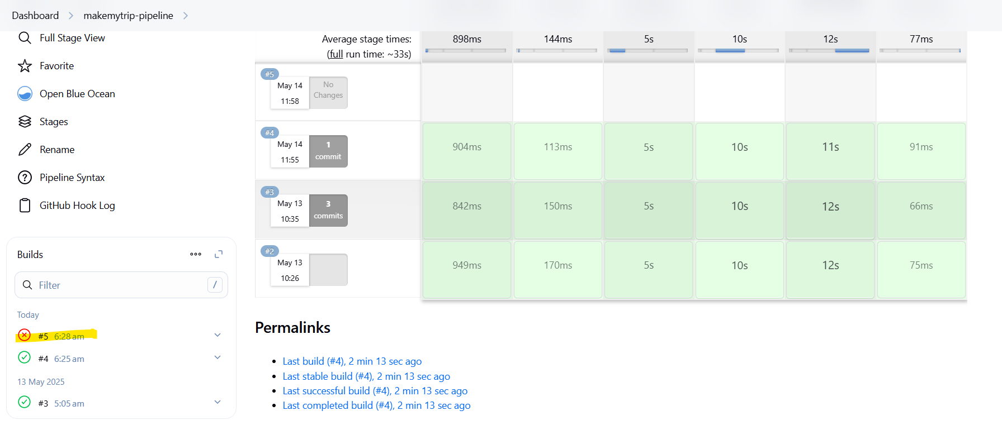

Due to authentication failure

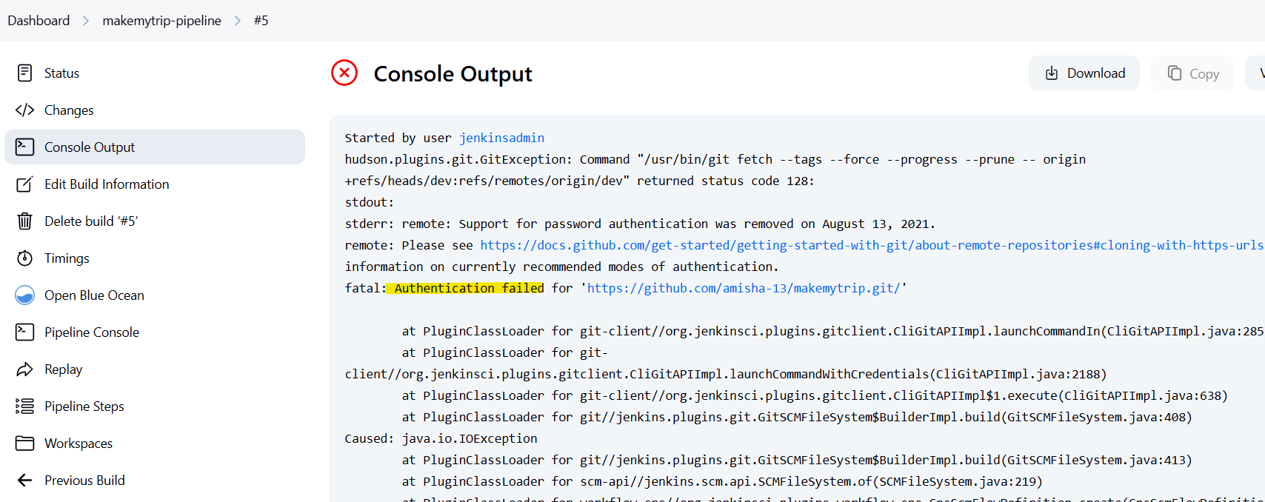

Create new cred for github - again username and password

Profile > settings > developer settings

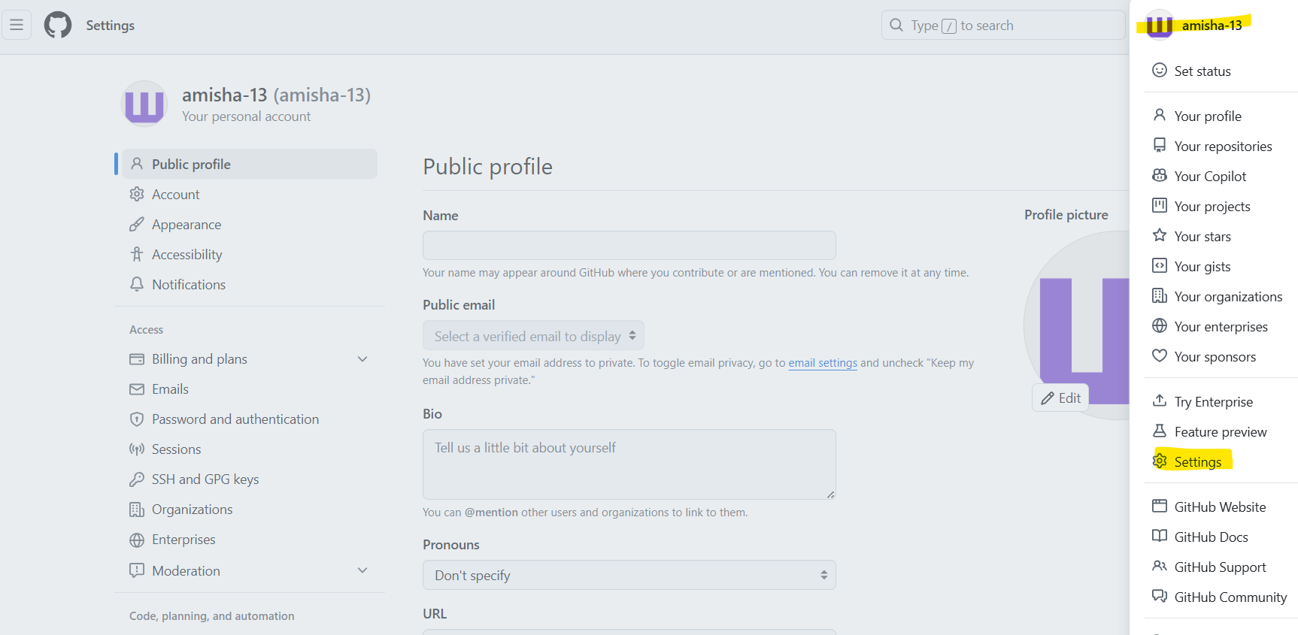

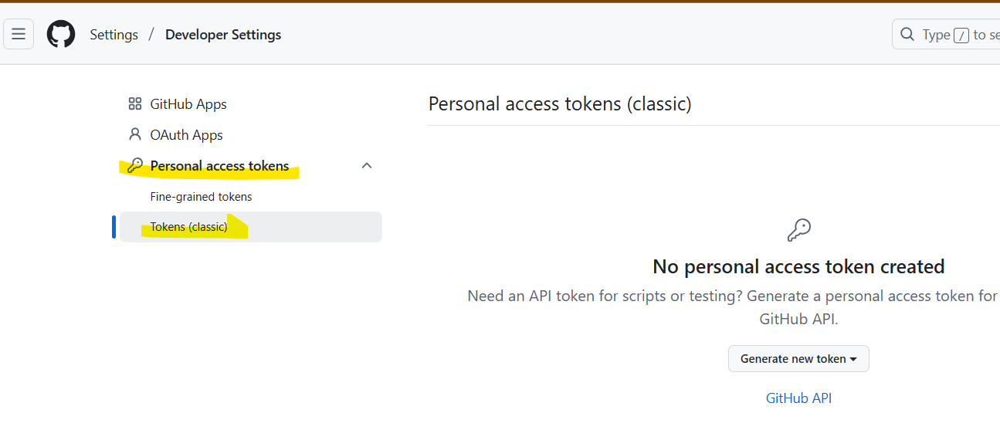

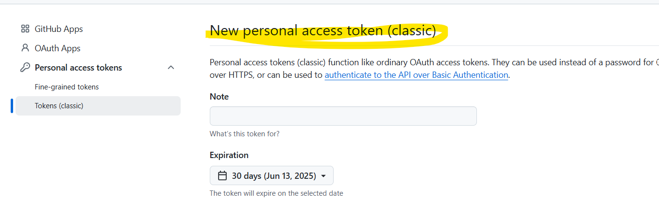

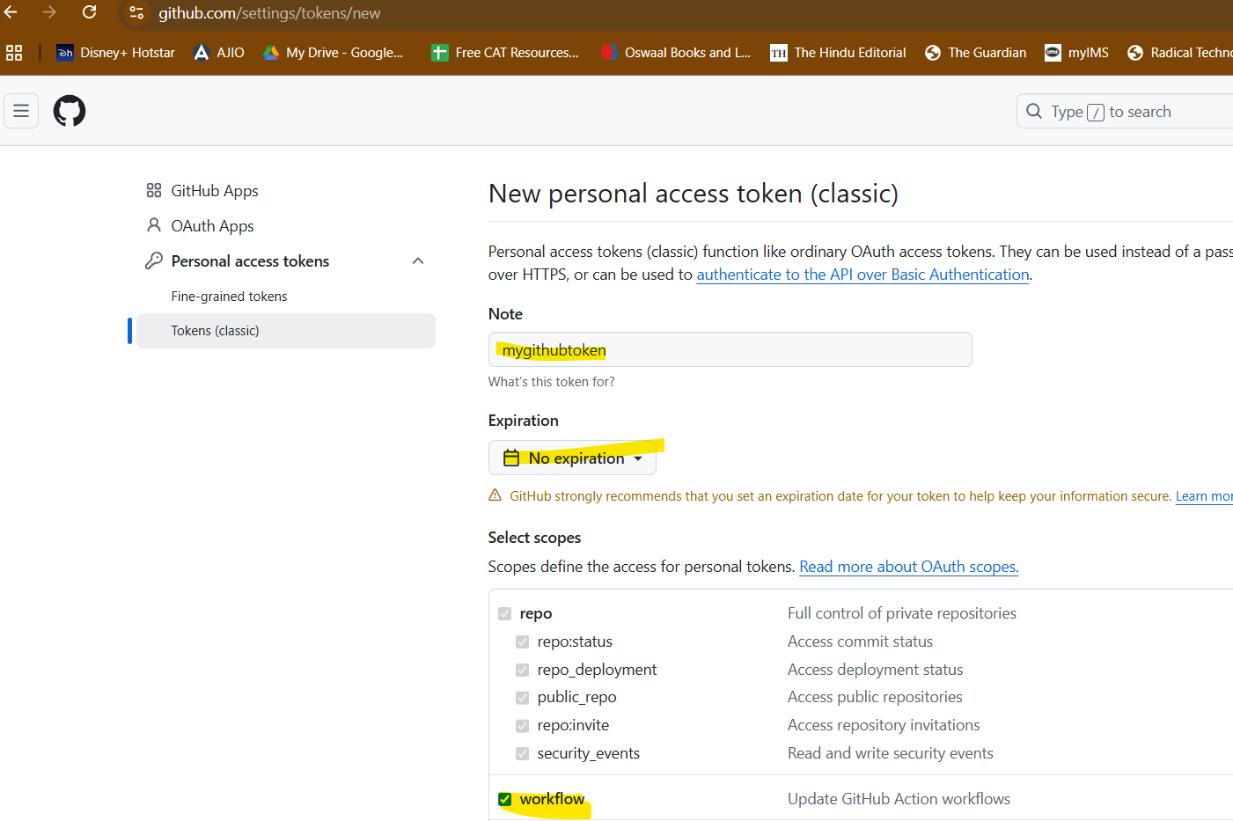

Add all workflows > generate

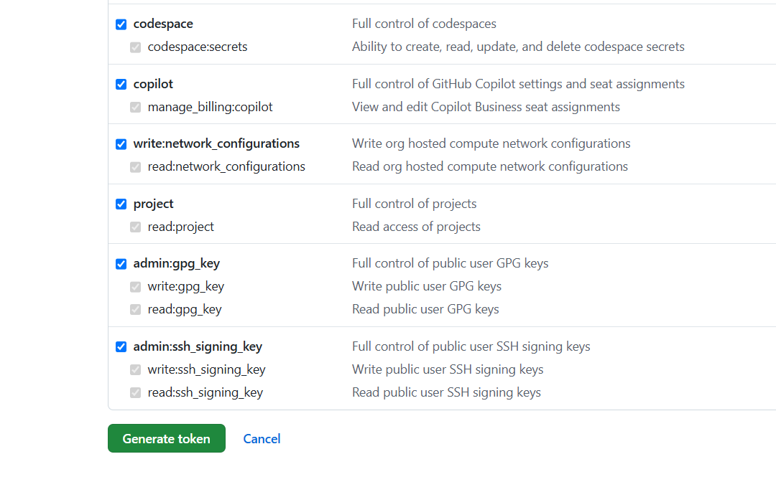

Create new global creds in jenkins

Type; username and password

Username and ID will be github username

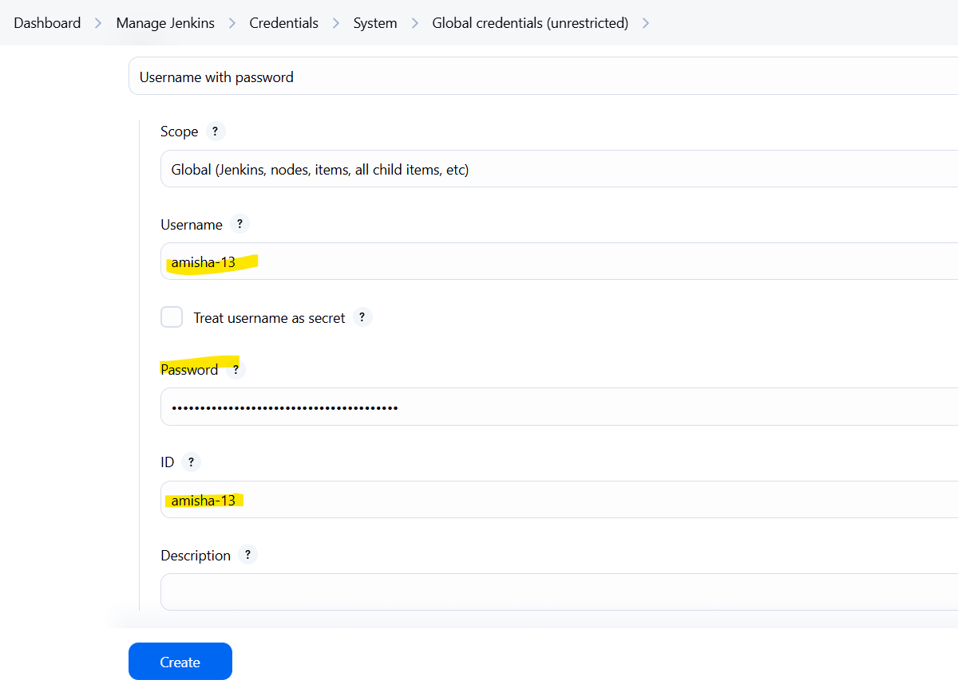

Password will be the github token

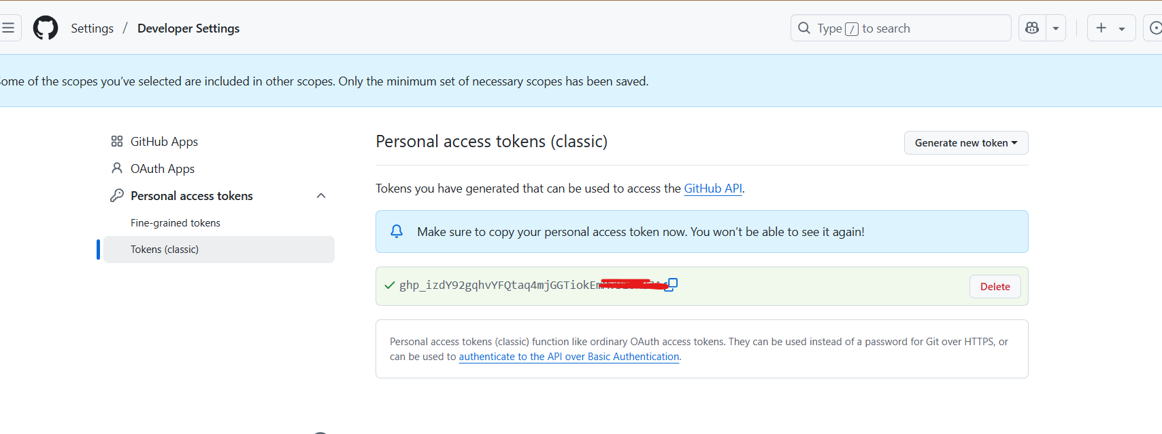

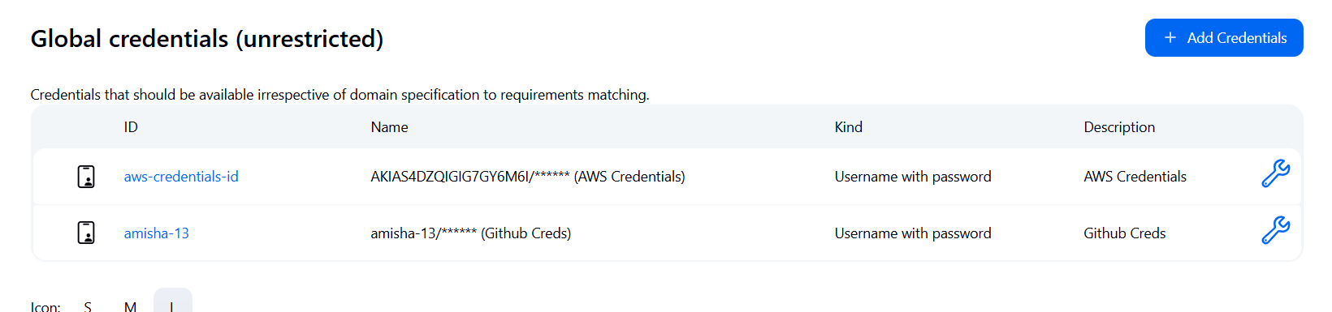

Now modify this in the previous pipeline job

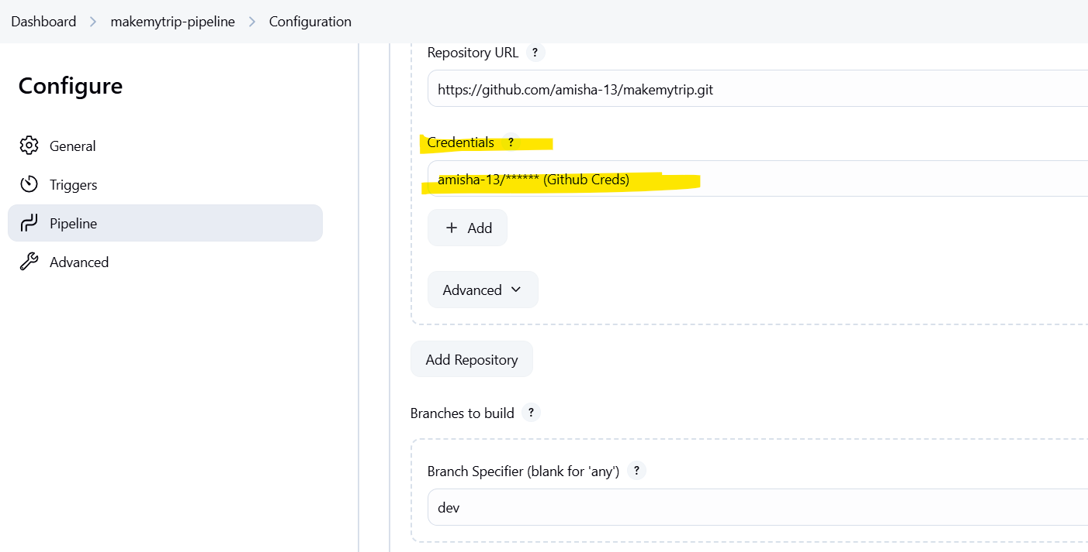

Build now > should run successfully

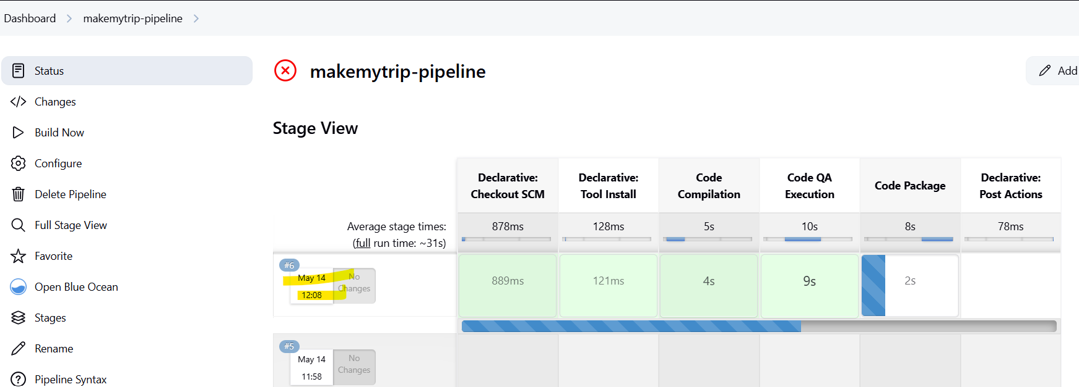

Jenkins CLI

Sudo - su

Service jenkins status

Service jenkins stop

If jenkins in down - check logs before starting it

Home Directory for Jenkins

/var/lib/jenkins

Default log file location

/var/lib/jenkins/jenkins.log



Looks like logs are not set up

service jenkins restart

service jenkins status

The service command supports only basic LSB actions (start, stop, restart, try-restart, reload, reload-or-restart, try-reload-or-restart, force-reload, status, condrestart). For other actions, please try to use systemctl.

Enable Logs in jenkins

======================

mkdir -p /etc/systemd/system/jenkins.service.d

sudo vim /etc/systemd/system/jenkins.service.d/override.conf

[Service]

StandardOutput=append:/var/log/jenkins/jenkins.log

StandardError=append:/var/log/jenkins/jenkins.log

save and exit -> :wq!

sudo systemctl daemon-reexec

sudo systemctl daemon-reload

sudo systemctl restart jenkins

tail -f /var/log/jenkins/jenkins.log

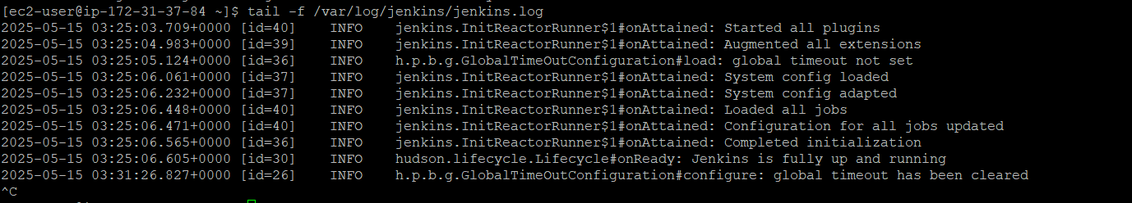

Install Jenkins Plugins using CLI

Search for the required plugin on Jenkins Plugins Index: <https://plugins.jenkins.io/>

Right now we are installing - gcp secrets manager credentials provider

Find latest version on github

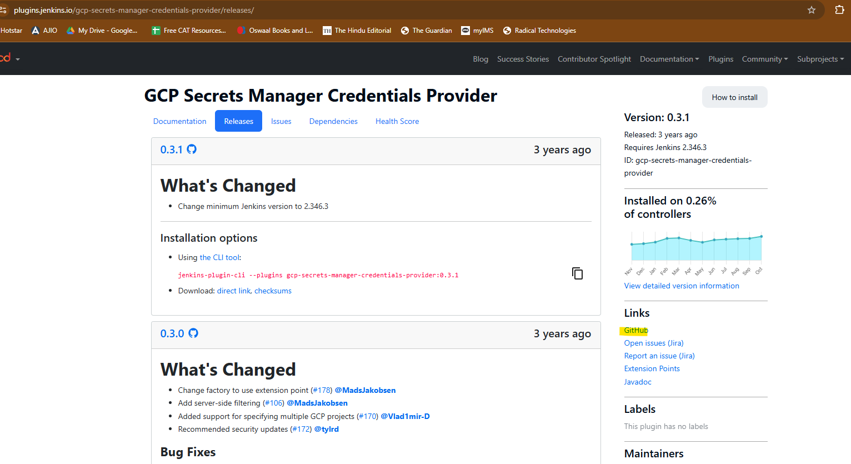

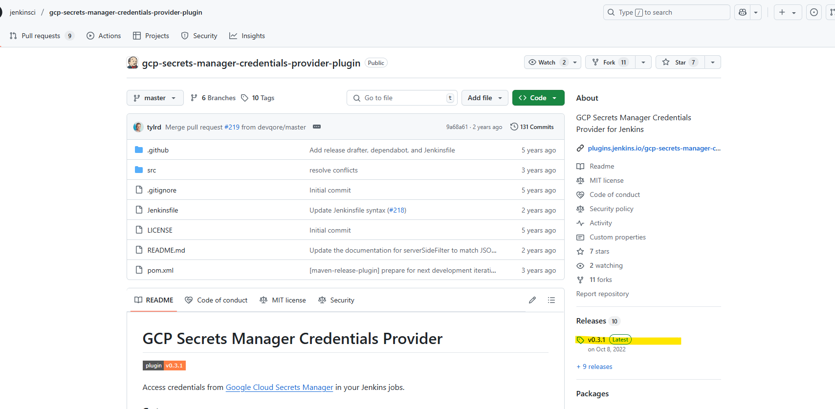

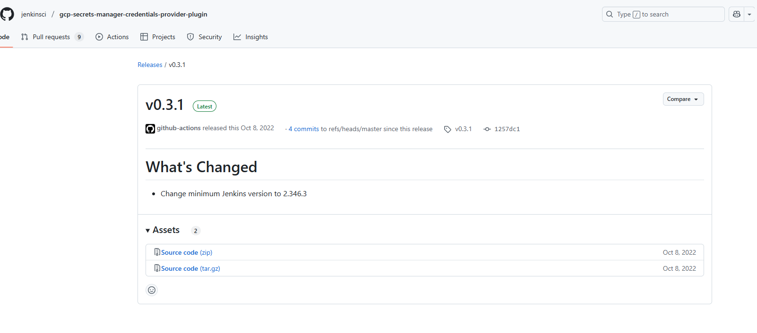

Source code is in zipped format

If you use this you need to extract it also

Search for

gcp credential plugin .hpi file

And find the download url

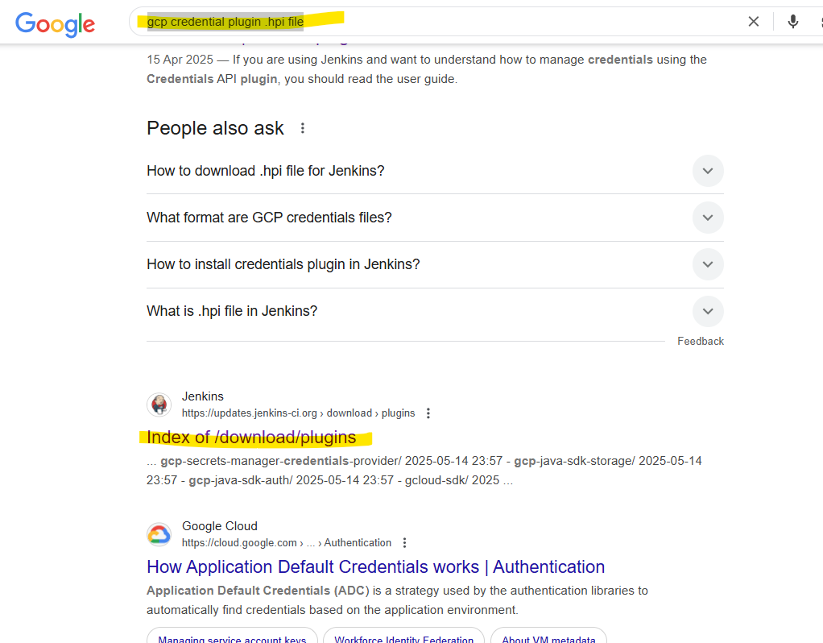

Look for the required plugin

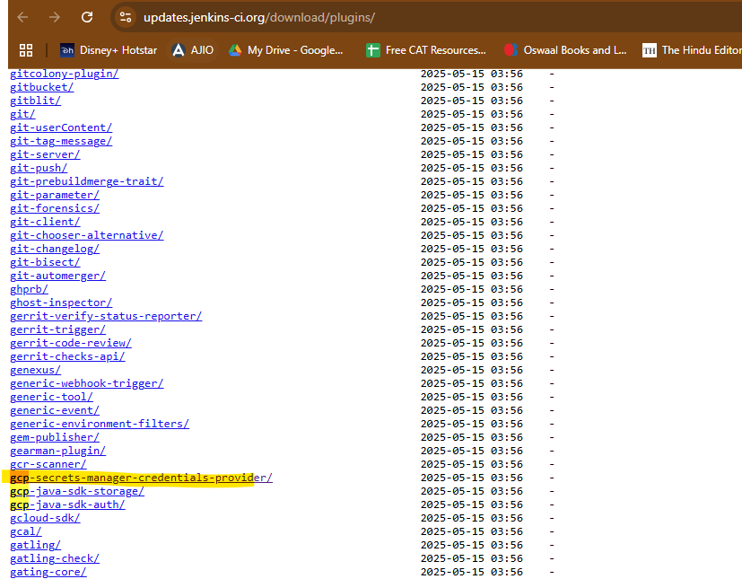

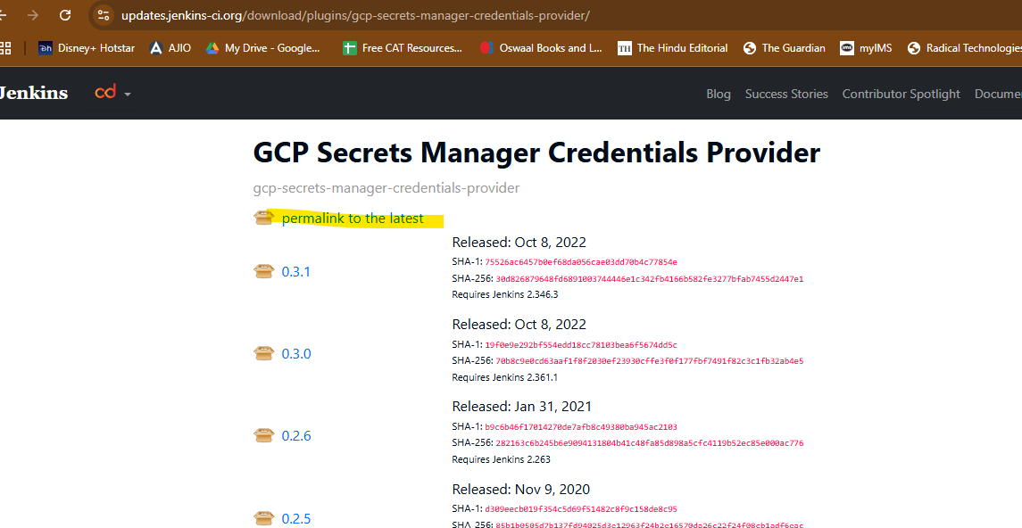

This will download the latest hpi file for the plugin

Instead of downloading, copy the link

<https://updates.jenkins-ci.org/latest/gcp-secrets-manager-credentials-provider.hpi>

========how to find plugin binary===============================

https://plugins.jenkins.io/gcp-secrets-manager-credentials-provider/

https://github.com/jenkinsci/gcp-secrets-manager-credentials-provider-plugin/releases/tag/v0.3.1

wget https://github.com/jenkinsci/gcp-secrets-manager-credentials-provider-plugin/archive/refs/tags/v0.3.1.zip

===========install plugin in jenkins using CLI========================

Login as a sudo user

>Sudo su -

>wget https://updates.jenkins.io/download/plugins/gcp-secrets-manager-credentials-provider/0.3.1/gcp-secrets-manager-credentials-provider.hpi

sudo mv gcp-secrets-manager-credentials-provider.hpi /var/lib/jenkins/plugins/

sudo chown jenkins:jenkins /var/lib/jenkins/plugins/gcp-secrets-manager-credentials-provider.hpi

sudo chmod 644 /var/lib/jenkins/plugins/gcp-secrets-manager-credentials-provider.hpi

sudo systemctl restart jenkins

================================

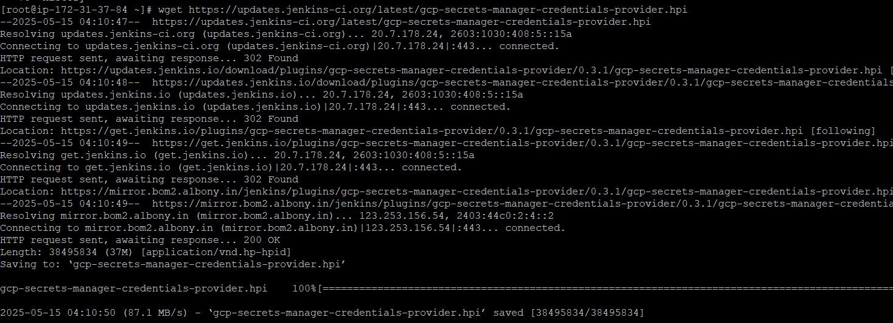





The gcp cred plugin is now installed

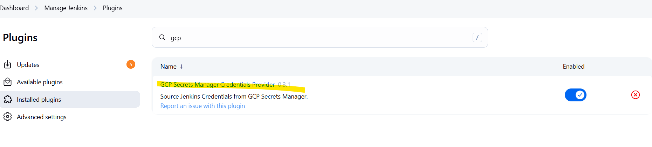

<https://medium.com/@viewlearnshare/troubleshooting-jenkins-common-issues-and-solutions-c646b32cf1f5>

Troubleshooting Jenkins: Common Issues and Solutions

<https://www.testgorilla.com/blog/jenkins-interview-questions/>

17th May

Jenkins Master Slave Architecture

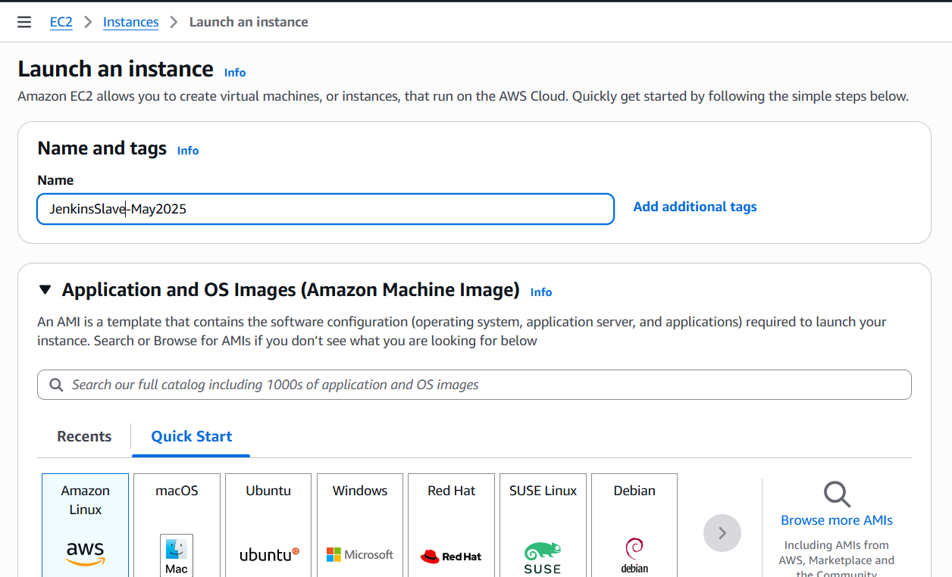

Select same key pair as jenkins master

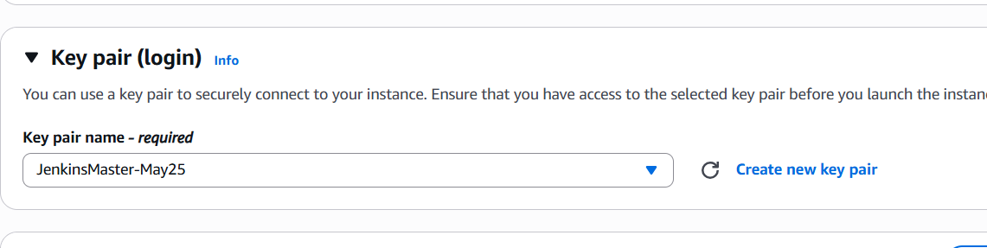

Launch instance

We will not install jenkins on this machine

Connect to the machine with putty

<https://github.com/satyam88/greentea/blob/master/Jenkins-Master-Slave-Configuration.docx>

Allow traffic on the slave server

Server > security > security group > inbound traffic

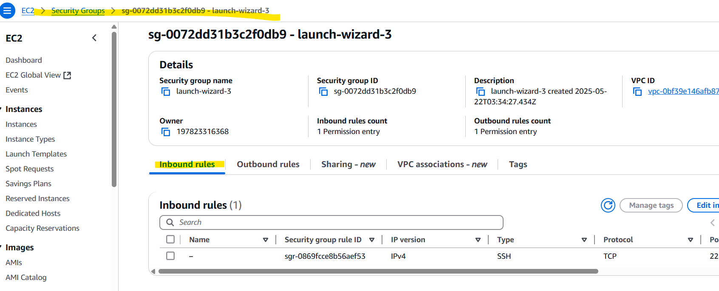

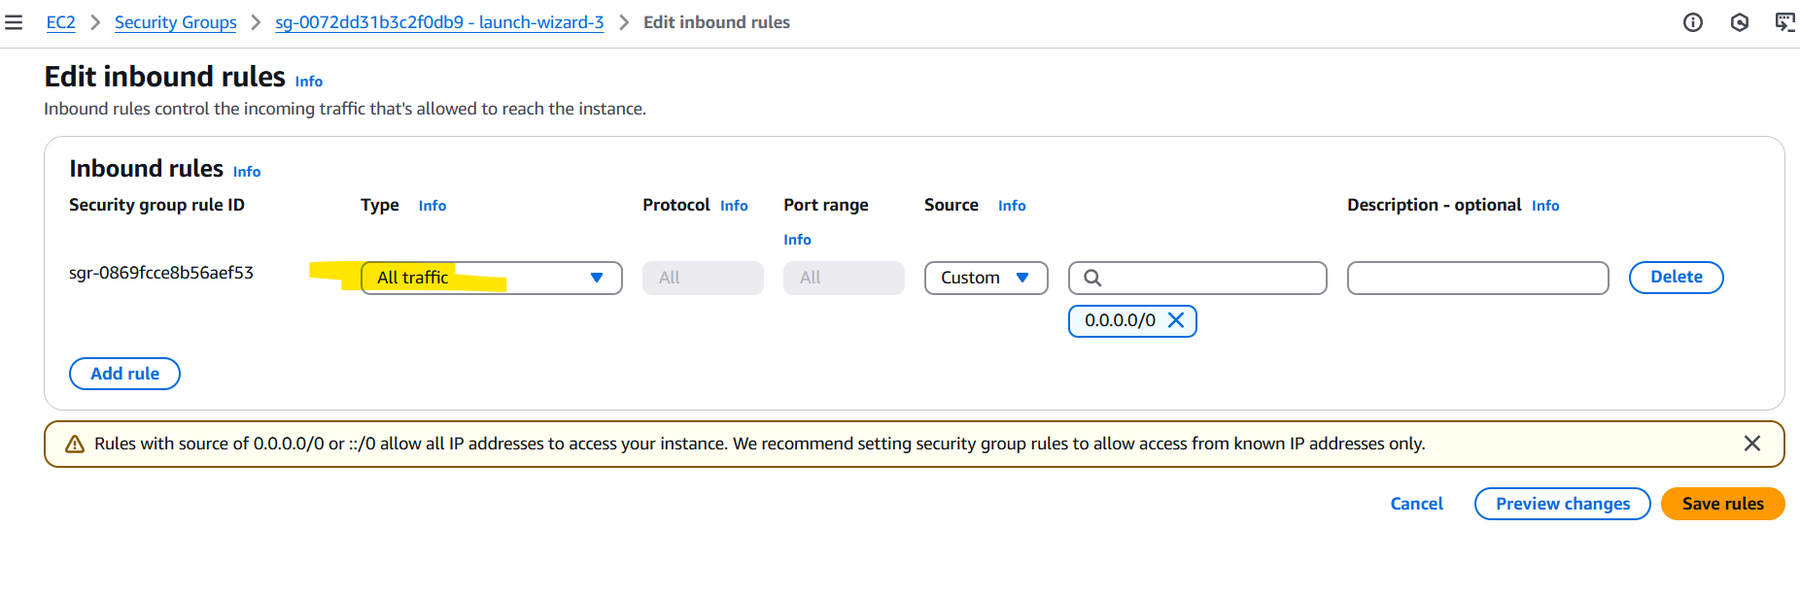

Install maven, git , java

<https://github.com/satyam88/greentea/blob/master/ami>

yum -y update

yum install -y git

yum install -y java-21-amazon-corretto

yum install -y java-21-amazon-corretto-devel

cd /opt

sudo wget https://dlcdn.apache.org/maven/maven-3/3.9.9/binaries/apache-maven-3.9.9-bin.tar.gz

sudo tar xvf apache-maven-3.9.9-bin.tar.gz

ls -ltr

cd

echo "export M2_HOME=/opt/apache-maven-3.9.9" >> .bash_profile

echo "export M2=$M2_HOME/bin" >> .bash_profile

echo "export PATH=$M2:$PATH" >> .bash_profile

source ~/.bash_profile

echo $M2_HOME

git --version; java --version; /opt/apache-maven-3.9.9/bin/mvn --version

Create a user in slave server

[root@ip-172-31-33-35 ~]# useradd jenkins-slave-01

[root@ip-172-31-33-35 ~]# id jenkins-slave-01

uid=1001(jenkins-slave-01) gid=1001(jenkins-slave-01) groups=1001(jenkins-slave-01)

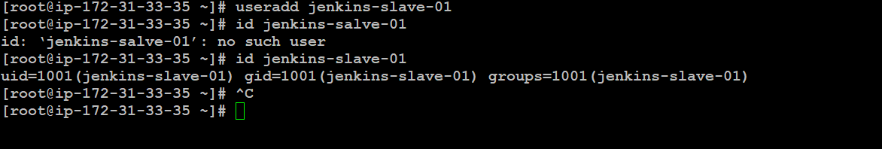

Switch to jenkins-slave-01 user

[root@ip-172-31-33-35 ~]# whoami

root

[root@ip-172-31-33-35 ~]# sudo su - jenkins-slave-01

[jenkins-slave-01@ip-172-31-33-35 ~]$ whoami

jenkins-slave-01

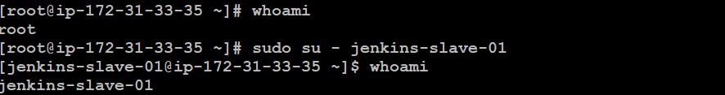

Generate a private key

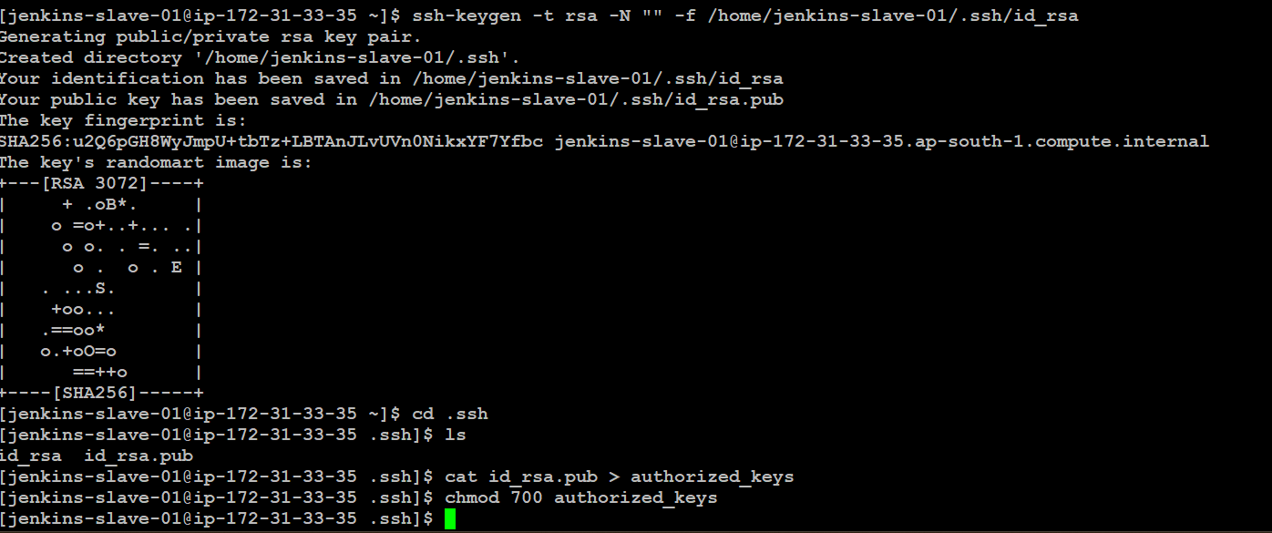

$ ssh-keygen -t rsa -N "" -f /home/jenkins-slave-01/.ssh/id_rsa

Generating public/private rsa key pair.

Created directory '/home/jenkins-slave-01/.ssh'.

Your identification has been saved in /home/jenkins-slave-01/.ssh/id_rsa

Your public key has been saved in /home/jenkins-slave-01/.ssh/id_rsa.pub

The key fingerprint is:

SHA256:u2Q6pGH8WyJmpU+tbTz+LBTAnJLvUVn0NikxYF7Yfbc jenkins-slave-01@ip-172-31-33-35.ap-south-1.compute.internal

The key's randomart image is:

+---[RSA 3072]----+

| + .oB*. |

| o =o+..+... .|

| o o. . =. ..|

| o . o . E |

| . ...S. |

| +oo... |

| .==oo* |

| o.+oO=o |

| ==++o |

+----[SHA256]-----+

$ cd .ssh

$ ls

id_rsa id_rsa.pub

$ cat id_rsa.pub > authorized_keys

$ chmod 700 authorized_keys

**Login to jenkins master now and scan the private key for jenkins slave**

> top

To view all process running on a machine

[ec2-user@ip-172-31-37-84 ~]$ sudo su -

Last login: Thu May 15 04:10:00 UTC 2025 on pts/1

[root@ip-172-31-37-84 ~]# mkdir -p /var/lib/jenkins/.ssh

[root@ip-172-31-37-84 ~]# cd /var/lib/jenkins/.ssh

[root@ip-172-31-37-84 .ssh]# ssh-keyscan -H 172.31.33.35 >> /var/lib/jenkins/.ssh/known_hosts

# 172.31.33.35:22 SSH-2.0-OpenSSH_8.7

# 172.31.33.35:22 SSH-2.0-OpenSSH_8.7

# 172.31.33.35:22 SSH-2.0-OpenSSH_8.7

# 172.31.33.35:22 SSH-2.0-OpenSSH_8.7

# 172.31.33.35:22 SSH-2.0-OpenSSH_8.7

[root@ip-172-31-37-84 .ssh]# chown jenkins:jenkins known_hosts

[root@ip-172-31-37-84 .ssh]# chmod 700 known_hosts

Replace IP with private of jenkins slave

Check if jenkins service is running

$ps -ef | grep jenkins

Login to jenkins > nodes

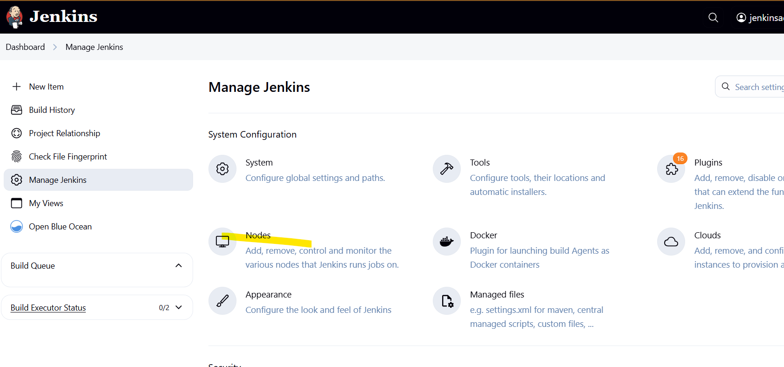

New node

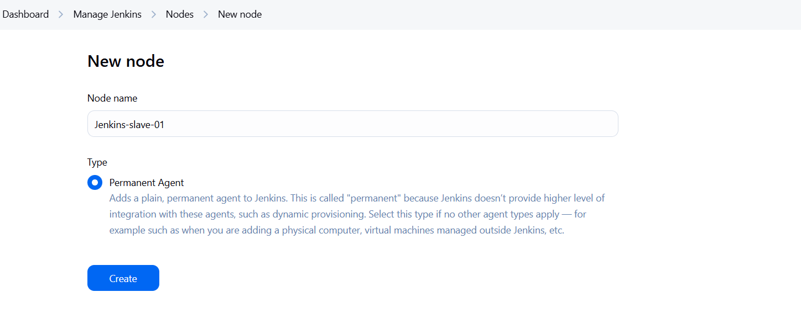

No of executor: 2

Home directory of slave: /home/jenkins-slave-01/



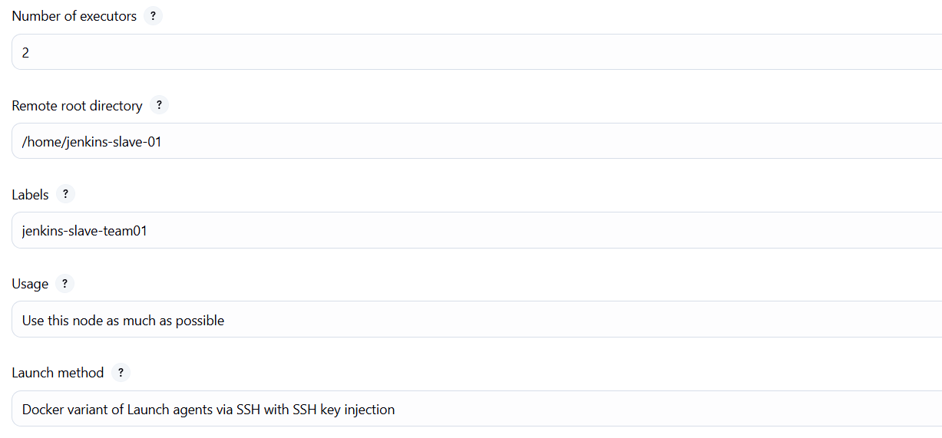

On jenkins slave:

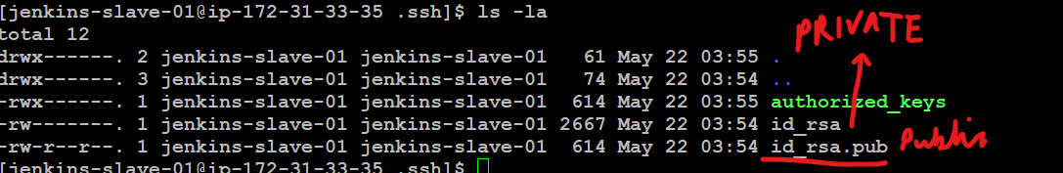

You can view the public and private keys

Copy the private key

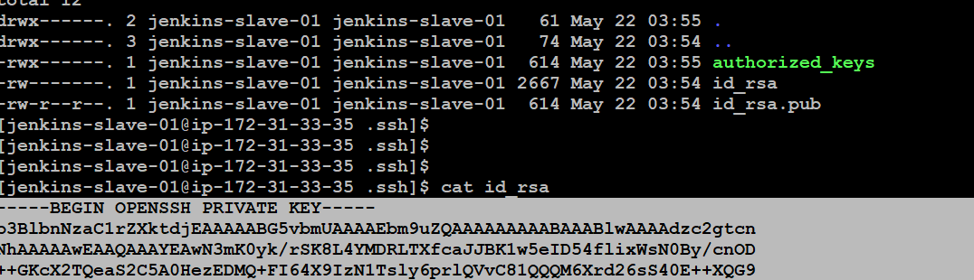

Enter private IP of slave machine

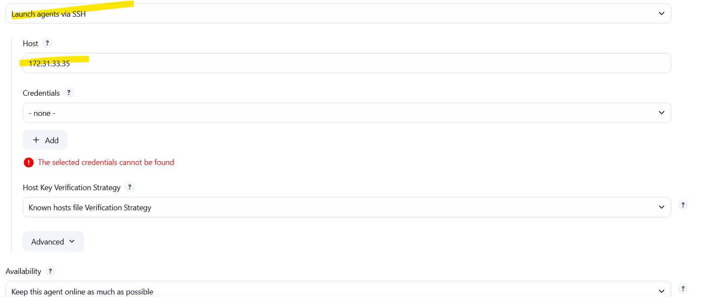

Create new credential -

SSH with private key

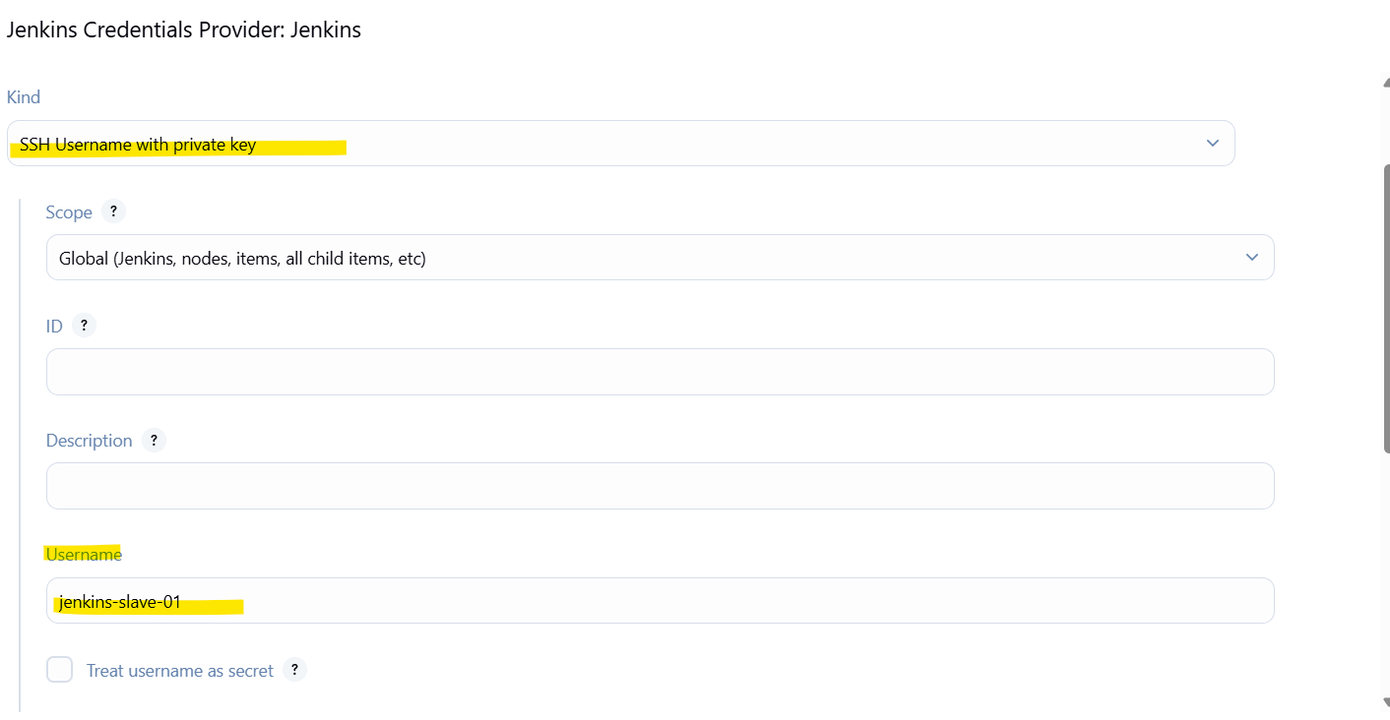

Add private key

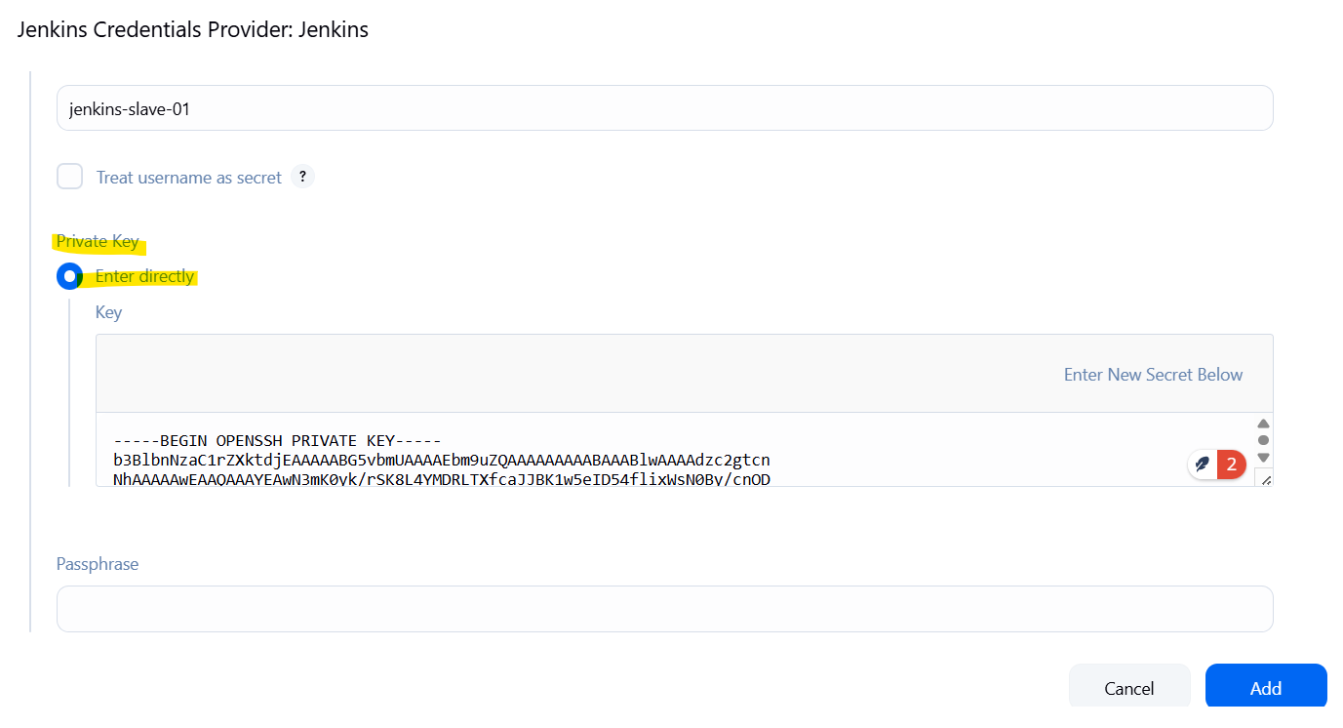

Add the credentials and select it

New node is added but is offline

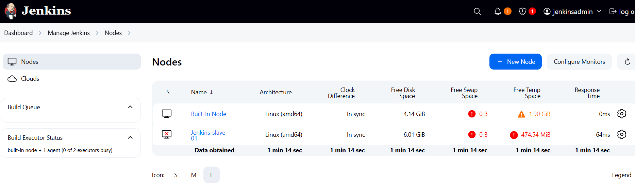

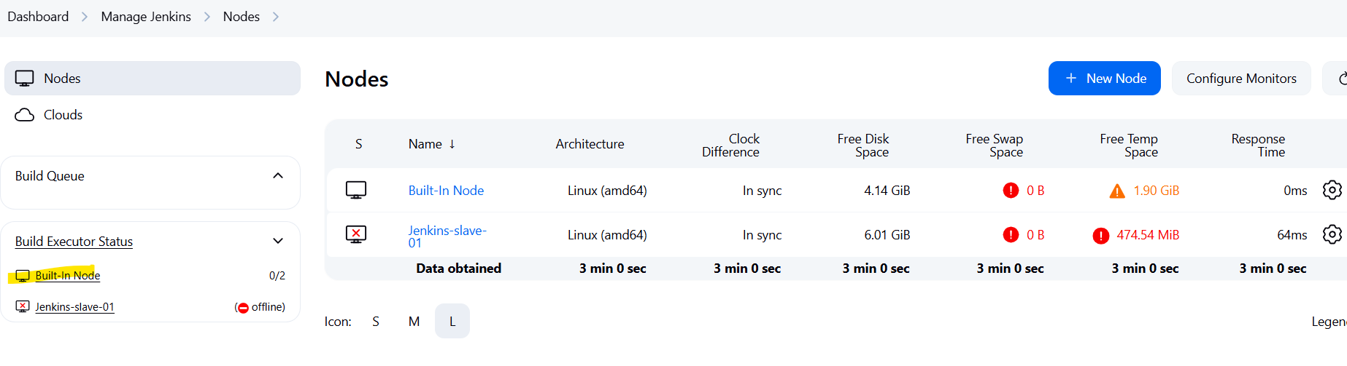

Click on node > configure

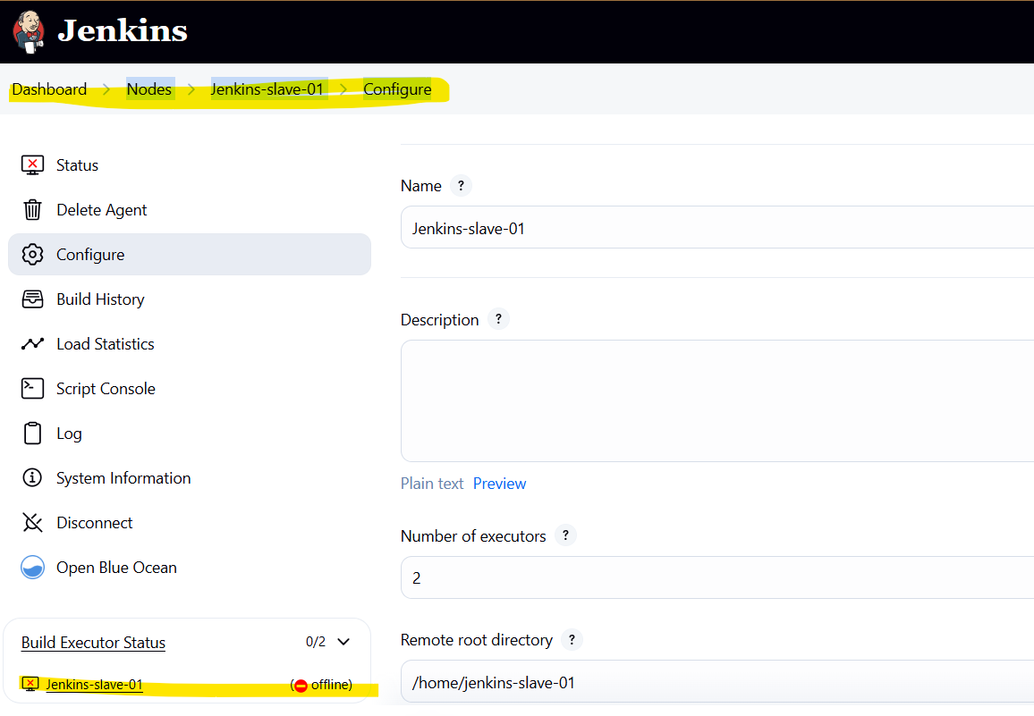

Node properties > Disk space monitoring thresholds > lower the values > 100 MB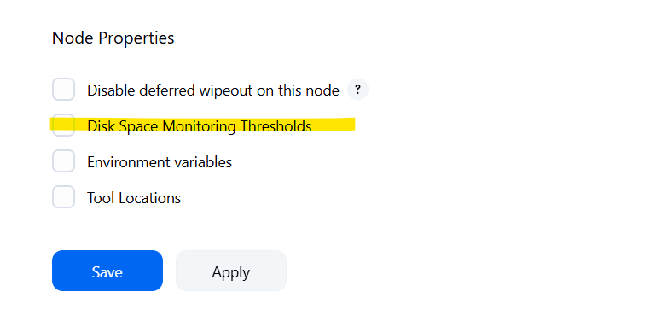

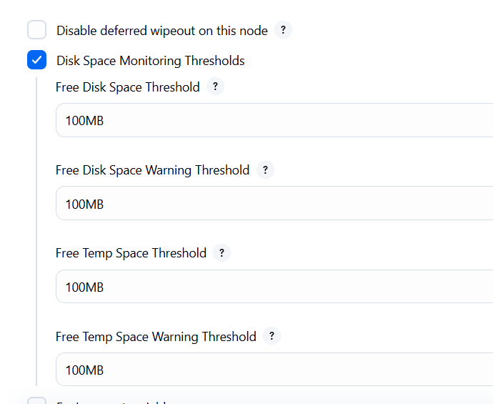

Agent status is now good

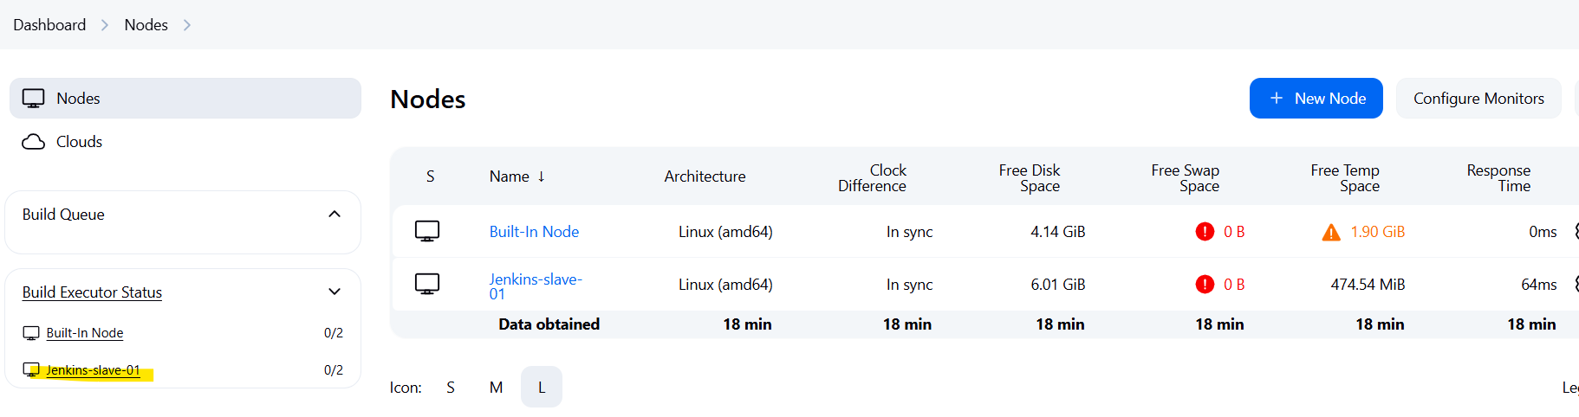

Agents showed show as in Sync

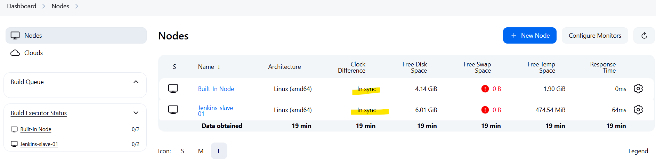

Now this slave is actually an agent you can mention in jenkinsfile

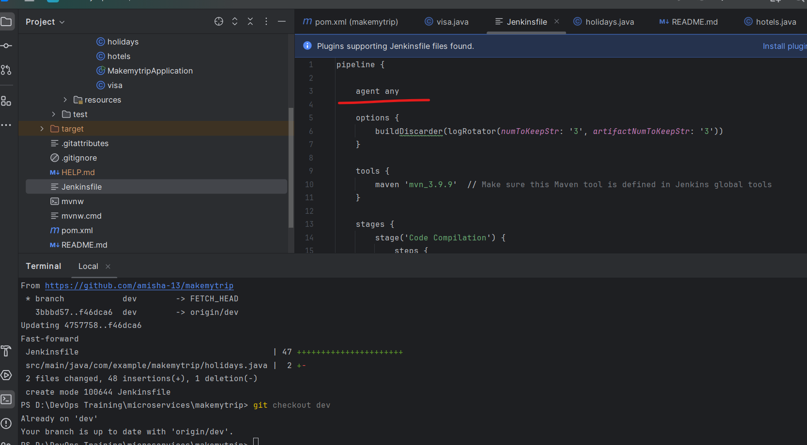

Earlier we were using any agent

Check syntax here

<https://www.jenkins.io/doc/book/pipeline/syntax/>

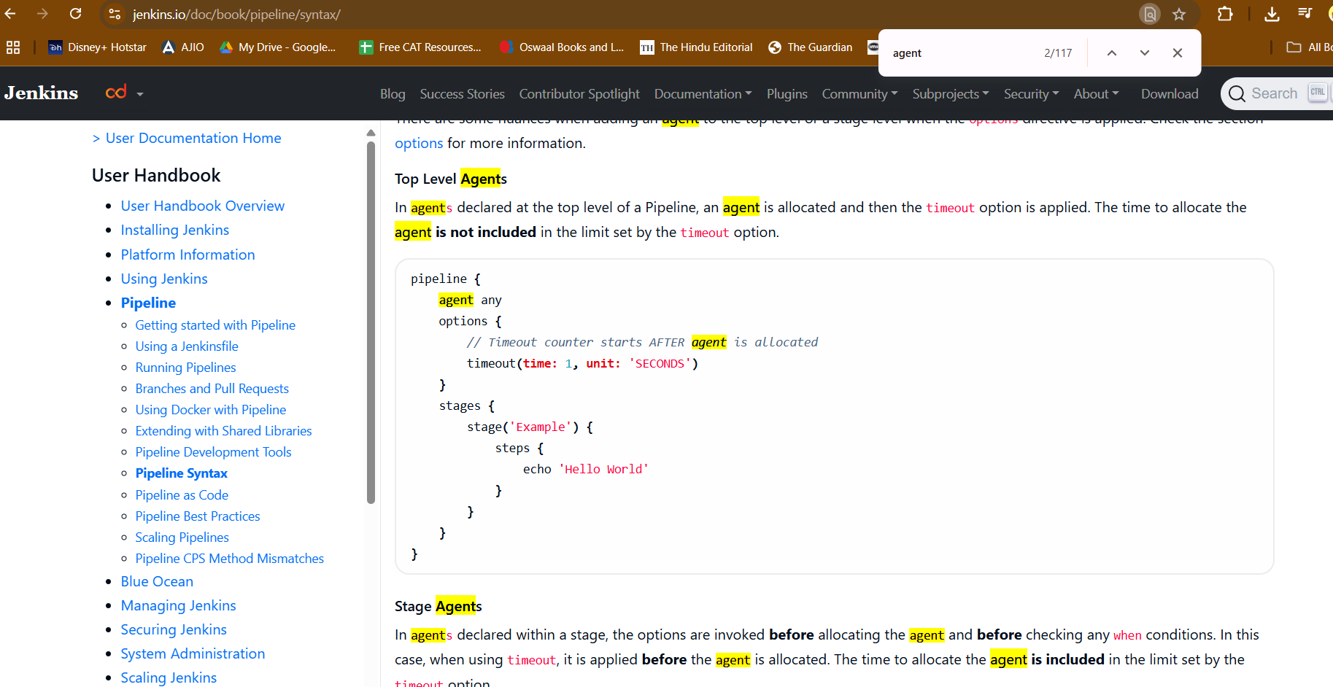

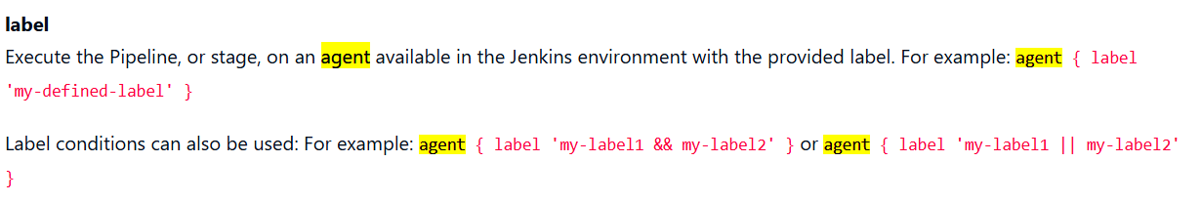

agent { label 'my-defined-label' }

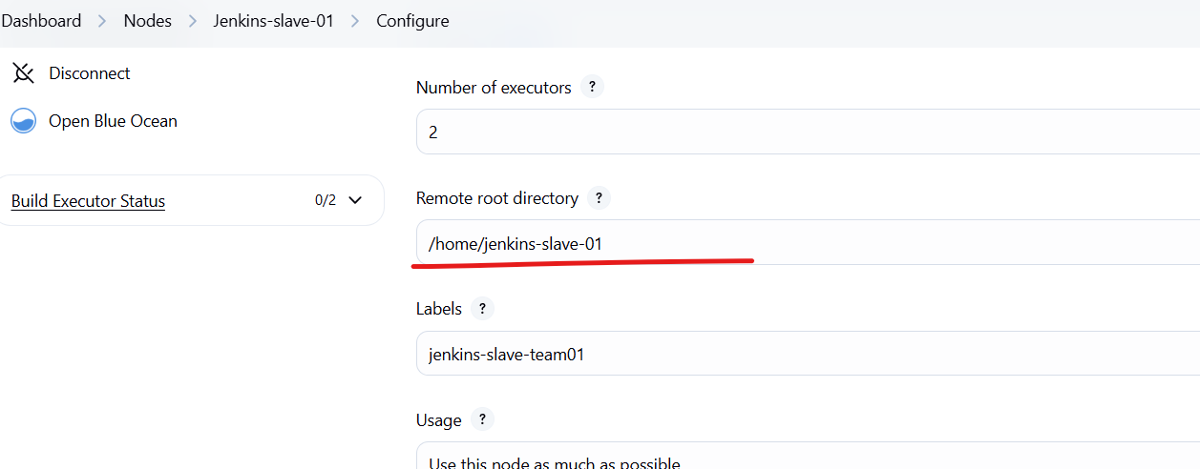

Copy the same label name

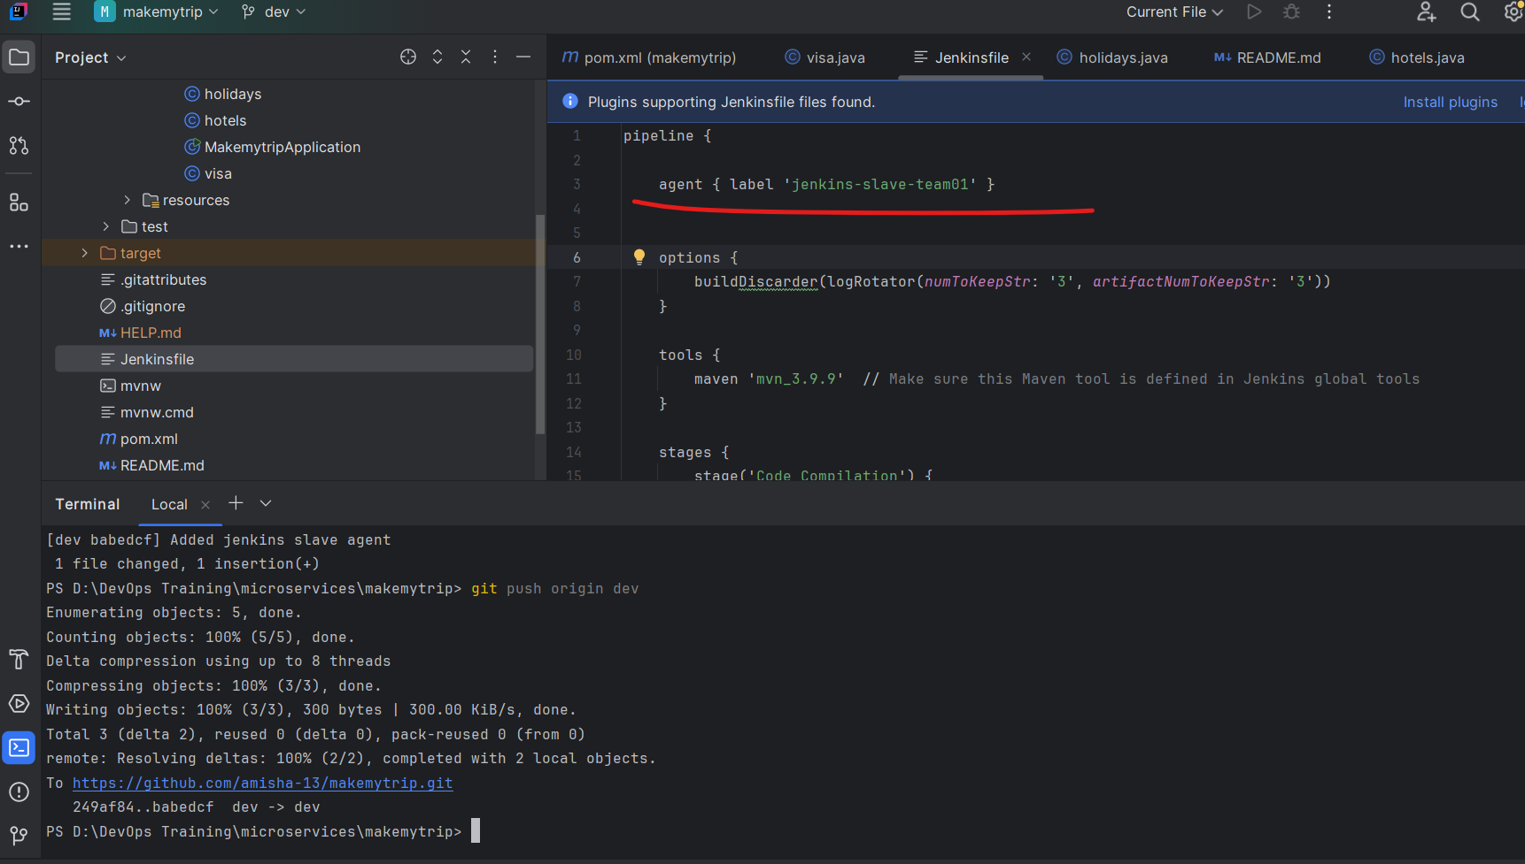

Edit your webhook and then push the code

This will trigger the pipeline

But the imp thing is where the job is running

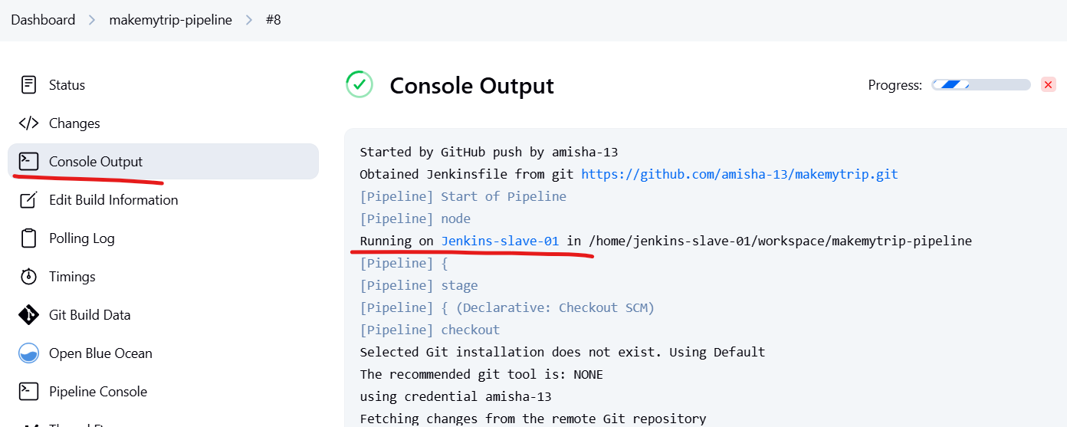

It is running on jenkins slave machine

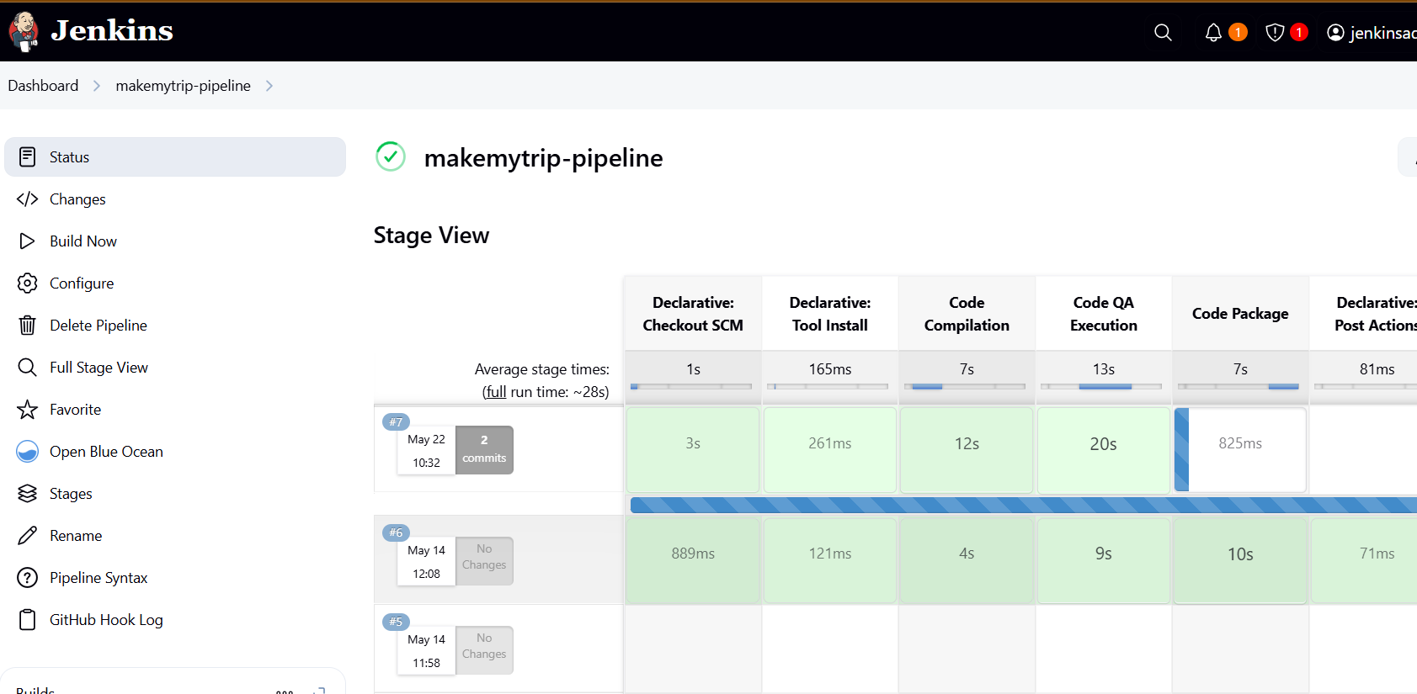

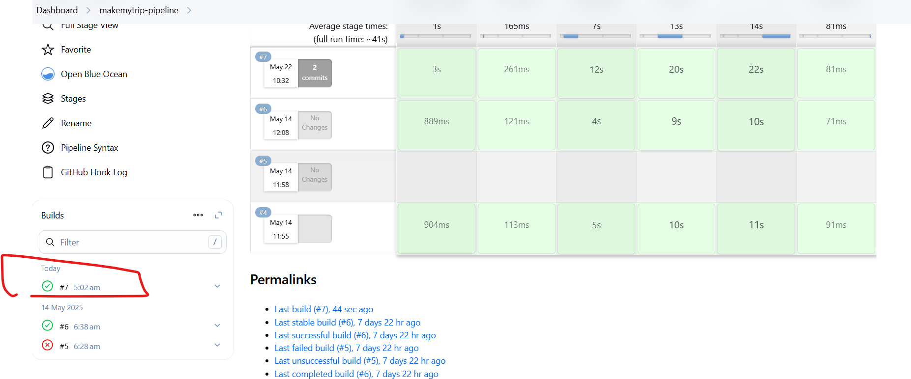

Also notice tat only last 3 records are saved

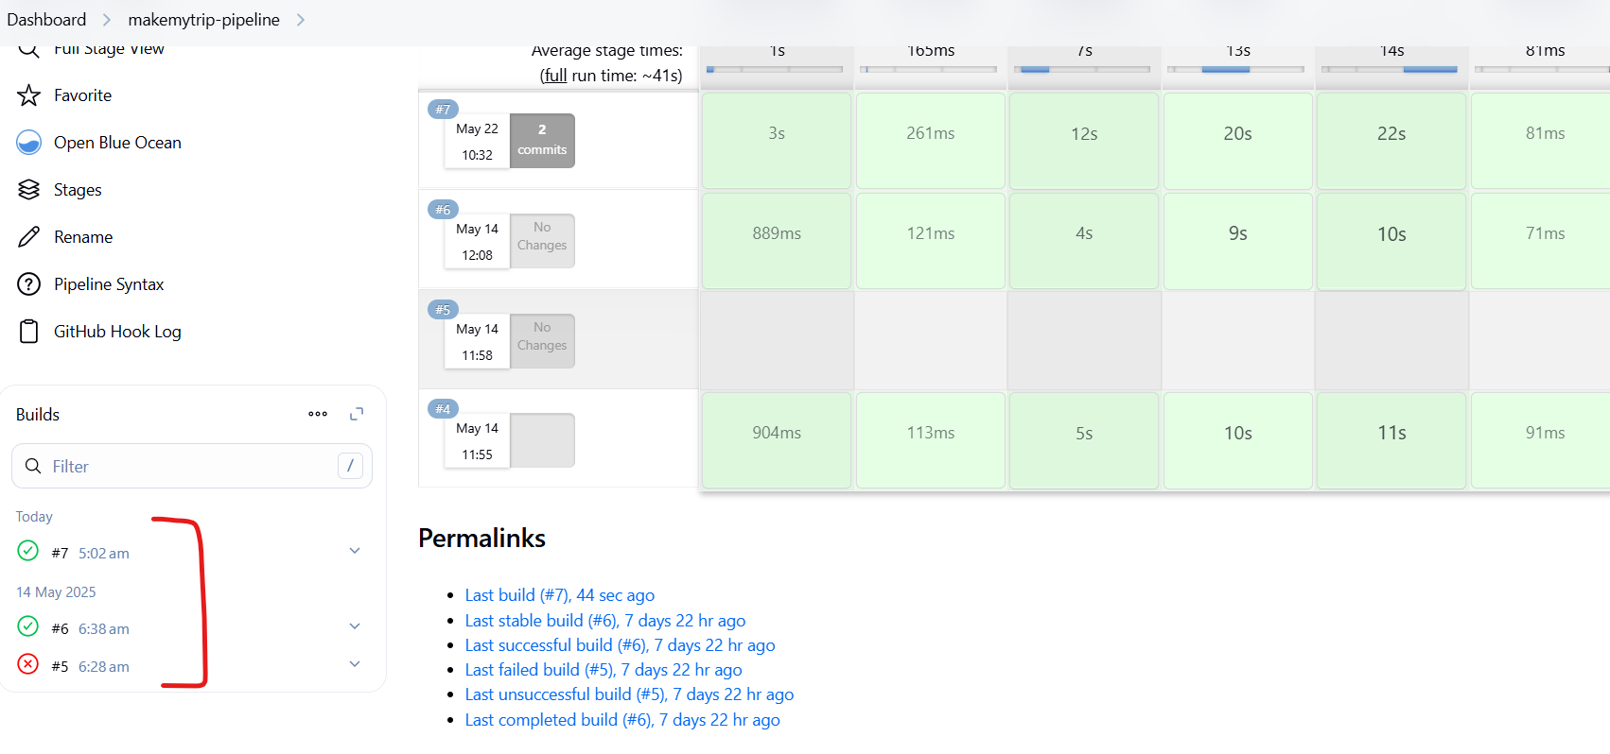

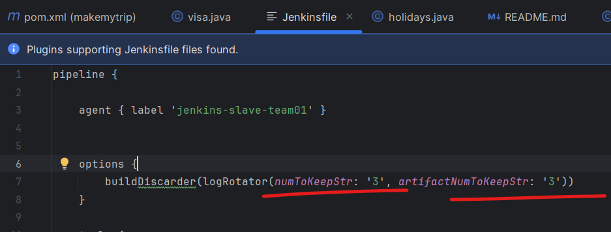

As seen in jenkins file

24th May

Craete a new repo

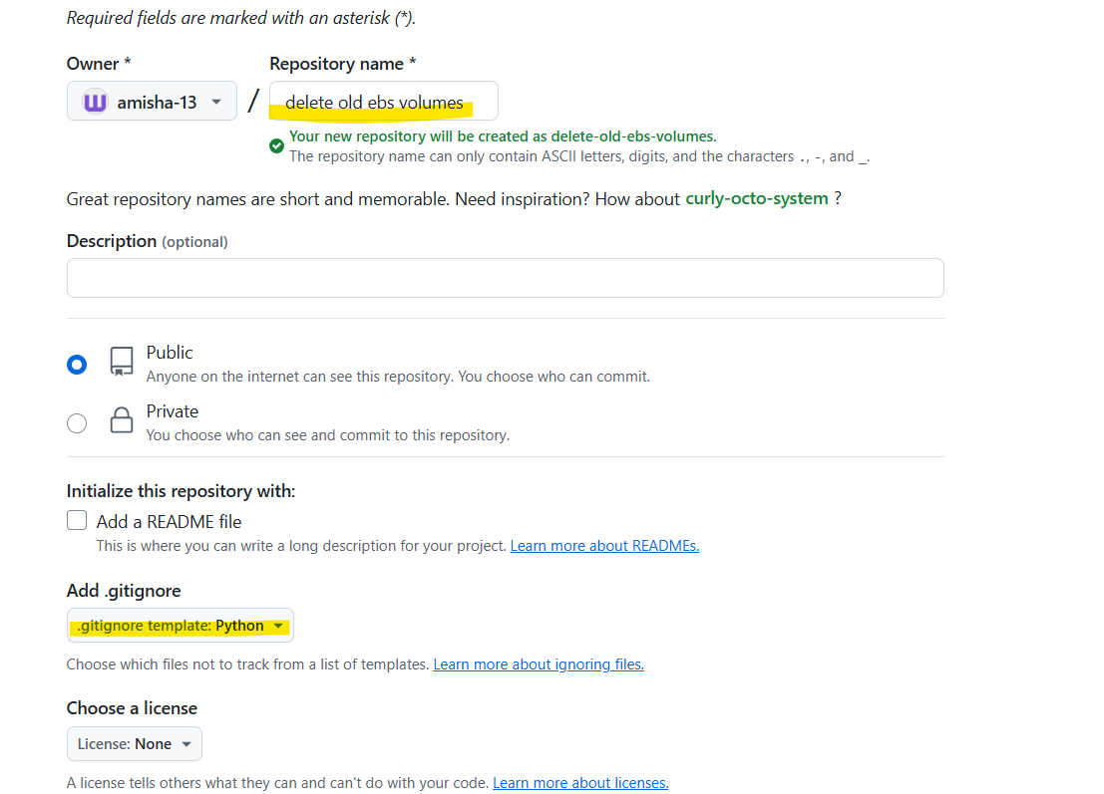

Add python gitignore

We will create a script with chatgpt to delete ebs unattcahe volumes older than 30 days

Paste the script in a new file in the rpo with .py extension

<https://github.com/amisha-13/delete-old-ebs-volumes/tree/main>

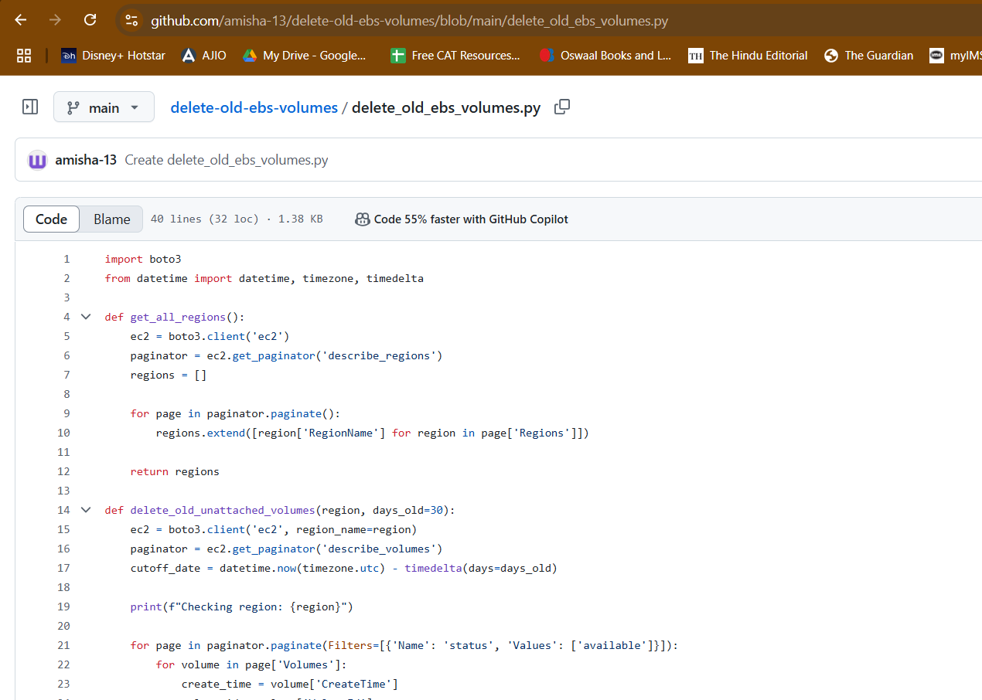

Install docker

Launch a new EC2 instance

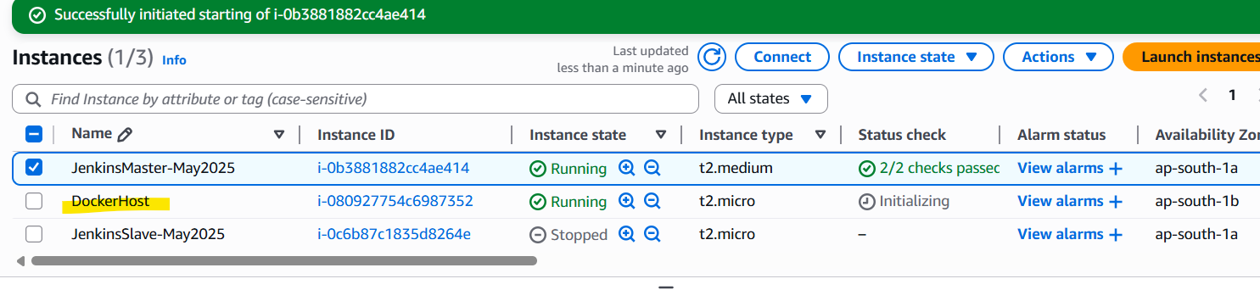

Connect to the machine using putty

>sudo su -

>yum install docker -y

>usermod -aG docker ec2-user

>service docker start

Redirecting to /bin/systemctl start docker.service

>chkconfig docker on

Note: Forwarding request to 'systemctl enable docker.service'.

Created symlink /etc/systemd/system/multi-user.target.wants/docker.service → /usr/lib/systemd/system/docker.service.

> docker version

Gives two outputs: one for docker client and the other for server

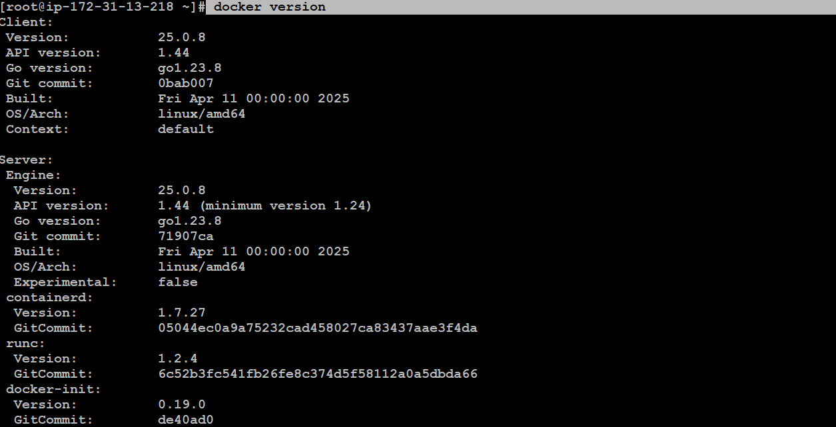

On docker server, there are docker engine, containerd, runc, docker init

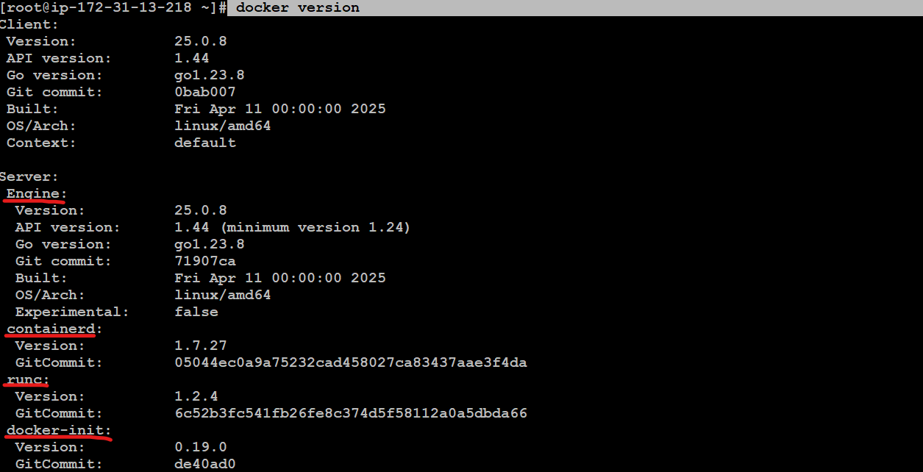

Check OS details

>cat /etc/os-release

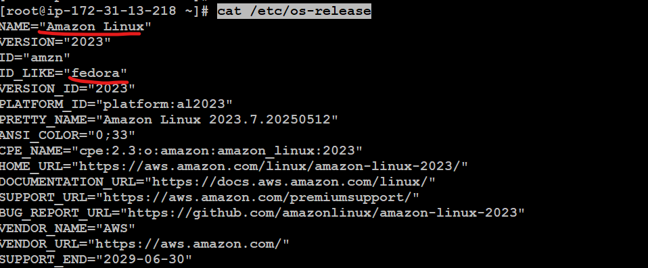

>docker

Lists all docker commands

># docker pull ubuntu

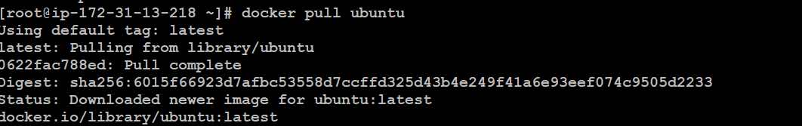

Downloads latest tag by default

Images are downloaded in layers

>docker images



>#docker pull jenkins/jenkins



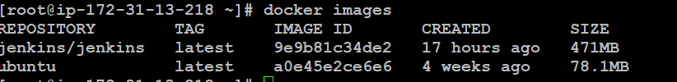

Run a container from ubuntu image

>docker run -itd --name container1 ubuntu

Retunrs container ID



You can create multiple containers from single image

[root@ip-172-31-13-218 ~]# docker run -itd --name container2 ubuntu

5ebd9f5997cf81b3ff5aa534bf3616935ef9e8821006bea7276ecbc953b79496

You cannot run multiple containers will same name



>docker images

View downloaded images

>docker ps

View containers

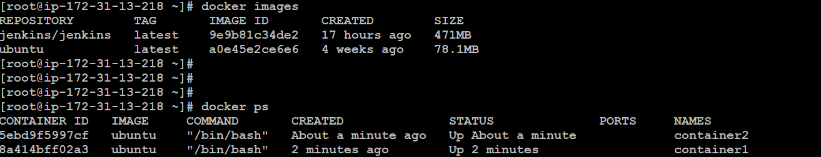

We want to create a container named jenkins-master and specify port 8080 create this from jenkins/jenkins image

> docker run -itd --name jenkins-master -p 8080:8080 jenkins/jenkins

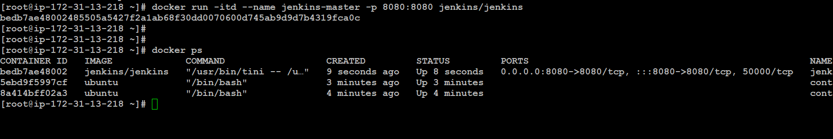

On Ec2 instance - Dockerhost - has a container which is having jenkins running on it

Jenkins can be accessible using the public ip of DockerHost instance and 8080 port as it has been exposed on 8080 port

15.207.247.30:8080



You just need to modify security group of this ec2 instance to allow inbound traffic from anywhere

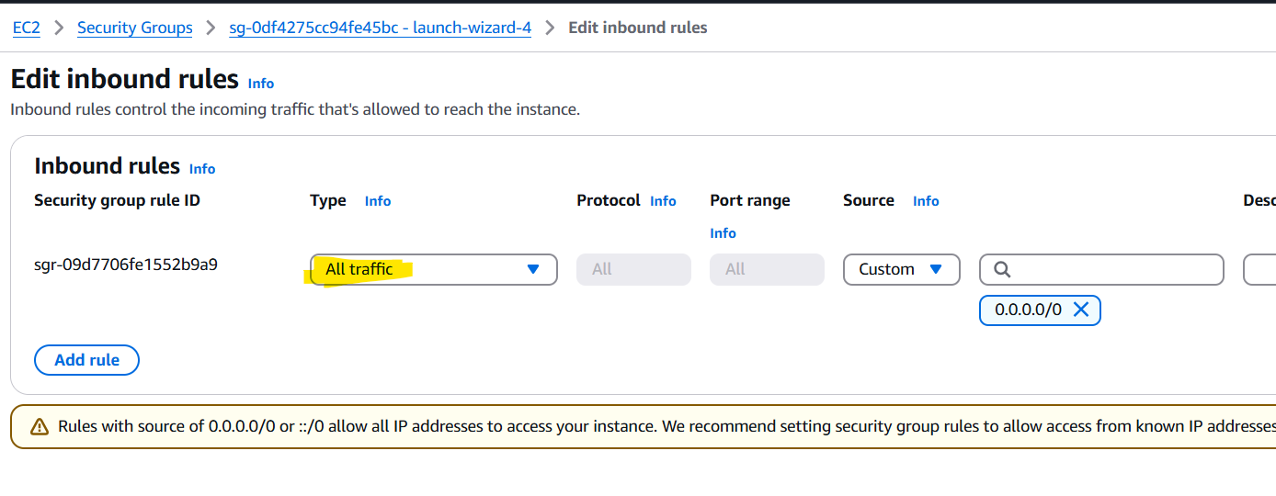



Now setup jenkins

You can login to this container using docker exec and its container id along wih a type of shell

> docker exec -it bedb7ae48002 bash

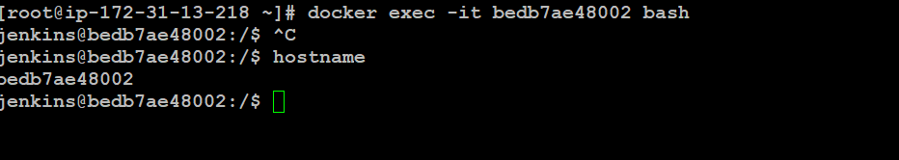

>hostname

Will return container ID of the container

Read this file inside container for its password

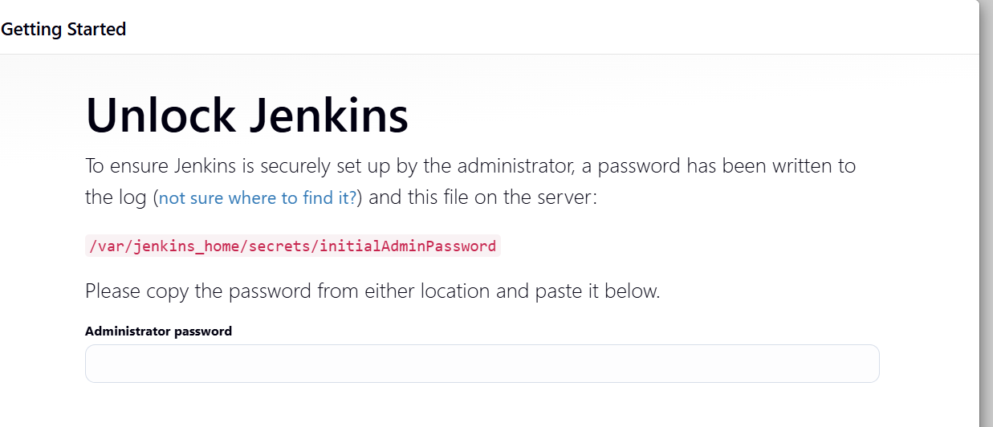

>cat /var/jenkins_home/secrets/initialAdminPassword



We downloaded jenkins image and used it to create a container and then exposed the container on 8080 port. We modified its security group to allow inbound traffic

We now have two jenkins:

1. One on ec2 instance
2. The other on a container on ec2 instance

>top

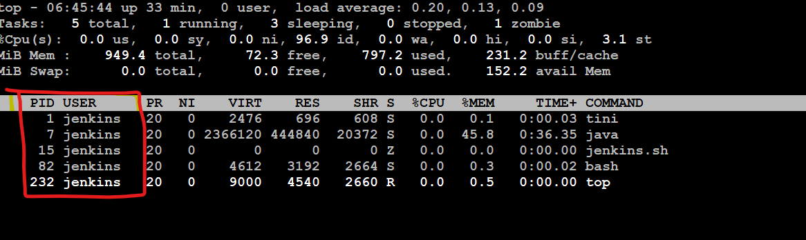

Every process ahs a user id and process id

Process ID may change but username will remain same.

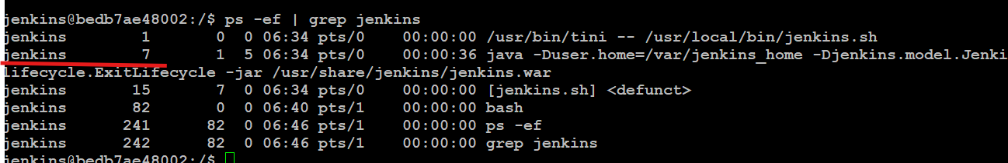

>exit

To exit from container

=============================

Dockerfiles

<https://github.com/satyam88/greentea/blob/master/dockerlab-24th-may>

cat > dockerfile

Paste the content in dockerfile and ctrl + D to exit the file

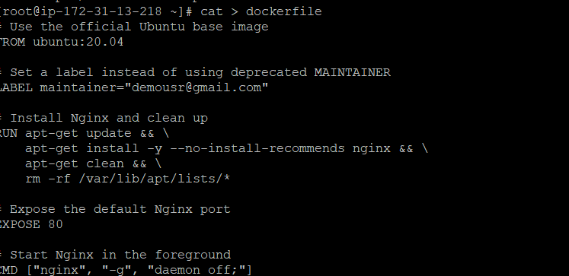

Dockerfile Example

==================

# Use the official Ubuntu base image

FROM ubuntu:20.04

# Set a label instead of using deprecated MAINTAINER

LABEL maintainer="demousr@gmail.com"

# Install Nginx and clean up

RUN apt-get update && \

apt-get install -y --no-install-recommends nginx && \

apt-get clean && \

rm -rf /var/lib/apt/lists/*

# Expose the default Nginx port

EXPOSE 80

# Start Nginx in the foreground

CMD ["nginx", "-g", "daemon off;"]

==========================

Now build the docker file

> docker build -t mynginximage .

. - refers to the dockerfile in current directy

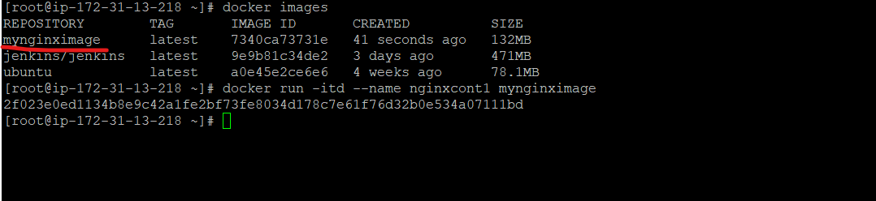

> now create container from the image

]# docker run -itd --name nginxcont1 mynginximage

2f023e0ed1134b8e9c42a1fe2bf73fe8034d178c7e61f76d32b0e534a07111bd

Logint o comatiner

# docker exec -it 2f023e0ed1134b8e9 bash

Check inginx service status

# service nginx status

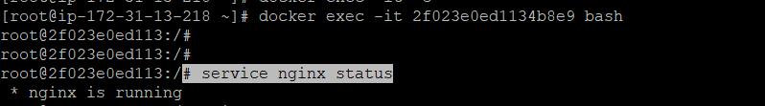

Check OS

>cat /etc/os-release

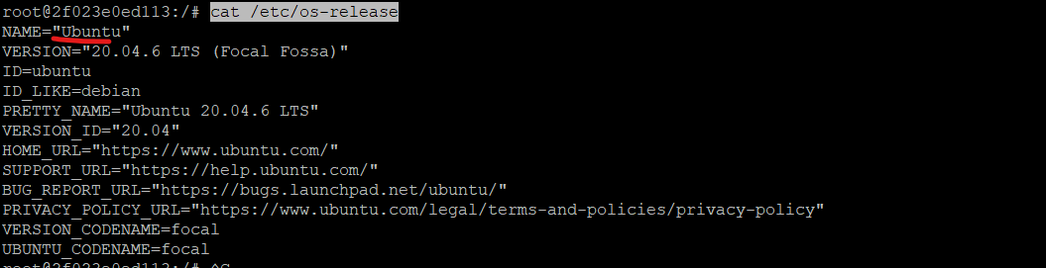

Install python also

Chnage in dockerfile to include python installation

Edit this line to include python installation

**apt-get install -y --no-install-recommends nginx && apt-get install -y python && \**

ANd build the image again

docker build -t mynginximagepython .

Run the container from new image

]# docker run -itd --name mypythoncontainer mynginximagepython

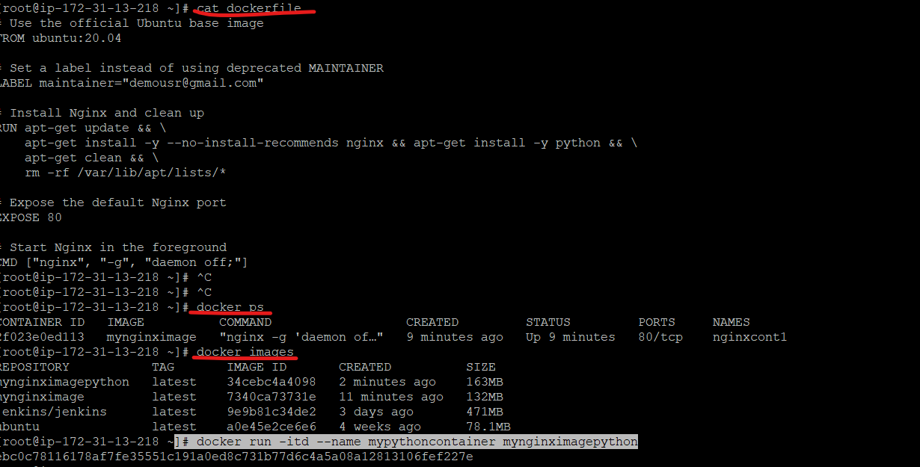

Notice the size of images - lesser the size, more lightweight it will be

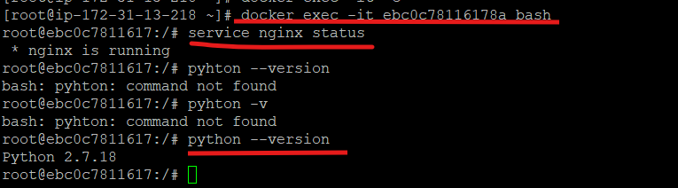

To create another docker file - rename/move this existing dockerfile

==============

# Use a base image with Debian/Ubuntu for flexibility

FROM ubuntu:20.04

# Update package list and install prerequisites

RUN apt-get update && \

apt-get install -y --no-install-recommends \

python3 python3-pip openjdk-11-jdk curl && \

apt-get clean && rm -rf /var/lib/apt/lists/*

# Verify installations

RUN python3 --version && \

java -version

# Set Python and Java environment variables (optional)

ENV JAVA_HOME=/usr/lib/jvm/java-11-openjdk-amd64

ENV PATH=$JAVA_HOME/bin:$PATH

# Create a working directory

WORKDIR /app

# Default command (adjust based on your use case)

CMD ["bash"]

=================

Work directory

Never run a container will root directory

Docker security - root access should not be there

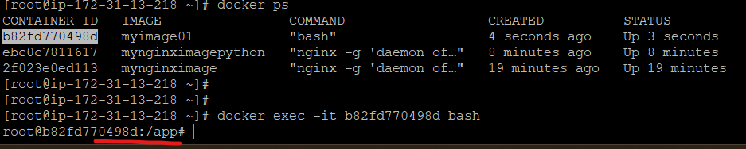

Default directory is app when we login to the container

Because of the statement

WORKDIR /app

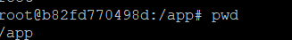

If you chck you are loggd in as root user which is a breach

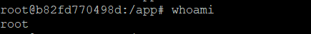

47 cat > dockerfile

48 docker build -t myimage01 .

49 docker images

50 docker run -itd --name container01 myimage01

51 docker ps

52 docker exec -it b82fd770498d bash

53 history

New dockerfile - set user

=============================

FROM jenkins/jenkins

LABEL maintainer="email2satyam88@gmail.com"

USER root

RUN mkdir /var/log/jenkins && \

chown -R jenkins:jenkins /var/log/jenkins

USER jenkins

ENV JAVA_OPTS="-Xmx512m"

ENV JENKINS_OPTS="--logfile=/var/log/jenkins/jenkins.log"

EXPOSE 8080

==============================

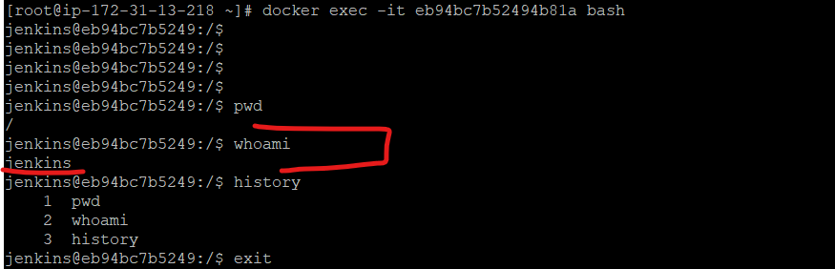

Logged in as jenkins user instead of root user

55 mv dockerfile mydockerfile

58 cat > dockerfile

59 cat dockerfile

60 docker build -t myjenkinsimage .

61 docker images

62 docker run -itd --name myjenkinscontainer myjenkinsimage

63 docker exec -it eb94bc7b52494b81a bash

1 pwd

2 whoami

3 history

Exit

DevOps Day 14 - 31st May 2025

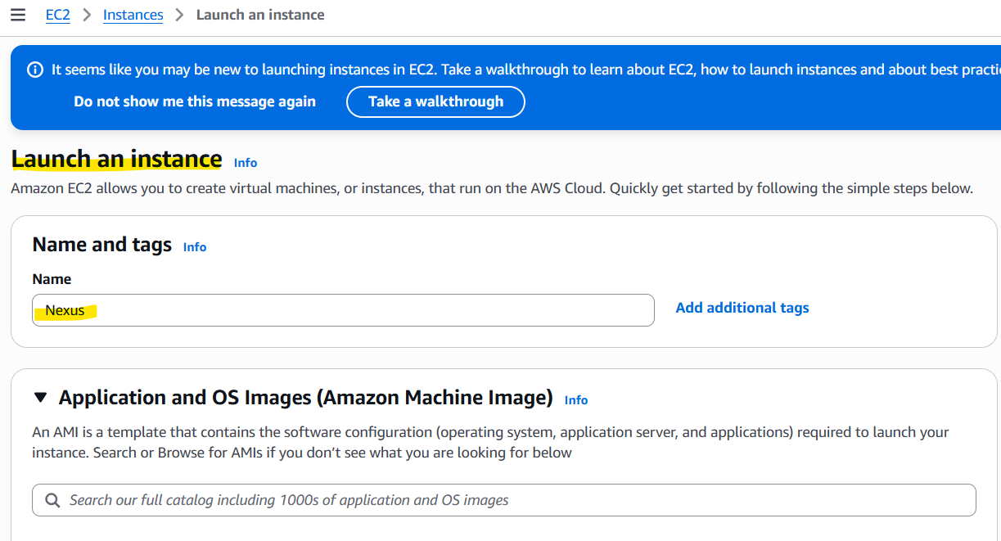

Nexus needs 4 GB RAM - use t2.medium

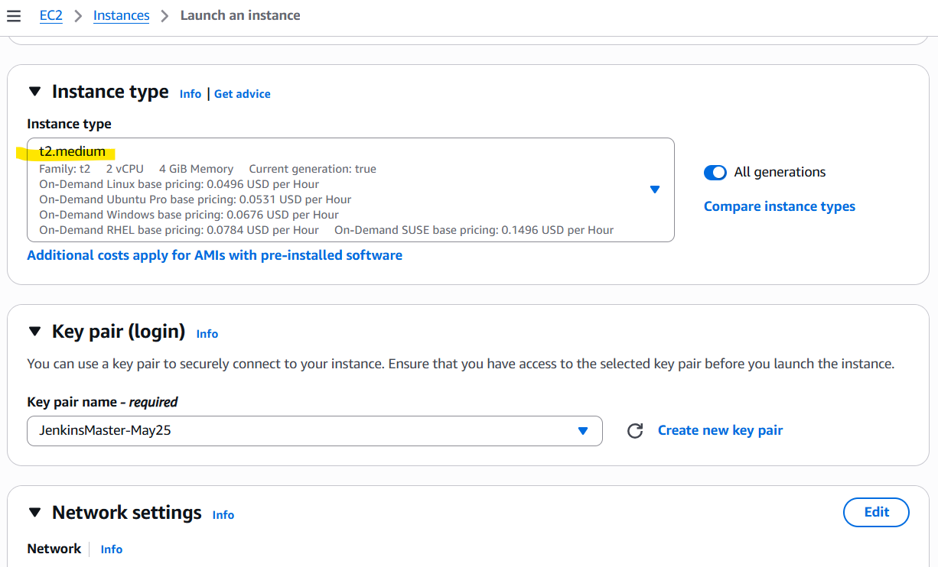

Modify security group - inbound rules

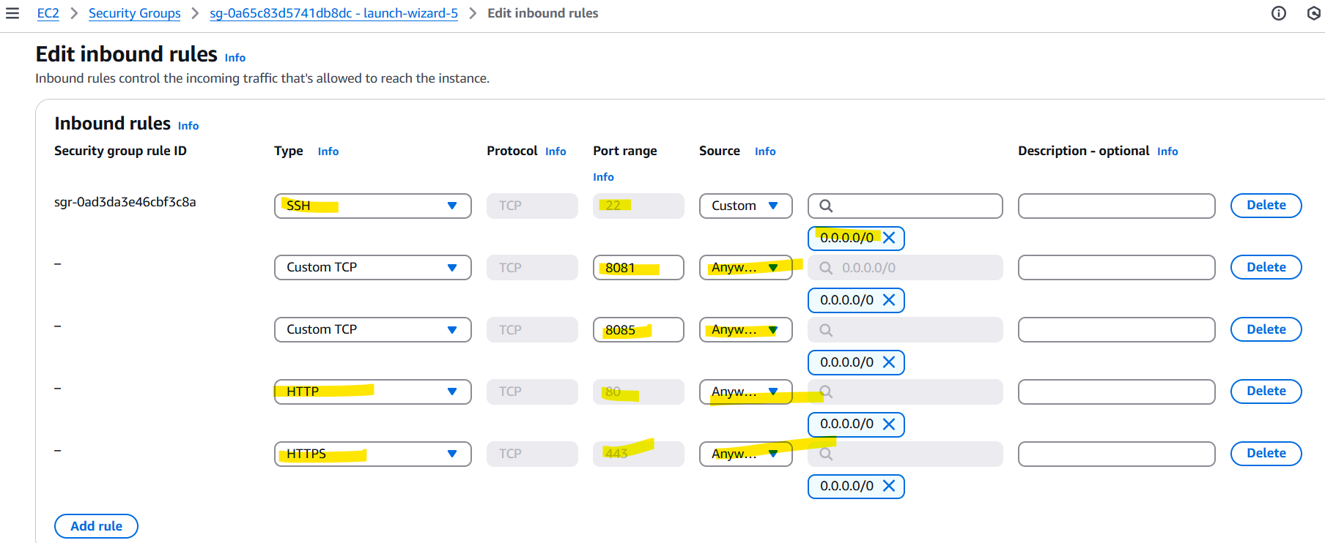

Login to instance using putty

$ sudo su -

**Switch to /opt folder**

> cd /opt

**Download java 21 compress file for linux**

> wget -c --header "Cookie: oraclelicense=accept-securebackup-cookie" <https://download.oracle.com/java/21/latest/jdk-21_linux-x64_bin.tar.gz>

>ls -ltr

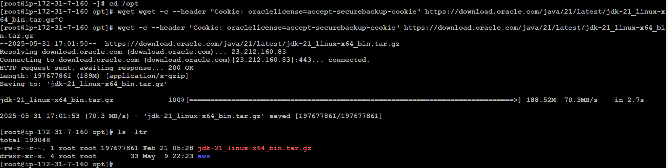

Unzip the tar file

>tar -zxvf jdk-21_linux-x64_bin.tar.gz

>ls -ltr



[root@ip-172-31-7-160 opt]# cd jdk-21.0.7/

[root@ip-172-31-7-160 jdk-21.0.7]# pwd

/opt/jdk-21.0.7

[root@ip-172-31-7-160 jdk-21.0.7]#

11 alternatives --install /usr/bin/java java /opt/jdk-21.0.7/bin/java2

12 cd bin

13 alternatives --install /usr/bin/java java /opt/jdk-21.0.7/bin/java 2

14 alternatives --config java

15 alternatives --install /usr/bin/jar jar /opt/jdk-21.0.7/bin/jar 2

16 alternatives --install /usr/bin/javac javac /opt/jdk-21.0.7/bin/javac 2

17 alternatives --set jar /opt/jdk-21.0.7/bin/jar

18 alternatives --set javac /opt/jdk-21.0.7/bin/javac

19 java -version

20 javac -version

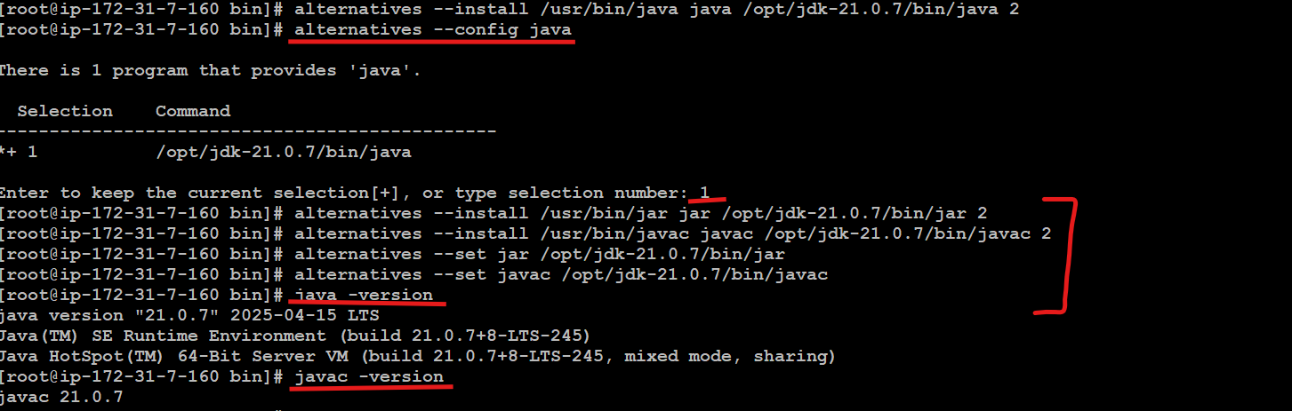

cd

echo "export JAVA_HOME=/opt/jdk-21.0.7" >> .bash_profile

echo "export JRE_HOME=/opt/jdk-21.0.7/jre" >> .bash_profile

echo "export PATH=$PATH:/opt/jdk-21.0.7/bin:/opt/jdk-21.0.7/jre/bin" >> .bash_profile

source ~/.bash_profile

echo $JAVA_HOME

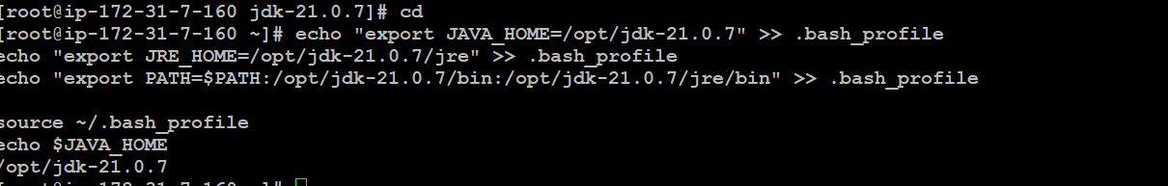

Download nexus, extract it and rename

>cd /opt

Download nexus

>wget <https://download.sonatype.com/nexus/3/nexus-3.80.0-06-linux-x86_64.tar.gz>

Extract it

>ls -ltr

>tar -zxvf nexus-3.80.0-06-linux-x86_64.tar.gz

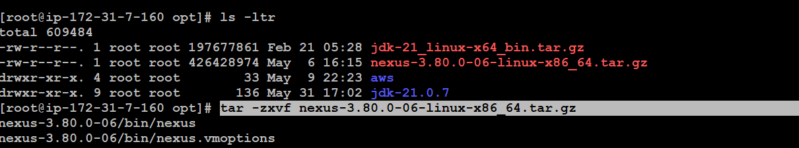

Rename it to nexus 3.80

>mv /opt/nexus-3.80.0-06 /opt/nexus-3.80

>ls -ltr

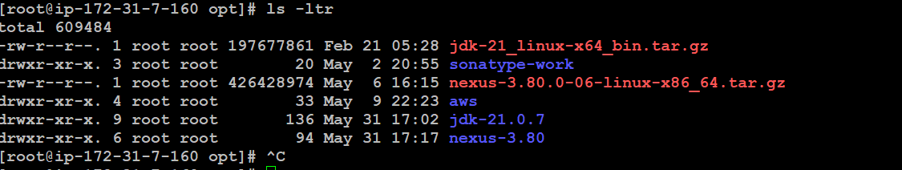

#Add the user nexus and give root privilege

>useradd nexus

>visudo

Add this line below root user

**nexus ALL=(ALL) NOPASSWD: ALL**

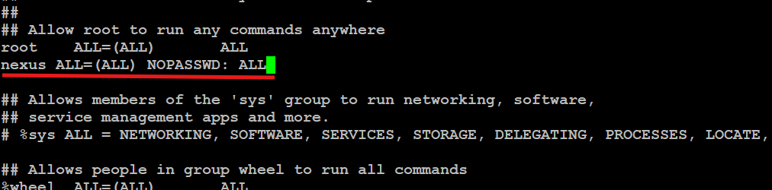

CTRL S + CTRL X

>id nexus

uid=1001(nexus) gid=1001(nexus) groups=1001(nexus)

#Change the ownership and permissions recursively for the directories nexus-3.80 and sonatype-work

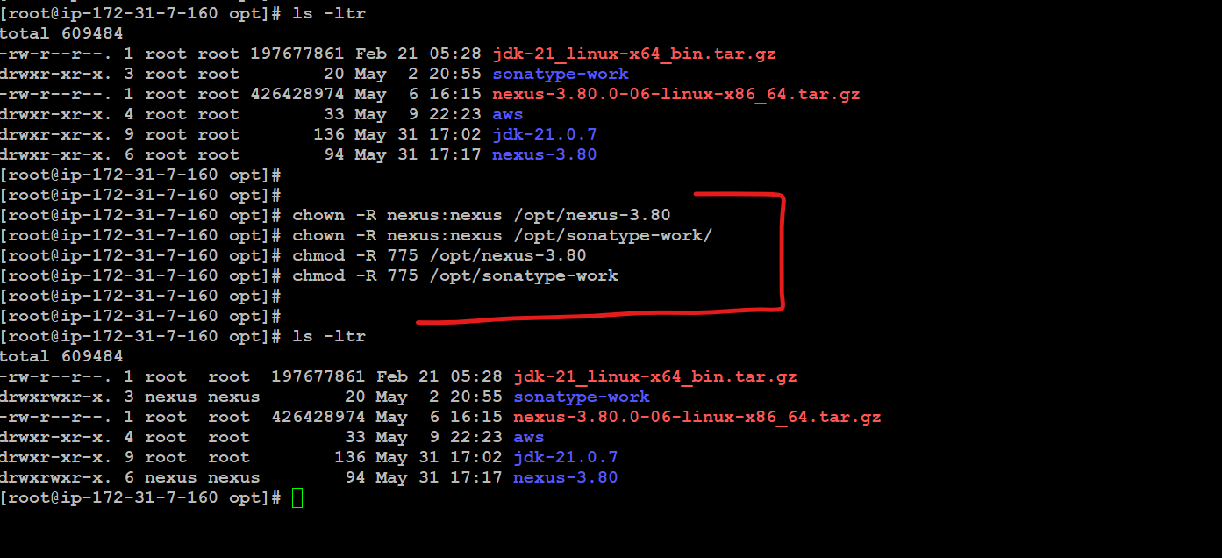

chown -R nexus:nexus /opt/nexus-3.80

chown -R nexus:nexus /opt/sonatype-work/

chmod -R 775 /opt/nexus-3.80

chmod -R 775 /opt/sonatype-work

775 permission in linux

the owner and group have read, write, and execute access (rwx), while other users have read and execute access (r-x)

#open /opt/nexus-3.45/bin/nexus.rc fine and uncomment run_as_user

vi /opt/nexus-3.80/bin/nexus.rc

run_as_user="nexus"

:wq!

create nexus as a service (to run the application as nexus user)

>ln -s /opt/nexus-3.80/bin/nexus /etc/init.d/nexus

48 whoami

49 sudo systemctl enable nexus

50 sudo systemctl start nexus

51 sudo systemctl status nexus

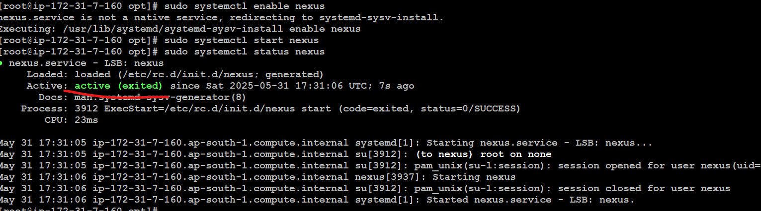

Go to browser and type publicip:8081

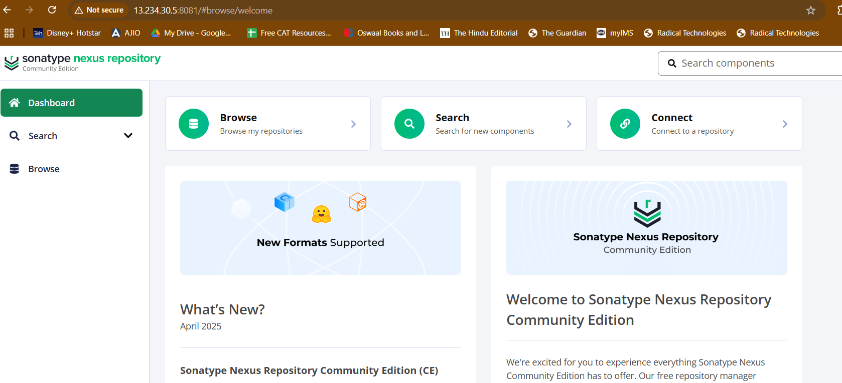

Nexus is accessible

Click on login

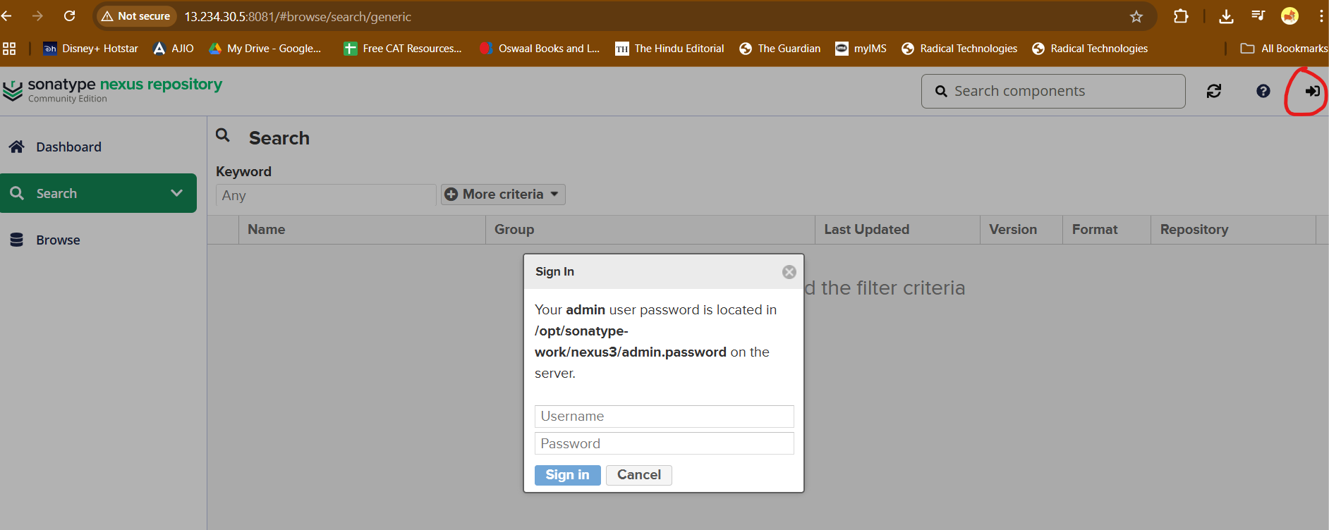

Go to instance to get the password

cat /opt/sonatype-work/nexus3/admin.password



Enter new password: nexus@123

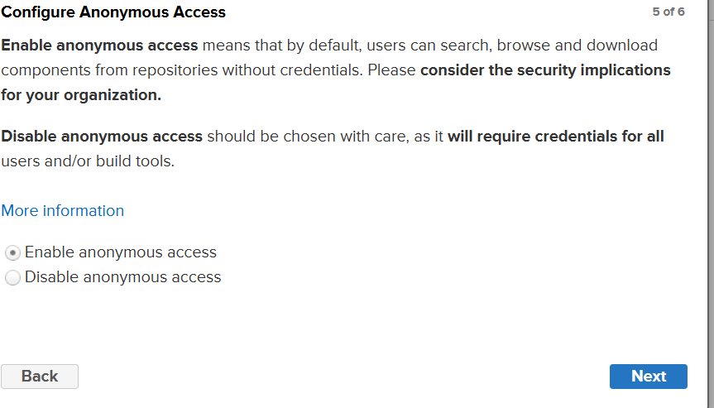

Enable anonymous access



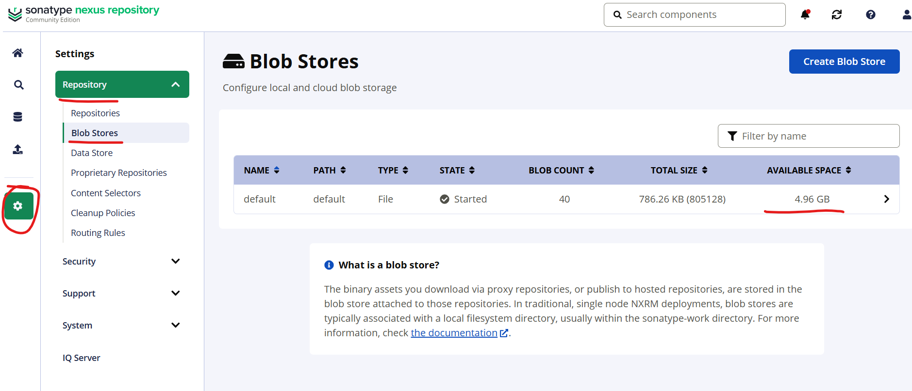

Blob store has hard disk space - 4.96 out of 8 GB

>df -h

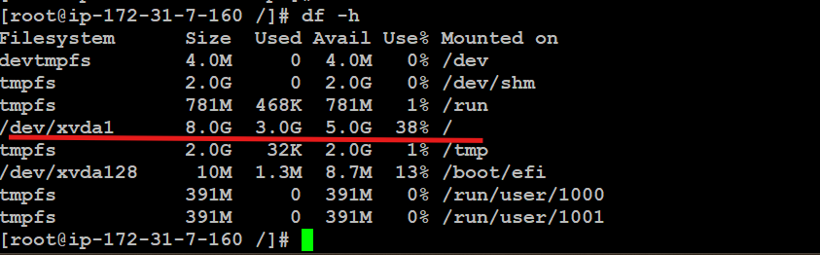

Out of 8 GB - 3 G is used by OS and 5 GB left is being used as blob storage by nexus

Open AWS S3

Create a bucket - cloud blob store

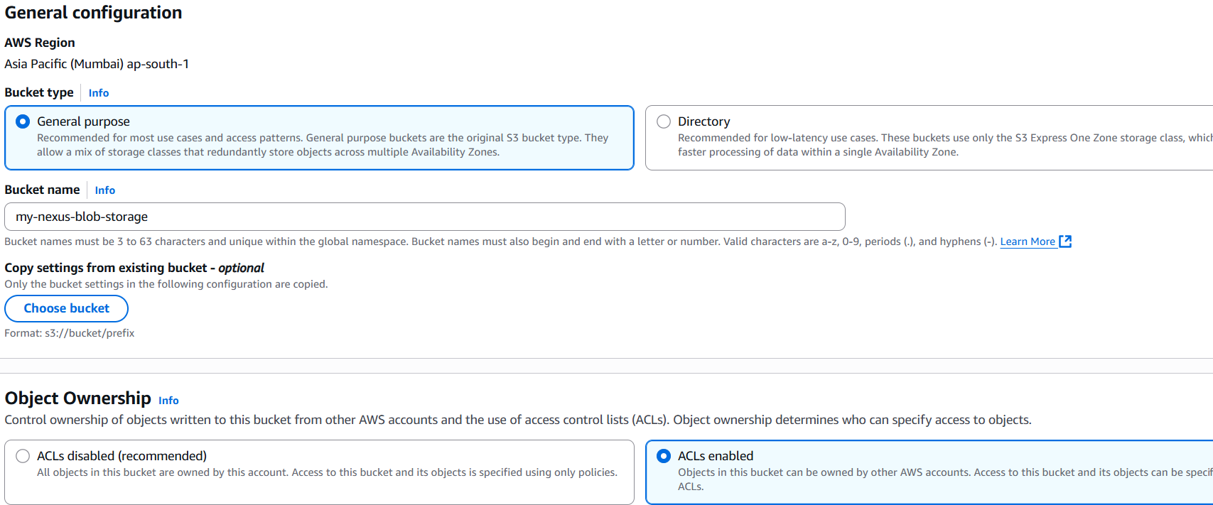

Create

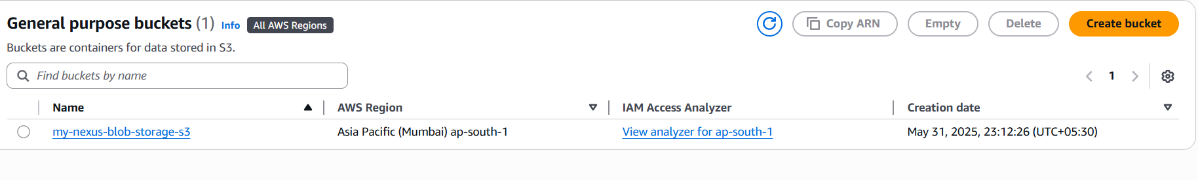

Create blob store in nexus

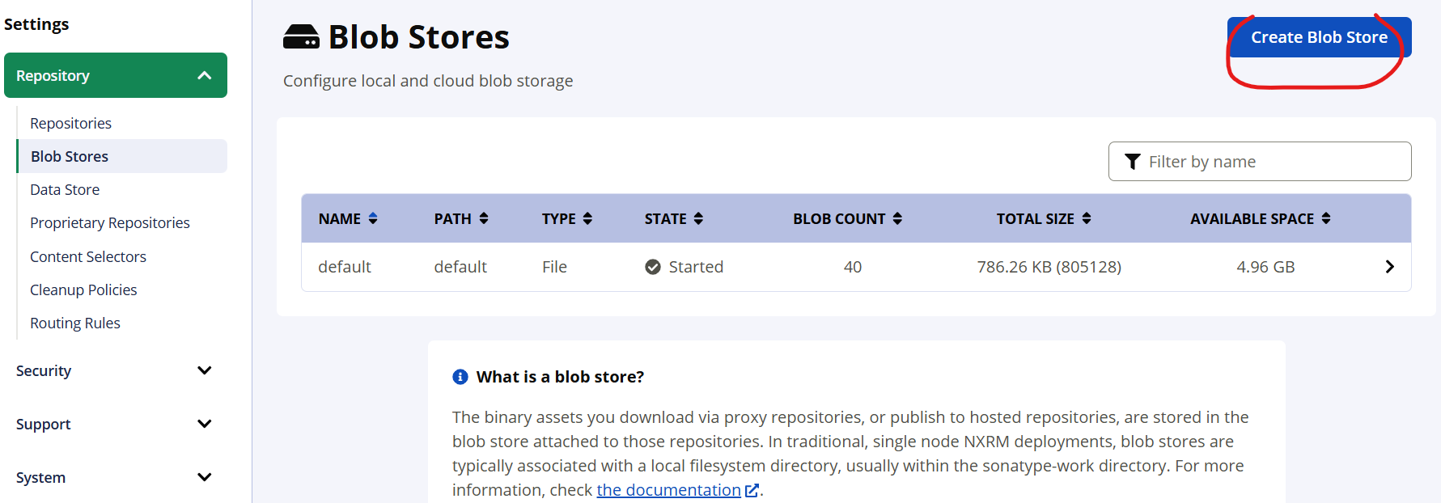

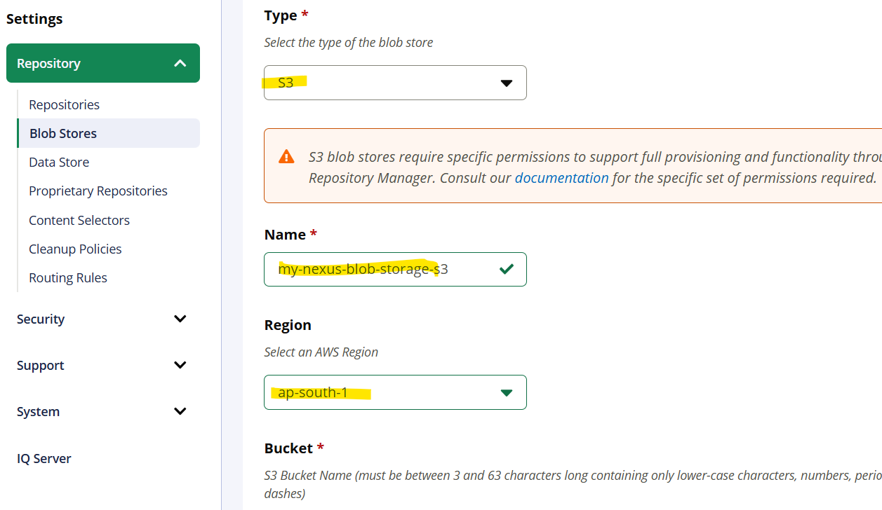

Create IAM user and attach role

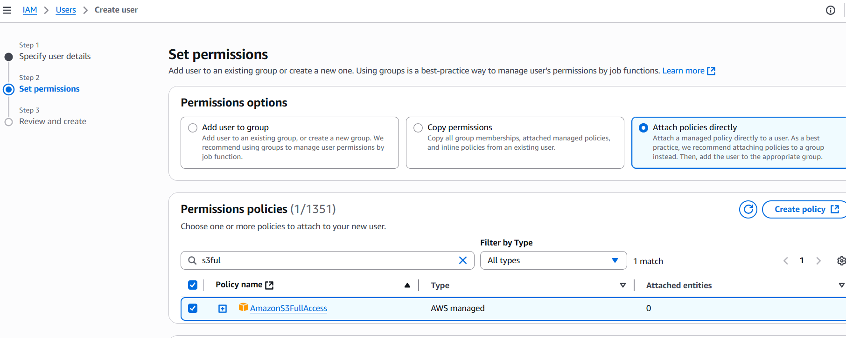

Checkout the IAM user and create access keys

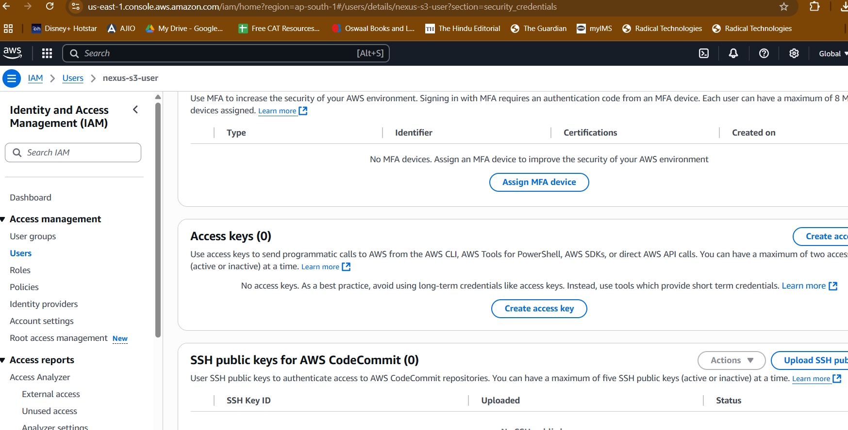

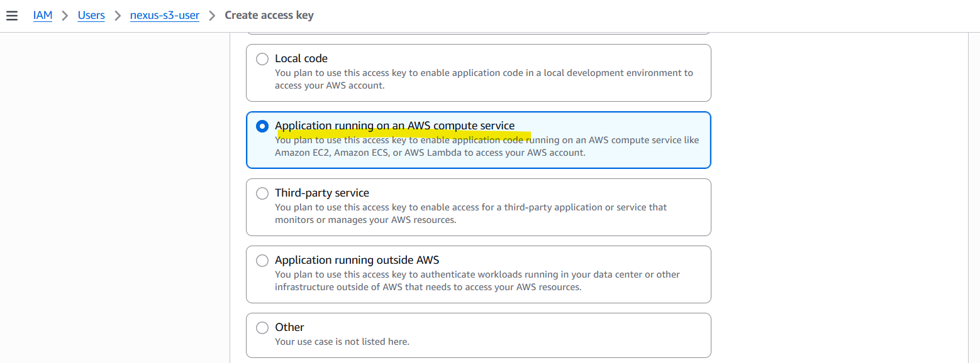

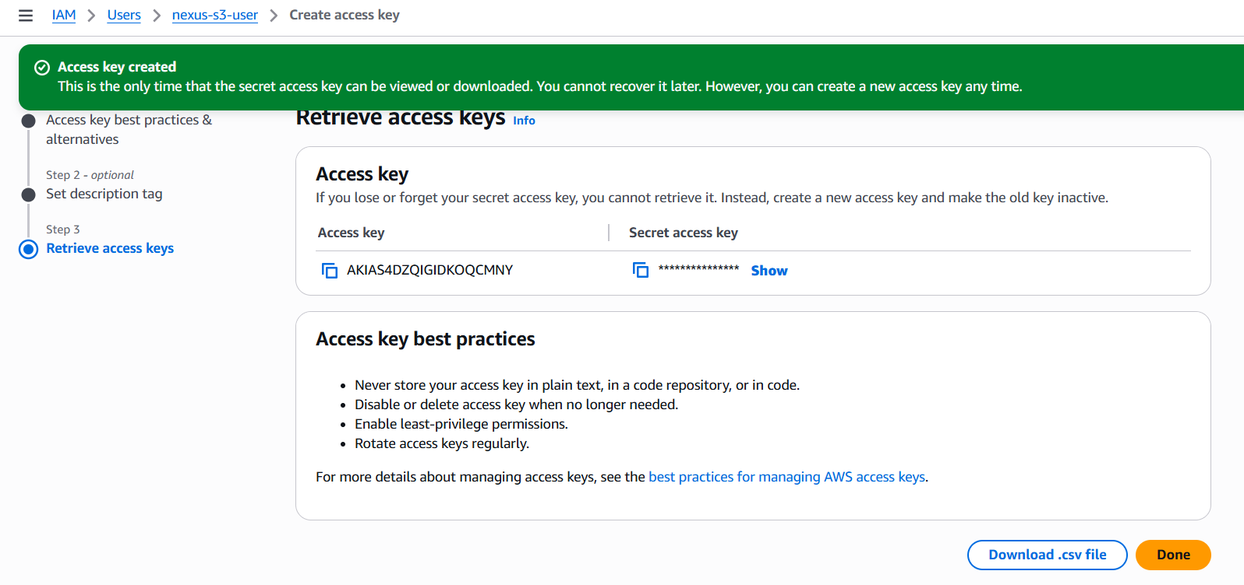

Use the access key and secret access key in nexus

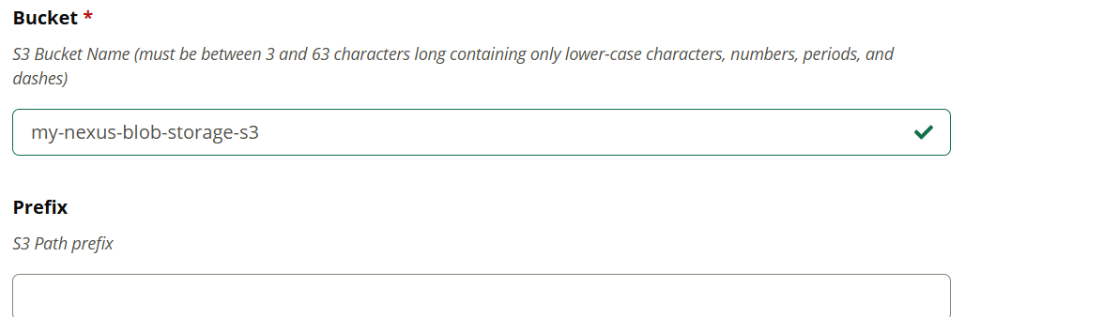

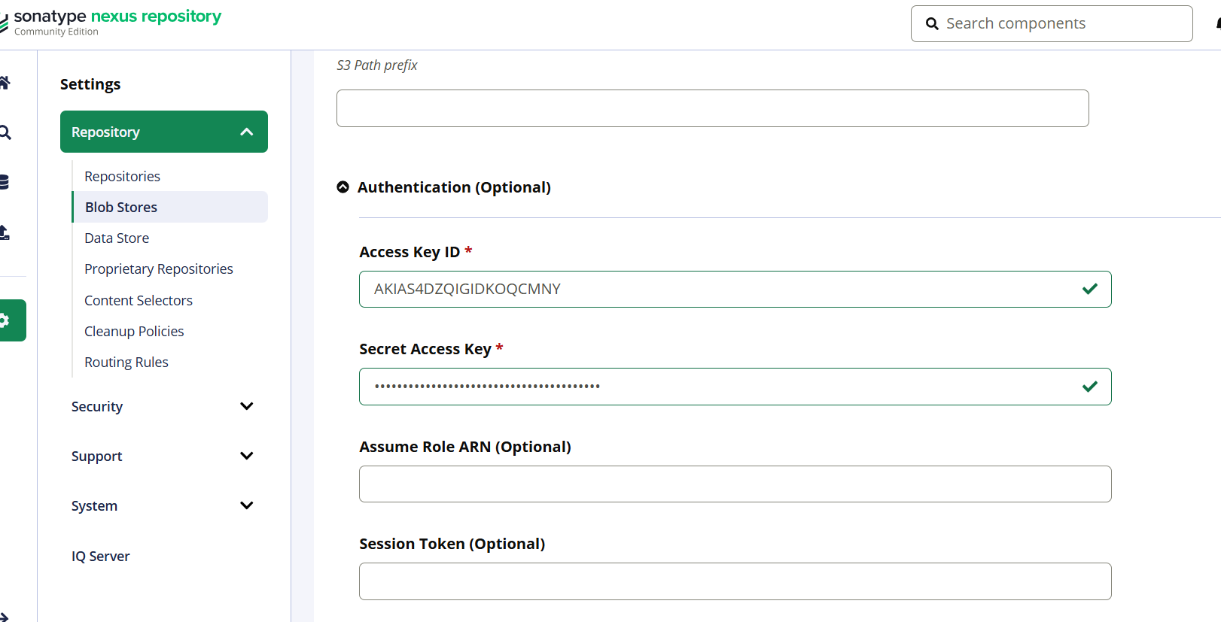

SAVE

Now we have two blob storage of which one has unlimited storage (S3)

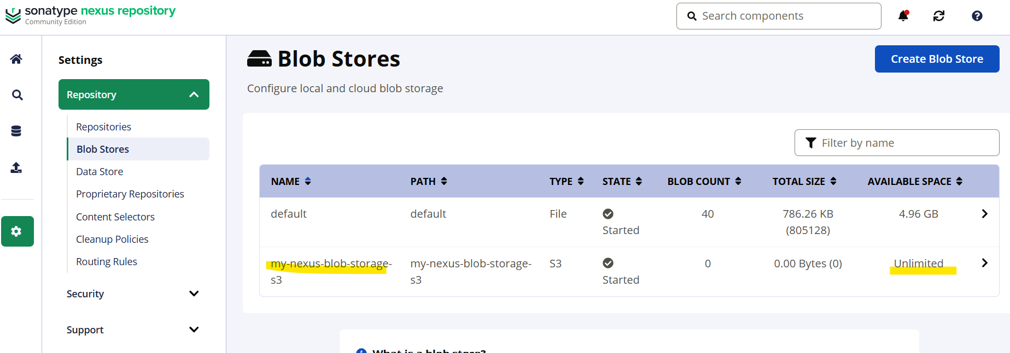

Create a repository

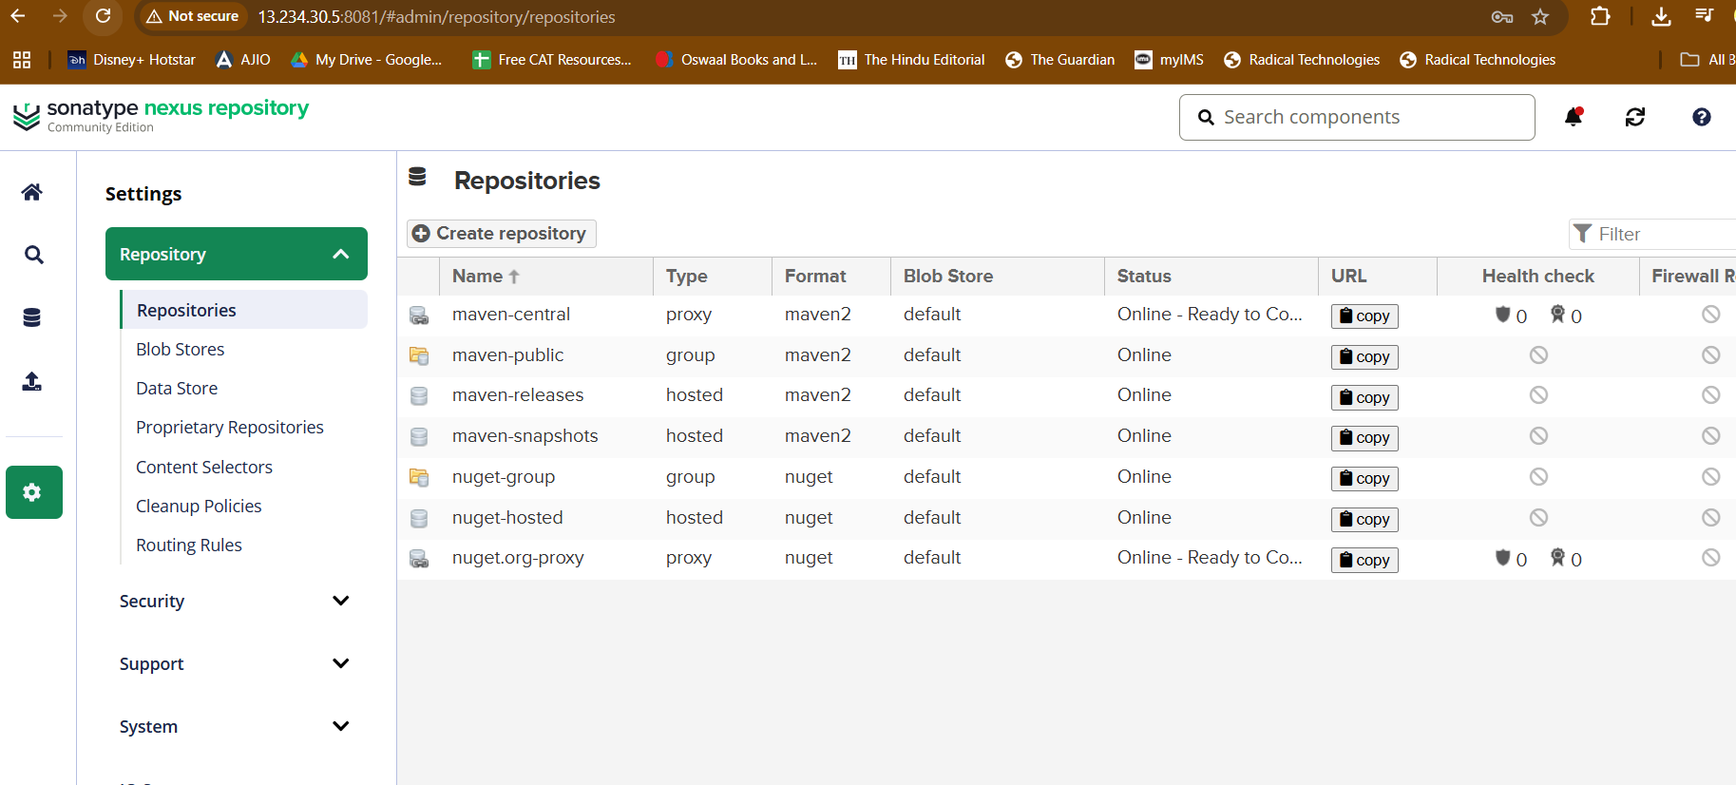

Select docker hosted

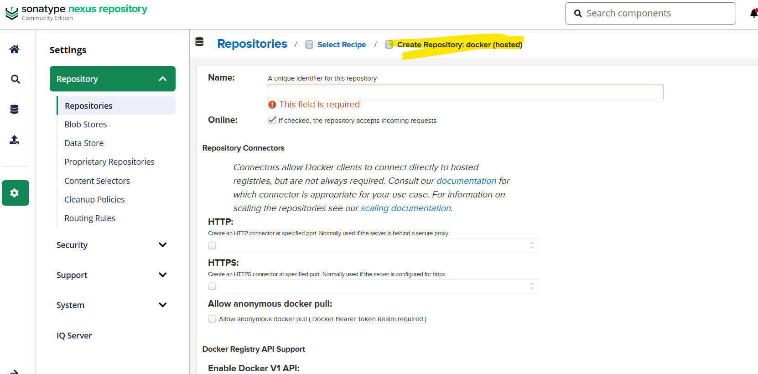

Enable HTTP: 8085 port

Allow anonymous docker pull

Select your blob storage

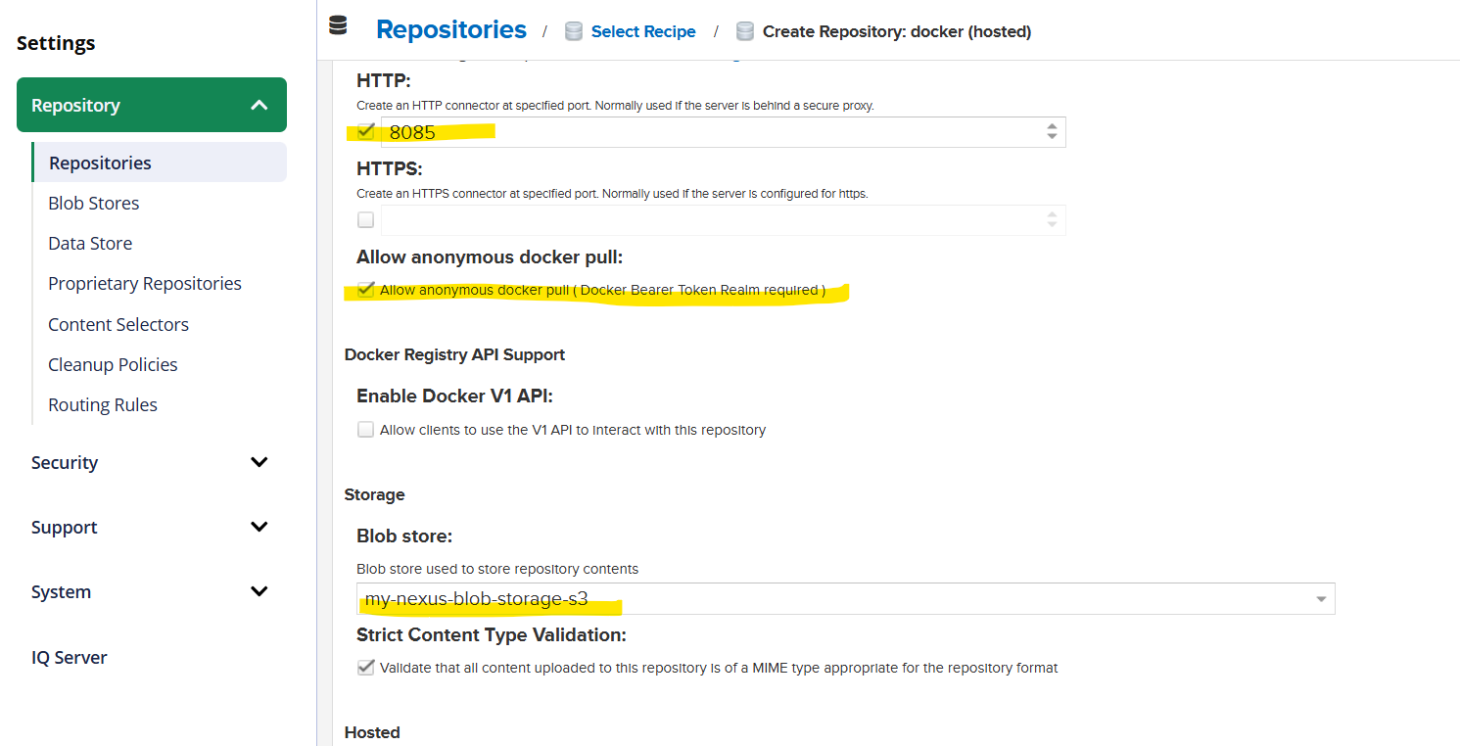

Create repository

Now you have a URL where you can push your artifacts

